Decisions (IF Statements) Worksheet – Year 8 Computer Studies

Remembering how to get the ‘Python Code’ doing Maths

If we want our program to work with numbers we must tell the program that certain variables will hold numbers.
When we input a number into our program
num1 = input(“please enter a number”)
…python automatically sets the variable as a string (a word, for example ‘twenty’ instead of 20)
If we want to do maths with the ‘inputs’ we need to tell the computer that the variable contains a number (integer)

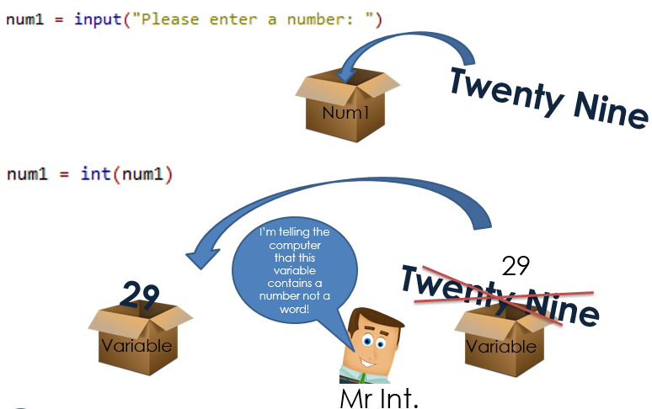

See below for examples of the int function in use so that calculations can be done in Python:
To the left you can see that two numbers have been entered and stored in variables num1 and num2.
As python stores inputs as strings we need to convert these variables into integers.
We do this performing the int function on each variable. Then we add them, store the result and print it to the screen.

EXAMPLE 1 – Working with numbers
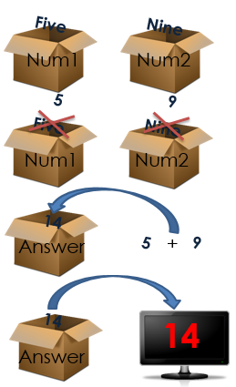
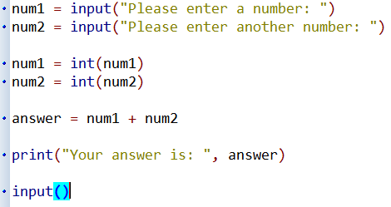

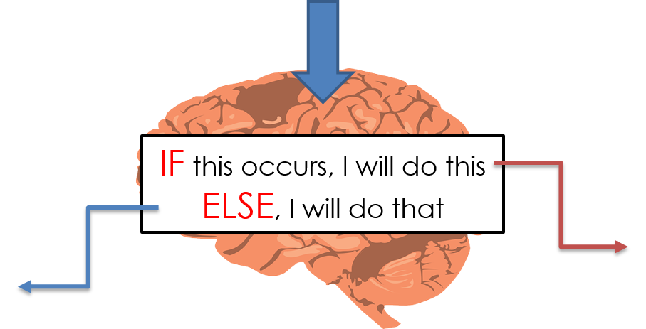

How to get the ‘Python Code’ making ‘Decisions’:
We can get programs make decisions using IF-ELSE statements.
If one thing is TRUE, we can run a sequence of code, if it is FALSE (ELSE) we can run another set of code.

In the example below, the IF statement checks if num1 is greater than num2. If it is TRUE, it will print a line of text stating that it is bigger, if it is FALSE (ELSE), it will display a different piece of text.
The example on the left compared two variables which contained numbers. If we want to check if a variable contains a piece of text we need to write the text in SPEECH MARKS.
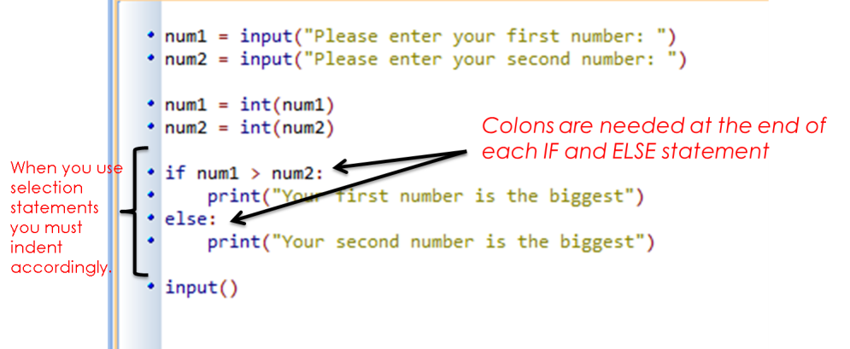

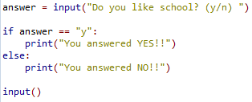

Programming Activities
The guidance and examples (shown above) will help with these tasks:

Remember, for these tasks, if the program asks the user for numbers you need to convert the variable which contains their input into an integer (int()). If the program attempts to check that a variable contains text, we must place the text in speech marks.

TASK 1
1. Write a program that will allow the user to input a value and output whether the value is zero or above (number >= 0) or below zero (number < 0).

TASK 2
2. Write a program and immediately create a variable which contains a password:

E.G.: set_password = “5idm0uth”

Then ask the user to try and guess the password and store this in another variable:

E.G.: user_guess = input(“Guess the password!”)

The program should display a suitable error message if the password is incorrect and a welcome message if the password is correct.

Remember that because we are checking if a variable contains text we need to put the text in speech marks and use the double equals sign.

TASK 3
3. Write a program that asks the user to enter a number from 1-10 to represent how they are feeling (1=Sad, 10=Happy). Get the program to output the message “I’m so sorry to hear you are not a happy bunny” if they type in a number from 1-5. Get the program to output the message “Good to hear you are feeling dandy!” if the enter a number greater than 5.

