AWS DevOps Engineer Intern Assignment
Deployment Documentation Report
Name: | Yogesh Madhukar Vanjari
College: | MIT College Chhatrapati Sambhajinagar
Branch: | BCA
Email: | Vanjariyogesh531@gmail.com
Date: | 10/07/2026

Objective
The objective of this assignment was to deploy a simple static website on an AWS EC2 instance running Amzon Linux, using Nginx as the web server. The task covered end-to-end DevOps fundamentals:
provisioning cloud infrastructure, basic Linux administration, web server configuration, and version control using Git and GitHub.

AWS Services Used
Service | Purpose
Amazon EC2 | Virtual server (Amzon Linux) used to host the website
Security Groups | Firewall rules allowing inbound SSH (port 22) and HTTP (port 80)
Elastic IP* | (eipalloc-081d75cc0f790dfa8) Static public IP attached to the instance
Key Pairs | SSH key-based authentication for secure instance access

Linux Commands Used
Command | Purpose
sudo yum update -y | Update package lists and upgrade installed packages
sudo yum install nginx -y | Install the Nginx web server
sudo systemctl status nginx | Check whether Nginx is running
sudo systemctl restart nginx | Restart the Nginx service
df -h | Check disk usage
free -h | Check memory (RAM) usage
ps aux | List running processes
sudo cp index.html /var/www/html/ | Replace the default Nginx page with a custom page

Steps Followed
- Launched an Amazon Linux EC2 instance (t2.micro) with a Security Group allowing ports 22 and 80.
- Connected to the instance via SSH using a downloaded key pair.
- Updated system packages and installed Nginx.
- Verified Nginx was running and the default page was accessible via the public IP.
- Created a custom HTML page with personal details and replaced the default Nginx page.
- Verified the custom website loaded correctly in the browser.
- Pushed the HTML file and a README.md (with setup steps and commands) to a GitHub repository.
- Prepared this documentation report summarizing the process.

Problems Faced & Solutions

[Example: SSH connection was refused initially because the Security Group did not allow port 22 from my IP — fixed by adding an inbound rule for SSH.]

Learnings
- How to launch and configure an AWS EC2 instance and Security Groups.
- Basic Linux server administration: package management, checking system resources, and processmonitoring.
- Installing, configuring, and managing the Nginx web server.
- Deploying static web content to a live server accessible over the internet.
- Using Git and GitHub to version-control and share a project.

Total Time Taken
Task | Time Taken
Task 1: EC2 Setup | 10 min
Task 2: Linux Basics | 5 min
Task 3: Website Hosting | 10 min
Task 4: Git & GitHub | 5 min
Task 5: Documentation | 20 min
Bonus Task | 10 min
Total | 60 min [1 hrs]

Deliverables & Links
EC2 Public IP: 3.84.26.95
Website URL: 3.84.26.95
GitHub Repository: [https://github.com/your-username/aws-devops-intern-assignment]

Screenshots
[Insert your screenshots here: EC2 Dashboard, SSH login, Nginx status, disk/memory usage, default Nginx page, and your custom website in the browser. In a Word/Google Doc, paste them below this line before exporting to PDF, or attach them as a separate ZIP as required by the assignment submission instructions.]

- : EC2 Dashboard
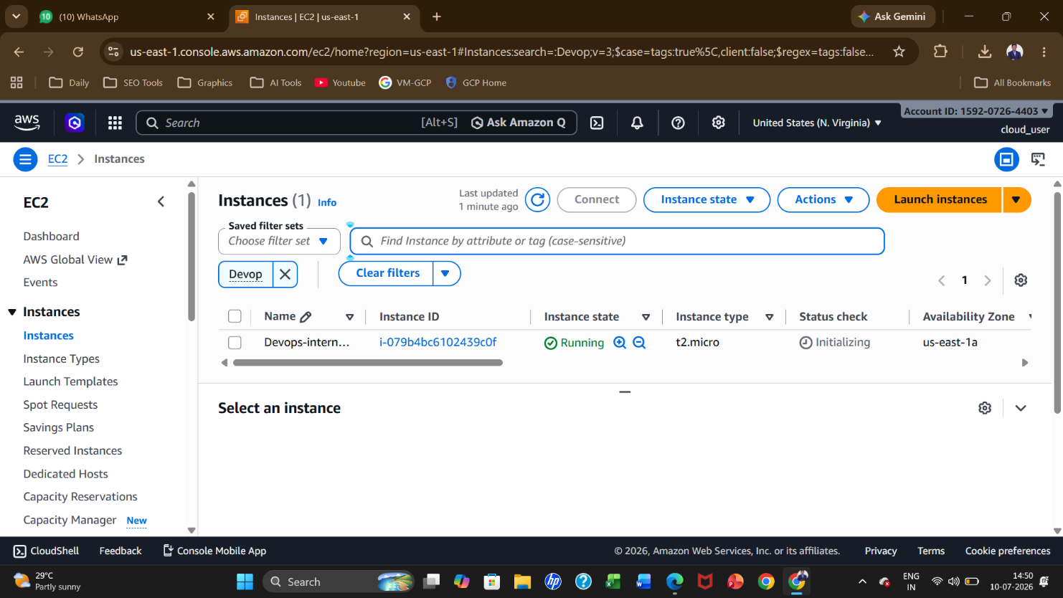

- SSH login

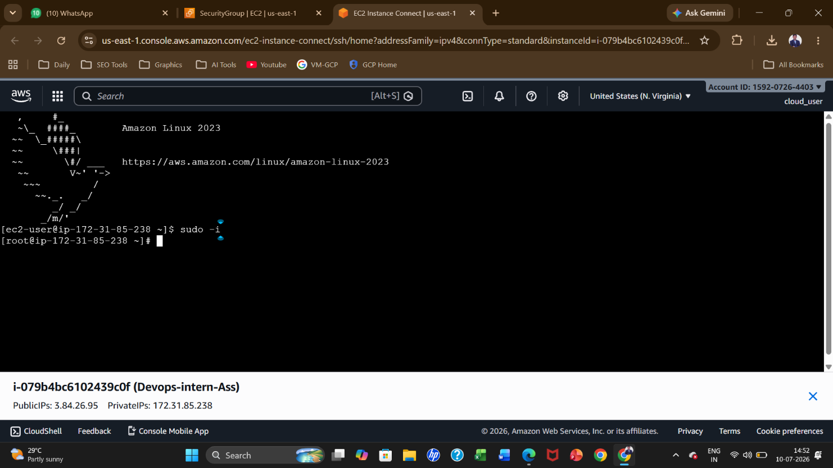

3.Nginx status 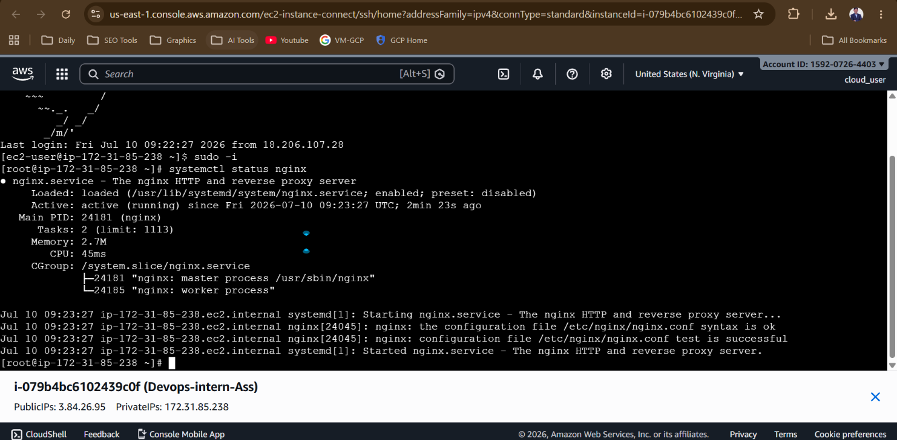

4.default Nginx page
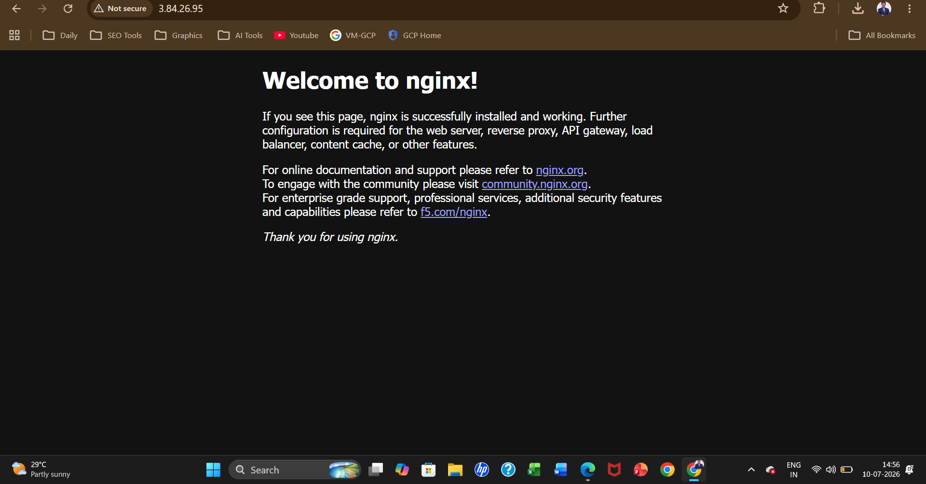

5.My custom website in the browser

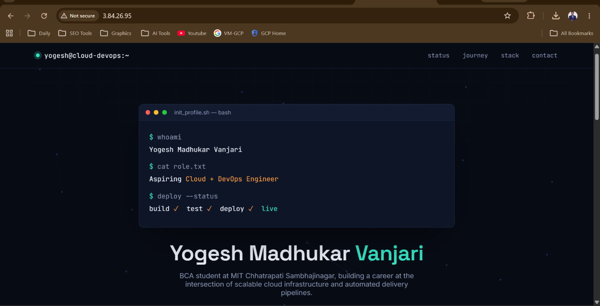

6.disk/memory usage
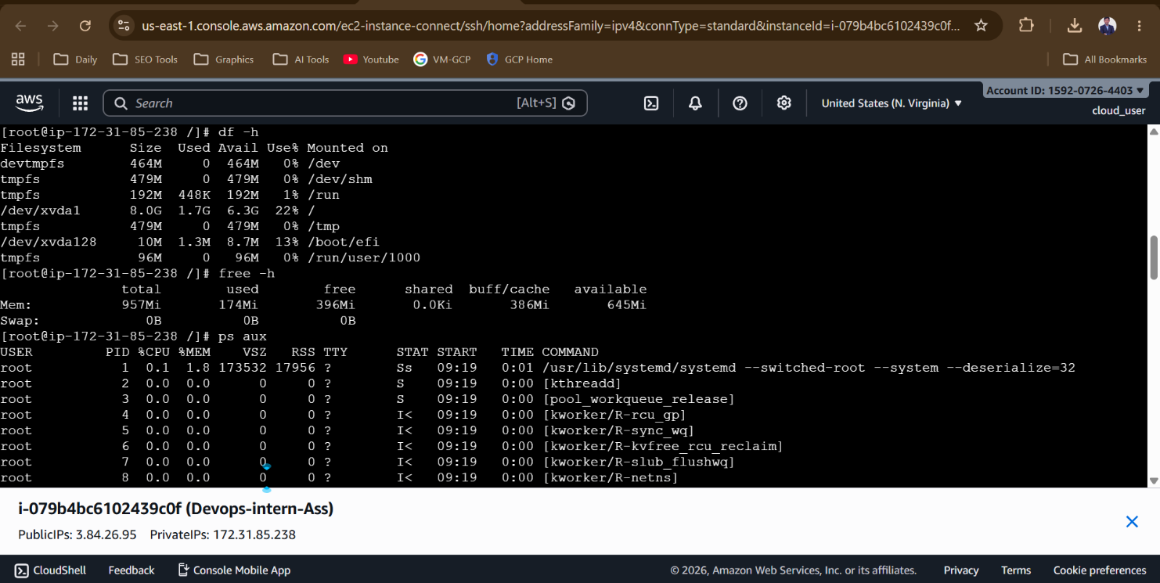
7. Git & Github Commands
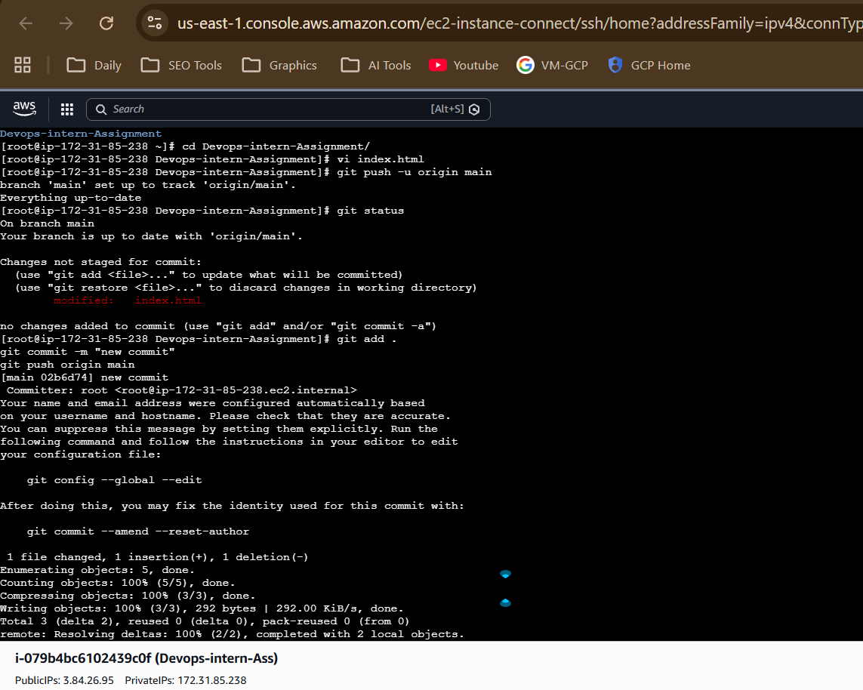
8.Security Group
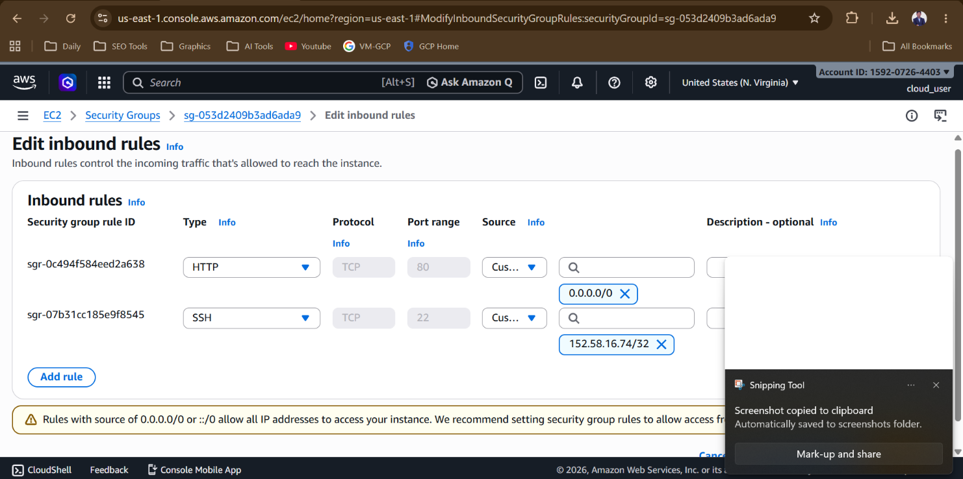9. Docker Setup
