**Persoanlity type reflection**

**Student ID:**

**Module leader:**

**Date of submission:**

**Table of Contents**

Introduction 3

Personality type 3

Reflection on results 4

Learning demonstration 4

Key takeaways 4

Conclusion 5

Appendix 6

# Introduction

Identifying personality type plays an important role in people's life as it helps in understanding preferences, strengths and weaknesses. In addition, personality type also directly impacts the collaboration and communication of people. This report is based on the results of the Typefinder personality test.

# Personality type

My personality type, as per the results of the Typefinder test, is ***ENFJ***, which stands for ***Extraverted, iNtuitive, Feeling and Judging.*** Through this personality type, I exhibit 4 styles: cognitive, energy, life and value. When it comes to ***energy,*** I prefer going on adventures and outdoor activities. For instance, I cannot sit still in a place for a long time. It leads to a negative impact on my energy level. In addition, I also prefer communicating with new people every day and making new friends. Align with this, I also prefer warm communication which emphasises emotions and thoughts. Following this, when it comes to ***cognitive skills***, I am a very idealistic person as I love pursuing goals in impractical or visionary ways. In addition, I also treat every subject and thing of life imaginatively. Along with this, I also possess progressive traits as I emphasise trying out new ideas instead of traditional ones.

Subsequently, when it comes to ***value***, I act as compassionate as I feel sad about the problems of other people. In addition, I also show empathy for the sufferings of other people. Most importantly, I make sure to follow ethics in my life in dealing with both my personal and professional life. For instance, I follow key ethical values such as honesty, respect, kindness and personal responsibility. Most importantly, I prefer to be associated with humanitarian works such as aid for disaster relief, and people suffering from war. Lastly, when it comes to ***lifestyle***, I am very ambitious about my goals. For instance, I put more effort and time into pursuing my goals. I am also very dedicated to my dreams as I devote enough time to my goals. In addition, I am a very organised person as I follow everyday tasks as per a set schedule. However, I have a strong feeling of being obeyed and respected by my family members, friends and other people in society.

# Reflection on results

I do think that the results do not accurately reflect my personality type. I possess a trait of compassion and responsibility, however, sometimes I do not prefer to engage actively in showing empathy for other people’s suffering. I focus, most importantly, on my goals, thus, I sacrifice my social life, and responsibilities. Following this, I prefer to stick to a set schedule, thus, I make sure that my schedule is not broken as it helps me pursue my goals.

Being aware of my personality type plays an important role in managing my personal life. Firstly, being organised helps me organise and finish my tasks regarding academic studies. I also set both short-term and long-term goals regarding my academic career thus, it helps me devote time and effort to these goals. In addition, it also helps me devote a particular time to my social life as it helps me engage actively with my friends and family members.

# Learning demonstration

I once had a severe disagreement with my friends as our opinions did not agree. My friends suggested that the 2000 dot-com bubble burst occurred due to the optimism of people about the internet age. However, I strongly persisted in my opinion that the crisis was due to the involvement of large amounts of speculative investments. Thus, now, by being aware of my personality type, I can make opinions based on logical thinking. Firstly, I would change my mind and tend to agree with my friends to avoid conflicts. Avoiding conflicts would help me in engaging in disagreements with other people. I can also conclude that the crisis was due to speculative investments, and how my friends did not agree with me. Due to the awareness of my personality type, I would try to avoid conflicts. Avoiding conflicts would help me in eliminating frustration and loneliness that can harm both my academic and personal life.

# Key takeaways

Taking the Typefinder test helps me identify that I am an organised and ambitious person. It will help me reach my goals as now I will devote more time and effort to executing my new goals and executing them as well. In addition, I will also emphasise sticking to a schedule that can help me avoid procrastination and prioritise important tasks.

# Conclusion

Based on the above statements, it can be concluded that the result of the personality test was ENFJ. The core values of this personality type are organised ambitious, and compassionate. The takeaways of this test play an important role in achieving goals due to the identification of key characteristics and traits of the personality type.

# Appendix

Apendix 1:

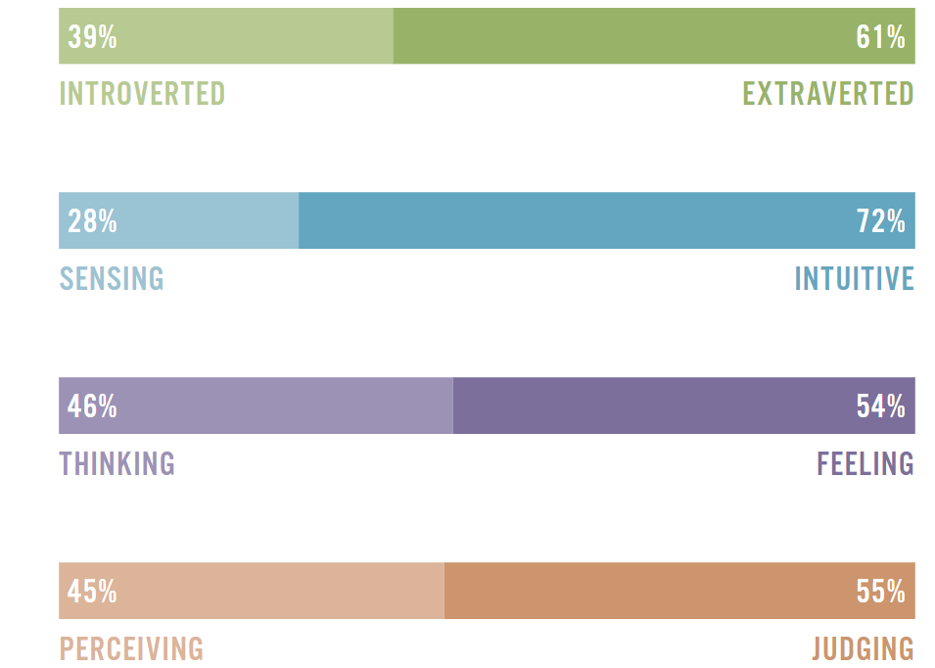

Source: https://www.truity.com/test/type-finder-personality-test-new

Appendix 2:

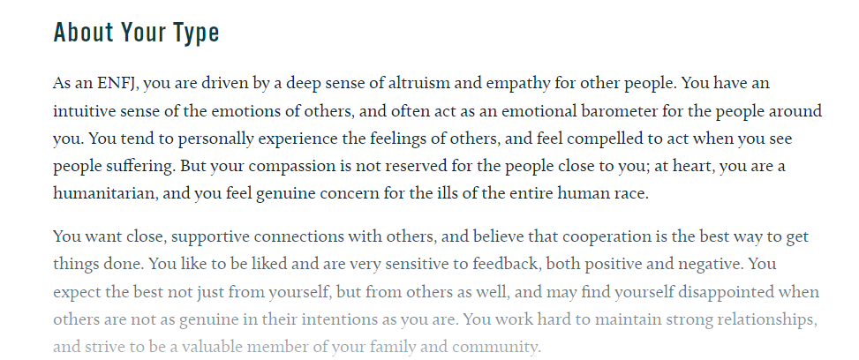

Source: https://www.truity.com/test/type-finder-personality-test-new