PROJECT REPORT
ESP32 Industrial IoT
Monitoring & Control System
IoT · Industrial Automation · Embedded Systems · Wireless Monitoring & Control

Project type | Student-built prototype
Author / Team | To be updated
Institution | To be updated
Guide | To be updated
Version / Date | To be updated

Table of Contents
1. Introduction 3
2. Problem Statement 3
3. Objectives 3
4. System Overview 4
5. Hardware Components 4
6. Software Architecture 5
7. ESP-NOW Communication 7
8. Web Dashboard 8
9. Hardware Connections 10
10. System Working 10
11. Testing and Validation 11
12. Results 12
13. Limitations 12
14. Future Scope 13
15. Conclusion 13
16. References 13

Status labels used in this report. Implemented: present in the current design, as described in the project information (firmware source is not yet included in the repository). Tested: validated on hardware and recorded in Section 11; none recorded yet. Planned: near-term work not yet done (validation, documentation of Sender pins, photographs). Future: possible extensions, not implemented. Items that depend on the firmware source are marked To be verified against source.

1. Introduction
This project is an ESP32-based system for monitoring environmental and object-detection parameters, with local relay control. It uses two ESP32 boards:
- Sender ESP32 reads a DHT11 (temperature, humidity), an MQ-2 gas sensor and two IR sensors.
- Receiver ESP32 receives the data over ESP-NOW, shows it on a 1.3” OLED, hosts a web dashboard on its own Wi-Fi access point, and drives two relays.
The design follows the basic Industrial IoT pattern: sensors collect field data, wireless communication transfers it, and a local digital interface provides monitoring and control.

2. Problem Statement
Monitoring temperature, humidity, gas level and object presence usually needs wired sensor runs or network infrastructure such as a router or cloud service. This project builds a low-cost alternative from common hardware: a wireless sensor node feeding a local display, a web dashboard and switching outputs, with no router or internet connection needed for local monitoring.

3. Objectives
- Wireless sensor data transmission (ESP-NOW)
- Real-time temperature and humidity monitoring
- Gas-level monitoring (raw sensor level, not calibrated concentration)
- IR-based object detection/status monitoring
- Local OLED display
- Web-based monitoring from a laptop or smartphone
- Live graphs of gas and temperature trends
- Relay control from the dashboard
- Two-ESP32 distributed architecture

4. System Overview
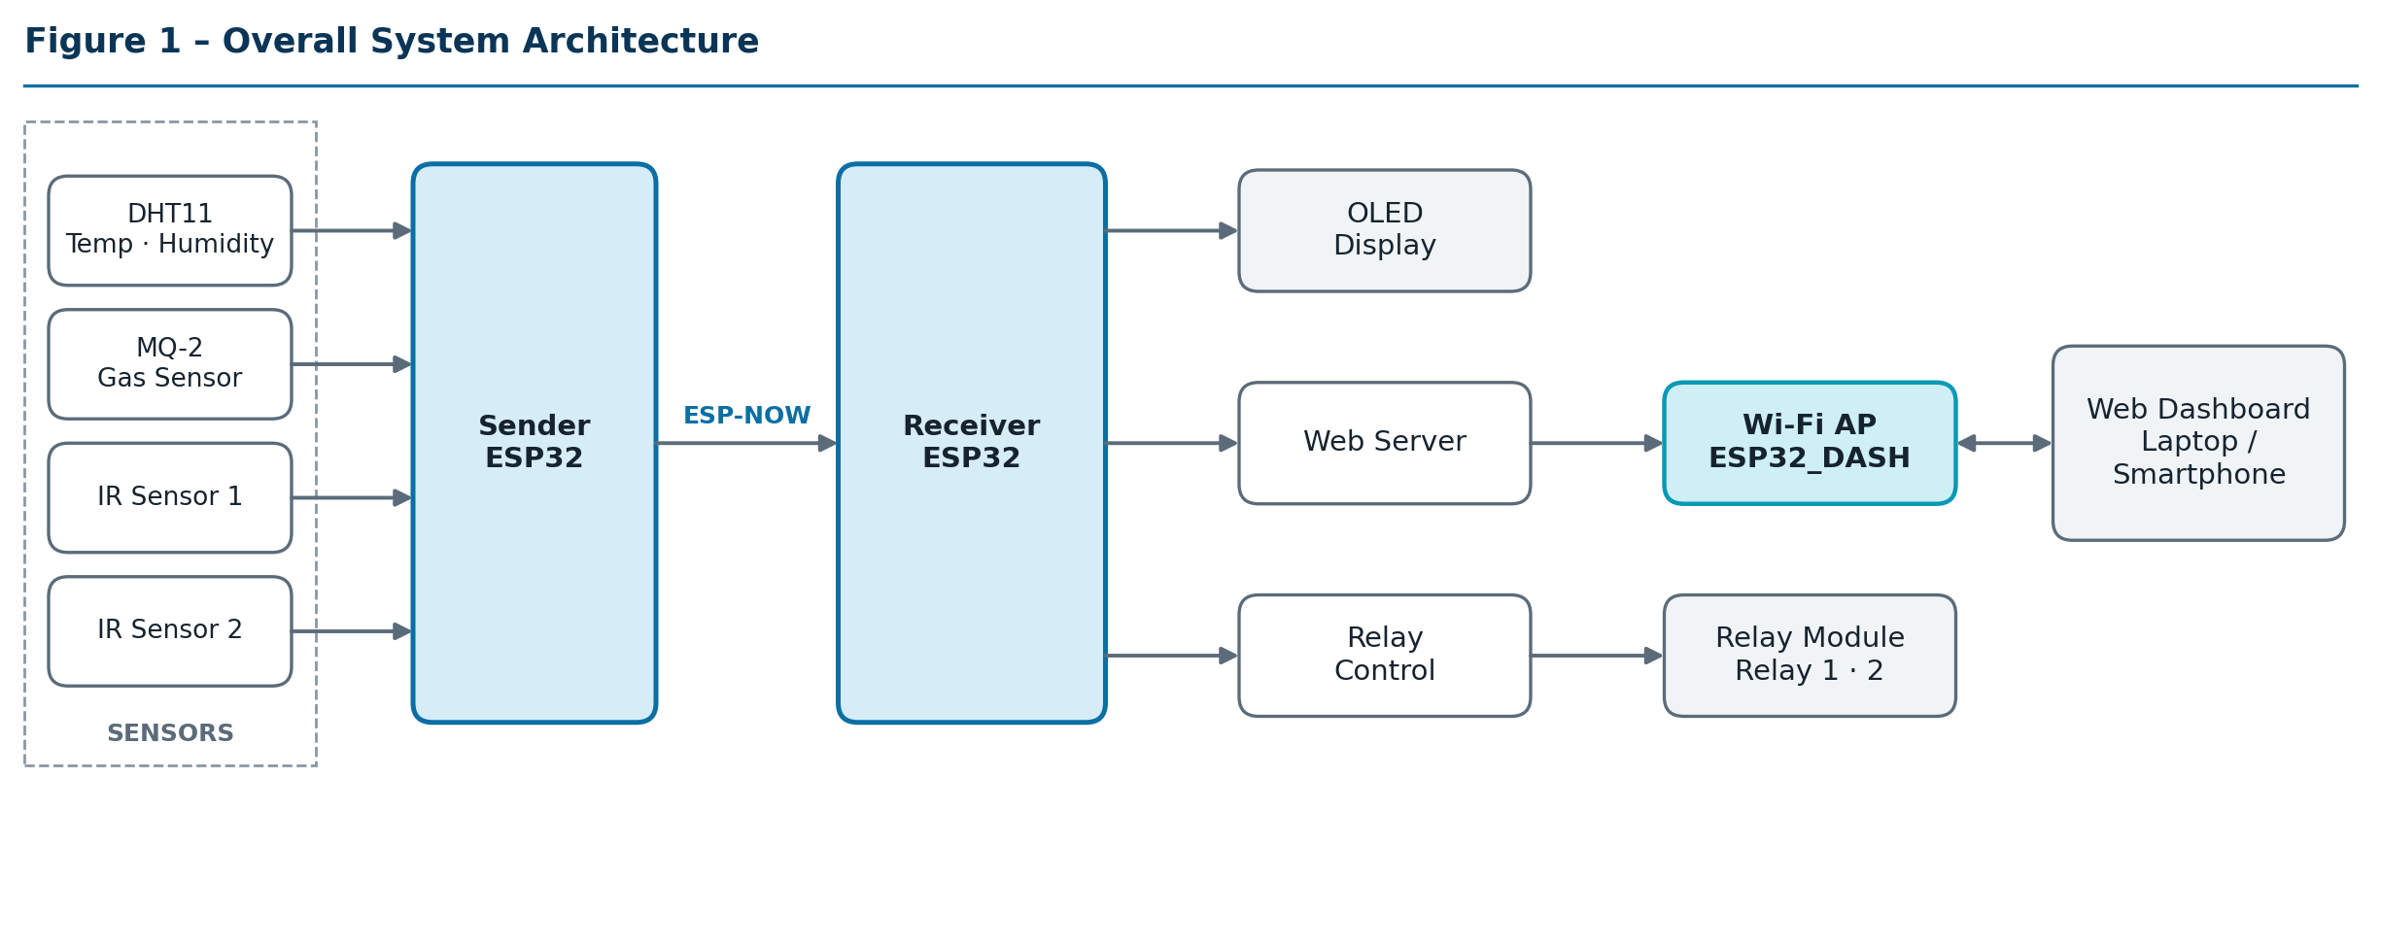
Figure 1 – Overall system architecture.
The Sender collects sensor data and transmits it over ESP-NOW. The Receiver passes it to three outputs: the OLED, the web server (reached through the ESP32 Wi-Fi access point) and the relay control.
Table 1 – Implementation status
Capability | Implemented | Tested | Planned / Future
Sensor acquisition (DHT11, MQ-2, IR 1, IR 2) | Yes | Not yet | Validation planned
ESP-NOW transmission and reception | Yes | Not yet | Validation planned
OLED display | Yes | Not yet | Validation planned
Wi-Fi AP and web dashboard with live charts | Yes | Not yet | Validation planned
Relay control from dashboard | Yes | Not yet | Validation planned
Sender GPIO documentation, photographs, screenshots | – | – | Planned
Calibrated gas measurement, cloud, authentication, alerts | No | – | Future (Section 14)

5. Hardware Components
Table 2 – Hardware components
# | Component | Qty | Role
1 | ESP32 development board | 2 | Sender and Receiver
2 | DHT11 temperature and humidity sensor | 1 | Temperature, humidity
3 | MQ-2 gas sensor | 1 | Raw gas sensor level
4 | IR sensor | 2 | Object detection/status
5 | 1.3” OLED display (I2C, U8g2) | 1 | Local display on the Receiver
6 | Relay module | 1 | Relay 1 and Relay 2 outputs
7 | Jumper wires, breadboard / prototype wiring | – | Interconnects
8 | USB power / programming connections | – | Power and flashing
Relay module channel count, OLED controller variant and I2C address, sensor supply voltages and load ratings: Not specified in the current implementation.
Table 3 – Receiver pin configuration (confirmed)
Function | GPIO
OLED I2C SDA | 21
OLED I2C SCL | 22
Relay 1 | 25
Relay 2 | 26
Sender pins (DHT11, MQ-2, IR Sensor 1, IR Sensor 2): To be updated according to final hardware wiring.
Photographs (placeholders). Hardware setup, Sender ESP32, Receiver ESP32: [Insert actual hardware photographs here]

6. Software Architecture
Table 4 – Technology stack
Layer | Technology
Hardware | ESP32, DHT11, MQ-2, IR sensors, OLED, relay module
Communication | ESP-NOW, Wi-Fi Access Point
Embedded software | Arduino framework, C/C++
Libraries | WiFi.h, esp_now.h, WebServer.h, Wire.h, U8g2lib.h, esp_wifi.h
Web | HTML, CSS, JavaScript, Chart.js (live temperature and gas trend graphs)

6.1 Sender ESP32
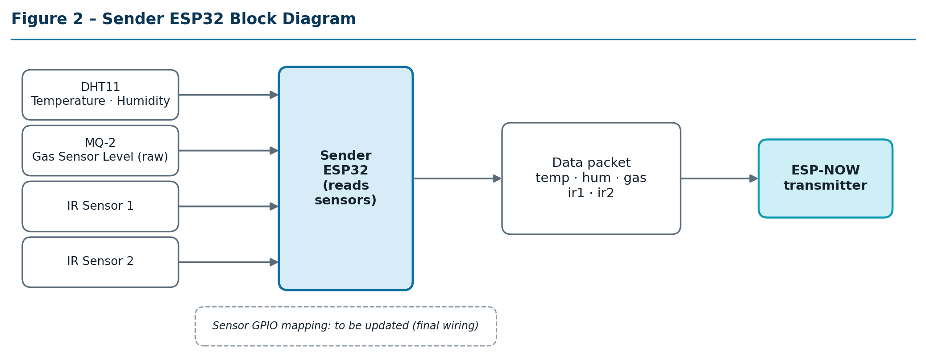
Figure 2 – Sender ESP32 block diagram.

6.2 Receiver ESP32
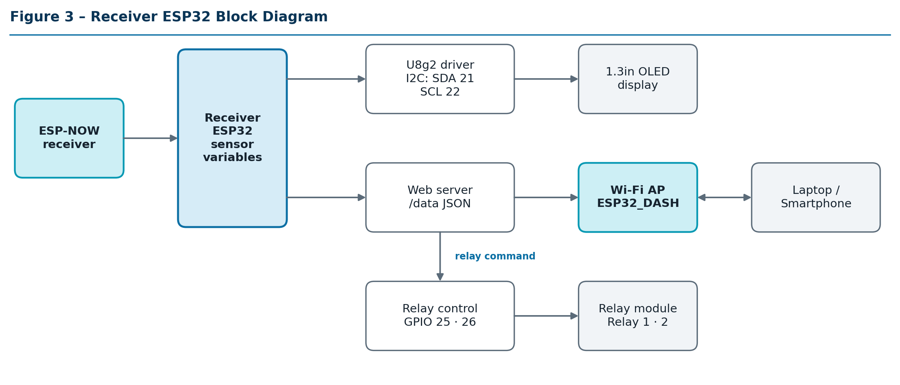
Figure 3 – Receiver ESP32 block diagram.

6.3 Firmware flow
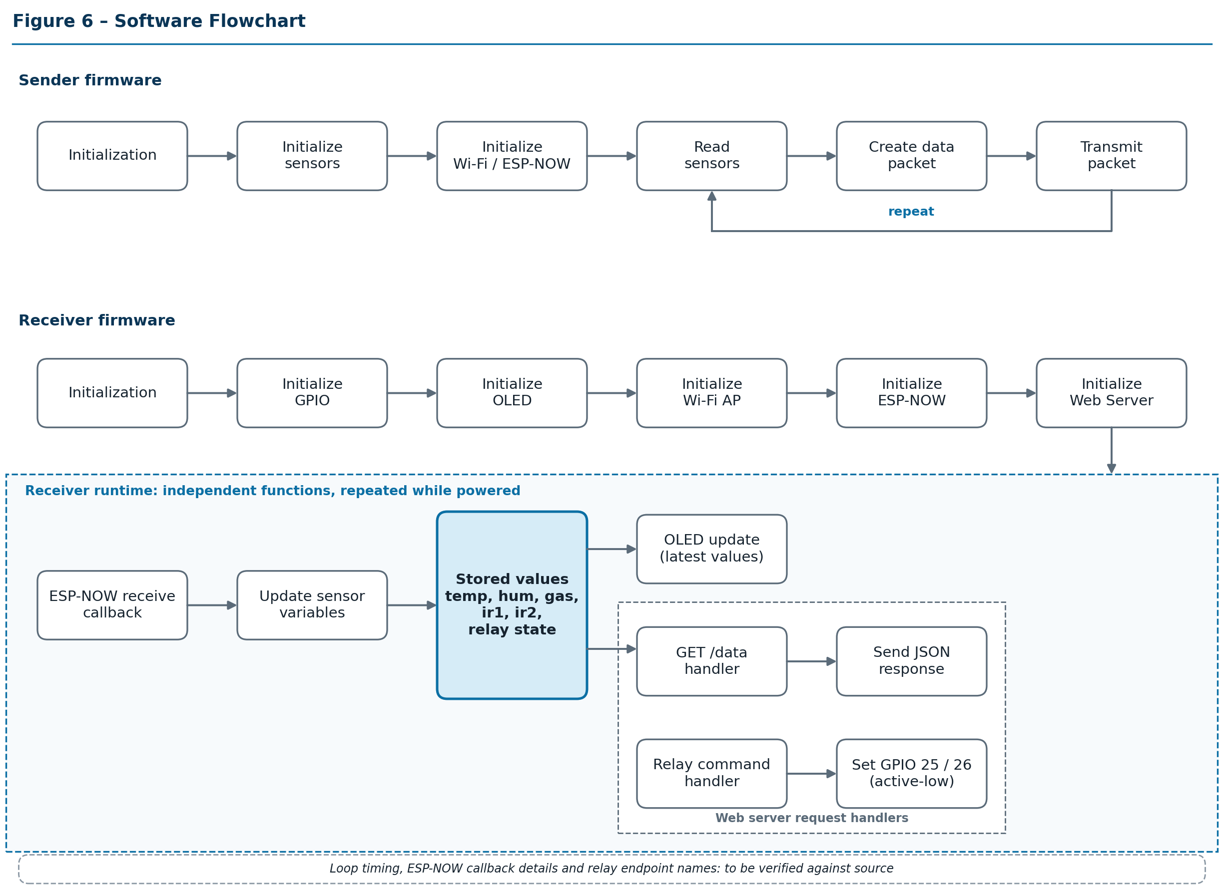
Figure 6 – Software flowchart.
The Sender initializes, then repeatedly reads sensors, builds a packet and transmits it. On the Receiver, initialization is followed by independent runtime functions rather than one serial sequence:
- The ESP-NOW receive callback updates the stored sensor values.
- The OLED update shows the latest stored values.
- The web server serves two separate request handlers: GET /data returns the stored values as JSON, and the relay command handler sets GPIO 25 / GPIO 26. Relay switching does not depend on the /data response.
The firmware is structured so that the web server keeps responding while sensor updates arrive.

6.4 Implementation details
Table 5 – Firmware details
Item | Current documentation | Status
Receiver GPIOs | OLED SDA 21, SCL 22; Relay 1 = 25, Relay 2 = 26 | Confirmed
Sender GPIOs | – | To be updated according to final hardware wiring
Data structure | temp, hum, gas, ir1, ir2 | Confirmed
JSON structure | temp, hum, gas, ir1, ir2, r1, r2 (approximate) | Field types to be verified
Data endpoint | /data | Confirmed
Relay endpoints | – | To be verified
Receiver Wi-Fi | Access point, SSID ESP32_DASH | Exact mode setting to be verified
Wi-Fi channel, Sender and Receiver MAC | – | To be verified
ESP-NOW receive callback | Updates stored sensor values | Details to be verified
OLED initialization | U8g2, I2C on GPIO 21/22 | Constructor / address to be verified
Dashboard refresh interval | Periodic automatic refresh | Interval to be verified
Cache handling | Cache prevention used | Method to be verified
Chart.js | Gas and temperature trend charts | Point count, CDN vs. local loading to be verified
Relay logic | Active-low for this relay module | Confirmed

7. ESP-NOW Communication
ESP-NOW is an Espressif protocol that lets ESP32 devices exchange short packets directly, without a Wi-Fi router. It has low protocol overhead and suits local sensor-to-controller links. Range and reliability have not been measured for this project.
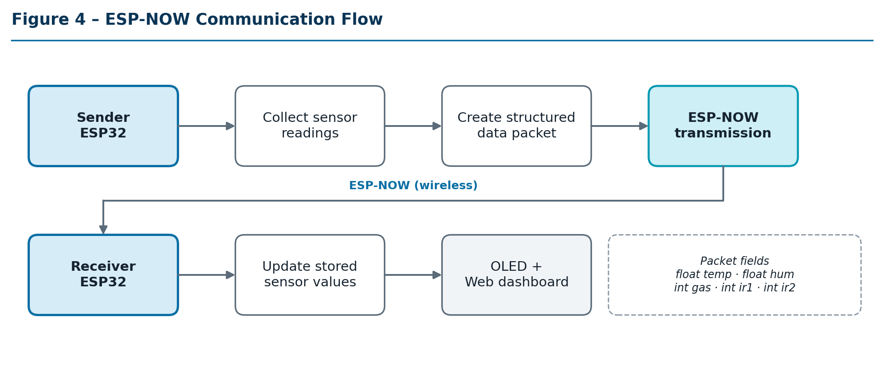
Figure 4 – ESP-NOW communication flow.
Table 6 – Data packet fields
Field | Type | Meaning
temp | float | Temperature from the DHT11
hum | float | Relative humidity from the DHT11
gas | int | Raw MQ-2 reading (Gas Sensor Level)
ir1 | int | IR Sensor 1 value
ir2 | int | IR Sensor 2 value
Sender and Receiver must use the same Wi-Fi channel for ESP-NOW to work. Channel selection, peer MAC handling and the meaning of each IR value: to be verified against source.

8. Web Dashboard
The Receiver hosts a local web server (WebServer.h) on its own access point, so the data path works without internet access. Several devices can connect to the access point, subject to the practical limits of the ESP32; no maximum user count is claimed. If Chart.js is loaded from a CDN, the client needs internet access for the charts; to be verified.
Access point | Value
SSID | ESP32_DASH
Password | 12345678 (defined in firmware; change before deployment)

8.1 Layout
Table 7 – Dashboard layout
Zone | Content
Top | Project title / system status
Metrics | Temperature, Humidity, Gas Sensor Level, IR Sensor 1, IR Sensor 2
Graphs | Gas Level Trend, Temperature Trend
Controls | Relay 1, Relay 2
The layout is responsive for laptop and mobile screens, with automatic refresh.
Screenshots (placeholders). Dashboard on laptop and on smartphone: [Insert actual dashboard screenshots here]

8.2 Data flow and API
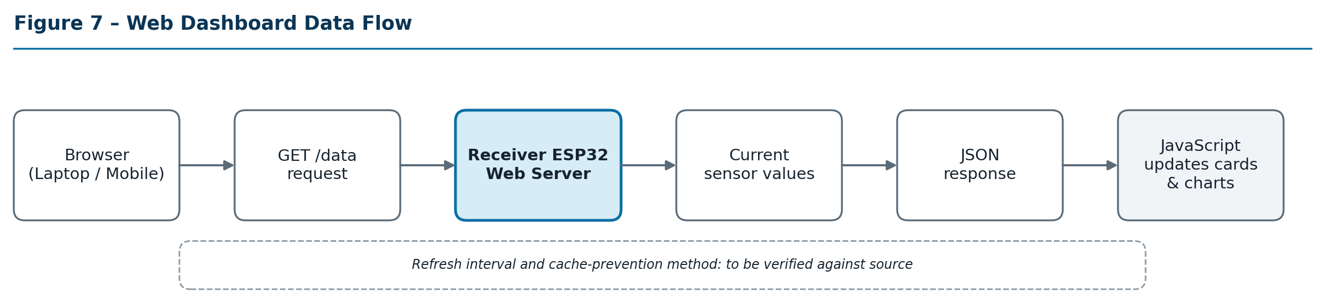
Figure 7 – Web dashboard data flow.
The browser sends GET /data; the Receiver returns the current values as JSON; JavaScript updates the cards and adds temperature and gas values to the charts. Cache prevention makes the browser fetch current data instead of a cached response.
Table 8 – /data response fields
Field | Description
temp | Temperature (DHT11)
hum | Humidity (DHT11)
gas | Raw MQ-2 Gas Sensor Level
ir1 | IR Sensor 1 value
ir2 | IR Sensor 2 value
r1 | Relay 1 state
r2 | Relay 2 state
Engineering note. The MQ-2 output shown in this project represents the sensor reading/level used for monitoring. Accurate gas concentration in PPM requires proper sensor calibration, load resistance considerations, environmental compensation, and gas-specific calibration.

8.3 Relay control
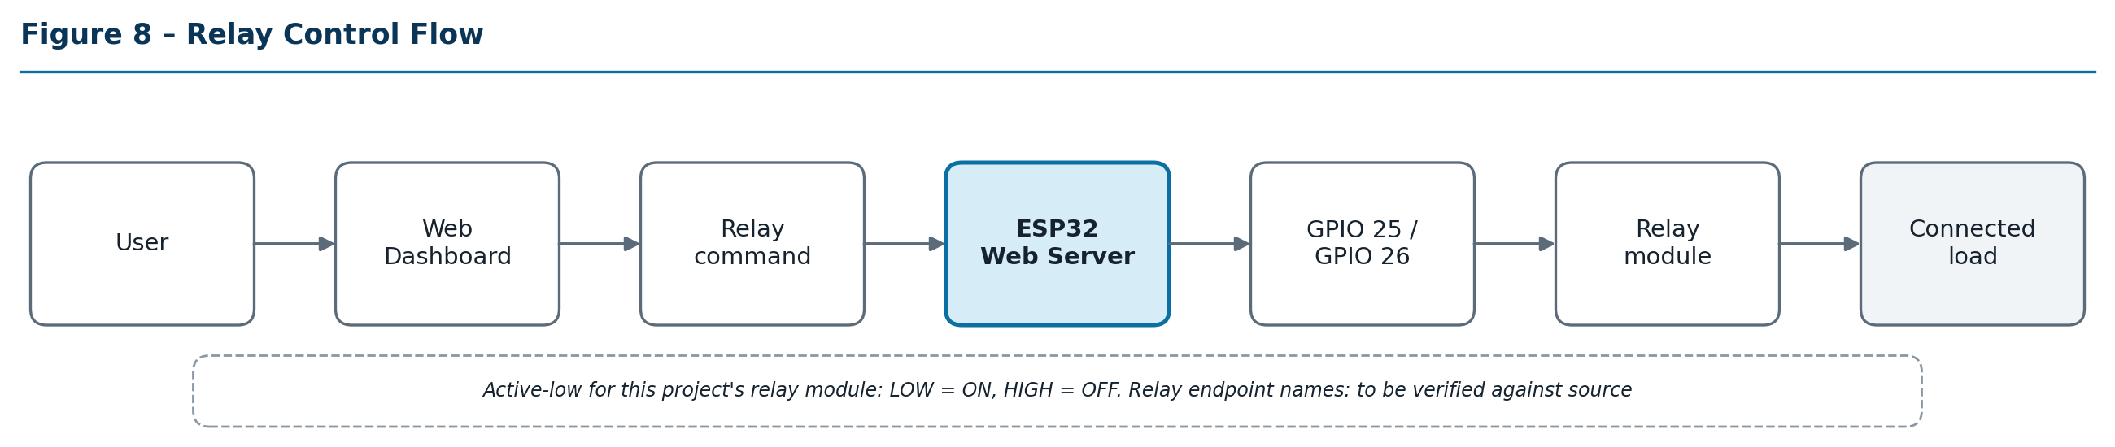
Figure 8 – Relay control flow.
Relay commands from the dashboard are handled by the Receiver web server separately from the /data request, and set GPIO 25 (Relay 1) and GPIO 26 (Relay 2). In the relay module used in this project the outputs are active-low: LOW = relay ON, HIGH = relay OFF. This applies to this project’s module only. Relay endpoint names: to be verified.

8.4 OLED display
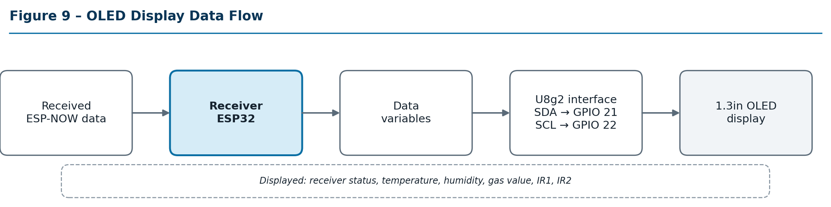
Figure 9 – OLED display data flow.
The OLED shows receiver status, temperature, humidity, gas value, IR1 and IR2, using U8g2 over I2C (SDA GPIO 21, SCL GPIO 22).
OLED photograph (placeholder). [Insert actual OLED photograph here]

8.5 Network notes
The access point is local; dashboard traffic stays within the ESP32 network. This is not production-grade security. Change the password before serious use and avoid hard-coding credentials in a public repository.

9. Hardware Connections
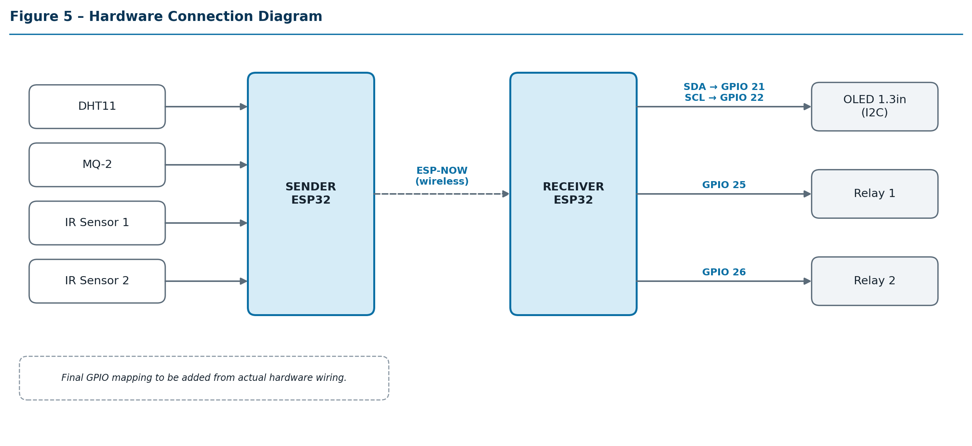
Figure 5 – Hardware connection diagram.
Sender pin assignments: final GPIO mapping to be added from actual hardware wiring. Power arrangement beyond USB and relay load wiring: Not specified in the current implementation.

10. System Working
- The Sender ESP32 powers up.
- Sensors are initialized.
- The Sender reads temperature and humidity from the DHT11.
- The Sender reads the MQ-2 gas sensor.
- The Sender reads IR Sensor 1 and IR Sensor 2.
- Readings are stored in a structured data packet.
- The packet is transmitted using ESP-NOW.
- The Receiver ESP32 receives the packet.
- The Receiver updates its sensor variables.
- The latest values are shown on the OLED.
- The Receiver web server provides sensor data at /data.
- A laptop or phone browser requests the latest data.
- JavaScript updates the metric cards.
- Temperature and gas values are added to the live charts.
- The user controls Relay 1 and Relay 2 from the dashboard; the relay command is handled separately from data requests.
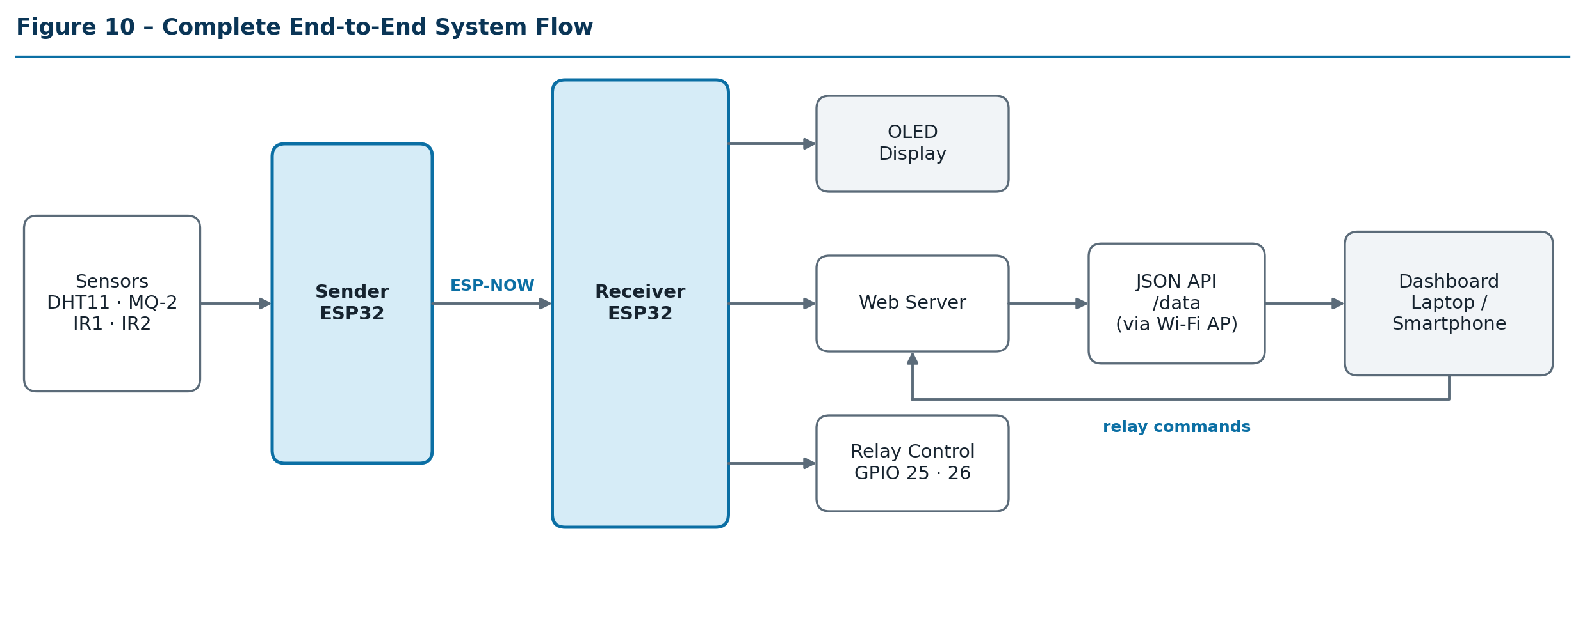
Figure 10 – Complete end-to-end system flow.
The Sender reads periodically, the Receiver updates when packets arrive, the dashboard polls /data, and the OLED shows the latest received values. Intervals: to be verified against source.

11. Testing and Validation
No tests have been performed or recorded. Every entry below is Pending Validation; actual results and PASS/FAIL status will be entered only after hardware testing.
Table 9 – Test matrix
ID | Test Description | Expected Result | Actual Result | Status | Remarks
T01 | Sender ESP32 startup | Boots; sensors and ESP-NOW initialize | To be filled | Pending Validation
T02 | DHT11 temperature reading | Plausible temperature reported | To be filled | Pending Validation
T03 | DHT11 humidity reading | Plausible humidity reported | To be filled | Pending Validation
T04 | MQ-2 sensor reading | Gas Sensor Level changes with gas exposure | To be filled | Pending Validation | Warm-up needed; uncalibrated
T05 | IR Sensor 1 | Value changes on object presence | To be filled | Pending Validation
T06 | IR Sensor 2 | Value changes on object presence | To be filled | Pending Validation
T07 | ESP-NOW communication | Receiver gets packets from Sender | To be filled | Pending Validation
T08 | Receiver OLED display | OLED shows latest values | To be filled | Pending Validation
T09 | Web dashboard access | Dashboard loads via ESP32_DASH | To be filled | Pending Validation
T10 | Live dashboard update | Cards refresh automatically | To be filled | Pending Validation
T11 | Gas graph update | Gas trend chart updates | To be filled | Pending Validation
T12 | Temperature graph update | Temperature trend chart updates | To be filled | Pending Validation
T13 | Relay 1 control | Relay 1 toggles from dashboard | To be filled | Pending Validation | Active-low
T14 | Relay 2 control | Relay 2 toggles from dashboard | To be filled | Pending Validation | Active-low
T15 | Mobile dashboard access | Dashboard usable on smartphone | To be filled | Pending Validation
Table 10 – Troubleshooting
Problem | Possible causes
ESP-NOW data not received | Different Wi-Fi channel; incorrect MAC address; ESP-NOW initialization failure; sender/receiver not configured correctly
Dashboard shows -- | Browser cannot reach /data; Receiver not receiving ESP-NOW data; web server issue; browser cache; network connection issue
OLED not displaying | Incorrect I2C wiring; wrong OLED address; incorrect SDA/SCL; library configuration
Relay not switching | Incorrect GPIO; active-low logic misunderstanding; relay power issue; wiring problem
Gas value unstable | MQ-2 warm-up; environmental changes; sensor characteristics; lack of calibration

12. Results
No numerical results are reported. The prototype is designed to demonstrate the capabilities below; evidence will be added after validation.
Capability | Evidence
Sensor data acquisition | [Add Serial Monitor screenshot]
Wireless transmission over ESP-NOW | [Add Serial Monitor screenshot]
Local visualization on the OLED | [Add OLED photograph / capture]
Web dashboard with live charts | [Add dashboard screenshots]
Relay control | [Add photograph or video]
Laptop and mobile access | [Add screenshots]

13. Limitations
- MQ-2 values are raw sensor levels, not calibrated PPM measurements, unless calibration is performed.
- ESP-NOW range depends on environment, antenna, interference and hardware; it has not been measured.
- This is a prototype and is not certified for industrial safety applications.
- Relay outputs must not be connected to dangerous loads without appropriate electrical protection and isolation.
- The Wi-Fi password is defined in firmware and should be changed for deployment.
- Sensor accuracy depends on sensor quality, calibration, environment and wiring.
- No database or cloud storage is used.
- The project focuses on local monitoring and control.

14. Future Scope
None of the following is implemented.
Area | Possible improvements
Connectivity | MQTT, cloud IoT dashboard, remote monitoring, multiple sensor nodes
Data | Database logging, historical storage, data export, SD card logging
Security | User authentication, HTTPS, better network security
Sensing | Sensor calibration, industrial-grade sensors, additional sensors
Automation | Alarm/buzzer, automatic relay rules, emergency shutdown system
Alerts and apps | Email/Telegram alerts, mobile application
Reliability | OTA firmware updates, watchdog and fault recovery
Hardware | Enclosure, PCB, industrial power supply

15. Conclusion
The project demonstrates a local ESP32-based IoT architecture combining sensor acquisition, ESP-NOW wireless communication, local processing, OLED visualization, web-based monitoring and relay control. It is a prototype: it makes no claim of industrial certification, calibrated gas measurement or production readiness. It provides a base that can be extended toward larger IoT and automation applications through the items in Section 14.

16. References
- Espressif Systems, ESP32 Series Datasheet and Technical Reference Manual. https://www.espressif.com/en/support/documents/technical-documents
- Espressif Systems, ESP-NOW, ESP-IDF Programming Guide. https://docs.espressif.com/projects/esp-idf/en/latest/esp32/api-reference/network/esp_now.html
- Espressif Systems, Arduino core for the ESP32 documentation. https://docs.espressif.com/projects/arduino-esp32/
- olikraus, U8g2 library documentation. https://github.com/olikraus/u8g2/wiki
- Aosong, DHT11 datasheet (version to be updated).
- Hanwei Electronics, MQ-2 gas sensor datasheet (version to be updated).
- Chart.js Contributors, Chart.js documentation. https://www.chartjs.org/docs/

