SMART SPORTZ - API MASTER SPECIFICATION

Internal API, External API Provider, Page Workflow, Webhook, Socket, and Credential Blueprint

Consolidated from Smart Sportz phase documents and current official provider documentation

Document | API Master Internal and External API Specification
Project | Smart Sportz
Scope | External APIs needed, where to get credentials, internal REST APIs, Socket.IO events, page-to-endpoint mapping, webhooks, API security, response format, and implementation rules
Backend Stack | Node.js, Express, Socket.IO, PostgreSQL, Prisma, Redis, service layer, repository pattern, middleware, validation, caching, audit logs
Frontend Stack | React, Vite, TypeScript, Tailwind, Redux, React Query, Framer Motion, reusable UI components
Style | Same compact black phase-document style: Times New Roman, black headings, single spacing, fixed tables, page border, compact margins
Date | July 5, 2026
Version | 1.0

API Master Intent
This document defines what external APIs Smart Sportz needs, where the developer gets each credential, and how those providers connect to the Smart Sportz backend.
It also defines internal APIs by frontend page and module so the frontend, backend, database, notification, payment, and live score systems can be developed with one consistent contract.

1. API Architecture Objective
Smart Sportz should expose one consistent internal API surface for the frontend and management portals while hiding all third-party provider secrets behind the backend. External provider integrations must be wrapped by internal services so providers can be replaced later without changing frontend pages.
- Use /api/v1 as the main REST namespace for all internal HTTP APIs.
- Use Socket.IO namespaces or rooms for live score, live dashboard, announcements, and real-time tournament updates.
- Keep payment, SMS, WhatsApp, email, push, media, maps, and AI provider credentials only in backend environment variables.
- Log every sensitive API action in DB-3 and mirror transactional DB-1 state into DB-2 according to the database master architecture.
- Use idempotency keys for payment, webhook, notification, upload, export, and retry-sensitive APIs.

2. API Ecosystem Overview
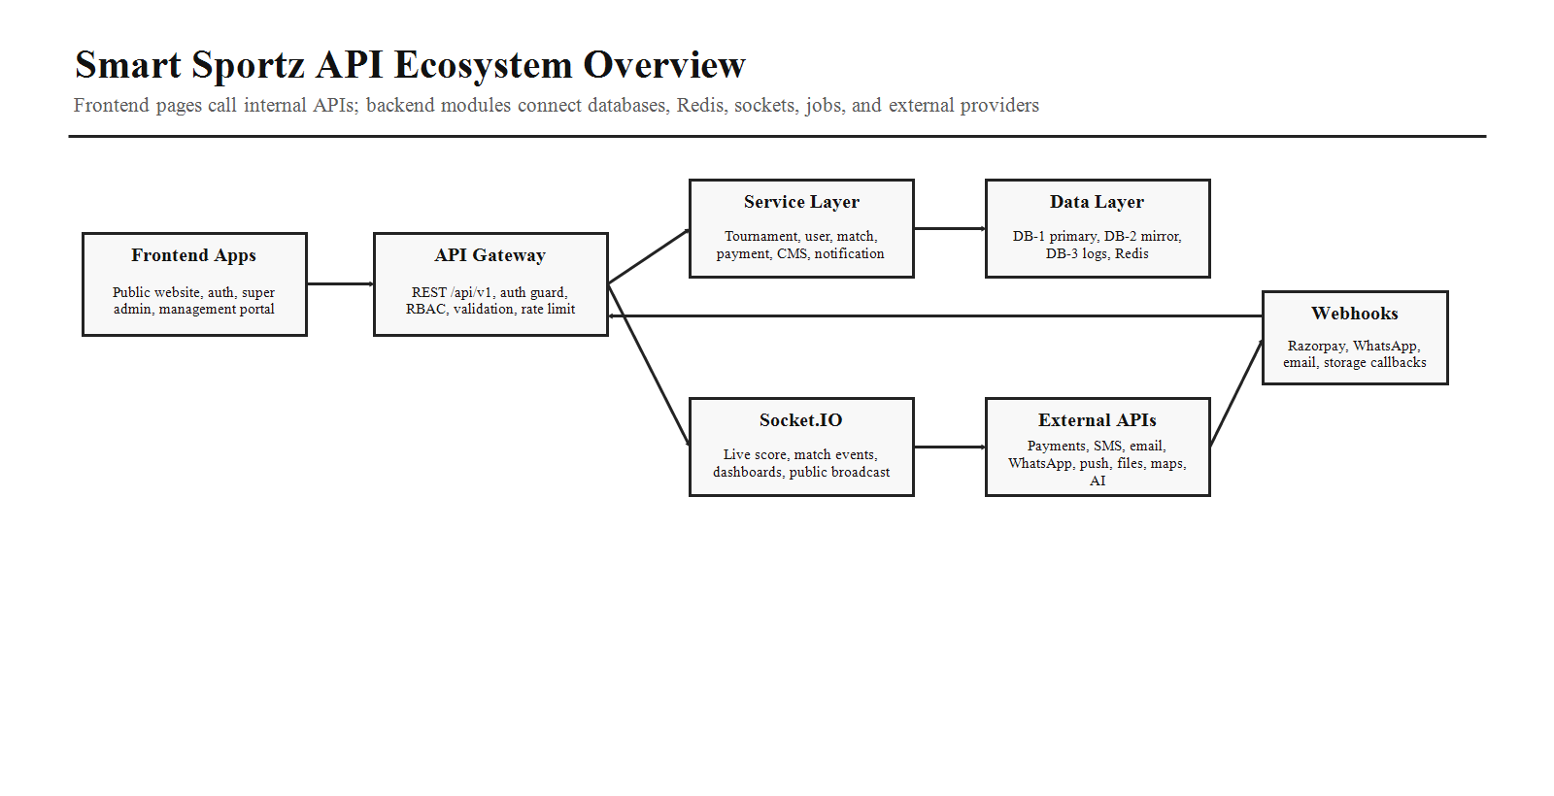
Layer | Responsibility
Frontend Pages | Public website, authentication, registration, payment, super admin, management user, live score, reports, and CMS pages call internal APIs only.
API Gateway | Express routes apply JWT authentication, RBAC, validation, rate limiting, request IDs, audit context, and error formatting.
Service Layer | Business logic for tournaments, registrations, teams, players, fixtures, live scores, payments, notifications, CMS, reports, and logs.
Data Layer | DB-1 editable primary data, DB-2 immutable mirror backup, DB-3 logs/events, Redis sessions/cache/live state.
External Providers | Razorpay, SMS provider, Meta WhatsApp Cloud API, email provider, Firebase Cloud Messaging, media storage, maps, CAPTCHA, and optional OpenAI APIs.

3. External APIs Needed and Where to Get Them
These external APIs are recommended for production Smart Sportz. The backend should integrate them through provider adapter services, not directly from frontend pages.
Need | Recommended Provider and Where to Get
Payments, refunds, invoices | Razorpay Payment Gateway. Create a Razorpay account, complete business/KYC requirements, then generate Test and Live API keys from the Razorpay Dashboard. Docs: https://razorpay.com/docs/api/ and auth/key guide: https://razorpay.com/docs/api/authentication/
Payment status callbacks | Razorpay Webhooks. Configure webhook URL in Razorpay Dashboard and store webhook secret in backend env. Docs: https://razorpay.com/docs/webhooks/
SMS OTP and alerts | Primary option: Twilio Programmable Messaging for global SMS, from Twilio Console/API keys. Docs: https://www.twilio.com/docs/messaging/api. India-focused options: MSG91 docs https://docs.msg91.com/ or Fast2SMS Dev API https://www.fast2sms.com/help/send-sms-dev-api/
WhatsApp notifications | Meta WhatsApp Business Platform Cloud API. Create Meta developer app, connect business, add phone number, generate access token, and configure webhook. Docs: https://developers.facebook.com/documentation/business-messaging/whatsapp/get-started
Transactional email | Resend or Twilio SendGrid. Resend API keys are managed in the Resend API Key Dashboard: https://resend.com/docs/dashboard/api-keys/introduction. SendGrid API keys are under Settings -> API Keys: https://www.twilio.com/docs/sendgrid/ui/account-and-settings/api-keys
Push notifications | Firebase Cloud Messaging. Create Firebase project, configure web/mobile app, get service account credentials, and send FCM messages from backend. Docs: https://firebase.google.com/docs/cloud-messaging
Image, gallery, document uploads | Cloudinary Upload API for managed media or AWS S3 for object storage. Cloudinary docs: https://cloudinary.com/documentation/image_upload_api_reference. S3 API docs: https://docs.aws.amazon.com/AmazonS3/latest/API/Welcome.html
Maps and venue location | Google Maps Platform. Create Google Cloud project, enable Maps JavaScript/Places/Geocoding APIs, create and restrict API key. Docs: https://developers.google.com/maps/documentation/javascript/get-api-key
Bot protection | Cloudflare Turnstile or Google reCAPTCHA. Turnstile widget gives sitekey/secret key from Cloudflare dashboard: https://developers.cloudflare.com/turnstile/get-started/. reCAPTCHA keys: https://docs.cloud.google.com/recaptcha/docs/create-key-website
Optional AI intelligence | OpenAI API for assistant features such as report summaries, match insights, content suggestions, and support assistant. Get project API keys from OpenAI Platform. API reference: https://platform.openai.com/docs/api-reference

4. External Provider Flow
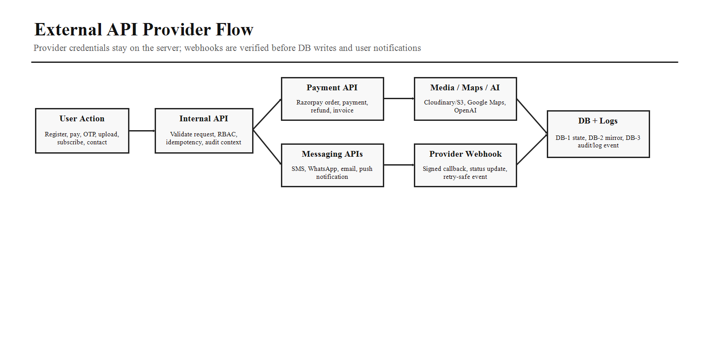
- Frontend never calls payment, SMS, WhatsApp, email, push, storage, maps secret, or AI provider secrets directly.
- Backend validates the user action, creates the provider request, stores a pending record in DB-1, and logs the attempt in DB-3.
- Provider webhook callbacks must be signature-verified before updating DB-1 state.
- Every webhook handler must be idempotent so repeated provider callbacks do not duplicate receipts, notifications, registrations, refunds, or logs.
- Provider failures should enter retry queues with clear status and alerting, not silently fail.

5. External API Environment Variables
Provider | Required Backend Environment Variables
Razorpay | RAZORPAY_KEY_ID, RAZORPAY_KEY_SECRET, RAZORPAY_WEBHOOK_SECRET
SMS | SMS_PROVIDER, TWILIO_ACCOUNT_SID, TWILIO_AUTH_TOKEN, TWILIO_MESSAGING_SERVICE_SID or MSG91_AUTH_KEY / FAST2SMS_AUTH_KEY
WhatsApp | WHATSAPP_PROVIDER, META_WHATSAPP_ACCESS_TOKEN, META_WHATSAPP_PHONE_NUMBER_ID, META_WHATSAPP_BUSINESS_ACCOUNT_ID, META_WHATSAPP_WEBHOOK_VERIFY_TOKEN, META_WHATSAPP_APP_SECRET
Email | EMAIL_PROVIDER, RESEND_API_KEY or SENDGRID_API_KEY, EMAIL_FROM_ADDRESS, EMAIL_REPLY_TO
Push | FIREBASE_PROJECT_ID, FIREBASE_CLIENT_EMAIL, FIREBASE_PRIVATE_KEY, FCM_WEB_VAPID_KEY
Media Storage | CLOUDINARY_CLOUD_NAME, CLOUDINARY_API_KEY, CLOUDINARY_API_SECRET or AWS_ACCESS_KEY_ID, AWS_SECRET_ACCESS_KEY, AWS_REGION, S3_BUCKET_NAME
Maps | GOOGLE_MAPS_API_KEY for browser-restricted frontend map loading and server-restricted geocoding key if needed
Bot Protection | TURNSTILE_SITE_KEY, TURNSTILE_SECRET_KEY or RECAPTCHA_SITE_KEY, RECAPTCHA_SECRET_KEY
OpenAI Optional | OPENAI_API_KEY, OPENAI_PROJECT_ID if AI features are enabled

6. Internal API Standards
All internal APIs should use a predictable REST contract, shared error shape, audit metadata, and consistent pagination/filtering. This keeps React Query integration clean and makes Super Admin and Management pages reusable.
Standard | Rule
Base URL | /api/v1
Authentication | JWT access token in Authorization header, refresh token rotation, Redis-backed session/revocation data.
Authorization | RBAC middleware checks role, permission, tournament scope, organization scope, and action type.
Validation | Validate body, params, query, files, and provider webhook signatures before service execution.
Response Shape | { success, data, meta, error, requestId, timestamp } with stable error codes.
Pagination | Use page/limit for normal tables and cursor pagination for heavy logs, match events, payments, and reports.
Filtering | Support status, sport, tournament, date range, search, role, permission, payment status, approval status, and venue filters.
Audit | Write DB-3 audit records for login, mutation, approval, payment, score change, export, settings, webhook, and security events.
Caching | Use Redis for public pages, lookup lists, sessions, dashboards, live state, and rate limits.

7. Internal API Module Map
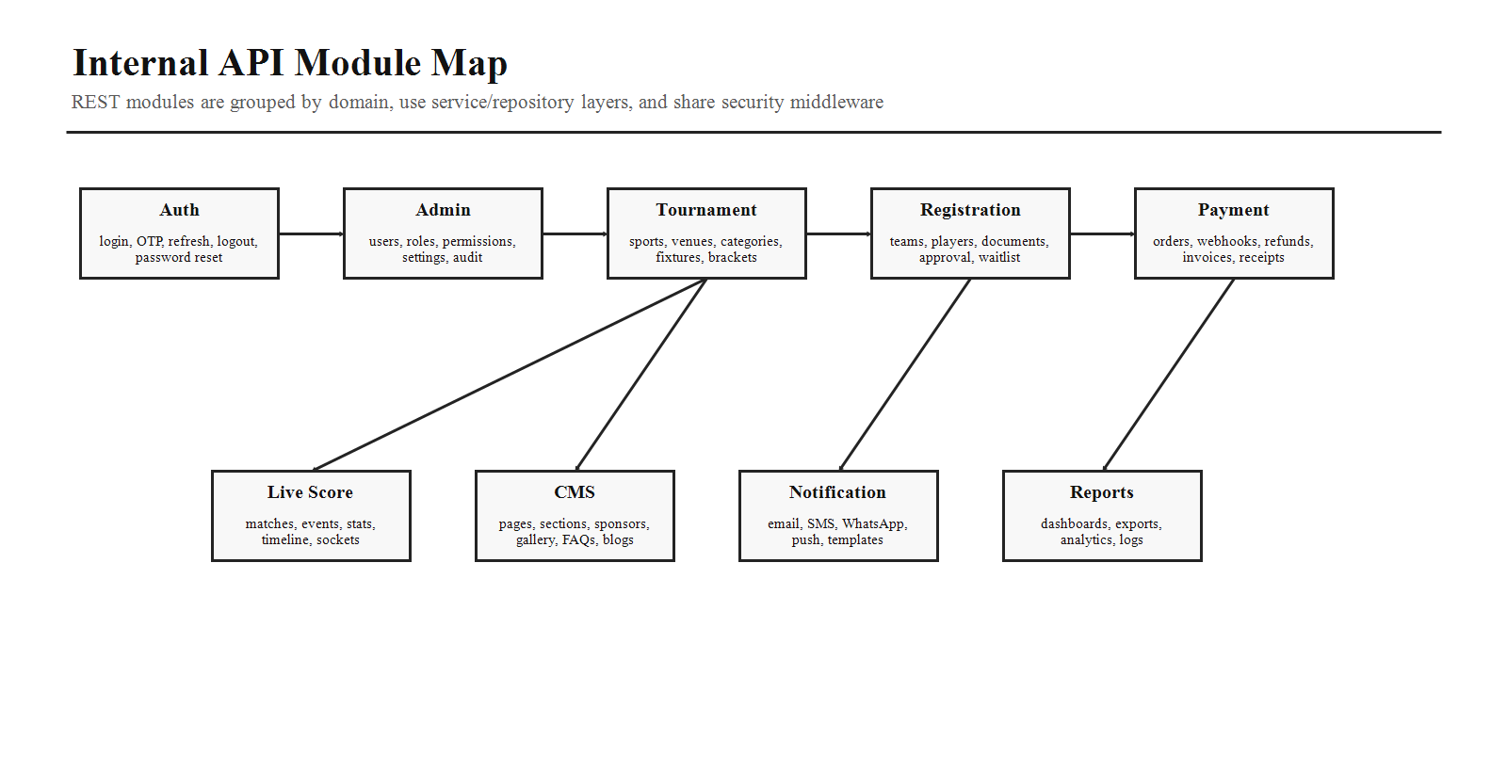
Module | Core Endpoints
Auth | POST /auth/login, POST /auth/otp/send, POST /auth/otp/verify, POST /auth/refresh, POST /auth/logout, POST /auth/forgot-password, POST /auth/reset-password, GET /auth/me
Users and RBAC | GET/POST /admin/users, GET/PATCH/DELETE /admin/users/:id, GET/POST /admin/roles, GET/POST /admin/permissions, PATCH /admin/users/:id/status
Tournament | GET/POST /tournaments, GET/PATCH/DELETE /tournaments/:id, POST /tournaments/:id/publish, POST /tournaments/:id/fixtures/generate, GET /tournaments/:id/brackets
Registration | POST /registrations/team, POST /registrations/player, POST /registrations/:id/documents, PATCH /registrations/:id/approve, PATCH /registrations/:id/reject, GET /registrations/status/:code
Teams and Players | GET/POST /teams, GET/PATCH /teams/:id, GET/POST /players, GET/PATCH /players/:id, POST /teams/:id/roster
Payments | POST /payments/orders, POST /payments/verify, POST /payments/webhook/razorpay, POST /payments/:id/refund, GET /payments/:id/receipt, GET /payments/:id/invoice
Live Score | GET /matches/live, POST /matches/:id/events, PATCH /matches/:id/score, PATCH /matches/:id/status, GET /matches/:id/timeline, GET /matches/:id/statistics
CMS | GET/POST /cms/pages, GET/POST /cms/sponsors, GET/POST /cms/gallery, GET/POST /cms/blogs, GET/POST /cms/faqs, POST /cms/publish
Notifications | POST /notifications/send, GET/POST /notifications/templates, GET /notifications/logs, POST /notifications/test
Reports and Logs | GET /reports/dashboard, GET /reports/tournaments, GET /reports/payments, GET /reports/export, GET /logs/audit, GET /logs/login, GET /logs/webhooks

8. Frontend Pages and Internal API Details
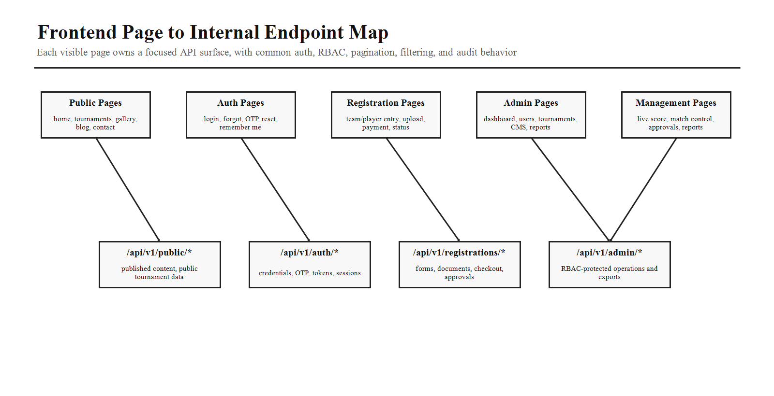
Page Area | Internal APIs Needed
Landing Home | GET /public/home, GET /public/tournaments/live, GET /public/sponsors, GET /public/stats, GET /public/gallery, GET /public/testimonials
Tournament Listing | GET /public/tournaments?status=&sport=&search=&page=, GET /public/sports, GET /public/venues
Tournament Detail | GET /public/tournaments/:slug, GET /public/tournaments/:id/fixtures, GET /public/tournaments/:id/standings, GET /public/tournaments/:id/gallery
Registration Form | POST /registrations/team, POST /registrations/player, POST /registrations/:id/documents, GET /registrations/status/:code
Payment Page | POST /payments/orders, POST /payments/verify, GET /payments/:id/receipt, GET /payments/:id/invoice
Auth Pages | POST /auth/login, POST /auth/otp/send, POST /auth/otp/verify, POST /auth/forgot-password, POST /auth/reset-password, POST /auth/refresh, GET /auth/me
Super Admin Dashboard | GET /admin/dashboard, GET /reports/dashboard, GET /logs/audit, GET /logs/login, GET /reports/payments
Super Admin Users/RBAC | GET/POST /admin/users, GET/POST /admin/roles, GET/POST /admin/permissions, PATCH /admin/users/:id/status, POST /admin/users/:id/reset-password
Super Admin Tournament Builder | GET/POST/PATCH /tournaments, POST /tournaments/:id/fixtures/generate, POST /tournaments/:id/publish, GET /tournaments/:id/brackets
Super Admin CMS | GET/POST/PATCH /cms/pages, /cms/sponsors, /cms/gallery, /cms/blogs, /cms/faqs, POST /cms/publish
Management Dashboard | GET /management/dashboard, GET /management/tournaments/:id/overview, GET /matches/live, GET /registrations?status=pending
Match Control | GET /matches/:id, PATCH /matches/:id/status, POST /matches/:id/events, PATCH /matches/:id/score, GET /matches/:id/timeline
Player Control | GET /teams/:id, PATCH /players/:id, POST /teams/:id/roster, POST /players/:id/documents, GET /players/:id/statistics
Announcements | POST /announcements, GET /announcements, POST /notifications/send, GET /notifications/templates
Reports | GET /reports/tournaments, GET /reports/registrations, GET /reports/payments, GET /reports/live-score, GET /reports/export

9. Critical Workflow APIs
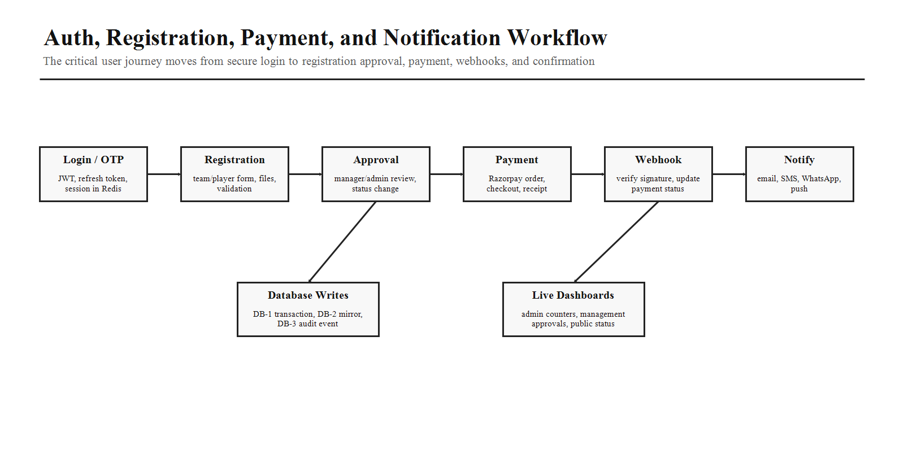
Workflow | API Sequence
Login | POST /auth/login -> create session in Redis -> return access token and refresh token -> DB-3 login event.
OTP Login or Verification | POST /auth/otp/send -> SMS provider adapter -> POST /auth/otp/verify -> mark verified -> audit event.
Team Registration | POST /registrations/team -> validate roster -> upload documents -> pending approval -> notify manager.
Approval | PATCH /registrations/:id/approve or reject -> DB-1 status change -> DB-2 mirror -> DB-3 approval audit -> notification queue.
Payment | POST /payments/orders -> Razorpay order -> frontend checkout -> POST /payments/verify -> pending confirmation.
Payment Webhook | POST /payments/webhook/razorpay -> signature verify -> idempotent status update -> receipt/invoice -> notification.
Live Score | POST /matches/:id/events -> DB-1 match event -> Redis active state -> Socket.IO broadcast -> DB-3 operator audit.

10. Socket.IO Event Contract
Event | Purpose
client:joinTournament | Public users, admin users, and management users join tournament room for updates.
client:joinMatch | Viewer or operator joins match room for live score and timeline events.
score:eventCreated | Server broadcasts new score event, card, foul, set, wicket, over, possession, substitution, or timeline item.
score:stateUpdated | Server broadcasts current scoreboard snapshot after every accepted scoring mutation.
match:statusChanged | Server broadcasts scheduled, live, paused, completed, abandoned, or result-approved state.
registration:statusChanged | Admin and management dashboards receive approval/rejection/payment status changes.
announcement:published | Tournament room receives public or role-scoped announcement.
dashboard:metricUpdated | Super Admin and management dashboards receive live counters and alerts.

11. Webhook API Rules
- Webhook routes must be public URLs, but protected by provider signature validation, secret tokens, replay protection, and idempotency.
- Razorpay webhook should update payment, order, refund, invoice, receipt, registration payment status, and DB-3 webhook log records.
- WhatsApp webhook should verify Meta webhook token during setup and then process inbound message/status callbacks safely.
- Email and push delivery callbacks should update notification logs, not user-facing state unless the business workflow requires it.
- Every webhook payload should be stored in DB-3 with provider, event type, provider event ID, checksum, status, and processed timestamp.

12. API Security Requirements
Requirement | Implementation Rule
JWT | Short-lived access tokens, rotating refresh tokens, Redis-backed revoke/session state.
RBAC | Permission checks at route and service level; tournament-scoped management users cannot access other tournaments.
Rate Limiting | Separate limits for auth, OTP, payment, public list, upload, webhook, and admin export endpoints.
CSRF/XSS | Use secure cookies if refresh tokens are cookie-based, sanitize CMS content, validate all input, and encode output.
Secrets | No provider secret in frontend code, logs, or documents uploaded by users. Use environment variables and secret manager.
PII | Encrypt sensitive fields where required, never store raw card data, and keep payment provider references only.
Audit | Log sensitive read/write, login, export, score correction, payment, webhook, and settings operations in DB-3.

13. API Documentation Deliverables
- Create OpenAPI/Swagger documentation for every REST route with method, path, auth, role, request body, query params, response, validation, and error codes.
- Create Postman collection grouped by Auth, Public, Tournament, Registration, Payment, Live Score, Admin, CMS, Notification, Reports, Logs, and Webhooks.
- Create Socket.IO event documentation with event name, room, payload, acknowledgement, permission rule, and sample response.
- Create environment variable documentation for local, staging, and production provider credentials.
- Create webhook setup guide with local tunneling, staging URL, production URL, signature validation, and replay testing.

14. External API Source Reference
Provider | Official Reference
Razorpay API | https://razorpay.com/docs/api/
Razorpay Authentication | https://razorpay.com/docs/api/authentication/
Razorpay Webhooks | https://razorpay.com/docs/webhooks/
Twilio Messaging | https://www.twilio.com/docs/messaging/api
Meta WhatsApp Cloud API | https://developers.facebook.com/documentation/business-messaging/whatsapp/get-started
Resend Email API | https://resend.com/docs/api-reference/introduction
SendGrid API Keys | https://www.twilio.com/docs/sendgrid/ui/account-and-settings/api-keys
Firebase Cloud Messaging | https://firebase.google.com/docs/cloud-messaging
Cloudinary Upload API | https://cloudinary.com/documentation/image_upload_api_reference
AWS S3 API | https://docs.aws.amazon.com/AmazonS3/latest/API/Welcome.html
Google Maps API Key | https://developers.google.com/maps/documentation/javascript/get-api-key
Cloudflare Turnstile | https://developers.cloudflare.com/turnstile/get-started/
Google reCAPTCHA | https://docs.cloud.google.com/recaptcha/docs/create-key-website
OpenAI API | https://platform.openai.com/docs/api-reference

15. AI Coding Instructions
- Build provider adapters under backend services so Razorpay, SMS, WhatsApp, email, push, media, maps, CAPTCHA, and AI providers can be swapped by configuration.
- Do not expose external provider secrets to React, public website pages, browser logs, or downloadable frontend bundles.
- Every internal endpoint must have route validation, service method, repository call, error code, audit behavior, and permission rule.
- Use React Query keys that match API modules and page ownership: public, auth, registrations, payments, admin, management, matches, reports, CMS.
- Create stable TypeScript shared types for request/response payloads and Socket.IO events.
- Write integration tests for auth, registration, payment verification, webhooks, live score events, CMS publishing, and permission boundaries.
- No mock APIs, no TODO comments, and no placeholder provider logic in production implementation.
API Master Completion Criteria
This API master document is complete when it gives the team the external API providers to obtain, the dashboard/docs location for each credential, the internal REST modules, frontend page-to-endpoint mapping, Socket.IO events, webhook rules, security requirements, environment variables, documentation deliverables, and coding instructions for Smart Sportz.

