**P.1). Write a SQL Query to create a table “Employee”.**

**Field Name Datatype Size**

**Emp_id varchar2 5**

**Emp_name varchar2 25**

**Address varchar2 50**

**Phone _number number 10**

**Designation varchar2 15**

**Salary number 15**

**1. Display the Structure of Table.**

**2. Add Qualification field at the end of employee table.**

**3. Modify the size of the name field 25 to 30.**

**4. Display the employee name whose salary is greater than 20,000.**

**5. Display the Employee details whose name start with “P”.**

**Name : Sanjana Parate**

**Date : 6-10-2023**

**Query: - Create Table Employee (Emp_no varchar2(5), Emp_Name varchar2(25), Address varchar2(50), Phone_number number(10), Designation varchar2(15), Salary number(15));**

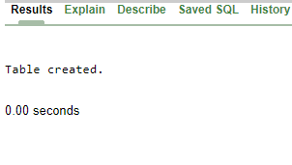

**1. Display the Structure of Table.**

**Query:-** DESC Employee;

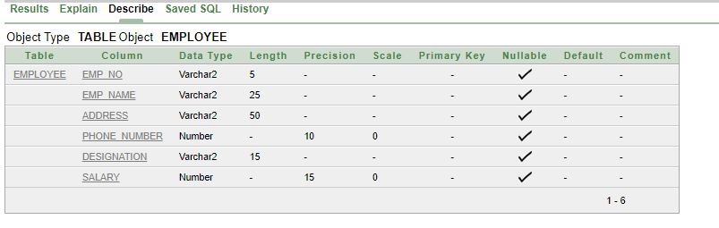

**2. Add Qualification field at the end of employee table.**

**Query:-** Alter Table Employee ADD(Qualification varchar2(15));

**Output:-**

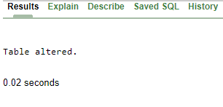

**Output :**

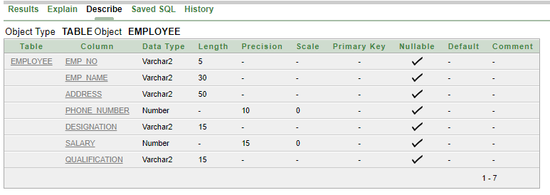

**3. Modify the size of the name field 25 to 30.**

**Query:-** Alter Table Employee Modify(Emp_Name varchar2(30));

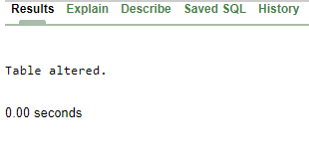

**Query:-DESC** Employee;

**Output:**

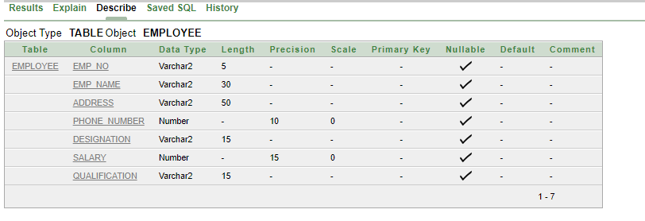

**4. Display the employee name whose salary is greater than 2000.**

**Query:-** Select(Emp_name) FROM Employee WHERE Salary>=2000;

**Output:-**

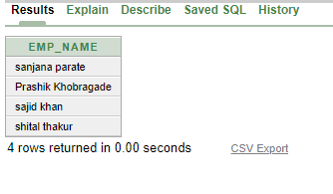

**5. Display the Employee details whose name start with “P”.**

**Query:-** Select * From Employee WHERE Emp_name LIKE 's%';

**Output :**

