**P.2). Write a SQL Query to create a table “student”:**

**Field Name Datatype Size Constraint**

Roll number 5 primary key

Name varchar2 30 first letter must start with ‘A’

Address varchar2 30 not null

City varchar2 30

DOB date

Phone number 11 unique key

Class varchar2 10 All upper letter

Marks number (10, 2) Not null can’t be 0.

1). Display the structure of database and insert 10 records.

2). Display student information for all student in city Pune and Nagpur.

3). Display student information where marks greater than 80 and less than 90.

4). Display student name where first two character of student name ‘An’.

5). Change student name to Ashish where student roll number 001.

**Name: Sanjana Parate**

**Date:06-10-2023**

**Practical 1. Write a SQL Query to create a table “STUDENT”.**

**Query:** CREATE table "STUDENT" ( "ROLL" NUMBER NOT NULL, "NAME" VARCHAR2(4000), "ADDRESS" VARCHAR2(4000) NOT NULL,"CITY" VARCHAR2(4000), "DOB" DATE,"PHONE" NUMBER,"CLASS" VARCHAR2(10),"MARKS" NUMBER NOT NULL,constraint "STUDENT_PK" primary key ("ROLL"))

**Output:**

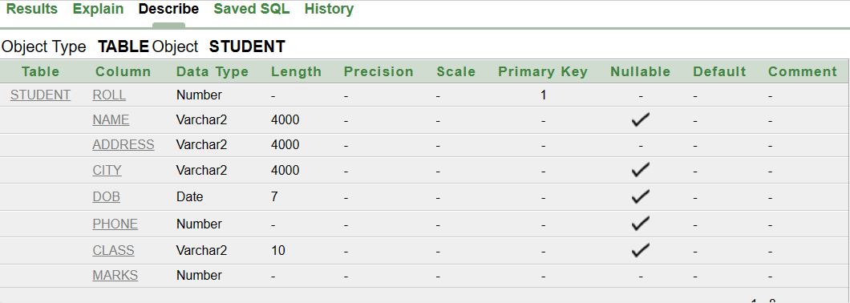

**Q.1. Display the structure of database and insert 10 records.**

**Query:** SELECT* FROM STUDENT;

**Output:**

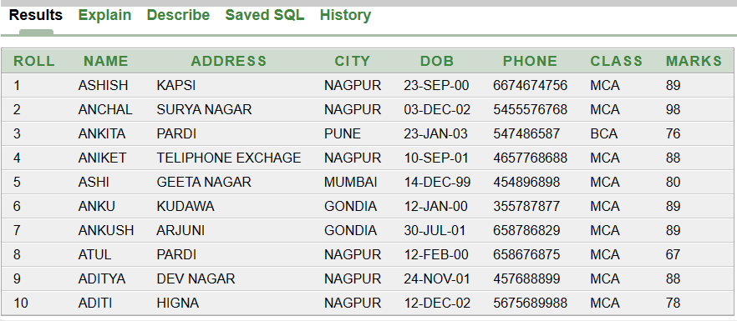

**Q.2. Display student information for all student in city pune and nagur.**

**Query**: SELECT(NAME) FROM STUDENT WHERE CITY IN( 'PUNE', 'NAGPUR');

**Output:**

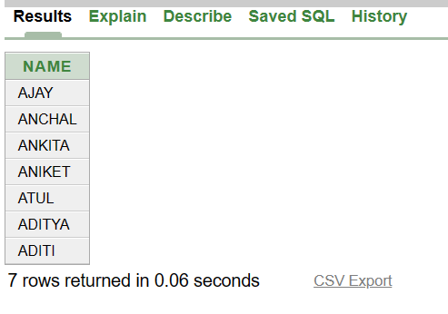

**Q.3. Display student information where marks greater than 80 and less than 90.**

**Query:** SELECT*FROM STUDENT WHERE MARKS>80 AND MARKS<90;

**Output:**

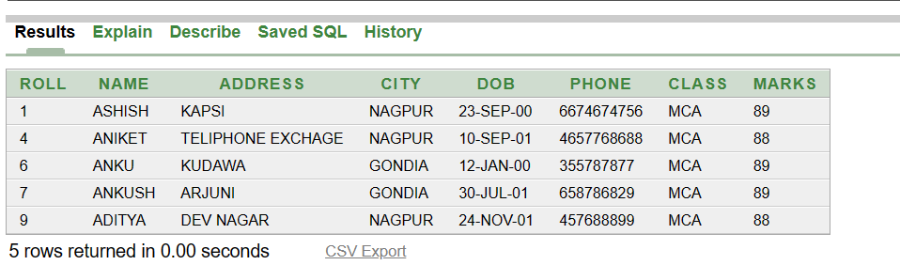

**Q.4. Display student name where first two character of student name ‘an’.**

**Query:** SELECT*FROM STUDENT WHERE NAME LIKE'AN%';

**Output:**

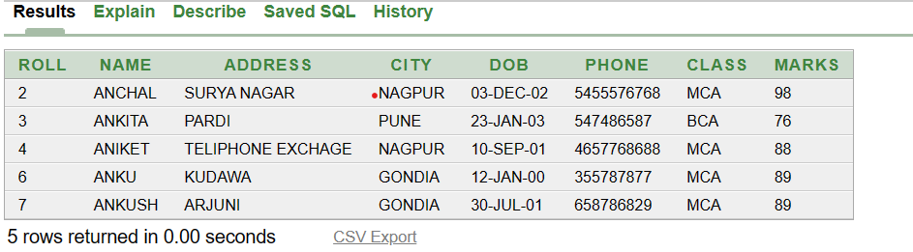

**Q.5. Display student name to ajay where student roll no.001.**

**Query**: UPDATE STUDENT SET NAME ='AJAY'WHERE ROLL=001;

**Output:**

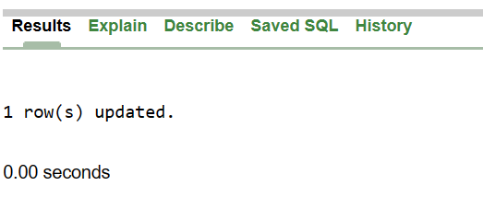

**Query**: SELECT* FROM STUDENT;

**OUTPUT:**

