**P3. Write a SQL query to create C_master with fields C_No, Name, Address, City, State and Pin_code:**

**Field Name Datatype Size**

C_no varchar2 10

Name varchar2 10

Address varchar2 10

State varchar2 20

City varchar2 20

Pin_code number 10

1. Create a sequence which will generate numbers from 1..999 in ascending order, with an interval of 1 and in cyclic order.
2. Insert 10 records.
3. Create index on c_master which column name c_no and state.
4. Create a view on c_master .
5. Select columns c_no, city which belongs to Nagpur and Mumbai.

**Name :Sanjana Parate**

**Date : 14-10-2023**

**Query :**

CREATE TABLE "C_MASTER"

( "C_NO" VARCHAR2(10), "NAME" VARCHAR2(10), "ADDRESS" VARCHAR2(10),

"STATE" VARCHAR2(20), "CITY" VARCHAR2(20), "PIN_CODE" NUMBER );

**Output :**

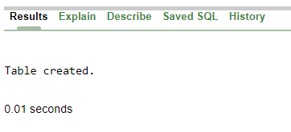

**1).Create Sequence Which Will Generate Number From 1.999 In Ascending Order, With An Interval Of 1 And In Cyclic Order.**

**Query :** Create sequence seq_1 start with 1 increment by 1 maxvalue 999;

**Output :**

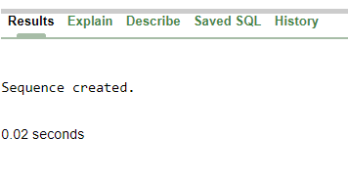

**1).Insert 10 Records**

**Query :** insert into C_Master(C_NO, Name, Address, State, City, Pin_code) values(seq_1.nextval,'Aditi','Mahal','Maharashtra','Nagpur',440026);

**Output :**

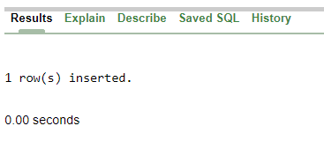

**Query :** select*from C_Master;

**Output :**

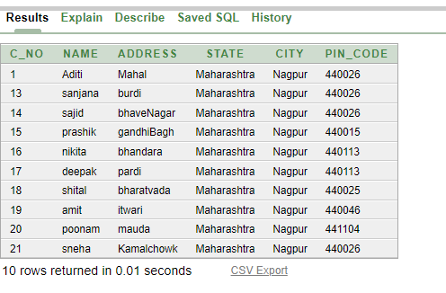

**3). Create Index On C_Master Which Column Name C_No And State.**

**Query :** create index C_index on C_master(C_no,State);

**Output :**

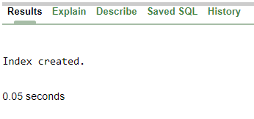

**4). Create View On C_Master.**

**Query :** create view view_c As select*from C_master;

**Output :**

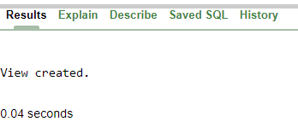

**Query :** select*from view_c;

**Output :**

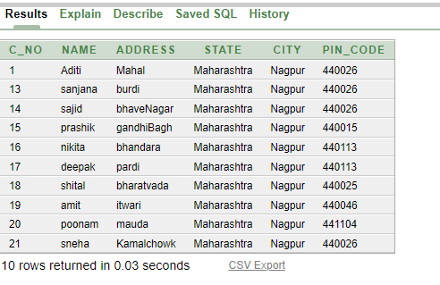

**5). Select Column C_No, City Which Belongs To Nagpur And Mumbai.**

**Query :** select*from c_master where city='Nagpur' or City='Mumbai';

**Output :**

