|  |  |  |
| --- | --- | --- |
| FIELDS | DATA TYPE | CONSTRAINST |
| CUST_ID | VARCHAR(3) | NOT NULL |
| L_NAME | VARCHAR(15) |  |
| F_NAME | VARCHAR(15) |  |
| AREA | VARCHAR(2) |  |
| PHONE_NO | NUMBER(8) |  |

**P4) Create the following tables and insert the following data into the created tables.**

**Find the name of all the customers.**

**Table Name : CUST1**

NAME : SANJANA PARATE

DATE :20-10-23

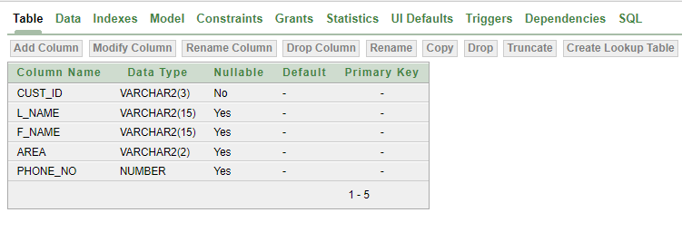

**Table Name : CUST1**

**Query :**

select*from cust1;

**Output :**

