**Q6.) create an tablespace named “dba_tablespace” with data file named “dba_tablespace_datafile.dbf” size 10M.**

**Name : Sanjana Parate**

**Date : 27-10-2023**

**Query :**

create tablespace dba_tablespace datafile 'c:/Program Files/Oracle/dba_tablespace_datafile.dbf' size 10M;

**Output :**

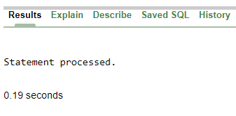

**Q7) Viewing information about tablespaces.**

**Name : Sanjana Parate**

**Date : 27-10-2023**

**Query :**

select *from dba_tablespaces;

**Output :**

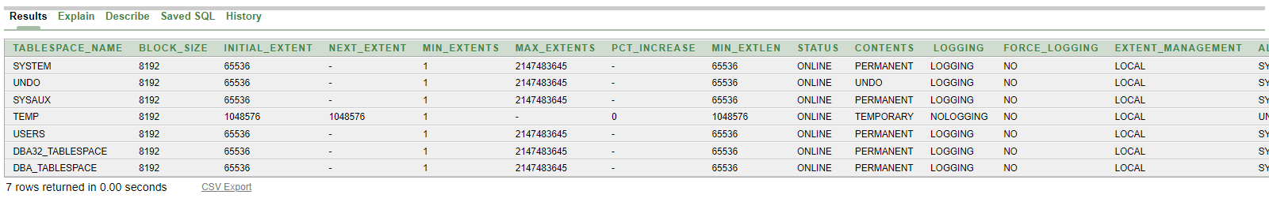

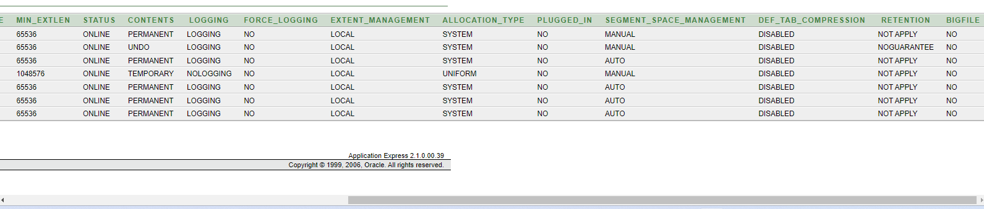

**Query :**

select *from v$tablespace;

**Ouyput :**

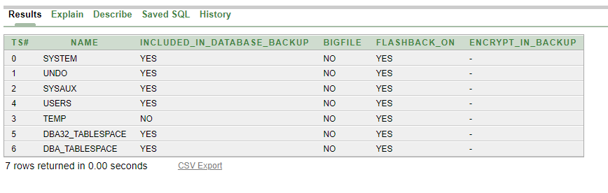

**Query :**

select tablespace_name from dba_tablespaces;

**Output :**

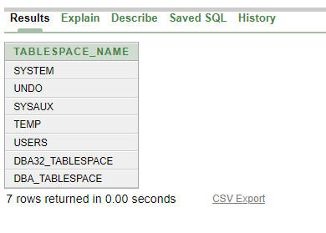

**Q8) Display the list of all tablespaces and its default storage parameters.**

**Name : Sanjana Parate**

**Date : 27-10-2023**