**Aim : write a java program to demonstrate concept of Event Handling**

**Developed By : Sanjana Parate**

**Date : 17-10-2023**

**//package core_java_application;**

import java.awt.Frame;

import java.awt.GridBagConstraints;

import java.awt.GridLayout;

import java.awt.Insets;

import java.awt.Label;

import java.awt.TextArea;

import java.awt.event.MouseEvent;

import java.awt.event.MouseListener;

import java.awt.event.WindowAdapter;

import java.awt.event.WindowEvent;

public class TrapEvents extends Frame implements MouseListener{

Label l;

TextArea area;

GridBagConstraints gbc;

TrapEvents()

{

l=new Label();

l.addMouseListener(this);

gbc=new GridBagConstraints();

gbc.fill=gbc.HORIZONTAL;

gbc.gridx=0;

gbc.gridy=0;

gbc.insets=new Insets(10,10,10,10);

add(l);

addWindowListener(new WindowAdapter()

{

public void windowClosing(WindowEvent we)

{

System.exit(0);

}

});

setSize(500,500);

setLayout(new GridLayout(2,1));

setVisible(true);

}

@Override

public void mouseClicked(MouseEvent e) {

l.setText("Mouse Clicked");

}

@Override

public void mousePressed(MouseEvent e) {

l.setText("Mouse Pressed");

}

@Override

public void mouseReleased(MouseEvent e) {

l.setText("Mouse Released");

}

@Override

public void mouseEntered(MouseEvent e) {

l.setText("Mouse Entered");

}

@Override

public void mouseExited(MouseEvent e) {

l.setText("Key Exited");

}

public static void main(String[] args)

{

new TrapEvents();

}

}

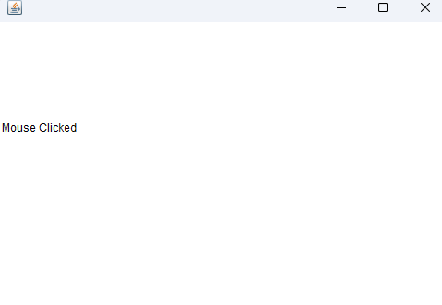**Output :**

