**12.Write a program in PHP to Upload image at run time**

**Name: Vanshika Rotke**

**Date: 25-10-2023**

***Codes:***

<!DOCTYPE html>

<html lang="en">

<head>

<meta charset="UTF-8">

<meta name="viewport" content="width=device-width, initial-scale=1.0">

<title>PHP FILE UPLOAD</title>

</head>

<body>

<form action ="upload.php" enctype="multipart/form-data" method="post">

Select image :

<input type="file" name="file"> <br/>

<input type="submit" name="submit1" value="upload"> <br/>

</form>

<?PHP

if (isset($_POST['submit1']))

{

$filepath="image/".$_FILES["file"]["name"];

if(move_uploaded_file($_FILES["file"]["tmp_name"],$filepath))

{

echo "<img src=".$filepath." height=150 width=150/>";

}

}

?>

</body>

</html>

**OUTPUT:**

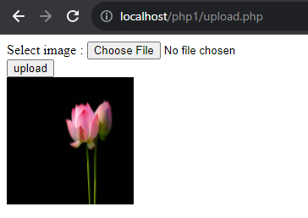h