AIM: Extract text from an image using Optical Character Recognition (OCR) with Tesseract and perform text summarization.
DESCRIPTION : Optical Character Recognition (OCR) is a technology that extracts text from images or scanned documents. Tesseract is a popular open-source OCR engine. To use Tesseract in Python, you can use the pytesseract wrapper along with the Pillow library for image processing. Before starting, you need to install Tesseract on your system. You can download the installer from the official Tesseract GitHub page or use a package manager like apt or brew on Linux or macOS. After installing Tesseract, you also need to install the required Python libraries.
SOFTWARES TO INSTALL :
https://github.com/UB-Mannheim/tesseract/wiki
CLICK ON tesseract-ocr-w64-setup-5.3.3.20231005.exe (64 bit)
Download Software and Install
COMMAND PROMPT INSTALL :
pip install pytesseract
pip install Pillow
CODING :
import os
from PIL import Image, ImageEnhance, ImageFilter
import pytesseract
# Optional: set tesseract path manually on Windows
pytesseract.pytesseract.tesseract_cmd = r"C:\Program Files\Tesseract-OCR\tesseract.exe"
# ====== Paths ======
IMAGE_FOLDER = r"C:\surekha\Lab Manual\R23" # Folder containing images
OUTPUT_FOLDER = r"C:\surekha\Lab Manual\R23\Summaries" # Folder to save summaries
# Create output folder if it does not exist
os.makedirs(OUTPUT_FOLDER, exist_ok=True)
# ====== Preprocess image ======
def preprocess_image(image_path):
img = Image.open(image_path)
img = img.convert('L') # Grayscale
img = img.filter(ImageFilter.MedianFilter())
enhancer = ImageEnhance.Contrast(img)
img = enhancer.enhance(2)
return img
# ====== OCR ======
def extract_text(img):
return pytesseract.image_to_string(img).strip()
# ====== Simple summarization ======
def summarize_text(text, num_sentences=3):
sentences = text.split('.')
summary = '. '.join(sentences[:num_sentences]).strip()
if summary and not summary.endswith('.'):
summary += '.'
return summary
# ====== Process all images in folder ======
def process_images(folder_path):
for filename in os.listdir(folder_path):
if filename.lower().endswith(('.png', '.jpg', '.jpeg', '.bmp', '.tiff')):
image_path = os.path.join(folder_path, filename)
print(f"\nProcessing image: {filename}")
img = preprocess_image(image_path)
text = extract_text(img)
if not text:
print("⚠️ No text detected.")
continue
summary = summarize_text(text)
print("📝 Extracted Text:\n", text)
print("🧠 Summary:\n", summary)
summary_file = os.path.join(OUTPUT_FOLDER, f"summary_{os.path.splitext(filename)[0]}.txt")
with open(summary_file, "w", encoding="utf-8") as f:
f.write(summary)
print(f"💾 Summary saved to: {summary_file}")
# ====== Main ======
if __name__ == "__main__":
if not os.path.exists(IMAGE_FOLDER):
print(f"❌ Image folder not found: {IMAGE_FOLDER}")
else:
process_images(IMAGE_FOLDER)
OUTPUT :
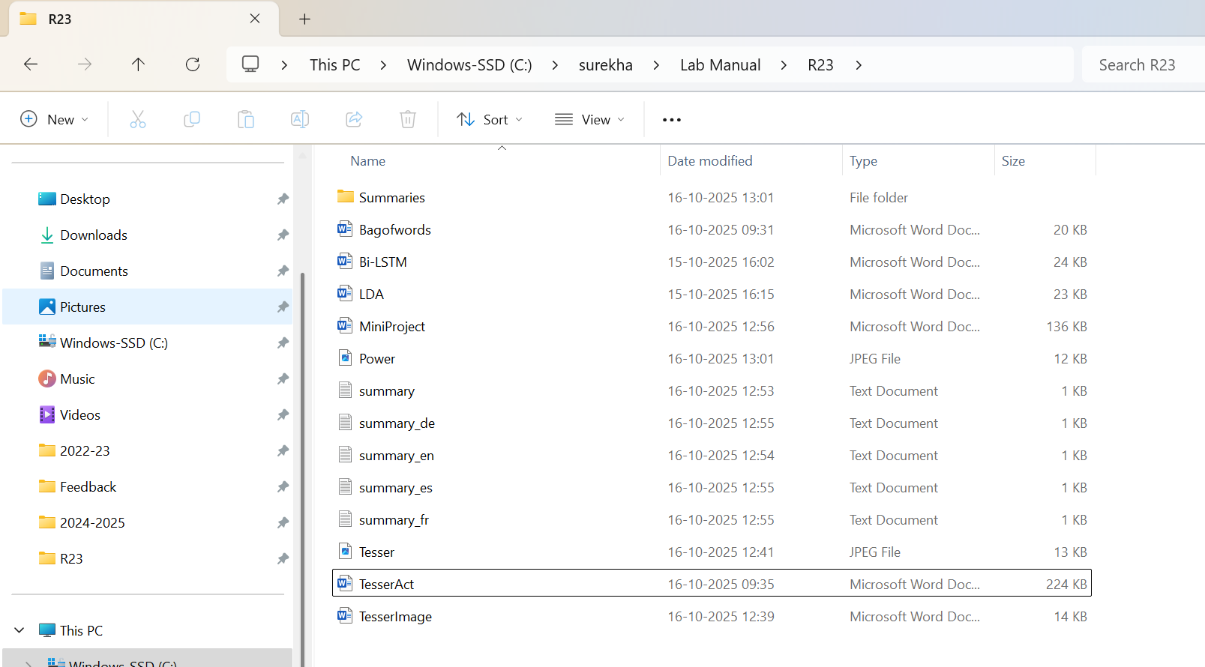

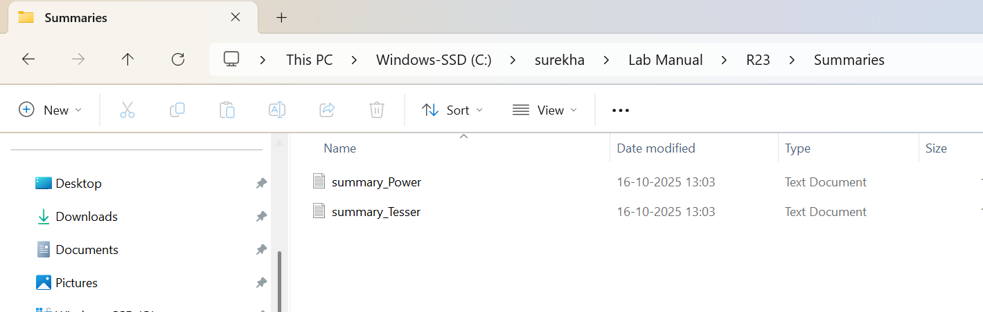
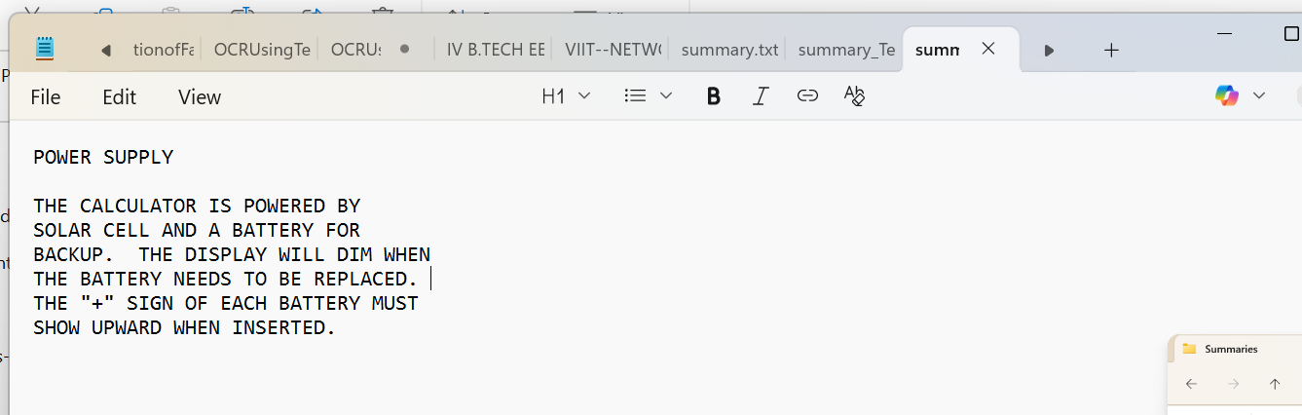
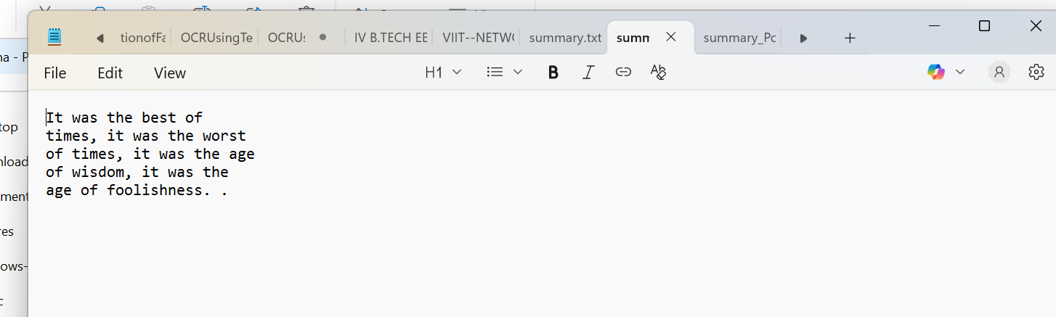
"C:\Users\Surekha Swarna\PycharmProjects\NLP3RDYEARPROJ\.venv\Scripts\python.exe" "C:\Users\Surekha Swarna\PycharmProjects\NLP3RDYEARPROJ\app.py"

Processing image: Power.jpeg
📝 Extracted Text:
POWER SUPPLY

THE CALCULATOR IS POWERED BY
SOLAR CELL AND A BATTERY FOR
BACKUP. THE DISPLAY WILL DIM WHEN
THE BATTERY NEEDS TO BE REPLACED.
THE "+" SIGN OF EACH BATTERY MUST
SHOW UPWARD WHEN INSERTED.
🧠 Summary:
POWER SUPPLY

THE CALCULATOR IS POWERED BY
SOLAR CELL AND A BATTERY FOR
BACKUP. THE DISPLAY WILL DIM WHEN
THE BATTERY NEEDS TO BE REPLACED.
THE "+" SIGN OF EACH BATTERY MUST
SHOW UPWARD WHEN INSERTED.
💾 Summary saved to: C:\surekha\Lab Manual\R23\Summaries\summary_Power.txt

Processing image: Tesser.jpeg
📝 Extracted Text:
It was the best of
times, it was the worst
of times, it was the age
of wisdom, it was the
age of foolishness...
🧠 Summary:
It was the best of
times, it was the worst
of times, it was the age
of wisdom, it was the
age of foolishness. .
💾 Summary saved to: C:\surekha\Lab Manual\R23\Summaries\summary_Tesser.txt

Process finished with exit code 0
RESULT :
Thus, we sextracted text from an image using Optical Character Recognition (OCR) with Tesseract and perform text summarization.

