# 机器学习（Machine Learning）吴恩达 梅徐胜

**课程内容纪要：**

**Welcome to Machine learning.欢迎来到最新机器学习课程。**

**What is machine learning? 什么是机器学习？**

**You probably use it many times a day without even knowing it.您可能甚至在不了解它的前提下每天多次使用。**

**Anytime you want to find out something like how do I make a sushi roll? 想知道我怎么做寿司卷？**

**You can do a Web search on Google ，Bing or Baidu to find out.**

**您可以随时在Google（谷歌） Bing 或 Baidu（百度）上进行网络搜索以找出答案。**

**And that works so well because their machine learning software has figured out how to rank web pages.**

**这很有效，因为他们的机器学习软件已经知道如何对网页进行排名。**

**Or when you upload pictures to Instagram or Snapchat and think to yourself. I want to tag my friends so they can see their picture.**

**或者，当你将图片上传到Instagram或Snapchat并且想标记我的朋友，以便他们可以看到他们的图片。**

**Well these apps can recognize your friends in your pictures and label them as well. That’s also machine learning.**

**好吧，这些应用程序可以识别您图片中的朋友并为他们贴上标签。这也是机器学习。**

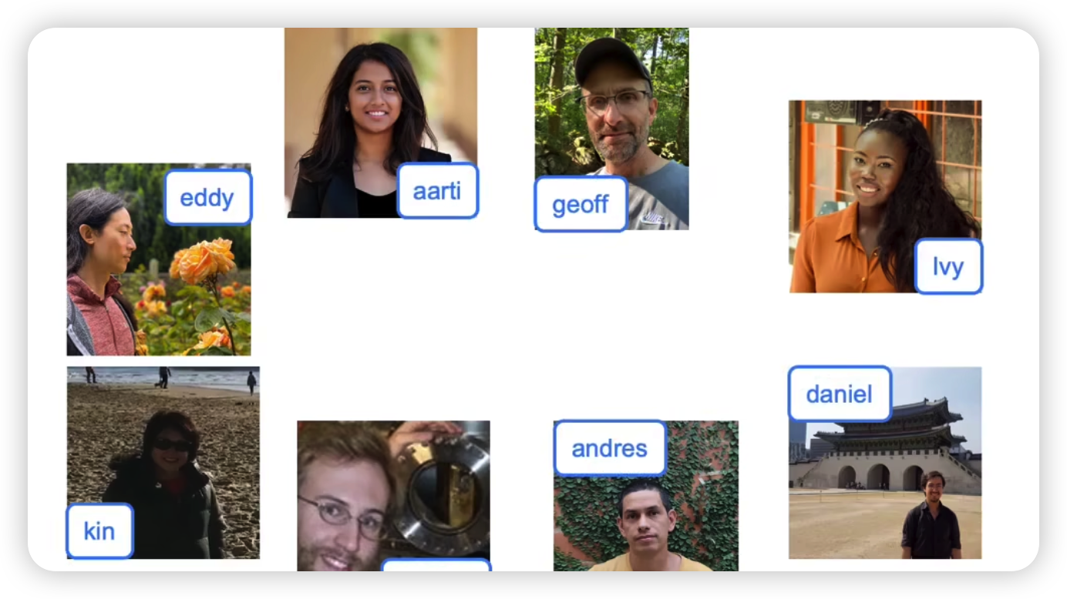

**Or if you’ve just finished watching a Star Wars movie on the video. Streaming service and you think what other similar movies can l watch? Well the Streaming service will likely use machine learning to recommend something. That you might like.或者，如果您刚刚在视频流媒体服务上观看《星球大站》电影并且您认为我还可以观看哪些类似的电影？那么流媒体服务可能会使用机器学习来推荐你可能喜欢的东西。**

**Each time you use voice to text on your phone to write a test message.每次您使用语音在手机上发送短信时。**

**》〉〉Hey Andrew, how’s it going?嗨，Andrew，想我了吗？**

**》〉〉Or tell your phone. “Hey Siri play a song by Rihanna”.或者和你的手机说。嘿Siri播放Rihanna的歌曲。**

**》〉〉Or ask your other phone okay Google show me Indian restaurants near me.或者使用手机访问谷歌附近的印度餐馆。**

**That’s also machine learning. 这也是机器学习。**

**Each time you receive an email titled, Congratulations! You’ve won a million dollars. 标题为“恭喜”的电子邮件时！（补充：因为coursera自动回复喜欢使用Congratulations）,你赢了一百万美元。**

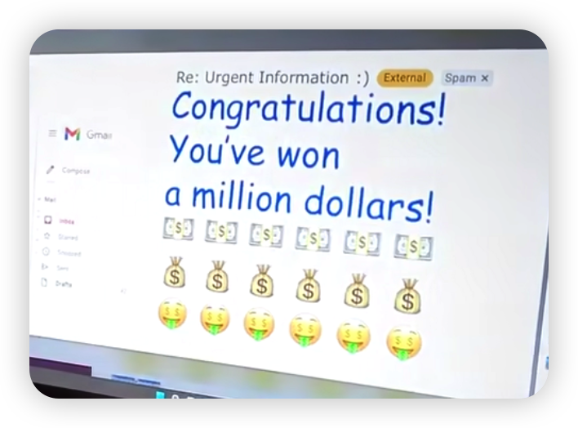

**Well maybe you’re rich, congratulations. 好吧，也许你很有钱，恭喜你。**

**Or more likely your email service will probably flag it as spam.也许您的邮件服务更有可能将其标记为垃圾邮件。**

**That too is an application of machine learning. 这也是机器学习的一个应用。**

**Beyond consumer applications that you might use ,Al is also rapidly. making its way into big companies and into industrial applications.除了您可能使用的消费者应用程序之外。人工智能还迅速进入大公司并应用在工业。**

**For example , I’m deeply concerned about climate change , and I’m glad to see. that machine learning is already hoping to optimize wind turbine power generation. Or in healthcare, is starting to make its way into hospitals to help doctors make accurate diagnosis.例如，我非常关注气候变化，我很高兴看到机器学习已经有希望优化风力涡轮机发电。在医疗保健领域，AI帮助医生做出准确诊断。**

**Or recently at Landing AI have been doing a lot of work, putting computer vision into factories to help inspect if something coming off the assembly line has any defects.**

**最近在Landing AI做了很多工作将计算机视觉应用到工厂中，帮助检查从装配线上下来的东西是否有任何缺陷。**

**That’s machine learning.这也是机器学习。**

**It’s the science of getting computers to learn without being explicitly programmed.这是一门让计算机在没有明确编程的情况下学习的科学。**

**In this course, you learn about machine learning and get to implement machine learning and code yourself. Millions of**

**Others have taken the earlier version of this course. Which is of course ,that led to the founding of coursera. and many learners ended up building exciting machine learning systems or even pursuing very successful careers in AI .**

**在本课程中，你将了解机器学习并自己实现机器学习和编码。数已万计的人参加了本课程的早期版本。当然这使得Coursera成立。许多学习者最终构建了令人兴奋的机器学习系统,甚至在人工智能领域追求非常成功的职业。**

**I’m excited that you’re on this journey with me .我很高兴你能和我一起踏上这段新的旅程。**

**Welcome and let’s get started.欢迎，让我们开始吧，加油！**