关于广研院的同学的使用方法：

由于大佬写的程序“输入定位”地方研究半天没搞懂是应该输入什么的，于是直接在浏览器开发者模式下使用谷歌浏览器获取位置的时候抓取了浏览器中network的内容 即

将其中的定位输入直接赋值成下面的信息

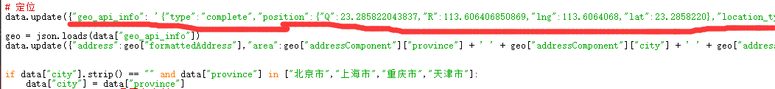

西电西安校区：

"geo_api_info": '{"type":"complete","position":{"Q":34.125743543837,"R":108.841380750869,"lng":108.841381,"lat":34.125744},"location_type":"html5","message":"Get ipLocation failed.Get geolocation success.Convert Success.Get address success.","accuracy":62,"isConverted":true,"status":1,"addressComponent":{"citycode":"029","adcode":"610116","businessAreas":[],"neighborhoodType":"","neighborhood":"","building":"","buildingType":"","street":"雷甘路","streetNumber":"238号","country":"中国","province":"陕西省","city":"西安市","district":"长安区","township":"兴隆街道"},"formattedAddress":"陕西省西安市长安区兴隆街道竹园三路西安电子科技大学长安校区","roads":[],"crosses":[],"pois":[],"info":"SUCCESS"}',

西电广研院校区：

"geo_api_info": '{"type":"complete","position":{"Q":23.285822043837,"R":113.606406850869,"lng":113.6064068,"lat":23.2858220},"location_type":"html5","message":"Get ipLocation failed.Get geolocation success.Convert Success.Get address success.","accuracy":62,"isConverted":true,"status":1,"addressComponent":{"citycode":"020","adcode":"440112","businessAreas":[],"neighborhoodType":"","neighborhood":"","building":"","buildingType":"","street":"九龙大道","streetNumber":"108号","country":"中国","province":"广东省","city":"广州市","district":"黄埔区","township":"九龙镇"},"formattedAddress":"广东省广州市黄埔区九龙镇御禾田公寓广州绿地城","roads":[],"crosses":[],"pois":[],"info":"SUCCESS"}',

然后运行configure_3chk.py 文件生成data_3chk.json 文件 最后运行submit_3chk.py 提交脚本即可完成一次上报 利用电脑的定时计划 设定时间每日即可上报完成