、

编号（No.）：（IHEP-）HEPS-TS-CB-TS-2022-001

**ADUVC**

**摘 要**

Abstract

|  |  |
| --- | --- |
| **起 草（Prepared by）** | 张群 |
| **校 核（Checked by）** |  |
| **会 签（Concurred by）** |  |
| **审 核（Reviewed by）** |  |
| **审 定（Verified by）** |  |
| **批 准（Approved by）** |  |

中国科学院高能物理研究所

Institute of High Energy Physics

Chinese Academy of Science

2022年06月

北京

*（This is an internal publication and does not necessarily reflect the views of the HEPS management.）*

# 安装sudo yum install libXext-devel

1.进入到configure下：

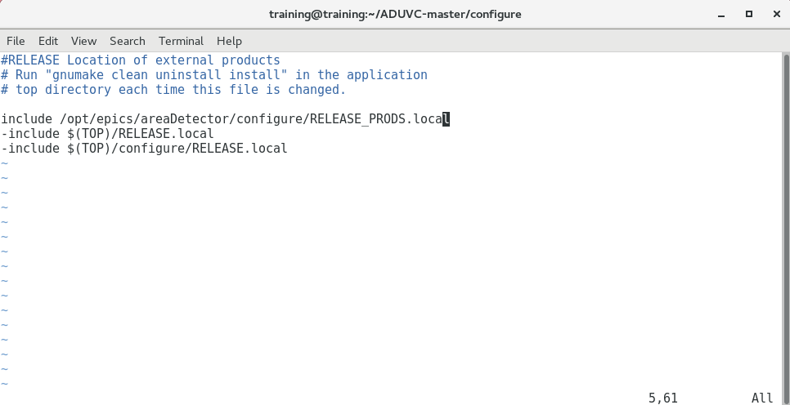

1. 进入到/home/training/ADUVC-master/iocs/uvcIOC/configure下

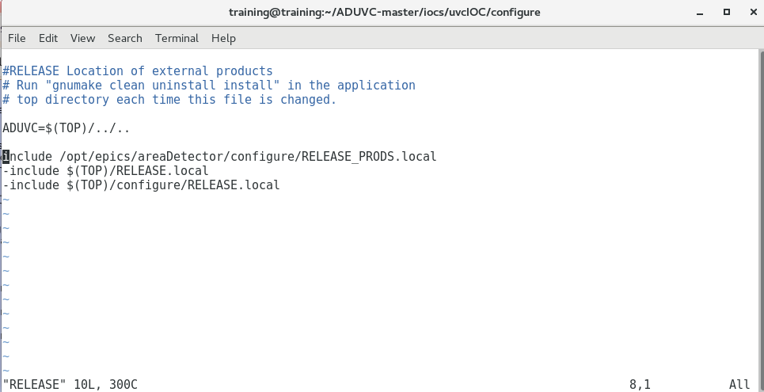

1. sudo usermod -a -G groupA，groupB user
2. 进入到/home/training/ADUVC-master/uvcSupport/cameraDetector下

make

sudo ./uvc_locater

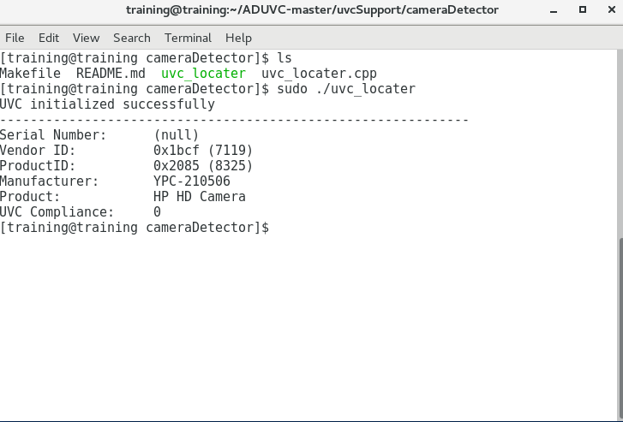5.5./etc/udev/rules.d

vim 99-aravis-cameras.rules

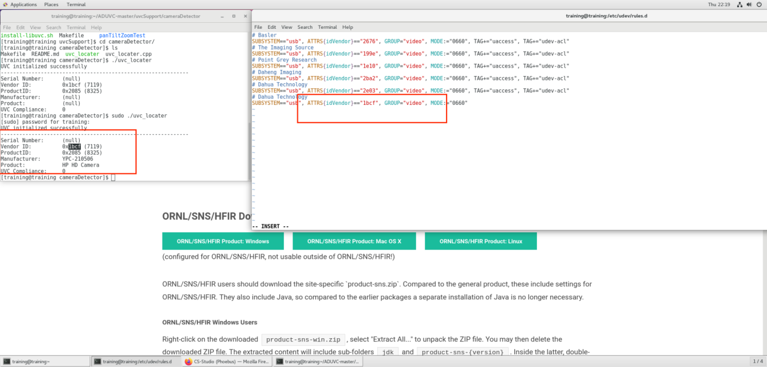

1. sudo udevadm control --reload-rules
2. 进入 /home/training/ADUVC-master/iocs/uvcIOC/iocBoot/iocADUVC下修改st.cmd

