**Guidelines for Data Visualization and Analysis Project**

**About the Project:**

In this project, you will be working with a dataset from the Superstore, aiming to answer 30 scenario-based questions through data visualisation and analysis. Your objective is to select the best chart for each question, explain your choice. This project will showcase your proficiency in data visualisation, critical thinking, and effective communication.

**Skills Required:**

* Proficiency in data visualisation concepts and techniques.
* Familiarity with Tableau or a similar data visualisation tool.
* Strong analytical and problem-solving skills.
* Ability to choose appropriate charts based on data characteristics and question requirements.
* Clear and concise communication skills.

**Deliverables:**

* A Google document containing solutions to the scenario based questions including the screenshot of relevant chart picked for each scenario, presented in a concise and well-structured format. Make sure to provide explanations that highlight your problem-solving skills.

**Rubrics for Assessment:**

Question Responses:

* Accuracy and completeness of answers for all 30 questions.
* Clear and concise explanations that address the question's context.

Chart Selection and Explanation:

* Thoughtful rationale for choosing specific chart types.
* Justification based on data characteristics, context, and communication goals.

Creative Enhancements:

* Effective use of creative elements to enhance visualisation quality.
* Enhancements that contribute to better understanding or engagement.

**Note**:

* Duplicate this document and proceed to write your solutions.
* For each scenario and question, provide a justification for the choice of chart type. Explain why it is the best option to visualise the data effectively.
* Attach screenshots of the charts you have created in Tableau for each scenario and question using the Superstore dataset. Label them clearly to match the corresponding questions in the Google Document.
* Submit the duplicated google doc file after completion.

Use these guidelines to structure your data visualisation and analysis project. Remember to maintain consistency in your responses, explanations, and visualisation styles. This project will not only demonstrate your skills but also your ability to effectively communicate complex information through visualisations. Good luck!

**Problem Statement: Choose the Best chart for any 30 scenario based questions from Superstore Dataset.**

Imagine you are a data enthusiast aiming to excel in data visualisation and analysis. In this task, you have been given any 30 scenario-based questions derived from the Superstore dataset, and your objective is to provide insightful answers using appropriate charts. For each question, you need to select a chart that best represents the data, explain why you chose that specific chart, and then proceed to build the chosen chart using Tableau.

Your responses should be succinct, organised, and illustrative of your problem-solving capabilities.

**Dataset Link:**

<https://community.tableau.com/s/question/0D54T00000CWeX8SAL/sample-superstore-sales-excelxls>

**Please keep in mind:**

1. **Answer Completion**: Ensure that you furnish answers for all any 30 questions and build charts for them.
2. **Encouraged Creativity**: Don't hesitate to employ visuals, creative elements, or any other innovative approaches to enhance the quality of your responses.

By completing this task effectively, you'll not only demonstrate your proficiency in data visualisation and analysis but also showcase your ability to effectively communicate complex concepts through both text and charts.

**Good luck!**

**Questions:**

1. Which product categories have the highest total sales in the "Superstore" dataset?

Technology has the highest total sales in the “Superstore” dataset, as seen in the following **Bar Chart**.

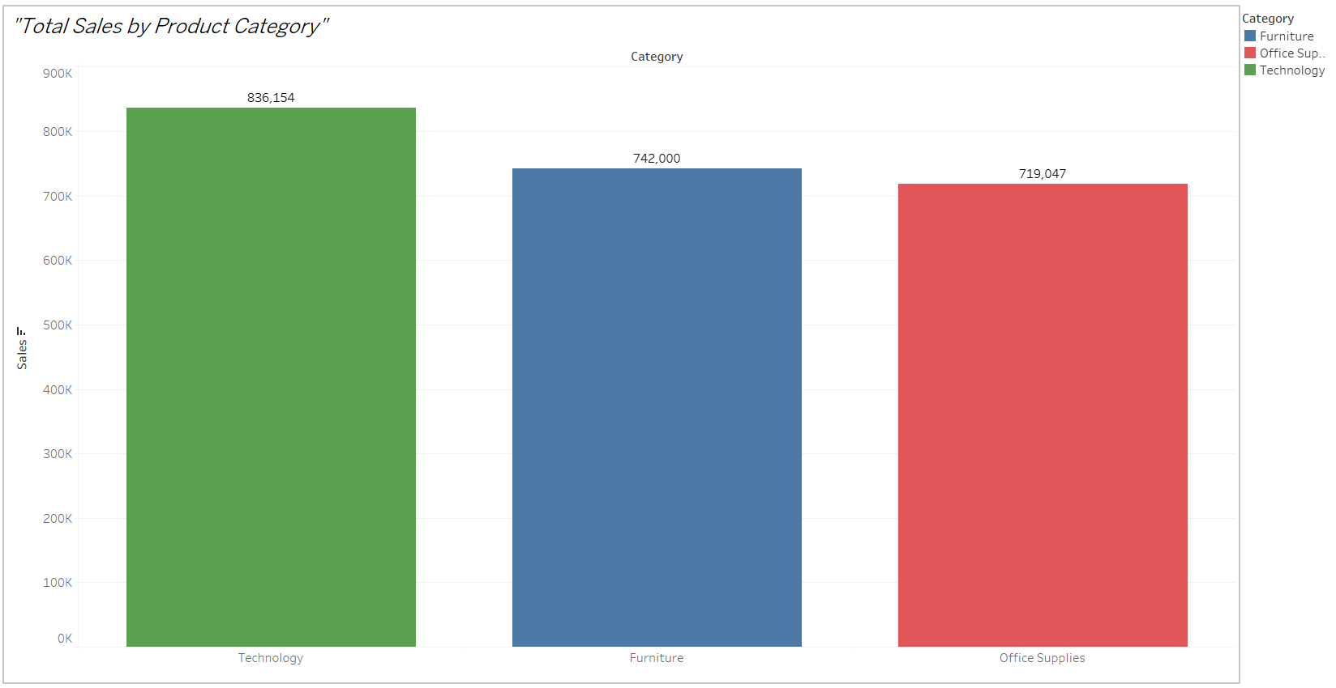

A **bar chart** is the best option to visualize the **Total Sales by Product Category** because of the following reasons:

1. **Ease of Comparison**:
   * Bar charts allow for a straightforward comparison of total sales across categories. The length of each bar represents the sales magnitude, making it easy to identify which categories have higher or lower sales.
2. **Clarity and Simplicity**:
   * Bar charts are simple and widely understood, ensuring the visualization is intuitive for any audience, regardless of their data literacy level.
3. **Categorical Focus**:
   * Since the question focuses on distinct product categories, a bar chart effectively represents discrete data, unlike line charts or scatter plots, which are more suited for continuous or relational data.
4. **Customization Options**:
   * Distinct colors for each bar enhance the visual appeal and make the categories easily distinguishable, adding to the chart's readability.
5. **Highlighting Insights**:
   * Sorting the bars in descending order emphasizes the highest-performing categories, directing attention to key insights.
6. How do the monthly sales amounts change over the course of a year?

The monthly sales amount change over the course of a year can be seen in the following **Line Chart**.

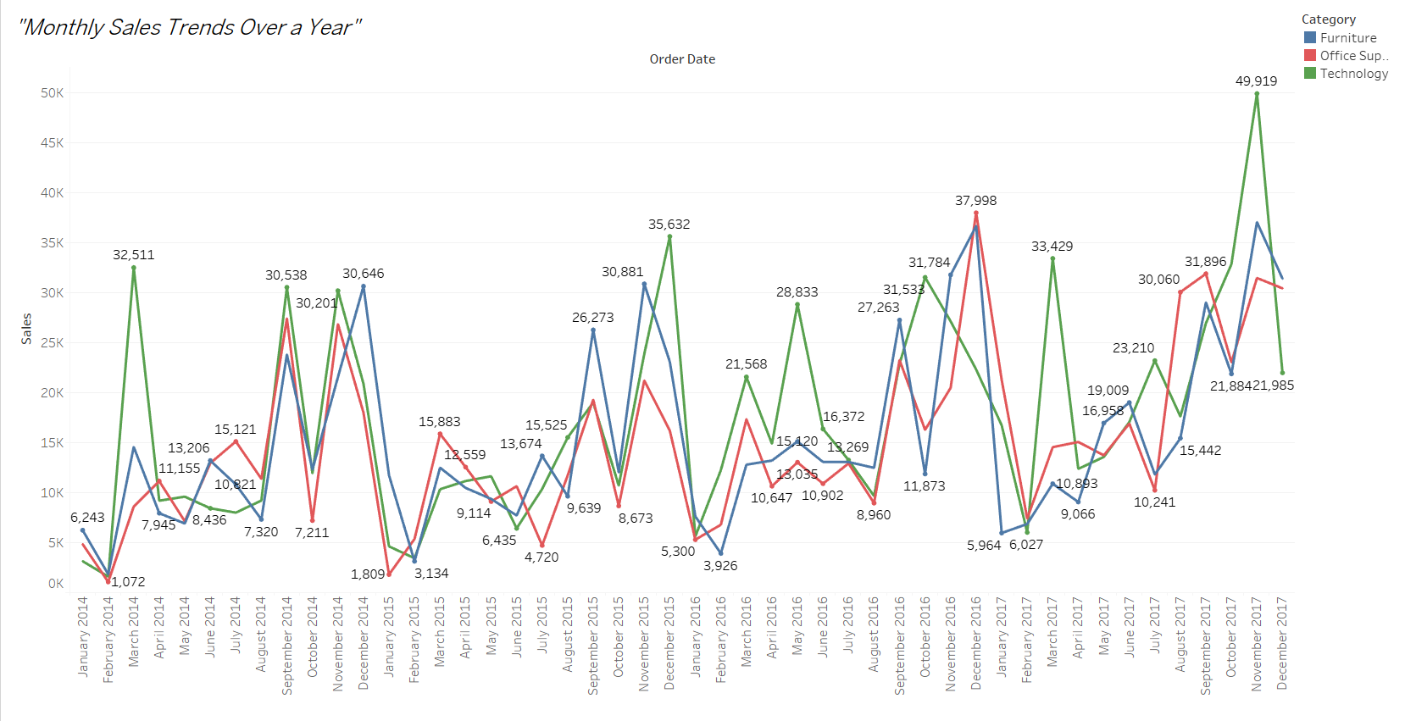

The **line chart** is the best option for visualizing **Monthly Sales Amounts Over The Course Of a Year** due to the following reasons:

1. **Captures Trends Over Time**:
   * A line chart emphasizes the continuous nature of time, making it easy to observe upward or downward trends in monthly sales.
2. **Highlights Seasonality**:
   * It clearly shows any seasonal patterns or spikes in sales during specific months.
3. **Easy to Compare**:
   * Adding multiple lines (e.g., for different categories or regions) enables comparisons while maintaining clarity.
4. **Intuitive for Time-Series Data**:
   * Line charts are universally recognized for time-based data, making them accessible and effective for communication.
5. How is the total sales amount distributed among different product categories?

Total sales distribution can be seen as proportioned parts in a pie in the following

**Pie Chart**.

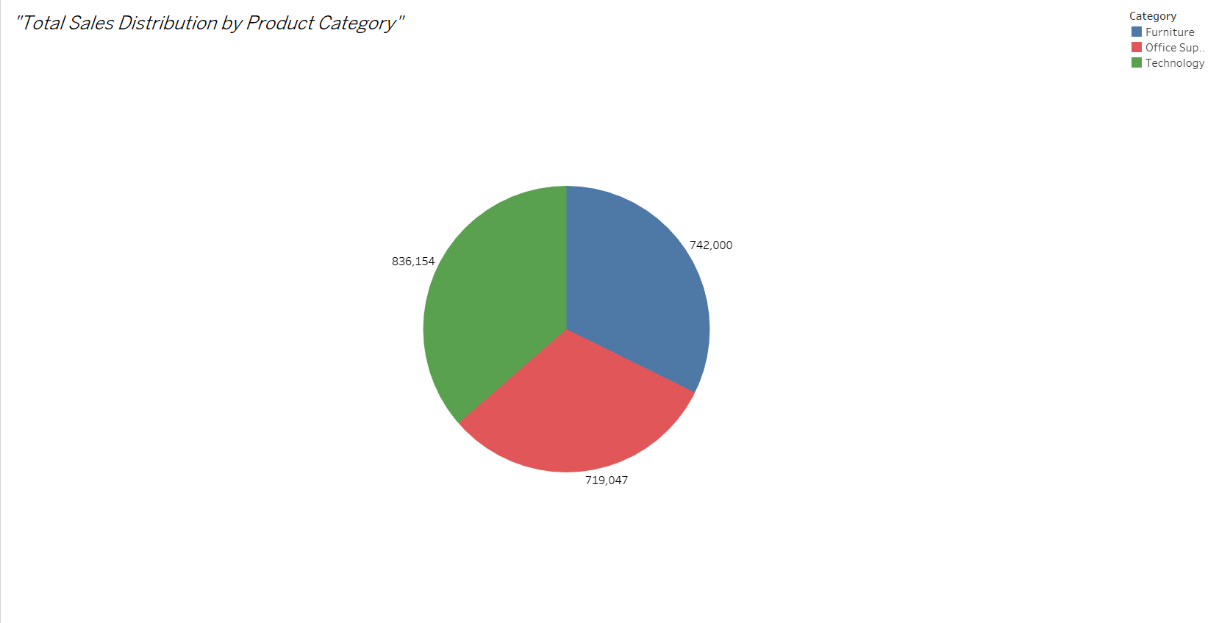

A **pie chart** was chosen to visualize **The Distribution of Total Sales Among Different Product Categories** for the following reasons:

1. **Proportional Representation**:

* Both chart types effectively show how total sales are divided across product categories, with the pie chart giving a clear proportion and the stacked bar chart providing a comparison of relative sizes.

2. **Visual Clarity**:

* Pie charts are ideal for showing part-to-whole relationships at a glance, while stacked bar charts offer more detailed comparisons if there are many categories or if you need to compare them with additional breakdowns (like regions).

3. **Categorical Focus**:

* Both charts are excellent for visualizing categorical data, making them the perfect choice for understanding how sales are distributed across different categories.

1. Can we analyze the sales performance of individual customers over time?

Yes, the analysis of the sales performance of (Top 10) individual customers over the course of time is given in the following **Line Chart**.

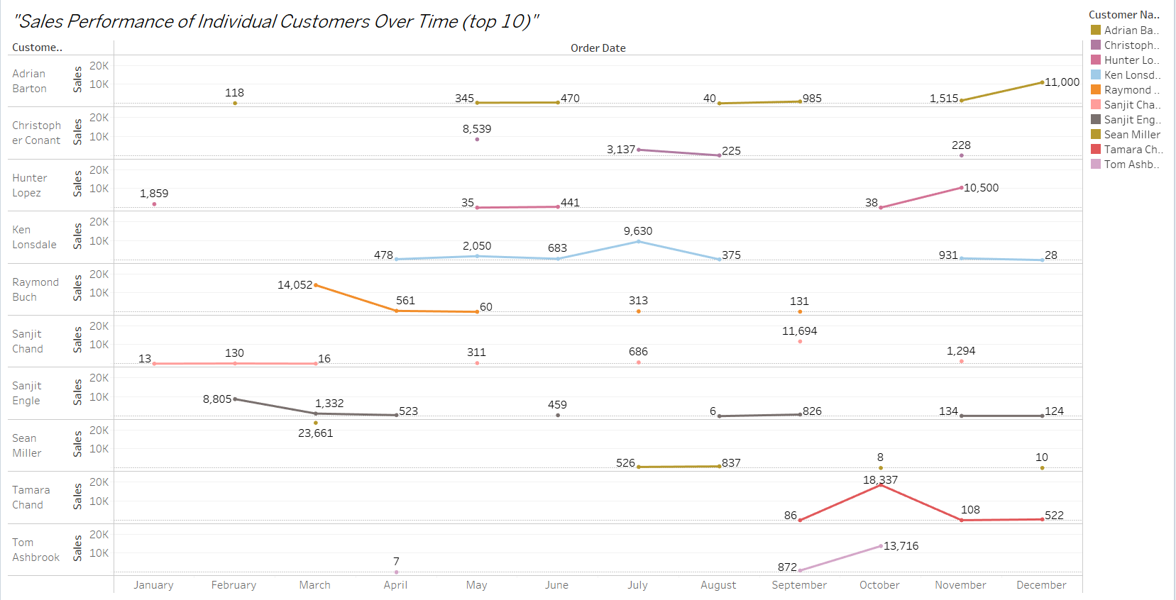

The **line chart** provides a clear, intuitive, and effective way to Analyze **The Sales Performance of Individual Customers Over Time**, making it the most suitable choice for this scenario.

1. **Tracking Performance Over Time**:
   * Line charts are great for visualizing changes in sales for individual customers over a period of time. The continuous nature of the line highlights trends, such as growth or decline in sales.
2. **Identifying Patterns**:
   * Line charts make it easy to identify trends, patterns, and fluctuations in a customer’s purchasing behavior across months or years, allowing you to see periods of high or low sales activity.
3. **Multiple Customer Comparison**:
   * If multiple customers are being analyzed, each customer’s sales can be represented by a different line, making it easy to compare their performance over time.
4. **Intuitive and Readable**:
   * Line charts are a clear and common way to present time-series data, making them intuitive for audiences to interpret.
5. How do sales vary based on different days of the week and product categories?

For furniture, most sales were on Sunday and then sales decreased with the least sale on Wednesday

For office supplies sales were irregular throughout the week, where Wednesday being the most sale while Thursday being the least sale

For technology, most sale was on Sunday while the least sale on Saturday with irregularities in between them.

The complete **Heat Map** chart can be seen down below

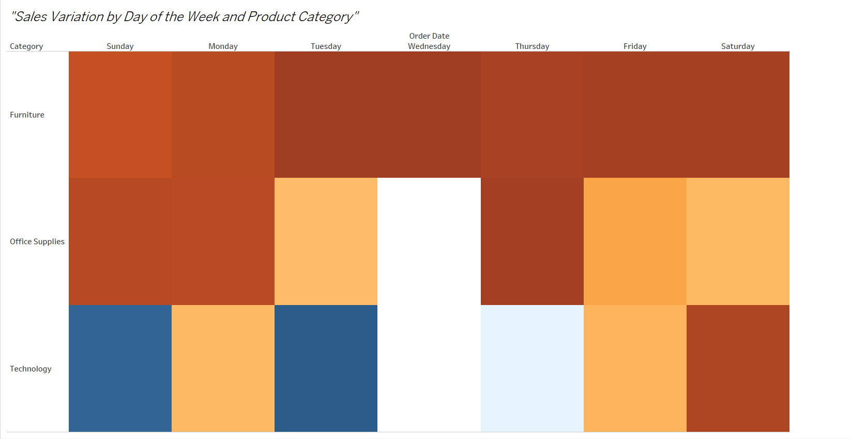

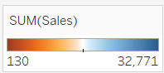

The **heat map** provides a clear, intuitive, and effective way to analyze **The Sales Variation by Day of the Week and Product Category**, making it the most suitable choice for this scenario.

1. **Effective for Multidimensional Data**:
   * Heat maps are perfect for visualizing data that has multiple dimensions, such as the days of the week and product categories. By using color to represent sales, the heat map makes it easy to spot patterns and variations.
2. **Clear Sales Comparison**:
   * The color variation in the heat map makes it easy to compare how sales vary across different days of the week for each product category, highlighting which days perform better.
3. **Quick Identification of Trends**:
   * By representing sales as colors, the heat map provides a quick and intuitive way to identify trends, such as whether certain product categories perform better on specific days.
4. **Space-Efficient**:
   * Heat maps allow you to display a large amount of information in a compact space. This is helpful when analyzing data for multiple categories and days, keeping the visualization clear without overwhelming the viewer.
5. **Visual Appeal**:
   * The color-coding in heat maps makes the data visually engaging and easy to interpret, making it easier for stakeholders to understand the distribution of sales.
6. Can we visualise the sales growth of different product categories over time?

Yes, the sales growth of different product categories over time can be seen in the following **Line Chart**.

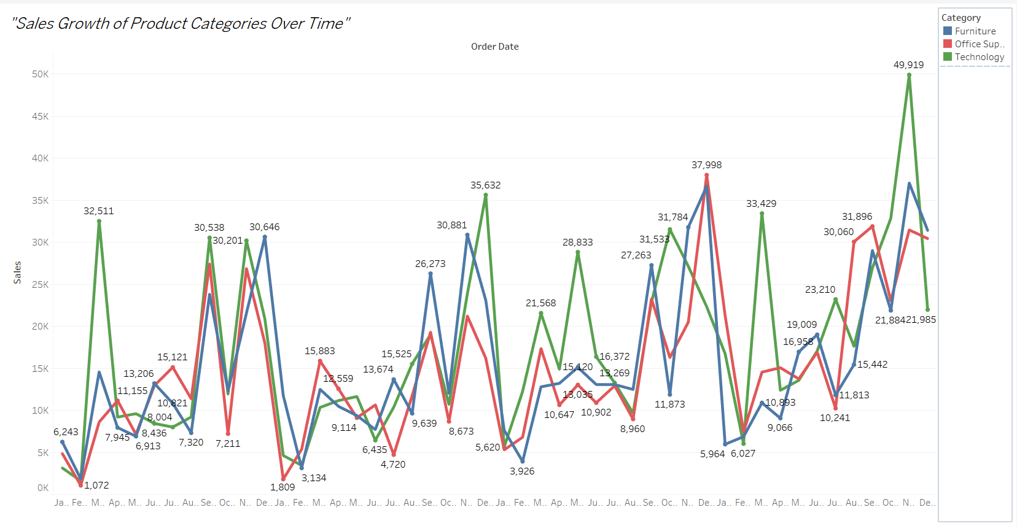

The **line chart** provides a clear, intuitive, and effective way to analyze **The Sales Growth of Product Categories Over Time,** making it the most suitable choice for this scenario.

1. **Tracks Growth Over Time**:
   * The line chart is ideal for representing continuous data like time. It shows sales trends for each product category, making it easy to observe growth patterns.
2. **Comparison Across Categories**:
   * Separate lines for each product category allow direct comparisons of their performance over time, highlighting which categories are growing faster or slower.
3. **Identifies Patterns and Milestones**:
   * The line chart reveals important insights, such as consistent growth, seasonal spikes, or dips in sales for each category.
4. **Simple and Intuitive**:
   * Line charts are widely recognized and easy to understand. They effectively convey sales growth trends to any audience, from analysts to stakeholders.
5. **Customizable Granularity**:
   * The chart can be adjusted to show sales trends by month, quarter, or year, offering flexibility to match the level of detail required.

This makes the line chart the most effective and visually clear way to visualize sales growth for different product categories over time. Let me know if you need further help!

1. How does the sales distribution vary across different regions in the "Superstore" dataset?

The sales distribution across different regions can be seen in the following

**Stacked Bar Chart**.

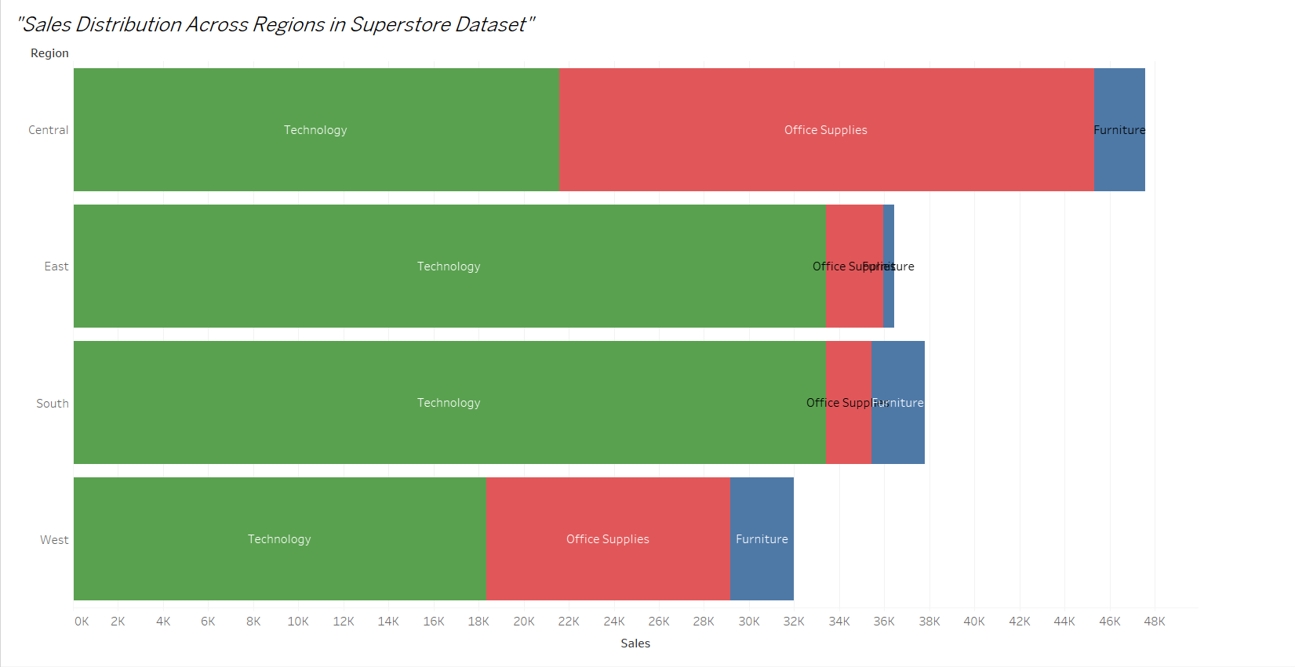

The **stacked bar chart** provides a clear, intuitive, and effective way to analyze **the Sales Distribution Across Regions** in Superstore Dataset, making it the most suitable choice for this scenario.

1 **Clear Comparisons**:

* Bar charts make it easy to compare total sales across regions at a glance. Sorting the bars helps highlight high-performing and low-performing regions.

2 **Category-Level Analysis**:

* Adding Category or Segment to the color shelf provides a breakdown of contributions within each region, offering more detailed insights.

3 **Space Efficiency**:

* Unlike maps, bar charts can effectively display data even when screen space is limited, making them ideal for small screens or reports.

4 **Customizable**:

* The chart can be adjusted to include filters, enabling dynamic exploration of regions, categories, or time periods.

5 **Widely Recognized**:

* Bar charts are familiar to most audiences, ensuring the data is easily understood without additional explanation.

1. Can we visualise the composition of profits across various subcategories within different customer segments?

Yes, the composition of profits across various subcategories with different customers can be visualized in following **Stacked Bar Chart**.

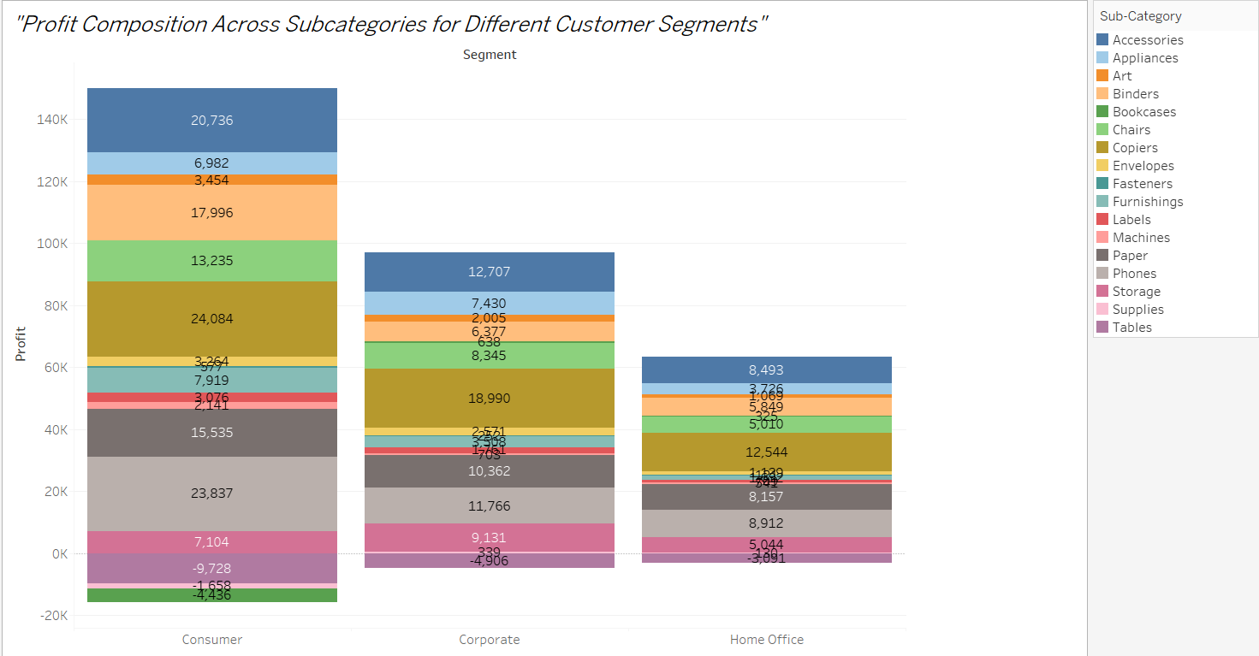

The **stacked bar chart** provides a clear, intuitive, and effective way to analyze **the Profit Composition Across Subcategories for Different Customer Segments**, making it the most suitable choice for this scenario.

1. **Shows Composition and Total**:
   * Stacked bars display the total profit for each segment while simultaneously showing the contributions of individual subcategories, making it a dual-purpose chart.
2. **Facilitates Comparison**:
   * By placing all segments side by side, the chart allows viewers to compare total profits and subcategory contributions across different segments easily.
3. **Highlights Key Contributors**:
   * The stack design clearly shows which subcategories contribute the most or least to each segment’s profit, helping identify areas of strength or concern.
4. **Compact and Efficient**:
   * A stacked bar chart is space-efficient, presenting both summary and detailed information without cluttering the visualization.
5. **Familiar and Intuitive**:
   * The chart type is widely understood, making it easy for stakeholders to grasp the insights at a glance.
6. What is the percentage contribution of each region to the overall sales?

In the following **Pie Chart** all “Four Sector” is the representation for percentage contribution of each of Four regions.

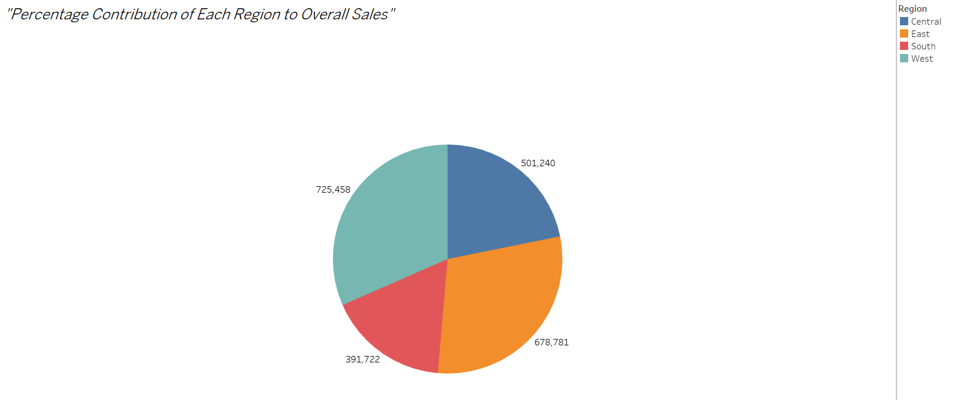

The **pie chart** provides a clear, intuitive, and effective way to analyze **the Percentage Contribution of Each Region to Overall Sales**, making it the most suitable choice for this scenario.

1. **Shows Proportions Clearly**:
   * Pie Charts are well-suited for visualizing percentage contributions, providing an intuitive sense of how regions compare to one another.
2. **Focus on Percentages**:
   * By showing percentages rather than absolute values, the chart emphasizes relative contributions, which is the focus of this question.
3. **Visually Appealing**:
   * The circular layout is visually engaging and draws attention to the data. The donut format adds a modern look and creates space for labels or central text.
4. **Compact Representation**:
   * A donut chart efficiently displays regional contributions in a single, uncluttered view, making it ideal for dashboards or presentations.
5. Can we visualise the profit margins associated with different shipping modes and customer segments?

Yes, in following **Clustered Bar Chart** the visualization of profit margins with different shipping modes and customer segments can be seen.

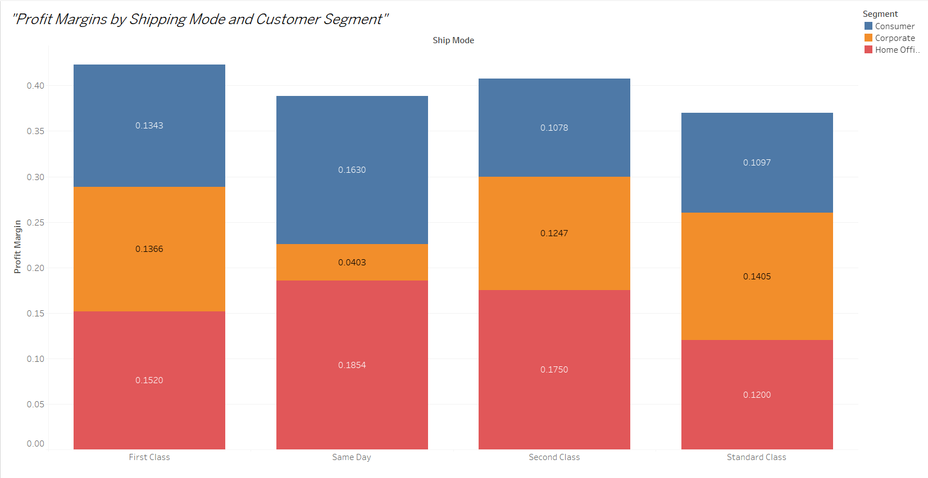

A **clustered bar chart** is ideal for **visualizing profit margins across different shipping modes and customer segments**. This chart type allows for a clear comparison of profit margins within and across customer segments for each shipping mode.

1. **Clear Comparison**:
   * Clustered bars allow easy comparison of profit margins across shipping modes within each customer segment.
2. **Emphasizes Relationships**:
   * This chart highlights the interaction between two categorical dimensions (Ship Mode and Segment) and their impact on profit margins.
3. **Compact Representation**:
   * By grouping bars, the chart presents detailed insights without requiring additional charts or space.
4. **Supports Decision-Making**:
   * The chart can help identify which shipping modes and segments yield the highest or lowest profit margins, aiding strategic decisions.
5. How long does it take to process orders for different product categories?

In the following **Bar Chart** it can be seen that average processing time of Furniture, Office Supplies and Technology is 4.5 days, 4.2 days and 4 days repectively.

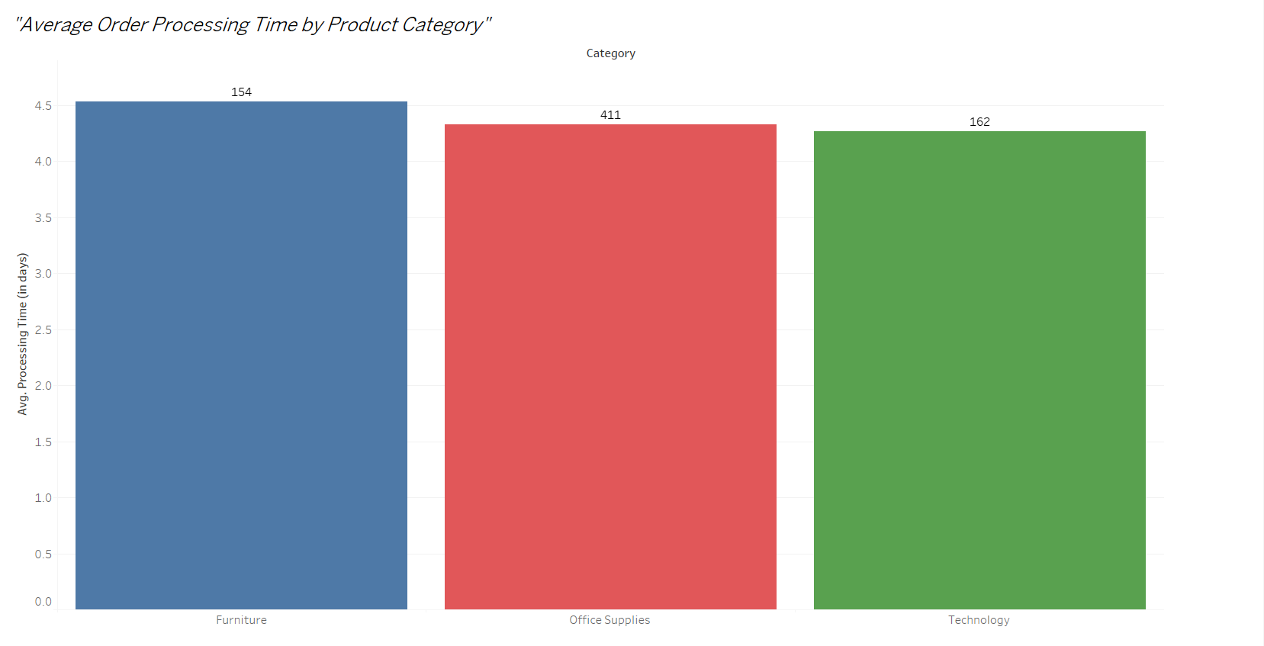

The **bar chart** provides a clear, intuitive, and effective way to analyze the "Average Order Processing Time by Product Category", making it the most suitable choice for this scenario.

1. **Straightforward Comparison**:
   * The bar chart allows for easy visual comparison of average processing times across categories.
2. **Focus on Averages**:
   * The chart highlights central trends (average processing time), which is likely the key focus of the question.
3. **Minimal Visual Clutter**:
   * Bar charts are simple and avoid unnecessary complexity, ensuring the focus stays on the data.
4. **Flexible for Enhancements**:
   * Filters or color coding (e.g., categories with higher processing times) can easily be added for deeper analysis.
5. How do discounts affect overall profit?

In the following **Scatter Plot** it can be seen that as the discount increases the profit margin decreases with it.

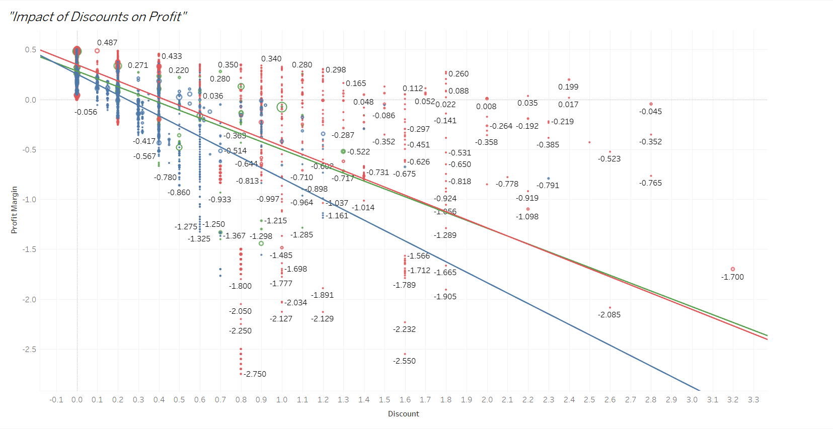

The **scatter plot** provides a clear, intuitive, and effective way to analyze the "The Impact of Discounts on Profits", making it the most suitable choice for this scenario.

1. **Shows Relationships Clearly**:
   * Scatter plots effectively show the correlation (or lack thereof) between two variables, like discount and profit.
2. **Highlights Trends and Outliers**:
   * The trend line reveals whether discounts negatively or positively affect profit, while outliers can indicate unusual transactions.
3. **Granular Insights**:
   * By showing individual data points, you can identify specific products, customers, or orders where discounts had the most significant impact on profit.
4. **Flexibility**:
   * The chart can be enhanced with filters (e.g., by category or region) for more targeted analysis.
5. Can we visualise the relationship between product sales and profitability for different product categories?

In the following **Scatter Plot** the visualisation shows that in the sales of technology the profit is very high, followed by office supplies leaving furniture with least profit.

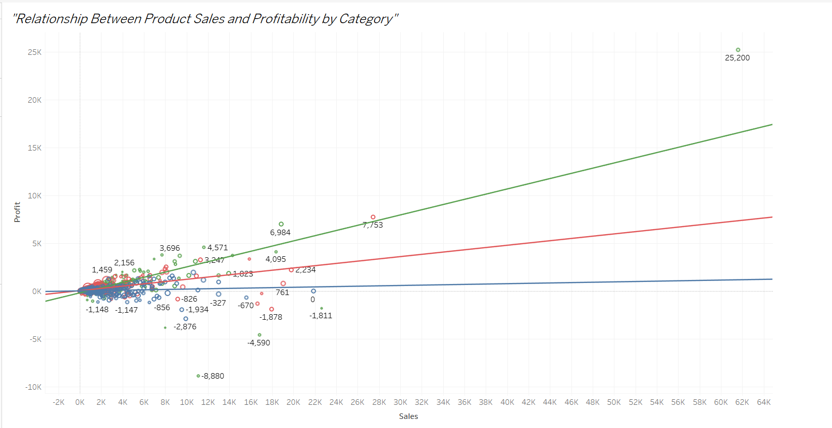

In the given visualization, green line represents technology, red line represents office supplies and blue line represents furniture.

The **scatter plot** provides a clear, intuitive, and effective way to analyze **the Relationship Between Product Sales and Profitability by Category**, making it the most suitable choice for this scenario.

1. **Clear Relationship Visualization**:
   * Scatter plots effectively show the correlation (if any) between sales and profit, revealing whether higher sales consistently result in higher profitability.
2. **Highlights Category Differences**:
   * Using color coding for categories makes it easy to compare performance across different product categories.
3. **Granular Insights**:
   * Each dot represents a product or sub-category, allowing detailed insights into which products are outliers in terms of profit or sales.
4. **Identifies Patterns**:
   * The trend line indicates overall trends, helping identify whether increased sales generally lead to increased profitability or if certain categories buck the trend.
5. What is the distribution of order quantities for products in the dataset?

The distribution of order quantities for products can be seen the following

**Histogram Chart**.

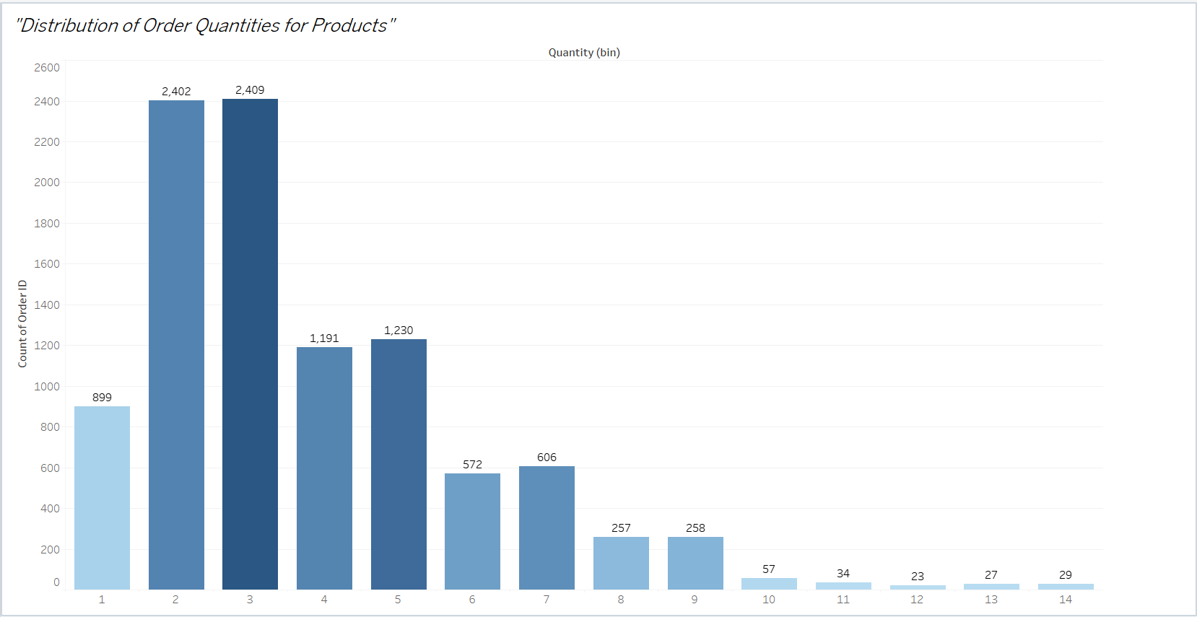

The **histogram** provides a clear, intuitive, and effective way to analyze the **Distribution of Order Quantities for Products**, making it the most suitable choice for this scenario.

1. **Shows Distribution Clearly**:
   * A histogram effectively visualizes the frequency of different order quantities, helping identify common and rare values.
2. **Highlights Patterns**:
   * It reveals whether the order quantities are evenly distributed, clustered, or skewed.
3. **Customizable Granularity**:
   * Bins can be adjusted to suit the level of detail required, allowing for a tailored view of the data.
4. **Focus on Frequency**:
   * The histogram is specifically designed to analyze the frequency distribution of a single measure like order quantity.
5. How do the profit distributions vary across different product categories?

The following **Box and Whisker plot** clearly shows that furniture has least profit while technology has most profit.

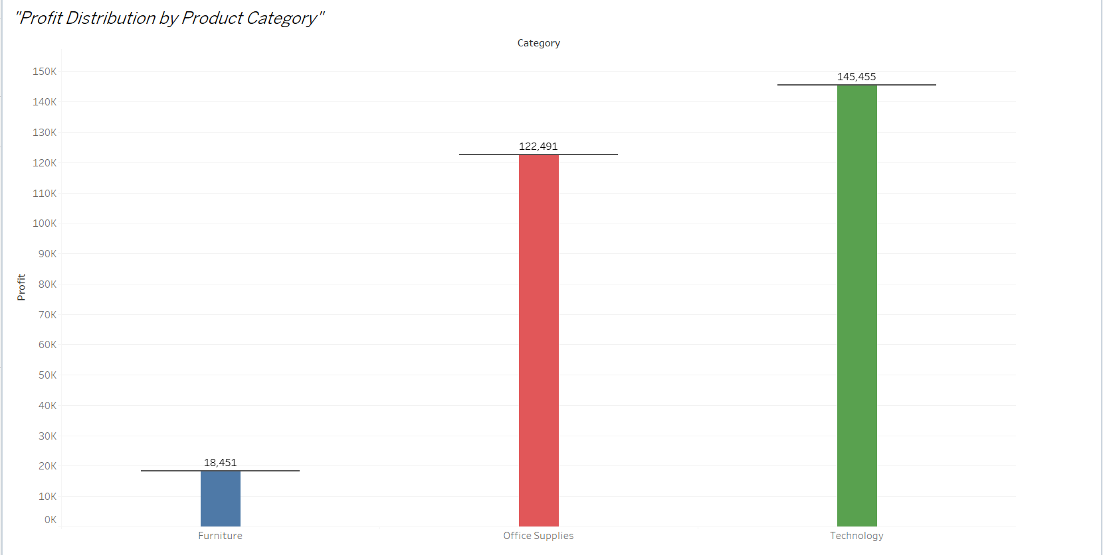

The **box-and-whisker plot** provides a clear, intuitive, and effective way to analyze the **Profit Distribution by Product Category**, making it the most suitable choice for this scenario.

1. **Detailed Distribution Analysis**:
   * This chart shows the range of profits within each category, highlighting medians, spread, and outliers.
2. **Facilitates Comparison**:
   * By placing all categories side by side, it’s easy to compare variability and central tendencies between them.
3. **Outlier Identification**:
   * Outliers in profit (exceptionally high or low values) are clearly marked, offering insights into unusual transactions.
4. **Compact and Informative**:
   * A box-and-whisker plot condenses a large amount of data into a visually comprehensible format.
5. Can we compare the shipping time distributions for different shipping modes?

In the following **Box and Whisker** plot it can be seen that 24 people selected same day shipping mode, 3357 people selected first class shipping mode, 6298 people selected second class shipping mode while remaining 29879 people chose standard mode.

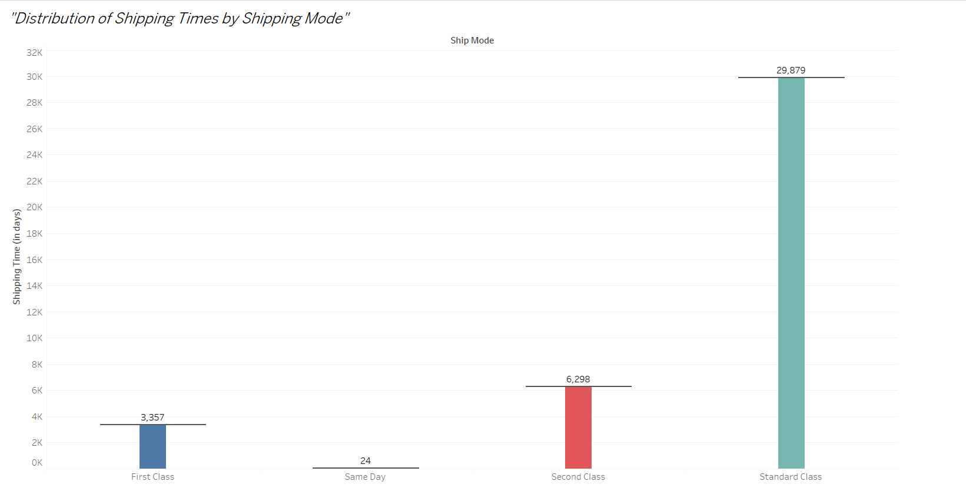

The **box-and-whisker plot** provides a clear, intuitive, and effective way to analyze the **Distribution of Shipping Times by Shipping Mode**, making it the most suitable choice for this scenario.

1. **Comprehensive Distribution Insights**:
   * It shows the spread of shipping times for each mode, including medians, interquartile ranges, and outliers.
2. **Facilitates Comparison**:
   * The side-by-side boxes make it easy to compare variability and central tendencies between different shipping modes.
3. **Outlier Detection**:
   * Highlights unusual shipping durations, which could indicate anomalies or delays.
4. **Compact and Informative**:
   * The chart provides a detailed yet concise overview of the data, ideal for analyzing distributions.
5. What is the monthly trend in the number of orders shipped?

In the following **Line Chart** it can be seen that January has the least shipped order which gradually increases with November and December being the most shipped order month.

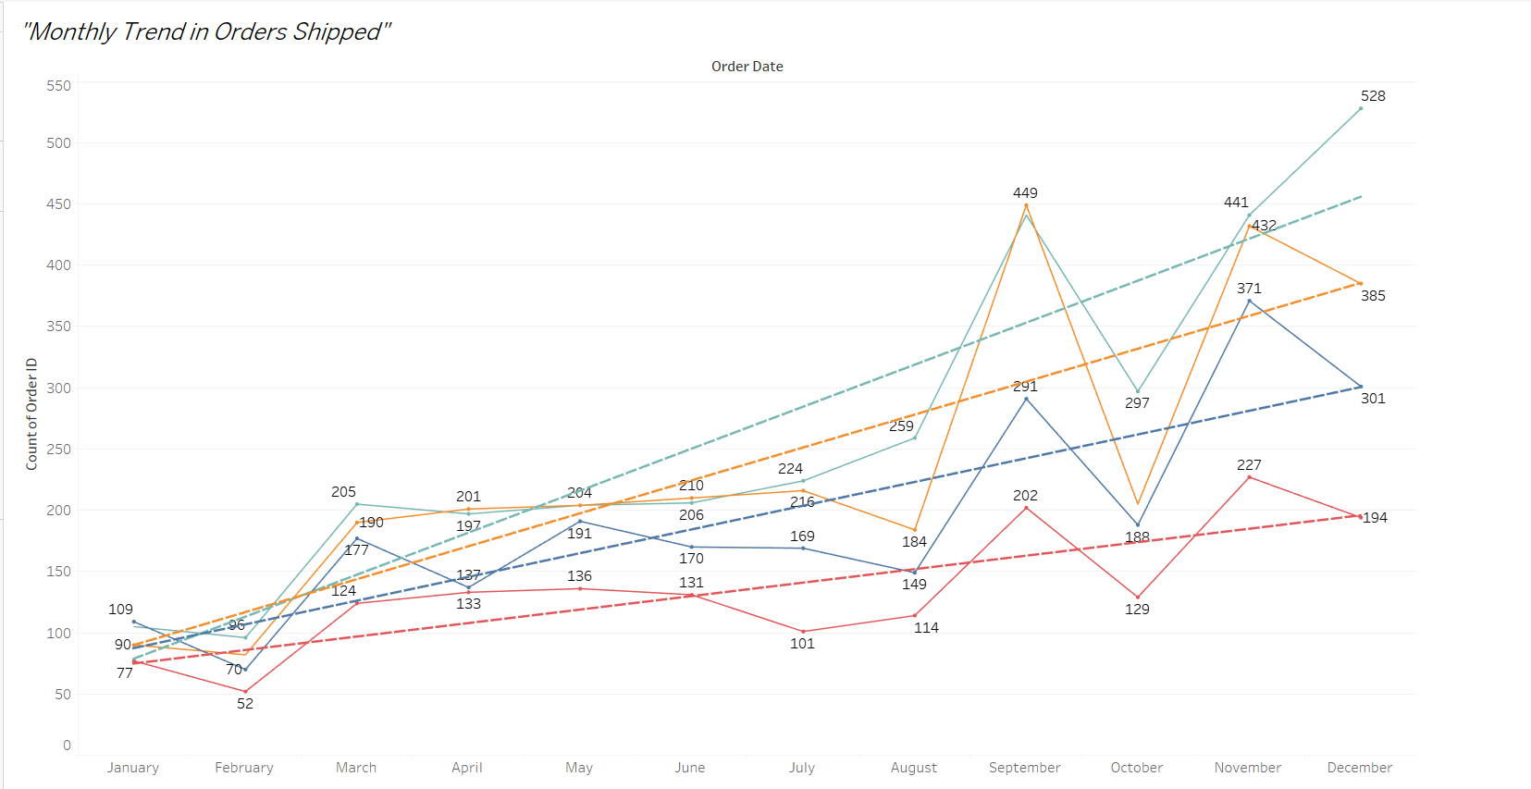

The **line chart** provides a clear, intuitive, and effective way to analyze the **Monthly Trend in Orders Shipped**, making it the most suitable choice for this scenario.

1. **Tracks Changes Over Time**:
   * The line chart clearly illustrates trends and patterns in the number of orders shipped each month.
2. **Highlights Seasonal Variations**:
   * Monthly data allows for easy identification of peak periods and slower months.
3. **Simplifies Temporal Analysis**:
   * A line chart makes it easy to spot upward or downward trends in shipping volume over time.
4. **Intuitive and Effective**:
   * Line charts are widely understood and highly effective for showing data over continuous intervals.
5. How do different customer segments perform in terms of sales and discount rates?

In the following **Clustered Bar Chart with Dual Axes** it can be seen that consumers are biggest buyer category and they are getting most discount rates followed by corporates with home office being the least buyer and therefore getting least discounts.

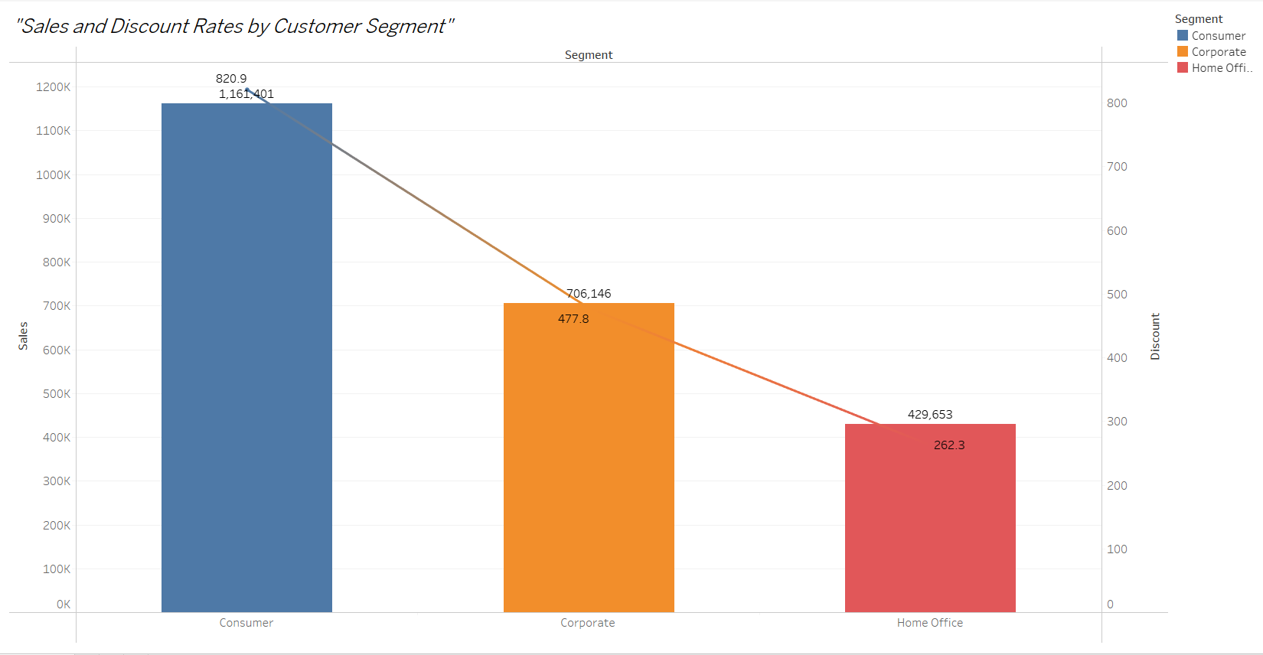

A **clustered bar chart with dual axes** is ideal for comparing **customer segment performance in terms of both sales and discount rates**. It allows you to see the sales and average discount rate side by side for each segment.

1. **Facilitates Direct Comparison**:
   * Displaying sales and discount rates on dual axes allows you to analyze the relationship between them for each segment.
2. **Emphasizes Dual Metrics**:
   * Combining bars (sales) with a secondary element (e.g., circles or a line for discount rates) ensures both metrics are visible and comparable.
3. **Supports Detailed Insights**:
   * By showing both metrics side by side, you can identify whether higher discounts correspond to higher sales in different segments.
4. **Intuitive and Informative**:
   * The clustered bar chart makes it easy to compare multiple metrics across distinct groups like customer segments.
5. What are the sales and profit trends across different product subcategories and regions in the Superstore dataset?

In the following **Stacked Line Chart** the upper 4 lines for different regions represents the sales column while the lower 4 lines for different regions represents the discount column repectively to each region throughout the course of 12 months.

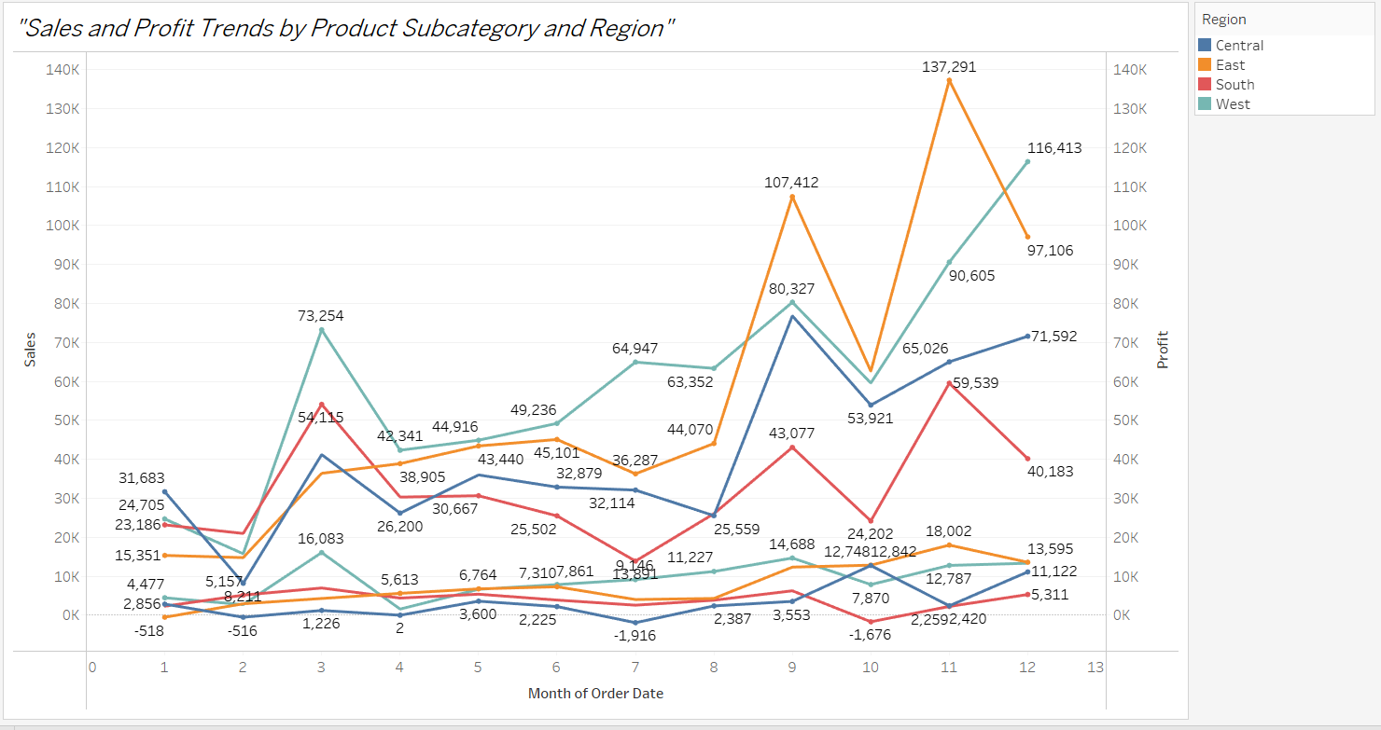

The **Stacked Line Chart** provides a clear, intuitive, and effective way to analyze the **Sales and Profit Trends by Product Subcategory and Region**, making it the most suitable choice for this scenario.

1. **Trends Over Time**:
   * A stacked line chart is ideal for showing trends over time, making it easy to analyze how sales and profit evolve month by month.
2. **Compares Multiple Metrics**:
   * By stacking lines for sales and profit, you can see both metrics simultaneously and analyze how each product subcategory contributes to the overall trend.
3. **Regional and Subcategory Breakdown**:
   * The use of color helps you distinguish between different regions and subcategories, allowing for clear comparisons across these dimensions.
4. **Highlights Changes**:
   * The line chart effectively highlights any spikes or dips in sales and profits over time, enabling a deeper understanding of the business dynamics.
5. What is the average delivery duration for different regions and ship modes?

In all the 4 regions the following **Bar Chart** shows that on an average, same day shipping mode takes 0 days, 1st class takes 2 days, 2nd class takes less than 4 days and standard class takes more than 4 days.

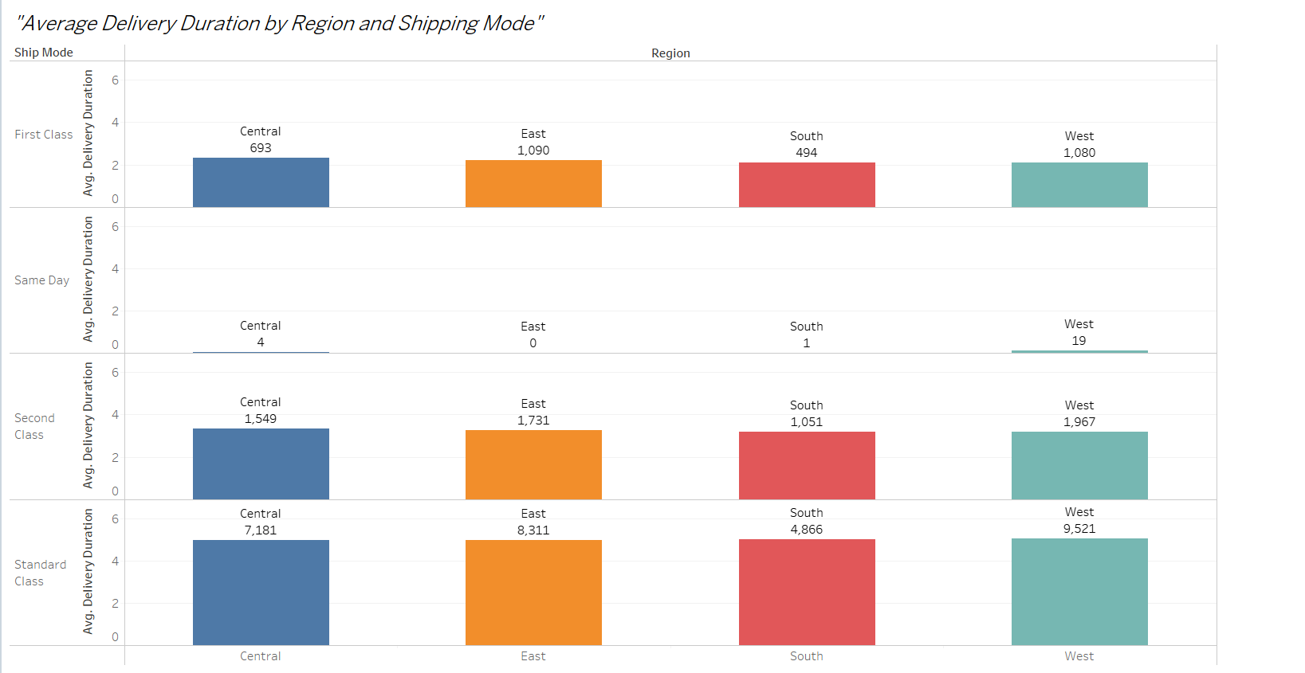

The **Bar chart** provides a clear, intuitive, and effective way to analyze the **Average Delivery Duration by Region And Shipping Mode**, making it the most suitable choice for this scenario.

1. **Clear Comparison Across Regions and Ship Modes**:
   * A bar chart is effective in comparing the average delivery durations for each shipping mode across different regions, as the length of the bars represents the magnitude of the duration.
2. **Color-Coding Enhances Visual Clarity**:
   * By color-coding based on regions or shipping modes, you can easily distinguish between different categories, making it simple to interpret the data.
3. **Emphasizes Differences**:
   * Bar charts allow you to visually highlight the regions and ship modes that have the longest or shortest delivery durations.
4. **Straightforward and Informative**:
   * Bar charts are easy to understand, even for users unfamiliar with the data, and they provide a direct comparison of average delivery times.
5. How has the average order quantity changed over the years for various product categories?

In the following **Line Chart** the Average order quantity can be visualised over the years for various different products.

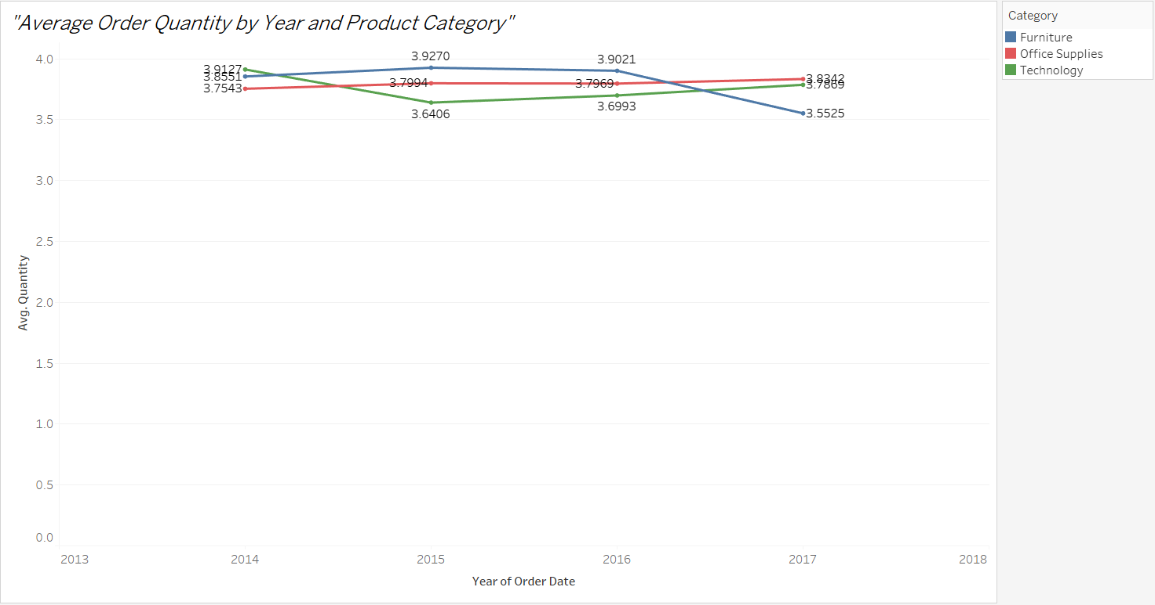

The **Line Chart** provides a clear, intuitive, and effective way to analyze the **Average Order Quantity by Year and Product Category**, making it the most suitable choice for this scenario.

1. **Effective for Time Series Data**:
   * Line charts excel at showing trends over time, which is essential when analyzing how the average order quantity changes from year to year.
2. **Comparison Across Categories**:
   * By using color to differentiate product categories, you can easily compare trends in order quantities for each category over time.
3. **Clear Trend Identification**:
   * The line chart clearly shows upward or downward trends, making it easy to spot shifts in order quantities across years.
4. **Simplicity and Clarity**:
   * Line charts are straightforward and ideal for visualizing continuous data, providing a clear view of changes in average order quantity over time.
5. Can we visualise the correlation between discount rates and order quantities for different customer segments?

In following **Scatter Plot** it can be visualised that the order quantities is directly proportional to discount rates.

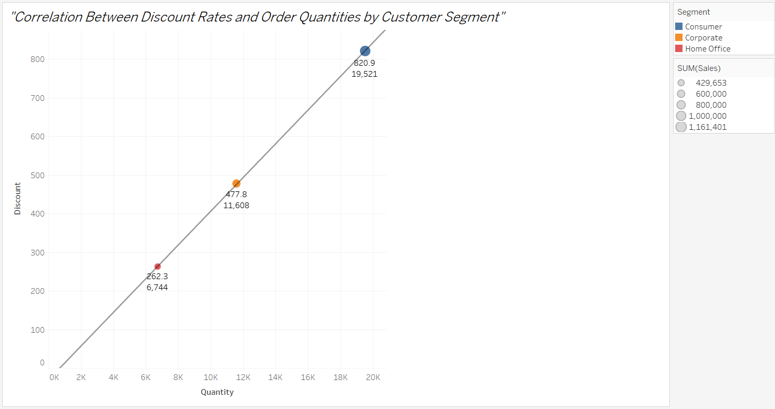

The **Scatter Plot** provides a clear, intuitive, and effective way to analyze the **Correlation Between Discount Rates and Order Quantities by Customer Segment**, making it the most suitable choice for this scenario.

1. **Displays Correlation Clearly**:
   * Scatter plots are excellent for showing the relationship between two continuous variables, making it easy to assess how discount rates relate to order quantities.
2. **Segmentation by Customer Type**:
   * Using color to differentiate customer segments allows you to visually identify any differences or trends in the correlation for each segment.
3. **Identifies Trends and Outliers**:
   * The scatter plot helps to quickly spot any outliers or trends, such as whether higher discounts lead to higher or lower order quantities, and how this varies by customer segment.
4. **Easy to Interpret**:
   * Scatter plots are intuitive and effective for understanding the nature of relationships between variables, especially when trying to assess correlation.
5. What is the proportion of orders returned in each region within the Superstore dataset?

In the following **Bar Chart** it clearly shows that there are no orders returned.

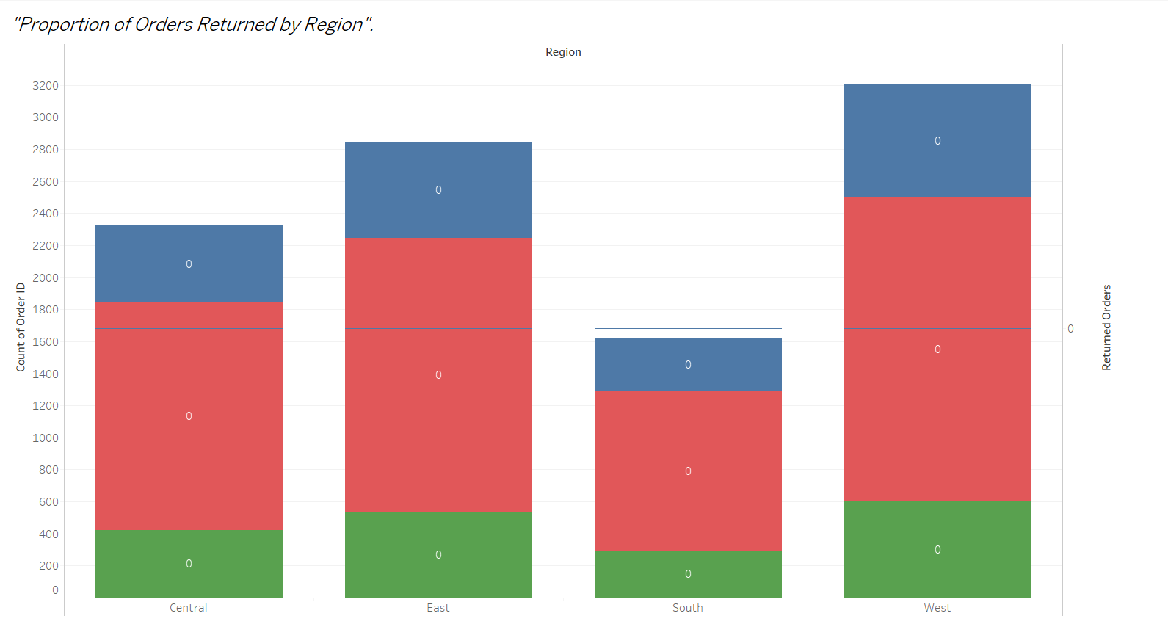

The **Bar chart** provides a clear, intuitive, and effective way to analyze the **Proportion of Orders Returned by Region**, making it the most suitable choice for this scenario.

1. **Clear Comparison**:
   * A bar chart is ideal for comparing proportions across regions. The length of the bars makes it easy to visually compare which regions have higher or lower return proportions.
2. **Precise Values**:
   * The bar chart makes it easy to read the exact proportion of returned orders, especially with labels showing the percentage on each bar.
3. **Flexible**:
   * A bar chart can be easily customized to compare other measures (like total sales or order count) side by side with returns if needed.
4. **Visual Clarity**:
   * A bar chart is simple and effective, particularly for highlighting relative proportions in a way that’s easy to interpret.
5. Can you compare the profit of different products for different subcategories?

The following **Bar Chart** visualises Profit Comparison of (Top10) different product for different subcategories.

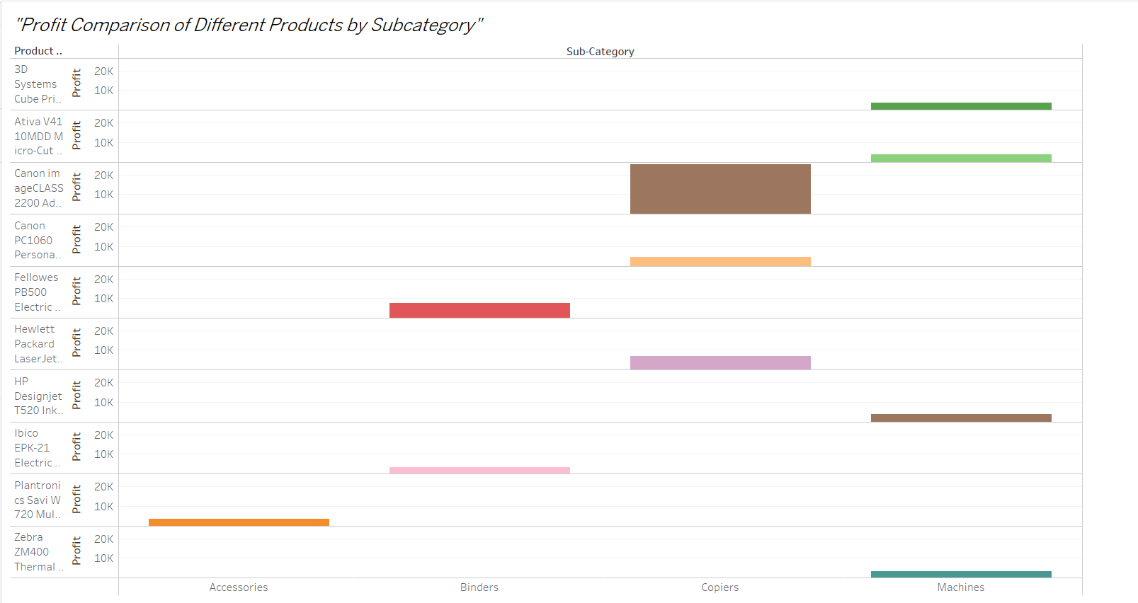

The **Stacked Bar chart** provides a clear, intuitive, and effective way to analyze the **Profit Comparison of Different Products by Subcategory**, making it the most suitable choice for this scenario.

1. **Shows Total and Breakdown**:
   * A stacked bar chart allows us to see the total profit for each subcategory while breaking it down by product. This provides a clear view of how each product contributes to the total profit within its subcategory.
2. **Easy Comparison**:
   * You can easily compare the profits of different products within each subcategory, and also compare the total profits across subcategories.
3. **Visual Clarity**:
   * The stacked format makes it clear how products perform relative to each other within subcategories, with different colors representing different products.
4. **Handles Multiple Categories Well**:
   * Stacked bar charts are effective when comparing multiple categories (in this case, products) across a common dimension (subcategories), making the data easier to digest.
5. Which shipping mode is the most commonly used in the Sample Superstore dataset?

The following **Bar Chart** clearly shows that most commonly used shipping mode is Standard Class followed by 2nd Class then 1st Class and then Same Day as least commonly used.

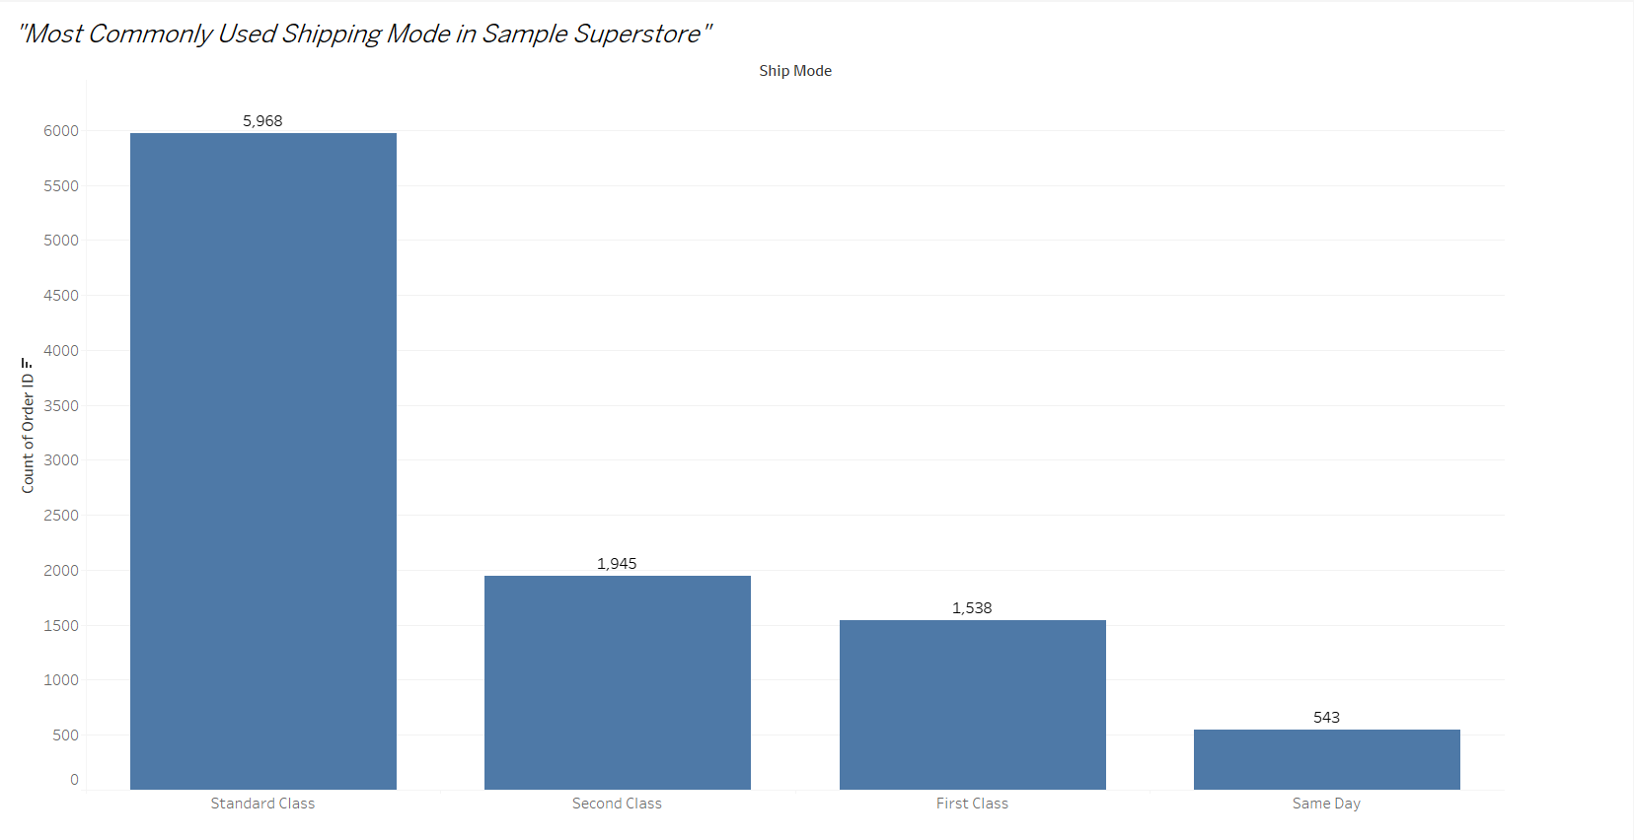

The **Bar Chart** provides a clear, intuitive, and effective way to analyze the **Most Commonly Used Shipping Mode in Sample Superstore**, making it the most suitable choice for this scenario.

1. **Easy Comparison**:
   * A bar chart allows us to clearly compare the frequency of each shipping mode, helping to identify which one is the most commonly used.
2. **Visual Clarity**:
   * Bar charts are straightforward and make it easy to read and understand the distribution of orders across different shipping modes.
3. **Effective for Categorical Data**:
   * Since Ship Mode is a categorical variable, a bar chart is well-suited to compare the count of each category (shipping mode) against others.
4. **Sorts Data Well**:
   * Sorting the bars in descending order ensures that the most common shipping mode stands out visually.
5. How does the sales performance of different regions evolve throughout the quarters of a year?

The following **Line Chart** shows irregularities in every quarter year for all the regions which gives the visualisation of sales performances in different region quarterly.

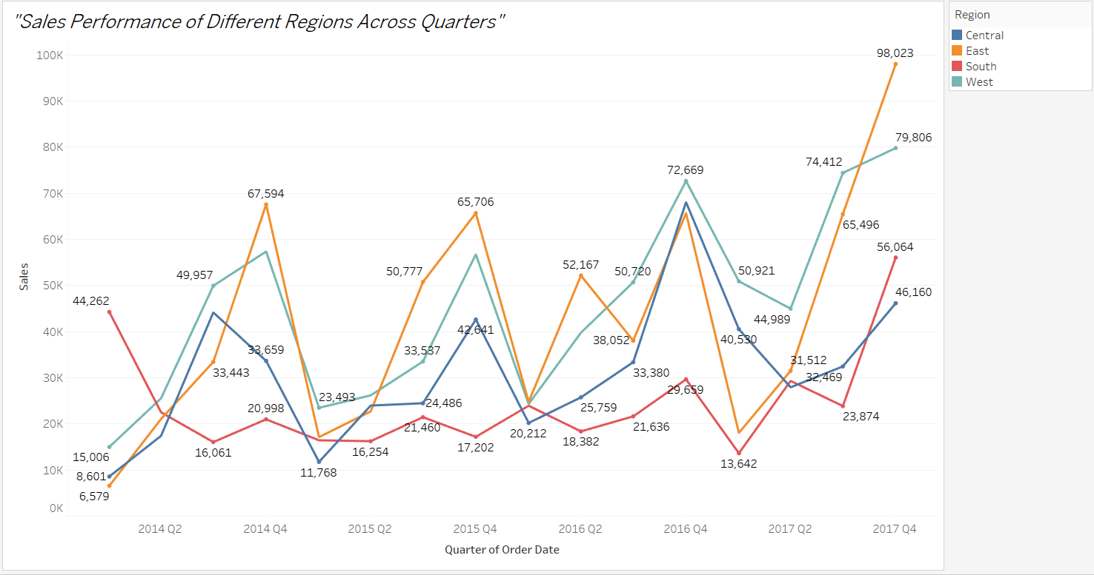

The **Line Chart** provides a clear, intuitive, and effective way to analyze the **Sales Performance of Different Regions Across Quarters**, making it the most suitable choice for this scenario.

1. **Tracks Trends Over Time**:
   * Line charts are perfect for displaying trends over time, making them ideal for showing how sales in different regions evolve throughout the quarters.
2. **Comparison of Multiple Categories**:
   * By using different colours for each region, you can easily compare the sales performance of multiple regions in a single view.
3. **Clear Visualization of Changes**:
   * The line chart visually connects data points, making it easy to track the rise and fall of sales across each quarter.
4. **Handles Time Data Well**:
   * Time-based data (like sales over quarters) is best represented with a line chart, as it clearly shows patterns, fluctuations, and seasonality.
5. What is the distribution of order priorities across different product categories?

The following **Pie Chart** shows the distribution of same day shipping mode against all other shipping mode because orders with same day shipping mode can be considered as **prioritised order**.

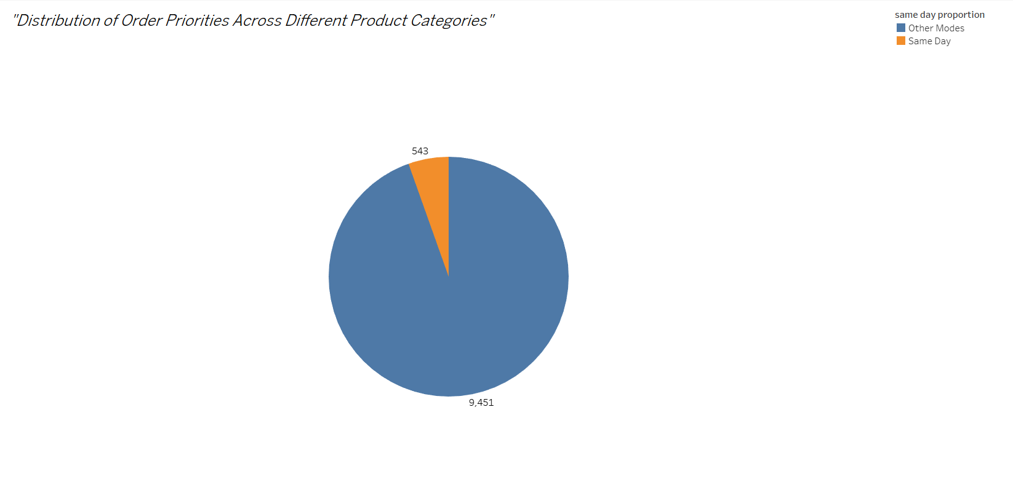

The **Pie Chart** provides a clear, intuitive, and effective way to analyze the **Distribution of order priorities across different products**, making it the most suitable choice for this scenario.

1. **Focus on Proportions**:
   * A pie chart is ideal for showing the relative share of each priority (or proxy) within a single product category.
2. **Intuitive and Clear**:
   * Pie charts are easy to understand, making them effective for non-technical audiences.
3. **Effective for Few Categories**:
   * Since pie charts work best with fewer segments, they are well-suited for showing distribution within a single category.
4. **Highlights Key Differences**:
   * Visual differences between slices make it easy to identify the dominant priority or mode.
5. What is the relationship between discounts and sales?

The following **Scatter Plot** shows that office supplies discount is tends towards constant even with increase in sales, while discount on furniture in little higher than office supplies when sale increases. But the discount on technology increases gradually with sales.

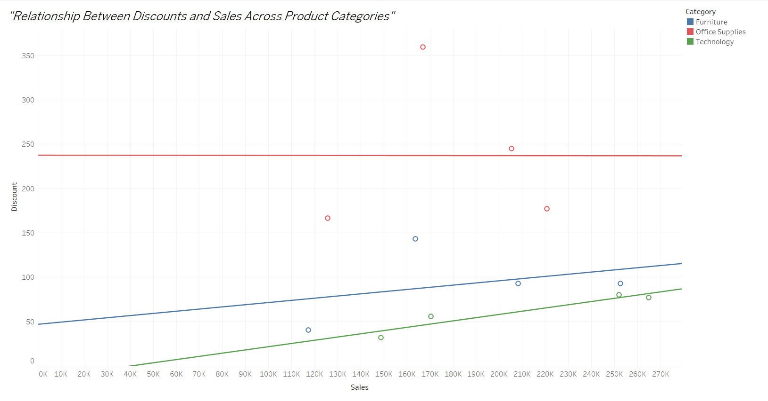

The **Scatter Plot** provides a clear, intuitive, and effective way to analyze the **Relationship Between Discounts and Sales Across Product Categories**, making it the most suitable choice for this scenario.

1. **Visualizes Relationships**:
   * A scatter plot directly shows how one variable (Discount) affects another (Sales), making it easy to identify trends and anomalies.
2. **Reveals Patterns**:
   * The spread of data points indicates whether the relationship is strong, weak, positive, or negative.
3. **Highlights Variations by Category**:
   * Using colors for categories or segments adds an extra layer of insight, showing if certain categories have stronger correlations.
4. **Supports Quantitative Analysis**:
   * Adding a trend line helps quantify the relationship and provides a clearer understanding of the overall pattern.
5. How does the average order value differ between repeat customers and new customers?

This following **Bar Chart** shows that all customers are repeat customers, there are no new customers.

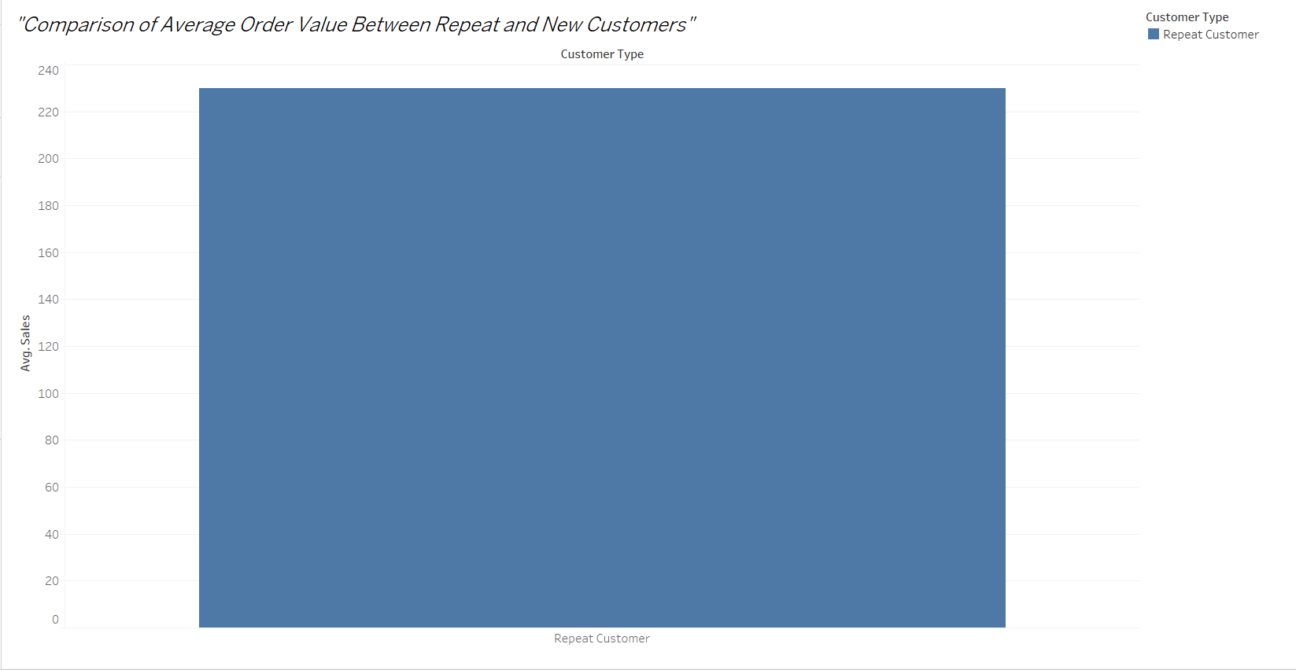

The **Bar Chart** provides a clear, intuitive, and effective way to analyze the **Comparison of Average Order Value Between Repeat and New Customers**, making it the most suitable choice for this scenario.

1. **Straightforward Comparison**:
   * A bar chart simplifies comparing order values between customer groups.
2. **Handles Limited Data**:
   * Even with limited data differentiation, the chart effectively highlights the key metric (average order value).
3. **Customizable**:
   * If future data includes "new customers," this setup can easily be updated to incorporate them.
4. What is the geographical distribution of returns and its impact on overall profitability?

The geographical distribution of returns and probability across regions given in the following **Scatter Plot**.

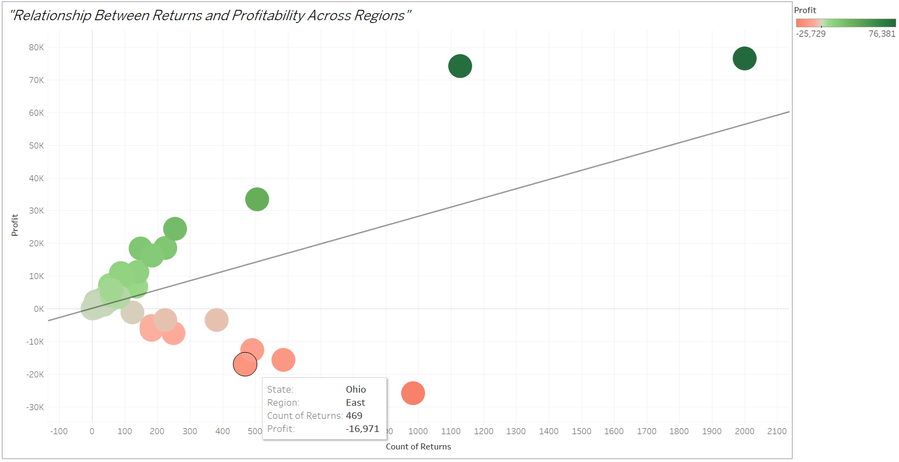

The **Scatter Plot** provides a clear, intuitive, and effective way to analyze the **Relationship Between Returns and Profitability Across Regions**, making it the most suitable choice for this scenario.

1. **Correlation Analysis**:
   * A scatter plot is ideal for showing the relationship between two quantitative variables (returns and profit).
2. **Identify Outliers**:
   * Easily spot regions with disproportionately high returns or low profitability.
3. **Clear Comparison**:
   * Each region is represented as a distinct point, making the visualization uncluttered and easy to interpret.
4. **Interactive Exploration**:
   * Adding tooltips and filters allows users to dive deeper into specific regions.