FLOOD DETECTION FROM AERIAL IMAGERY USING DEEP LEARNING
Pavithran S, BalaYoghi V, Vishal K
Third year, Artificial Intelligence and Data Science,
Kamaraj College of Engineering and Technology, Virudhunagar.
Objectives:
- To build a binary classifier that separates flood from no-flood aerial images using MobileNetV2 transfer learning.
- To audit the dataset for shortcuts before training, so that the reported accuracy measures flood content and not the way the photographs were captured.
- To compare a frozen feature extractor against a fine-tuned backbone across three random seeds, selecting the variant on validation data alone.
- To tune the decision threshold so that recall is maximised under a precision floor of 0.85, because a missed flood costs lives while a false alarm costs an inspection.
- To explain every prediction with a Grad-CAM heat map and to verify that evidence with a size-controlled deletion test.
- To deploy the trained model as a Streamlit application and export TensorFlow Lite builds for drones and phones.
Problem Statement:
Floods are among the most frequent and destructive natural disasters, and the speed of the emergency response depends on how quickly the flooded areas are located. Drones and aircraft now capture far more aerial imagery than human operators can inspect in time, so the bottleneck is no longer taking the pictures but reading them. This project automates that reading step: it classifies an aerial image as flood or no flood using a MobileNetV2 network that is first trained as a frozen feature extractor and then fine-tuned on the AIDER aerial dataset. Because a wrong verdict in a disaster either costs lives or wastes rescue effort, the system also shows the visual evidence behind every decision as a Grad-CAM heat map, so that an operator can tell whether the model responded to flood water or to something irrelevant. The decision threshold is chosen on validation data only, and the held-out test set never influences any choice.
Methodology Diagram:
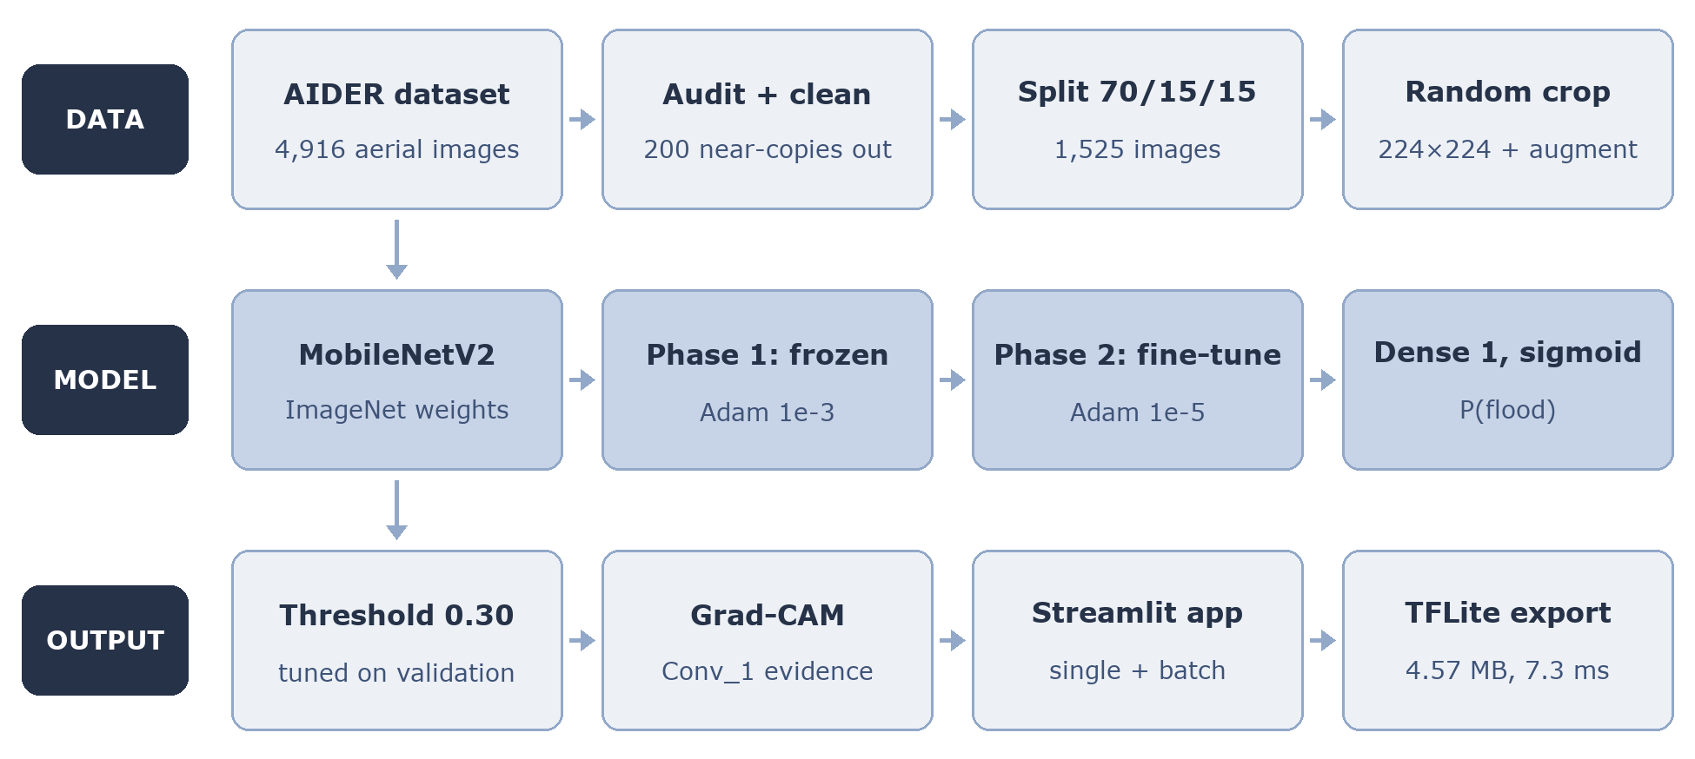

Screenshots:
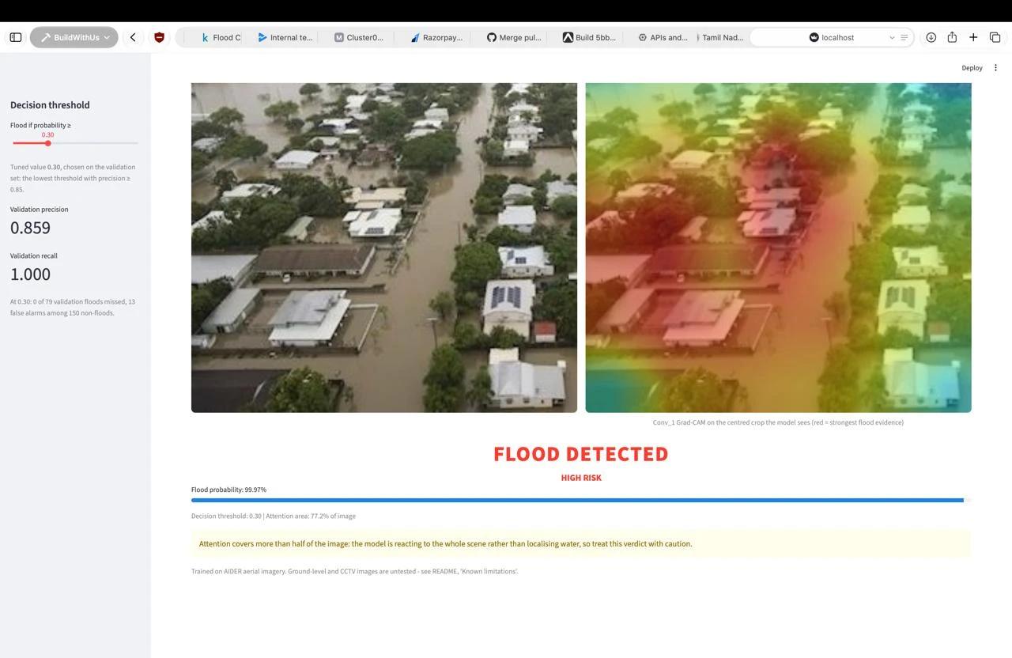 | 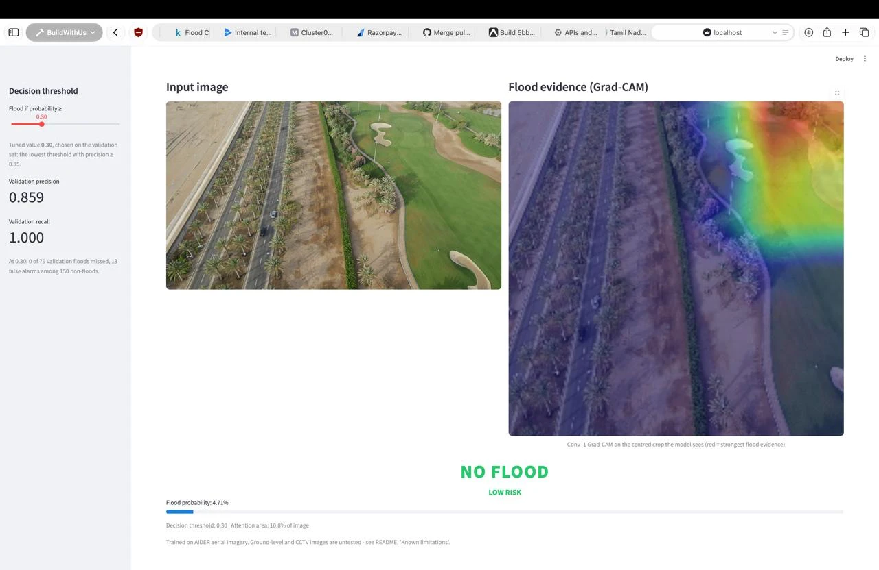
Fig. 1 Flood detected — P(flood) = 99.97 % | Fig. 2 No flood — P(flood) = 4.71 %
Results:
Metric — test set, 228 images, threshold 0.30 | Value
Recall (floods found) | 0.987 — 77 of 78
Precision | 0.865 — 12 false alarms among 150
F1 score / Accuracy | 0.922 / 0.943
ROC AUC / Average precision | 0.9955 / 0.9932
System Requirements:
H/W requirements:
Processor: Apple silicon M-series or x86-64 CPU (developed on an Apple M4)
RAM: 8 GB minimum, 16 GB recommended
Hard Disk: 5 GB free space
GPU: optional — Apple Metal GPU used through tensorflow-metal
Operating system: macOS, Linux or Windows
S/W requirements:
Python version 3.11
Deep learning libraries: TensorFlow 2.16.2, Keras 3.15.1, TensorFlow Lite
Supporting libraries: NumPy, Pandas, scikit-learn, OpenCV, Matplotlib
Streamlit 1.60 for the web application
Dataset: AIDER — Aerial Image Dataset for Emergency Response, licensed CC BY 4.0
Conclusion:
- The fine-tuned MobileNetV2 finds 77 of the 78 flood images in the held-out test set at ROC AUC 0.9955, so aerial flood screening can be automated reliably.
- Fine-tuning the backbone is measurably better than using it frozen — test accuracy 0.9649 ± 0.0044 against 0.9474 ± 0.0494 over three seeds.
- Grad-CAM together with a deletion test shows that the verdict rests on the region the heat map highlights, which gives an operator a reason to trust or reject it.
- The 4.57 MB float16 TensorFlow Lite export runs in 7.3 ms on a CPU and reproduces every decision of the full model, so the system can run on a drone or a phone.

