SPORT BETTING DAPP

line 1: 1st moath azaizeh   
line 2: department of *Computer eng*   
line 3: *PSUT*line 4 irbid,jordan  
line 5: moa20190287@std.psut.edu.jo

line 1: 4th Abdullrahman Wasfi  
line 2: department of *Computer eng*  
line 3: *PSUT*line 4: Jerash, Jordan  
line 5: abd20190270@std.psut.edu.joline 1: 2nd Given Name Surname  
line 2: *dept. name of organization   
(of Affiliation)*  
line 3: *name of organization   
(of Affiliation)*line 4: City, Country  
line 5: email address or ORCID

line 1: 5th Given Name Surname  
line 2: *dept. name of organization   
(of Affiliation)*  
line 3: *name of organization   
(of Affiliation)*line 4: City, Country  
line 5: email address or ORCIDline 1: 3rd Given Name Surname  
line 2: *dept. name of organization   
(of Affiliation)*  
line 3: *name of organization   
(of Affiliation)*line 4: City, Country  
line 5: email address or ORCID

line 1: 6th Given Name Surname  
line 2: *dept. name of organization   
(of Affiliation)*  
line 3: *name of organization   
(of Affiliation)*line 4: City, Country  
line 5: email address or ORCID

*Abstract*— Decentralized applications (dApps) have emerged as a disruptive force in the technology and finance sectors, leveraging blockchain technology to create platforms that are transparent, secure, and user-centric. In this paper, we present the design and implementation of a decentralized sports betting dApp that will revolutionize the sports betting industry by leveraging Ethereum and smart contracts. The primary goal of the project is to provide users with a transparent and secure betting experience by eliminating intermediaries and enabling peer-to-peer interactions. The project's scope includes both front end and back end development, as well as intuitive user interfaces, smart contract design, and integration with dependable external data sources. We implemented the necessary functionalities for bet placement, result verification, and payout distribution using a systematic and iterative methodology. To ensure the dependability and security of user funds, rigorous testing and security measures have been implemented. We hope to demonstrate the potential of blockchain technology in transforming the sports betting industry by promoting transparency, fairness, and user empowerment by developing this decentralized sports betting dApp.

Keywords—component, formatting, style, styling, insert (key words)

# Introduction (*Heading 1*)

Cryptocurrency arose as a digital cash system designed to operate autonomously, independent of financial institutions [1]. Because of its decentralized nature, it enables a trustless payment system that eliminates the need for intermediaries, giving users complete control and ownership of their funds. Over time, cryptocurrency has grown in popularity as a viable alternative to traditional fiat currency, prompting more people to use it in transactions involving goods and services [2]. Decentralized applications (dApps) have emerged as a game-changing concept in technology and finance. These apps use blockchain technology to provide a decentralized, transparent, and secure platform for a variety of purposes. Unlike traditional applications that rely on central authorities, decentralized applications empower users by eliminating intermediaries and enabling peer-to-peer interactions. This decentralized approach has a number of potential benefits, including increased transparency, data immutability, enhanced security, and greater user control over their assets. The motivation for selecting a sports betting dApp as the project is that it sits at the crossroads of two rapidly growing industries: blockchain technology and sports betting. For decades, sports betting has been a popular recreational activity, generating significant revenue worldwide. Traditional sports betting platforms, on the other hand, frequently suffer from issues of trust, fairness, and transparency. A decentralized sports betting dApp can address these concerns and revolutionize the industry by leveraging the power of blockchain. The main goal of this project is to create and deploy a decentralized sports betting dApp that uses Ethereum and smart contracts to provide users with a transparent and secure betting experience. The dApp will allow users to place bets on various sporting events and have the results settled seamlessly using blockchain technology.

The project scope includes both the front end and back end development of the dApp. The front end will include the creation of an intuitive and user-friendly interface through which users will be able to browse available sports events, view odds, place bets, and track their betting history. The back end will be focused on creating smart contracts in Solidity to handle the logic for bet placement, result verification, and payout distribution.

The project's goal in developing this sports betting dApp is to demonstrate the potential of decentralized applications in revolutionizing the sports betting industry. It aims to demonstrate the benefits of blockchain technology, such as transparency, fairness, and user empowerment, and to contribute to the wider adoption of decentralized solutions across multiple industries.

components, incorporating the applicable criteria that follow.

# lireacture reviwe

## Block Sports: A decentralized sports betting exchange Version

Block Sports is a sports betting company dedicated to building a decentralized and autonomous oracle network ecosystem. By providing a transparent and secure platform, the project hopes to revolutionize the industry. The development will be staged to ensure a smooth transition to a fully decentralized system.

In the beginning, Block Sports will run a small number of Oracle nodes from a single high-quality data source. During the platform's beta phase, this controlled environment allows for close supervision and validation. The company intends to stay in this stage until they achieve the desired exchange throughput, which both validates the platform and encourages progression to the next stage.

In stage two, the majority of Block Sports oracles will be transferred to external trusted parties such as established partners and community groups. This strategic move aims to foster growth and attract more interest by allowing operators to receive the full benefit of operation while Block Sports covers the costs associated with data sources. Although permission and access management for Oracle nodes will continue to be handled manually by Block Sports, automatic fee claiming will be available.

As the platform grows in size and security requirements increase, stage three will introduce more Oracles and enforce data source diversity across the network. Operators will be responsible for covering the costs of alternative data sources. Block Sports will assist in this transition.

Finally, in stage four, the emphasis will be on developing an autonomous Oracle ecosystem by removing any required oversight that Block Sports has over the network. This includes Oracle monitoring, blacklisting, and whitelisting. While the solutions for this stage are not yet finalized, Block Sports intends to reach this stage and will provide additional information to the public as it becomes available.

The roadmap highlights the company's progress since 2018, beginning with the creation of smart contract prototypes and a functional exchange demo. To raise operational funds, a crowdsale is planned, and the team will be expanded through hiring. In a TestNet Beta, the platform will be tested and integrated with smart contracts before being released as a fully functional Block Sports Exchange on the Neo MainNet.

Block Sports is a limited liability company registered in Macedonia (FYROM) that ensures compliance with gaming, financial, and securities laws in the country. Third-party security services will audit the platform's security, and bug bounty programs will be implemented to address any vulnerabilities.

The platform makes use of the BSX token, which is a dividend-paying token rather than a utility token for betting. A 2% operational fee is charged upon the completion of a successful bet, with 75% of the fees distributed to holders of staked BSX tokens. Active oracle operators will be paid a percentage of the fees based on the total number of third-party oracles. The remaining 20% of fees will be used to fund Block Sports' long-term development.

The token sale is scheduled for the third quarter of 2018, with specifics to be announced later. Whitelisting will be required for the crowdsale, and individual investor caps will be established. Investors, an operational reserve, and the team are all represented in the token distribution. Tokens reserved for the company and founders will be vested over the course of 18 months, ensuring alignment with the success of the project.

By leveraging the potential of blockchain technology, decentralized oracles, and a dividend-bearing token model, Block Sports aims to create a disruptive platform that revolutionizes the sports betting industry. They strive to provide a superior betting experience for users by providing a transparent and secure platform, while rewarding token holders and oracle operators for their participation and contribution. [3]

# Methodology

The methodology used to design and develop the decentralized sports betting dApp involved a systematic and iterative approach to ensure the project's success. The following steps were taken:

Design of Smart Contracts: The design of smart contracts was a critical step in the development process. The necessary data structures and functionalities for the betting platform were identified. Storage structures were defined for match details, bets, and user information. Functions for placing bets, calculating payouts, and dealing with match results have been added. To ensure security and efficiency, appropriate data types, modifiers, and access control mechanisms were considered. Web3 Integration: Due to its widespread adoption and robustness, Ethereum was chosen as the blockchain platform for the dApp. Integration with Ethereum was accomplished through the use of libraries such as Web3.js and ethers.js. These libraries provided the tools required to connect the web app to the Ethereum blockchain. For testing purposes, the connection was configured to a suitable Ethereum network, such as a local development network or testnet.

User Authentication: To verify and authenticate users, a secure authentication system was implemented. Standard authentication mechanisms were considered, such as username/password or Ethereum address-based authentication. This ensured that only authorized users could gain access to and use the betting platform.

Betting Interface: To allow users to view available matches and place bets, a user-friendly web interface was designed and developed. The interface displayed match information such as teams, odds, and betting options. Users were able to seamlessly select their bets, specify the stake amount, and submit their bets.

Betting Mechanics: Betting rules and parameters, such as minimum and maximum bet amounts, odds calculation, and payout distribution, were established. To handle bets, calculate payouts, and distribute winnings, the necessary logic was implemented in smart contracts. This ensured that the betting process was fair and accurate.

Event Management: Event handling mechanisms were implemented in the smart contracts to trigger actions based on match outcomes. Functions were created to handle match result updates and distribute winnings to the correct bettors. Events were emitted to notify the front-end application of important contract state changes, providing users with real-time updates. The frontend and backend programming languages, frameworks, and tools were chosen based on industry standards and compatibility with Ethereum and web development. Because of its native support for Ethereum-specific features, Solidity, the programming language for smart contracts on Ethereum, was chosen for backend development. To create a user-friendly interface for the frontend, a combination of HTML, CSS, and JavaScript was used. To interact with the Ethereum blockchain, Web3.js or ethers.js libraries were used. The methodology used a structured approach that included smart contract design, web3 integration, user authentication, match data management, betting interface development, betting mechanics implementation, event management, and rigorous testing and security measures. The programming languages, frameworks, and tools chosen were in line with the project's requirements and goals, resulting in a robust and functional decentralized sports betting dApp.

# Implementation

The "SportBetting" contract is intended to make football betting easier. It is written in Solidity and has a pragma version of 0.8.0. The contract is made up of several functions and data structures.

The contract includes a state variable called "owner," which stores the contract owner's address. This variable is used to enforce access control via a modifier known as "onlyOwner." This modifier ensures that specific functions can only be performed by the contract owner.

The contract's core functionality is the management of football matches. Two structs are defined in the contract: "Match" and "MatchInfo." A football match is represented by the "Match" struct, which includes its ID, home team, away team, finished status, winner, and betting-related data. The "MatchInfo" struct provides a streamlined view of a match's information, which is primarily used for retrieval.

The contract keeps track of an array called "matches," which contains instances of the "Match" struct. The "addMatch" function allows the owner to add new matches. This function takes as input the names of the home and away teams and generates a new match, storing it in the "matches" array.

The contract includes the "finishMatch" function to handle match results. This function ends a match and determines the winner by providing the match ID and the name of the winning team. It also invokes the "distributeFunds" function to distribute the winnings.

The "placeBet" function allows users to bet on matches. They supply the match ID and the bet amount, and the contract validates the conditions, such as the match not being completed and no winner being determined. If the conditions are met, the contract adds the user's address to the "bets" mapping and includes their address in the "bettors" array.

The "distributeFunds" function computes the total bets as well as the total bets on the winning team. It then distributes the funds to the winners in proportion to their bet amounts and the total bets placed on the winning team.

The contract also includes functions for obtaining match data. The function "getMatchCount" returns the total number of matches in the "matches" array. The "getMatch" function takes an index parameter and uses the "MatchInfo" struct to retrieve detailed information about the match at that index.

The contract also includes the "getTotalBets" function, which computes and returns the total number of bets placed on a specific match.

Overall, the "SportBetting" contract allows for the management of football matches, including the ability for users to place bets and the distribution of funds to winners.

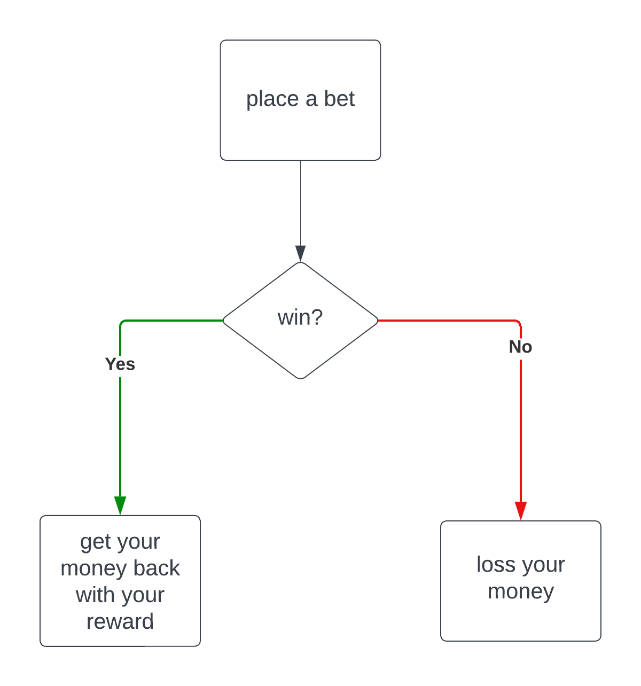

Figure general flow

The above graph gives us the main flow of our website a

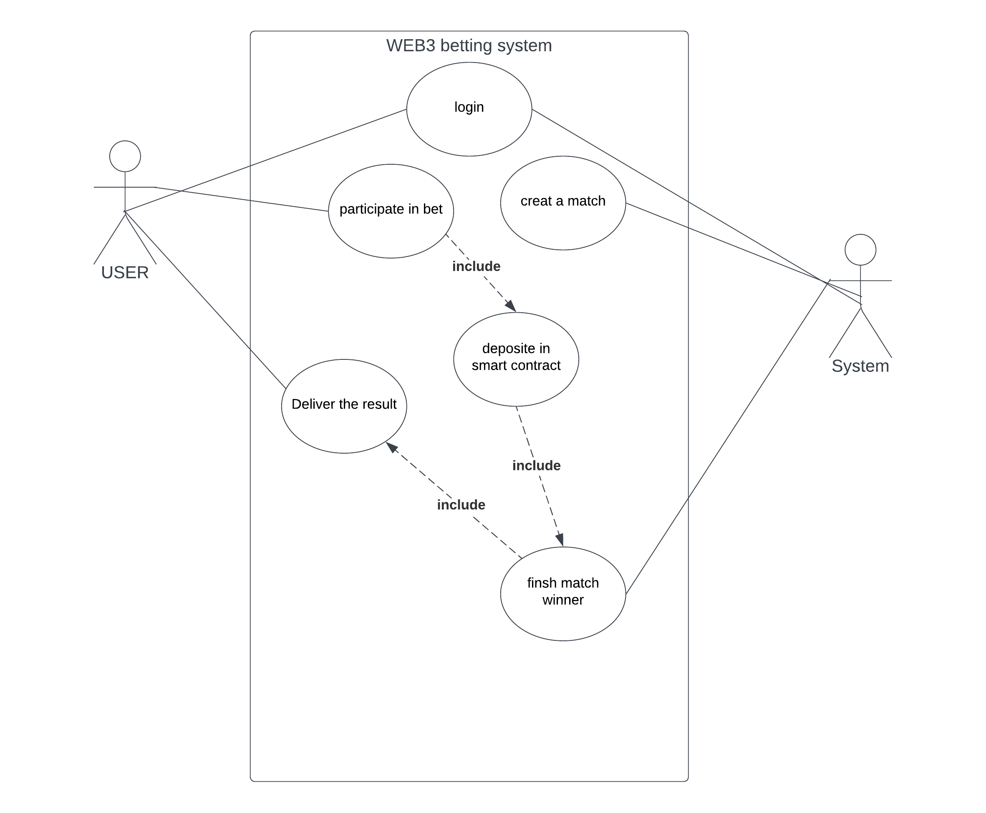

Figure : USE CASE

This is a us case diagram to under stand our system

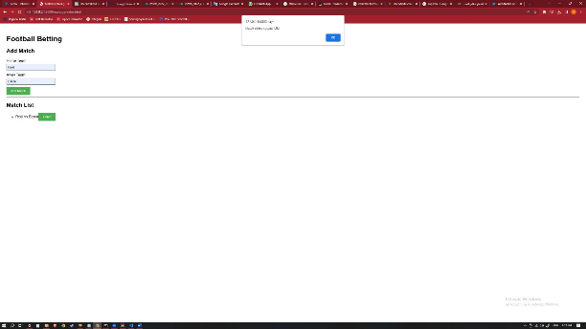

Figure : creating new match to start betting

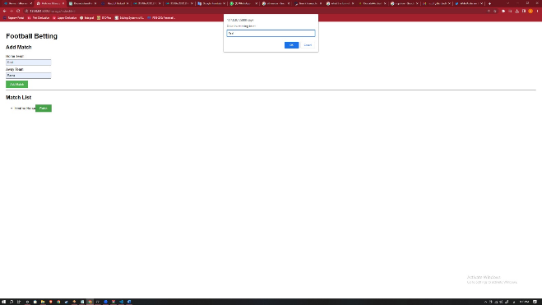

Figure : user choosing the winning team

# CONCLUSION

In this paper, we presented the design and implementation of a decentralized sports betting dApp that will revolutionize the sports betting industry by leveraging Ethereum and smart contracts. By eliminating intermediaries and enabling peer-to-peer interactions, the project was able to achieve its goal of providing users with a transparent and secure betting experience.

The dApp's front and back ends have been finished, including the creation of an intuitive user interface, smart contract design, and integration with external data sources. The project's success was ensured by the systematic and iterative methodology used in the design and development process.

We demonstrated the potential of blockchain technology in transforming the sports betting industry by implementing the dApp. By leveraging blockchain features such as transparency, immutability, and enhanced security, the dApp promotes transparency, fairness, and user empowerment. By removing intermediaries, the dApp offers users a direct and secure betting experience, increasing trust and removing concerns about unfair practices.

The successful implementation of the decentralized sports betting dApp is a step toward broader adoption of decentralized solutions across multiple industries. It demonstrates how decentralized applications can provide transparent, secure, and user-centric platforms.

Future work can focus on further enhancing the user experience, expanding the range of sports events available for betting, and integrating additional features such as social interactions among users and trying to implement Chainlink to enhance the trustiness of our website

Overall, the project contributes to the broader goal of transforming industries through the power of blockchain technology and decentralized applications, promoting transparency, fairness, and user empowerment in various sectors.

##### References

1. “A peer-to-peer electronic cash system,” Bitcoin, https://bitcoin.org/en/bitcoin-paper (accessed May 24, 2023). J. Clerk Maxwell, A Treatise on Electricity and Magnetism, 3rd ed., vol. 2. Oxford: Clarendon, 1892, pp.68–73.
2. “Topic: Bitcoin,” Statista. [Online]. Available: https://www.statista.com/topics/2308/bitcoin/ K. Elissa, “Title of paper if known,” unpublished.
3. “Block Sports: A decentralized sports betting exchange,” Block Sports: A decentralized sports betting exchange. [Online]. Available: https://webcache.googleusercontent.com/search?q=cache:IG-cQcWBljwJ:https://neironix.io/documents/whitepaper/6170/Block_Sports_White_Paper_v1.pdf&cd=2&hl=en&ct=clnk&gl=jo Y. Yorozu, M. Hirano, K. Oka, and Y. Tagawa, “Electron spectroscopy studies on magneto-optical media and plastic substrate interface,” IEEE Transl. J. Magn. Japan, vol. 2, pp. 740–741, August 1987 [Digests 9th Annual Conf. Magnetics Japan, p. 301, 1982].
4. M. Young, The Technical Writer’s Handbook. Mill Valley, CA: University Science, 1989.

**IEEE conference templates contain guidance text for composing and formatting conference papers. Please ensure that all template text is removed from your conference paper prior to submission to the conference. Failure to remove template text from your paper may result in your paper not being published.**