Princess Sumaya University for Technology

King Abdullah II Faculty of Engineering

Computer Engineering Department



**EMBEDDED SYSTEMS FINAL DESIGN PROJECT**

**GROUP NUMBER #20**

**Fire Fighting Robot**

*Authors: Supervisor:*

Abdelrahman Wasfi 20190270 Dr. Belal Sababaha / Dr. Anastassia Gharib

Mohammad Turki 20190782

Mohammad Tarayra 20181011

*January20, 2024*

**TABLE OF CONTENTS**

Abstract 2

1 INTRODUCTION and BACKGROUND 2

1.1 OBJECTIVES2

2 DESIGNS 2

2.1 COMPONENTS USED 2

2.2 DESIGN DESCRIPTION 3

2.3 ELECTRICAL DESIGN 3

2.4 MECHANICAL DESIGN 4

2.5 SOFTWARE DESIGN 5

3 PROBLEMS AND RECOMMENDATIONS 6

3.1 PROBLEMS 6

3.2 RECOMMENDATIONS 6

4 CONCLUSIONS 6

#### ***Abstract***

*Embedded Systems are integral to our daily lives, contributing to convenience. The Firefighting robot project was designed to develop an embedded system capable of fire detection. It utilized the PIC16F877A microcontroller, in conjunction with additional components such as a flame sensor, DC motors, and a servo motor. The created robot demonstrated the ability to identify fires from any direction.*

# 1 INTRODUCTION and BACKGROUND

In this undertaking, we developed a firefighting robot with the capability to identify and approach fires for prompt extinguishment. The robot incorporates a flame sensor to manage its response to the fire. Motor control is achieved through an H-bridge linked to a 12V battery, and the robot is equipped with four flame sensors strategically positioned on its front, back, right, and left sides. Additionally, a water pump (on the 2nd H-bridge), connected to a tube and a compact water reservoir, is employed for firefighting purposes.

## **1.1 OBJECTIVES**

* Designing and implementing a robot to identify and extinguish fires effectively.
* To use the PIC16F877A microcontroller to design a robot.

# 2 DESIGNS

### 2.1 COMPONENTS USED

* PIC16F877A

In this project, The microcontroller used was the PIC16F877A. Embedded C language was used to program it.

* 4 Flame Sensors (for fire detecting)
* 2-H-bridge
* Water pump, tank, and tube
* 4 DC Motors and 4 wheels
* Servo Motor
* 12V Battery
* 9V Battery
* Body

### 2.2 DESIGN DESCRIPTION

### The PIC16F877A microcontroller was combined with a 12V battery source, flame sensors, DC motors, and a water pump in the project. Flame sensors were positioned at the front, right, left, and rear of the robot. Upon detecting a fire from any direction, the robot would reorient itself to directly face the fire. Subsequently, it approached the fire and halted to maintain a predetermined distance. Once stationary, the water pump activated, directing water through a tube connected to a servo motor. The servo motor's movement widened the range of the tube, enabling effective firefighting by covering a broader area.

### 2.3 ELECTRICAL DESIGN

The electrical schematic of the connected ports with the PIC16F877A, and 2-H bridges shown in the figure below:

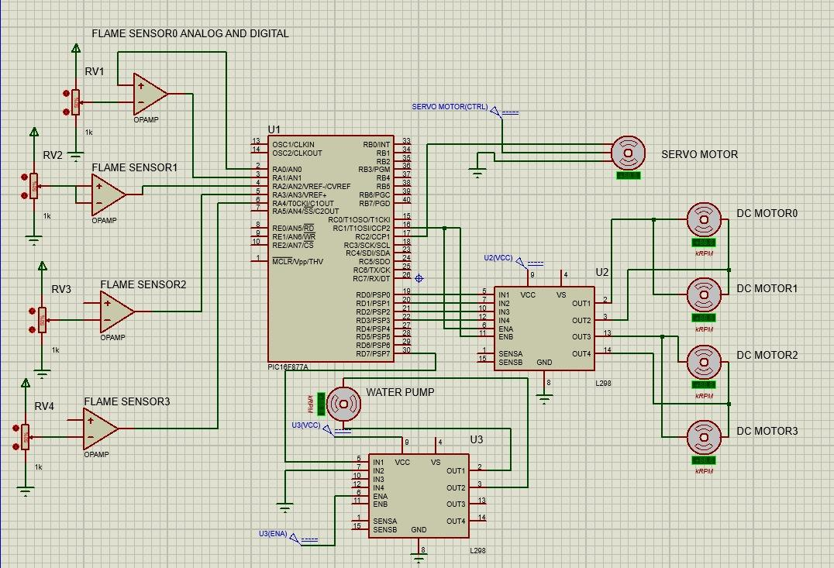

Figure 1: Schematic Design

### 2.4 MECHANICAL DESIGN

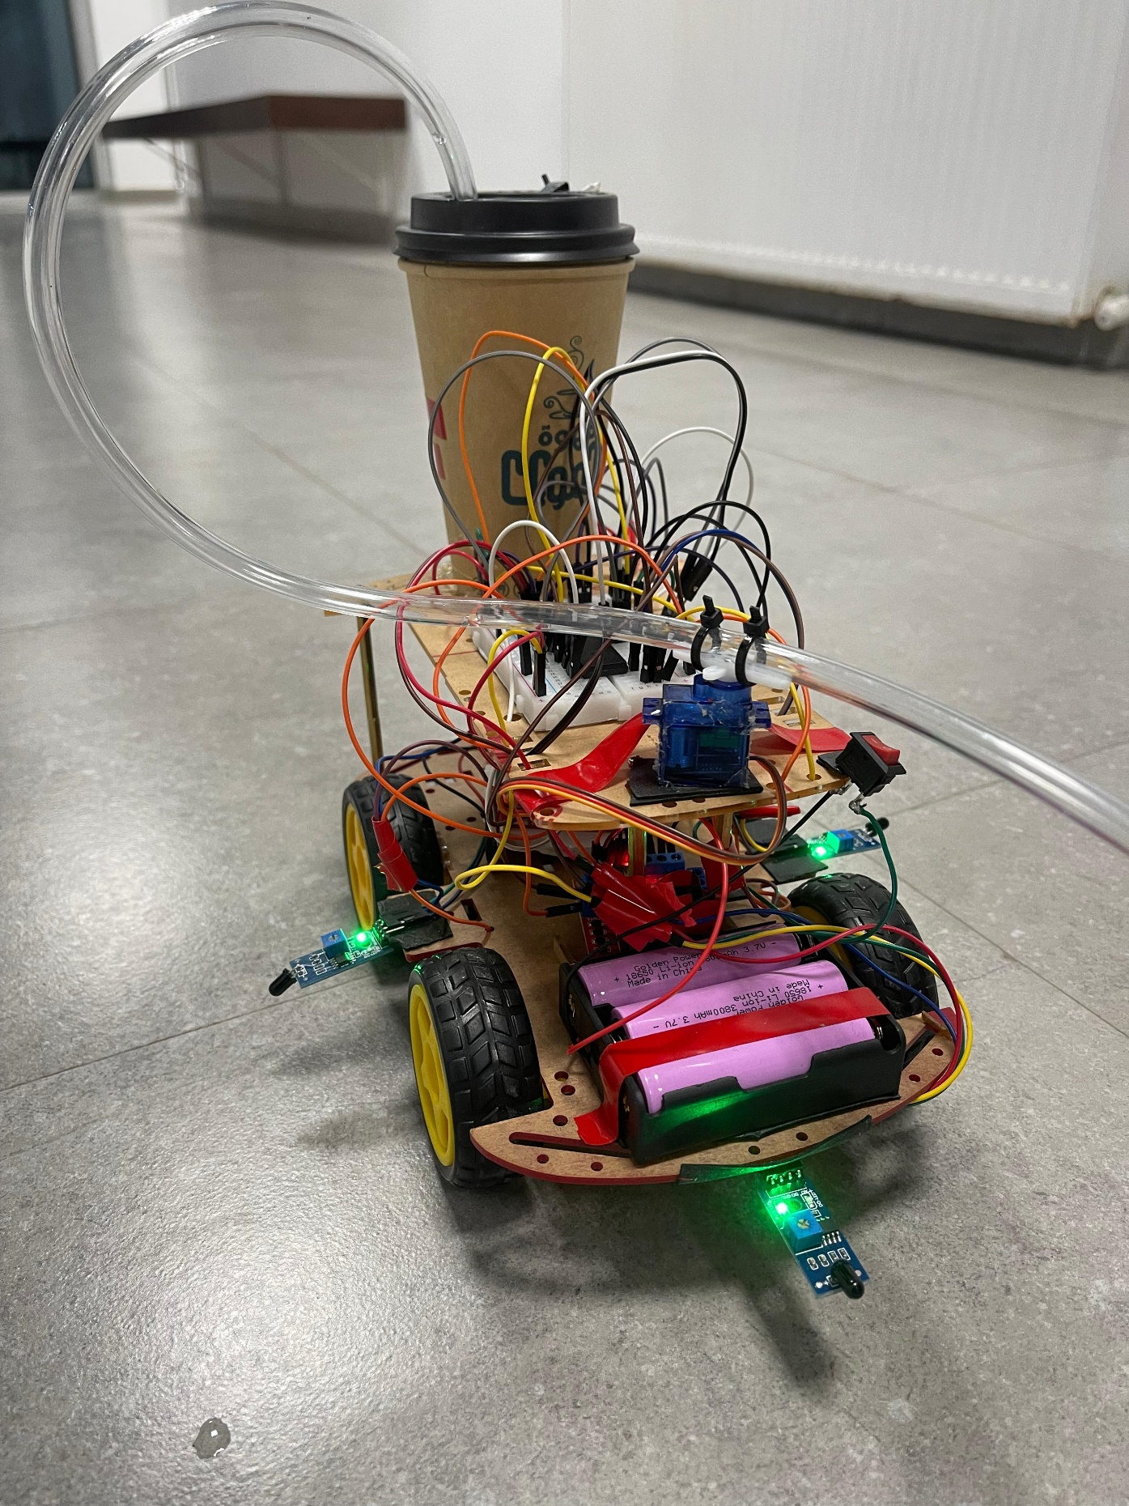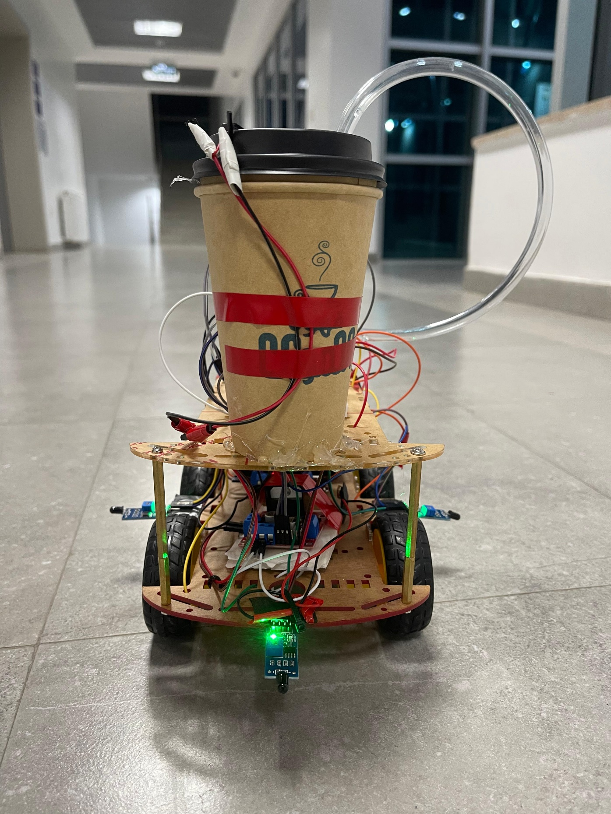

Figure 2: Front view

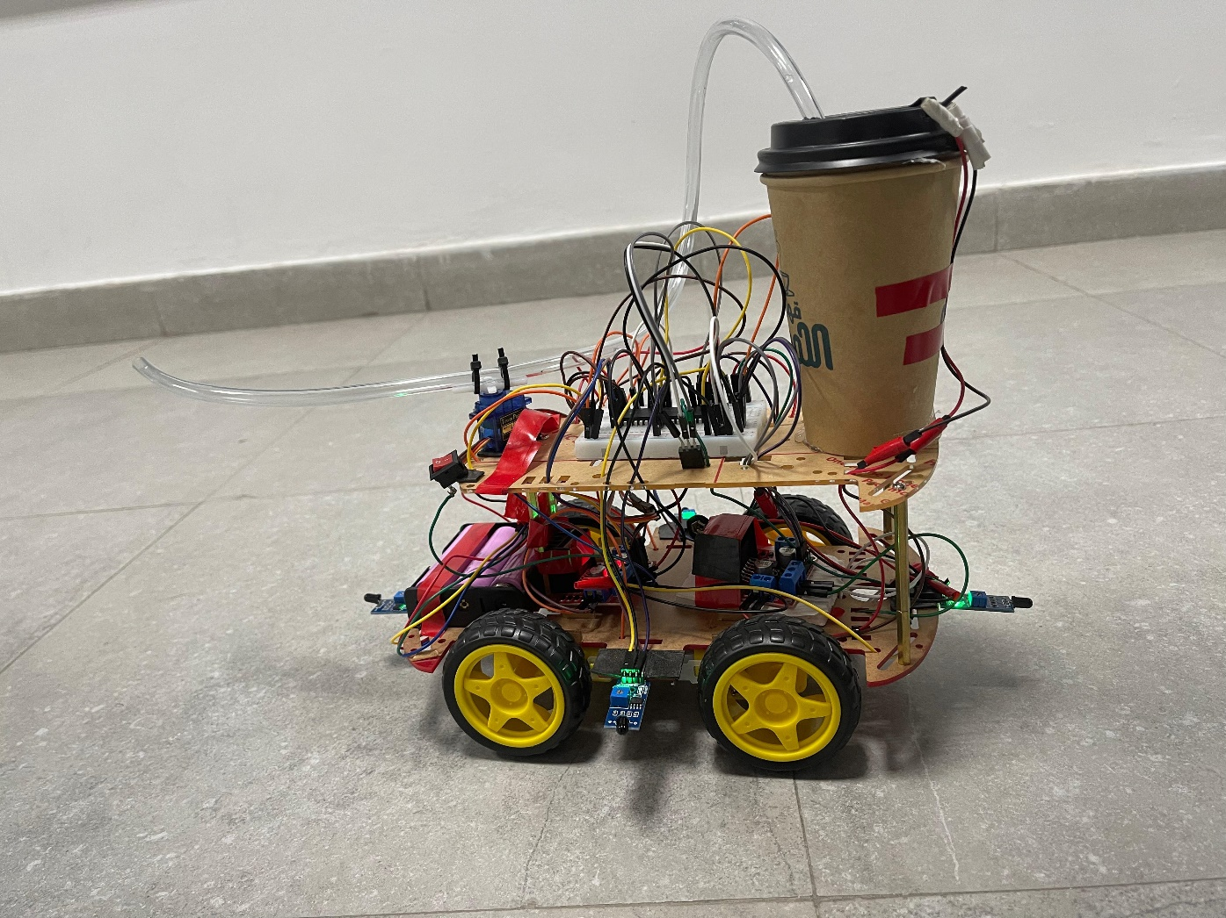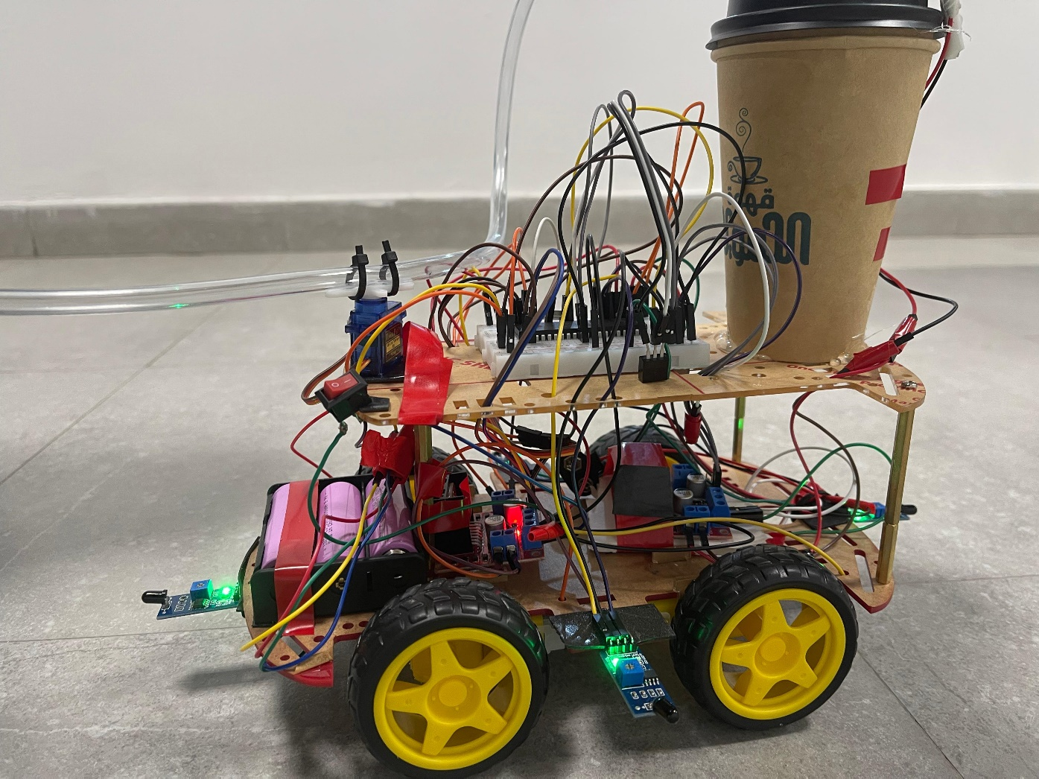

Figure 3: Left view

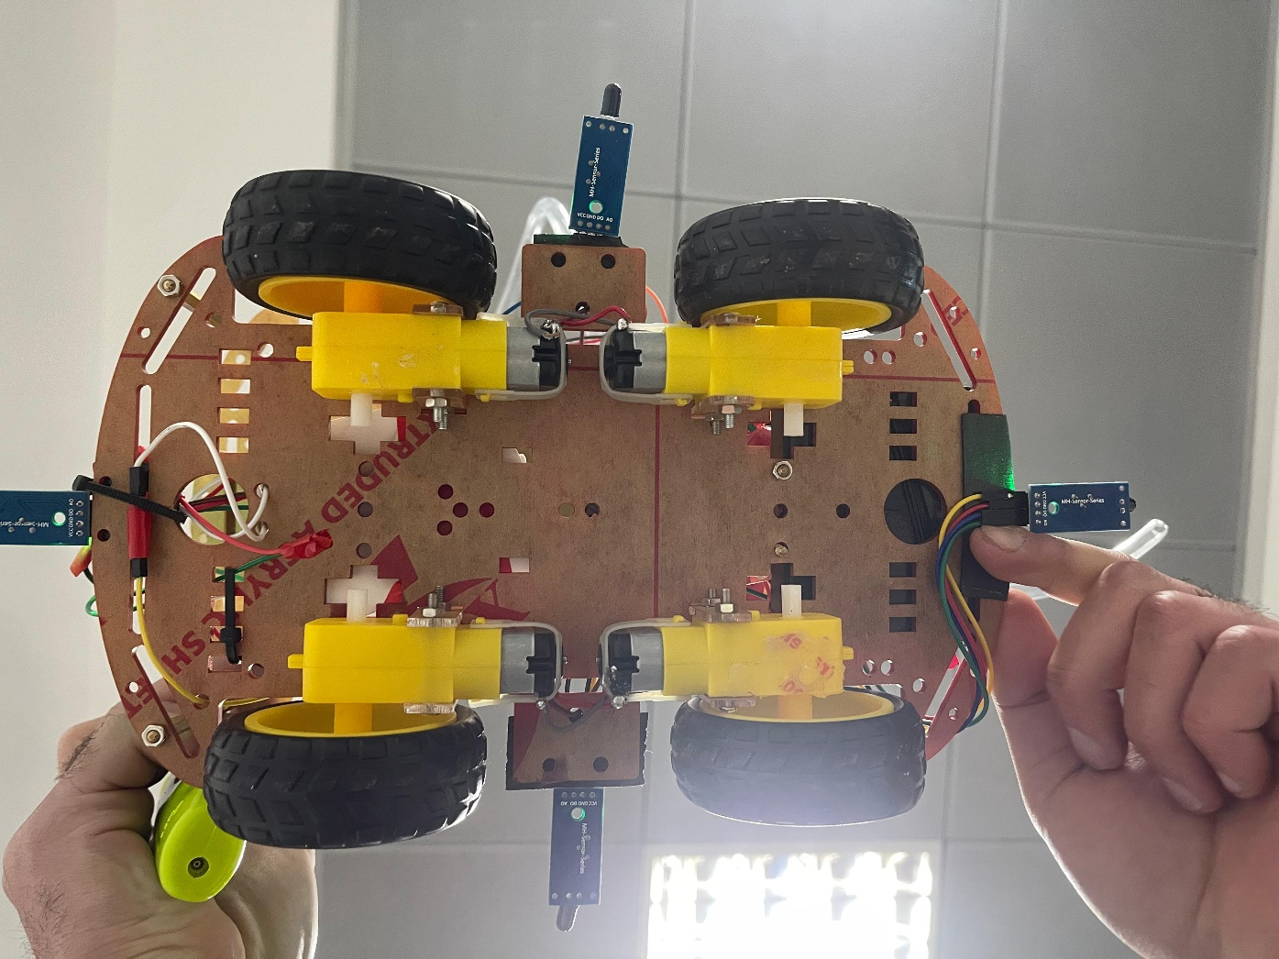

Figure 4: DC motors back



Figure 5: Servo motor

### 2.5 SOFTWARE DESIGN

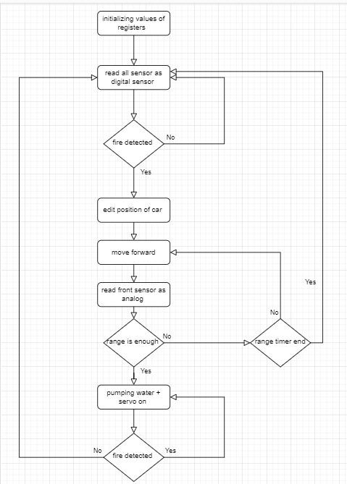

Figure 7: Flow Chart

# 3 PROBLEMS AND RECOMMENDATIONS

### 3.1 PROBLEMS

When we wrote individual codes for the flame sensor, servo motor, and robot movement, each code functioned correctly on its own. However, when we integrated them into a single code, issues arose. The primary challenge stemmed from the flame sensor, as it sometimes misinterpreted sunlight and room light, triggering false alarms.

Another issue we encountered was with the water pump activation timing. Initially, attempts to operate the pump without a relay or transistor were unsuccessful, and it remained unresponsive. This problem was resolved by incorporating a transistor.

Dealing with electrical components presented its own set of challenges. Although the code ran flawlessly on the easypic and the hardware was correctly connected on the breadboard, the robot failed to respond. It took us some time to identify that the Master Clear node on the breadboard was malfunctioning.

Additionally, when we attached a full water tank to the end of the robot's body, it became unbalanced and was on the verge of tipping backward. To address this issue, we added a tank-sized body to the opposite end to ensure balance.

### 3.2 RECOMMENDATIONS

There is significant potential for enhancing this design. With more extensive resources, the system could incorporate a mobile application and GPS navigation to reach fires beyond the flame sensor's range. Users could send the robot to specific locations through the mobile app. Additionally, the robot could be equipped to contact emergency services like 911 and transmit the location of large and uncontrollable fires.

# 4 CONCLUSIONS

In general, embedded systems effectively fulfill our objectives and contribute to simplifying our lives. Our design successfully met its goal by detecting fires from any direction and extinguishing them using the water pump. Through extensive testing, we gained valuable insights and learned from our mistakes, enabling us to enhance performance in future endeavors.