**Assignment : Design a " TV Sales / Selling"  e-commerce portal Homepage. It should contain following sections :-**  
a) Header  
b) Banner  
c) Popular products  
d) Testimonials  
e) Footer

1. **Header:**

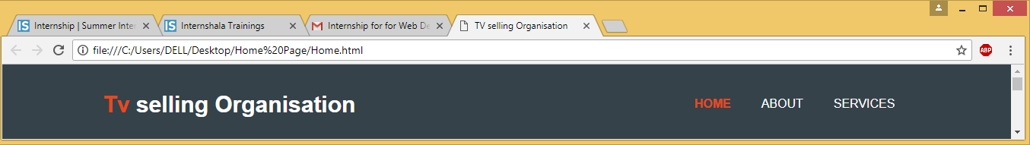

1. **Banner:**

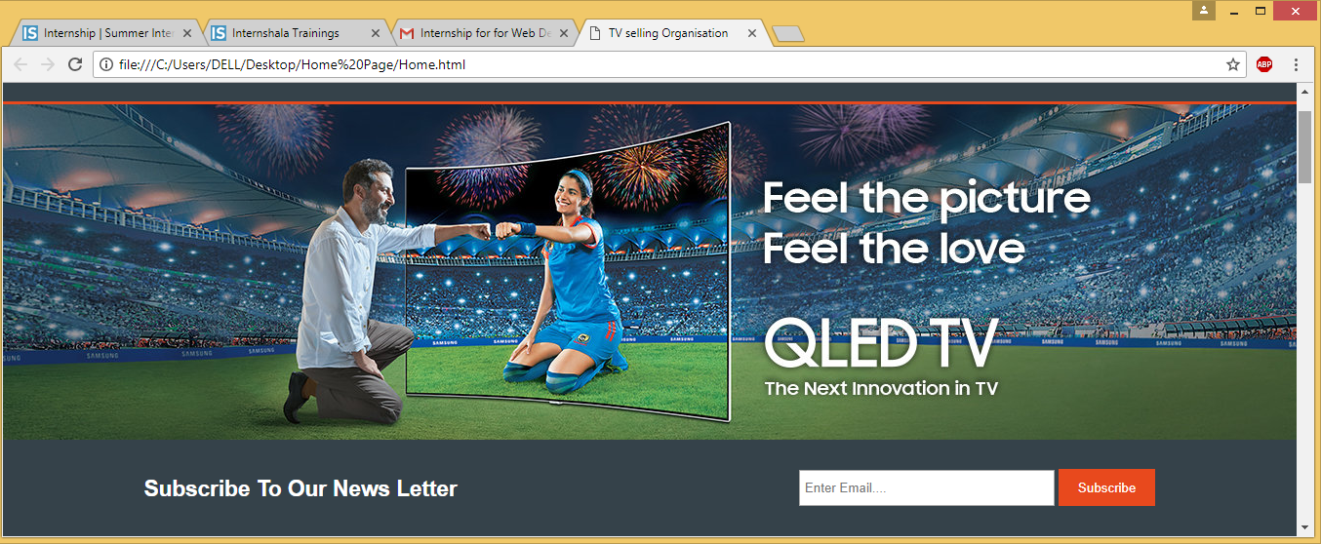

1. **Popular Products :**

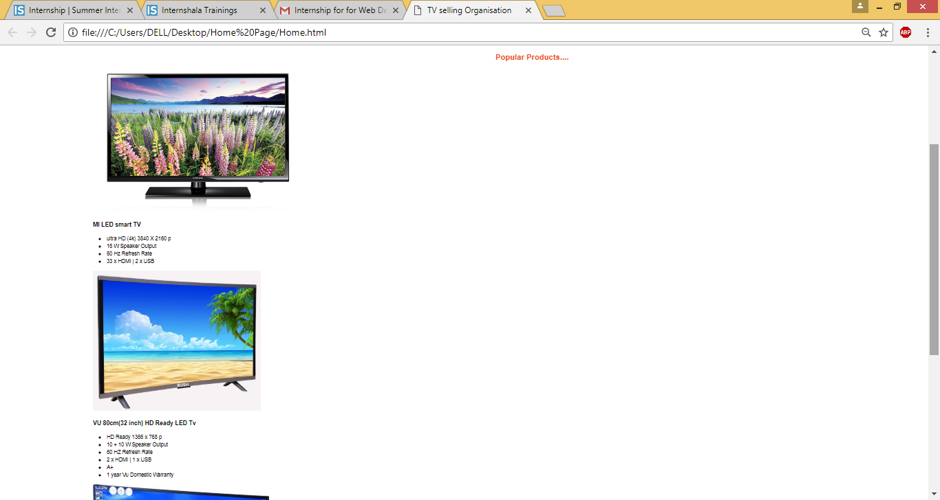

1. **Testimonials:**

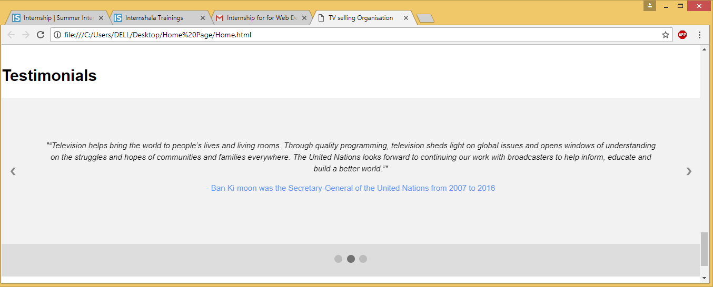

1. **Footer :**

