**UNIT 4 ACTIVITY 3 ASSIGNMENT**

**User Guide**

**UserGuide_Luo**

**July 23, 2018**

**Evan Luo**

**Teacher: Darian Leduchowski**

**Purpose of the program**

The purpose of this program is to teach a lesson about exponent laws, which are part of the grade 9 academic math curriculum. The main screen will provide a short opening to introduce the lesson and clarify certain definitions pertaining to exponents for the user. This application allows the user to read through the content of different lessons and do practice questions on the side of each lesson. Furthermore, this software has a ten-question quiz that users may take after reading through and learning the lessons. However, the above functions can be done in a traditional classroom; therefore, this application contains images that will appeal to the grade nine demographic and includes a greater sense of interaction than traditional math learning environments where students can learn at their own pace with automated marking and summary reports (during the quiz).

**Instructions on how to install and run the program**

**For those who need access to the source code (eg. Mr. Leduchowski),**

1. Unzip the TutorialApp.zip file by selecting “Extract All…”

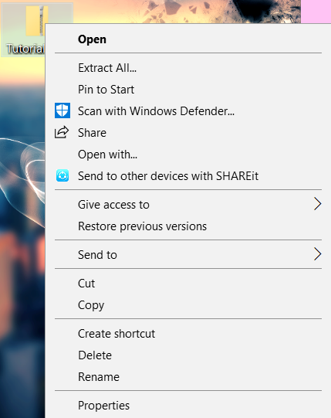

1. Open Netbeans IDE



1. File bar of Netbeans 🡪 Open Project…

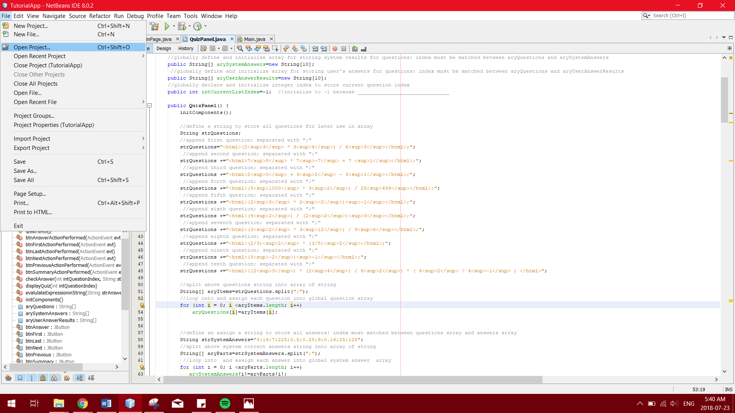

1. Select Tutorial App folder 🡪 TutorialApp again 🡪 “Open Project”

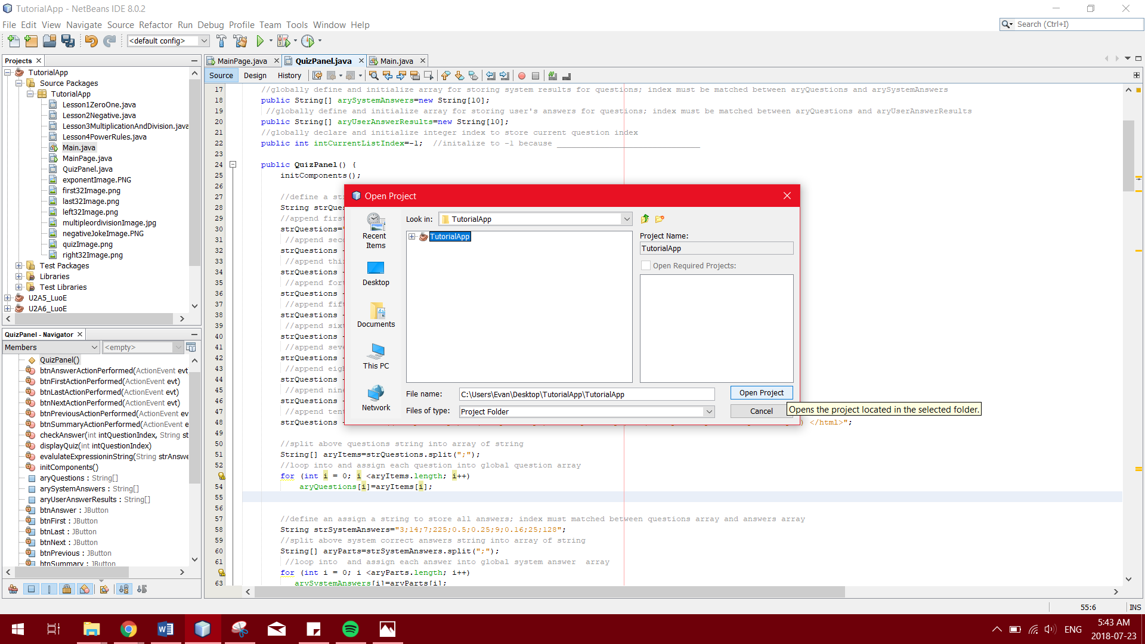

**For most regular users of this application (eg. Grade nine students),**

1. Unzip the TutorialApp.zip file by selecting “Extract All…”



1. Open TutorialApp (unzipped) folder 🡪 TutorialApp folder again

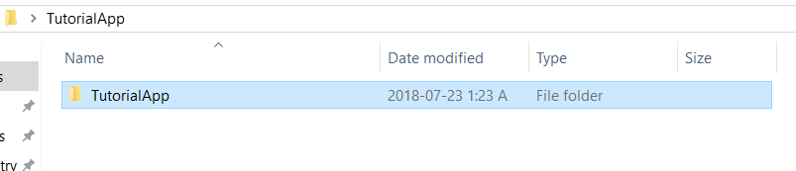

1. Open dist folder 🡪 TutorialApp Executable Jar File

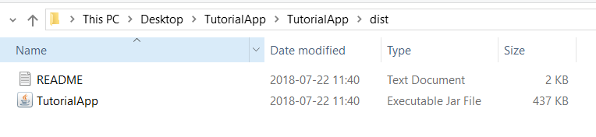  
NOTE: User must have a JRE (Java Runtime Environment) installed on their computer to open the Executable Jar File.

**How to use the program**

There are 3 main interfaces that users will navigate throughout the usage of this application: the main screen, the lesson screens, and the quiz screen.

When opening the application, the main window will appear before the user. The user will then read through the opening introducing the lesson, and the user will proceed to reading the lessons or taking the quiz. To do so, the user shall select their desired destination through the menu bar or the buttons on the main screen.

The MOST IMPORTANT NOTE to navigating and using the program is that multiple non-main windows cannot be opened at the same time. Therefore, it is necessary that one non-main window is closed before accessing another non-main window.

**THE MAIN WINDOW**  
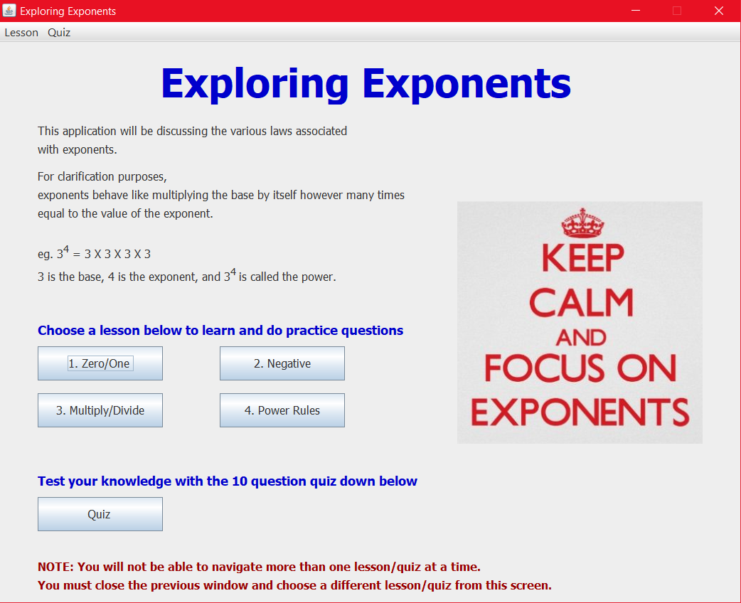

6

5

4

2

3

1

KEY FEATURES OF THE MAIN WINDOW

1. Opening of Lesson: introduces the lesson and clarifies any terms that may be needed

2. Menu Bar: user can select where they want to navigate through the menu bar items

3. Lesson Button: on user click, the button will display the corresponding lesson window

4. Quiz Button: on user click, the button will display the ten-question quiz window

5. Note: another reminder that multiple non-main windows cannot coexist

6. Exit Application “X”: unless user wants to exit application, do not click this “X”

***users have two options to open lessons/quiz, the menu bar or the buttons***

**THE LESSON WINDOW**On lesson windows, users read through the content and do the practice questions by selecting their preferred answers through the checkboxes, then submitting them.

*The following image is not a direct replica of Lessons 2, 3, and 4; however, the key features are the exact same with different content, questions, and a possible image.*

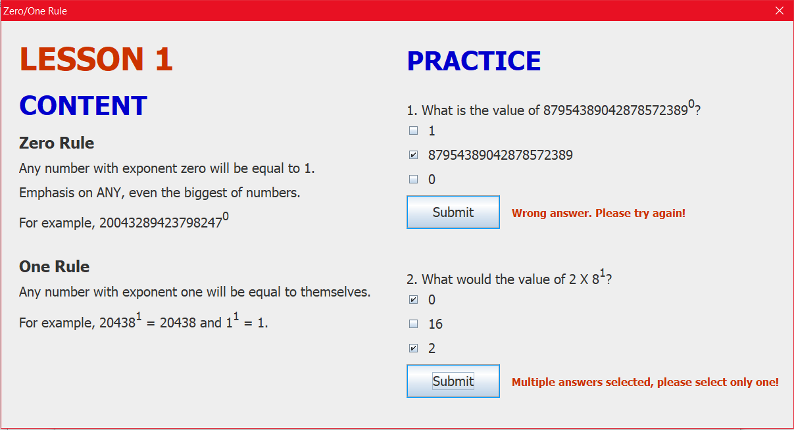

4

3

7

6

5

2

1

KEY FEATURES OF THE LESSON WINDOW

1. Lesson Number: indicates which lesson number that the user is on

2. Content of Lesson: material that user reads through to learn the lesson

3. Practice Question: questions that user will try to answer after reading through content

4. Multiple Choice Boxes: user will select their answer by checking the corresponding box to their desired answer

5. Submit Button: on user click, the button will display feature 6

6. Question Verdict: after the submit button has been clicked, a message will pop up according to the four different cases: answer is correct/incorrect, no answer has been selected, or multiple boxes have been checked.

7. Exit Window “X”: this is the only way for users to navigate to other non-main windows like Lesson 2 or the quiz (close window, then open from main)

**THE QUIZ WINDOW**

On the quiz window, users are testing their learning from reading the lessons and completing the practice questions in a final ten-question quiz on all the content from the lessons. Users will have to input their answers into the answer fields and save their answers to see if they were right or wrong for that question. They also have the option to see a summary report of their quiz at any moment, showing the user’s number of correct answers, incorrect answers, and unanswered questions. Users can navigate through the quiz using the action buttons; therefore, it allows users to revisit or skip questions during the quiz.

*The image of the quiz window down below is for the first question, it will have slight differences in its appearance from question to question (eg. summary report or the question itself)*

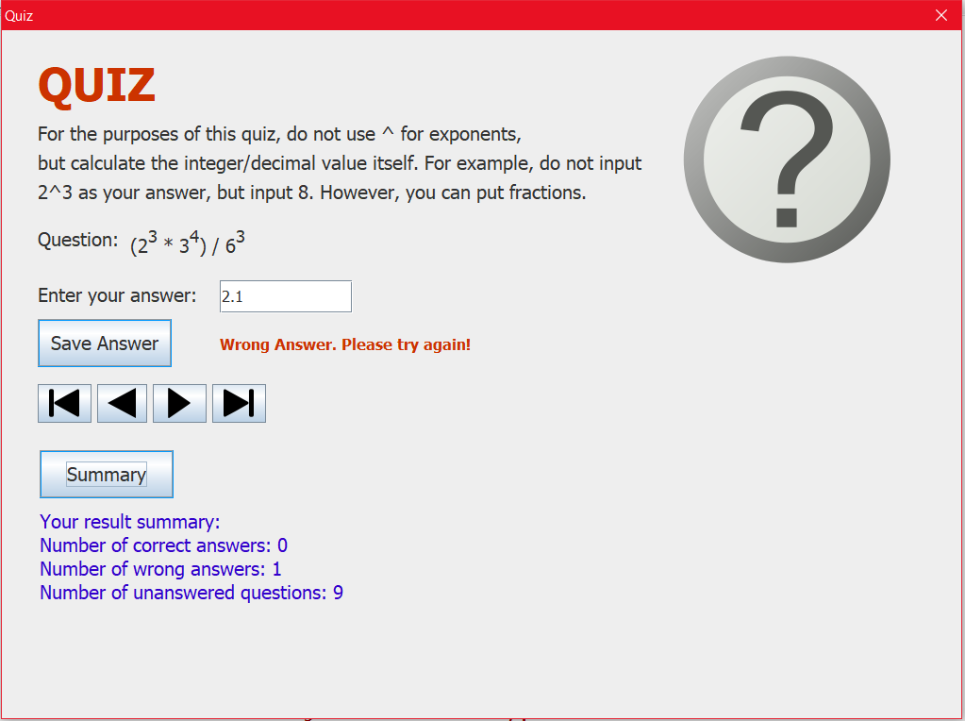

9

8

7

6

5

4

3

2

1

KEY FEATURES OF THE QUIZ WINDOW

1. Warning: message telling users to not use “^” to indicate exponents, but to simply use the integer or decimal values of those powers / fractions are allowed

2. Quiz Question: this is the question that the user attempts to solve

3. Answer Field: user inputs their answer into this text field

4. Save Answer Button: saves answer into the result summary and displays verdict

5. Verdict Message: will either display incorrect answer or correct answer message after save answer button has been clicked

6. Action Buttons: from left to right, will send user back to first question,

 will send user to previous question, will send user to next question, and will send user to last question

7. Summary Button: on user click, it will present user with updated summary report

8. Summary Report: will display current summary of the quiz’s progression from correct answers to incorrect answers to unanswered questions

9. Exit Window “X”: this is the only way for users to navigate to other non-main windows like the lessons (close window, then open from main)

*This marks the end of the user guide.*

Hope you enjoy using the Exploring Exponents software!