# A Virtual Pet in Scratch – Mark Scheme

1. Create a Function to kill the pet– students successfully create a function that when called causes a pet-death simulation.
   1. Function block used – 1 mark
   2. Script within function to simulate death – 1 mark

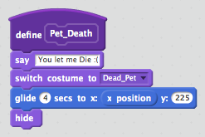

1. Use a Variable and a loop to track Pet_Hunger
   1. Create a variable to store Pet_hunger – 1 mark
   2. Use a “repeat until” loop to – 1 mark
   3. Pet_Hunger is altered within the loop – 1 mark
   4. Pet_Death is called once the loop is terminated – 1 mark

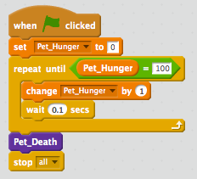

1. Altering Pet_hunger
   1. Create a new Sprite to represent food – 1mark
   2. Create a script that alters Pet_Hunger when the sprite is clicked – 1 mark

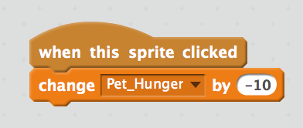

1. Independently use a Variable and a loop.
   1. Create a variable to store Pet_Tiredness – 1 mark
   2. Use a “repeat until” loop to – 1 mark
   3. Pet_Tiredness is altered within the loop – 1 mark
   4. Pet_Death is called once the loop is terminated – 1 mark

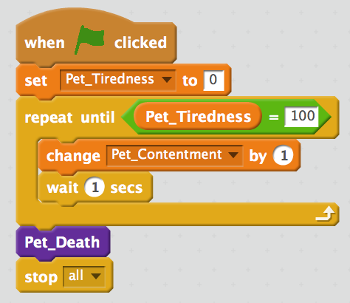

1. Using a list
   1. Function block used – 1 mark
   2. List created containing at least 5 strings – 1mark
   3. Random number used to pick an item from the list. – 1mark

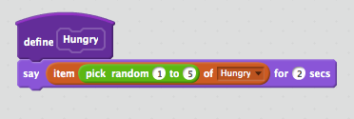

1. Customisation – up to 5 marks to be awarded for script customisations. Teacher discretion.

Examples might include:

* 1. Altering “repeat until” loops to allow for varied times for different events. – 1 mark
  2. Creating additional events such as movement of the pet in response to changes in variable values – 2 marks
  3. Using additional lists to produce a greater variety of pet responses to variable changes – 2 marks

Total – 20 marks