

**Faculty of Engineering and Technology**

**Electrical and Computer Engineering Department**

**Computer Design Lab**

**ENCS4110**

**Experiment No. 4**

**ARM Addressing Modes**

Prepared by:

**Abdel Rahman Shahen** **1211753**

Partners:

 no partners

Instructor: Dr. Abdel Salam Sayyad

Teaching assistant: Eng. Hanan Awawdeh

Section: 5

Date: 11/17/2023

# 

# **Abstract**

Employing a theoretical framework to investigate the Register Addressing Mode, Register Indirect Addressing Mode, ARM's Autoindexing Pre-Indexed Addressing Mode, ARM's Autoindexing Post-Indexing Addressing Mode, and the Program Counter Relative (PC Relative) Addressing Mode. The primary objectives of this study are to elucidate the operational principles and advantages of each addressing mode within the ARM architecture. Key findings reveal the versatility of these modes in facilitating efficient memory access, with a particular emphasis on the dynamic autoindexing capabilities. The significance of these results lies in their direct impact on optimizing code execution and enhancing overall program performance. In conclusion, this research provides a nuanced understanding of ARM addressing modes, empowering programmers with essential insights for effective utilization in ARM architecture development.

# **Table of Contents**

**Abstract** I

**Table of Contents** II

**Table of Figures** VI

**1.Theory** 1

**1.1 ARM addressing modes** 1

**1.1.1** **Literal Addressing Mode** 1

**1.1.2** **Register Indirect Addressing Mode** 1

**1.1.3** **ARM's Autoindexing Pre-indexed Addressing Mode** 2

**1.1.4** **ARM's Autoindexing Post-indexing Addressing Mode** 3

**1.1.5** **Program Counter Relative (PC Relative) Addressing Mode** 3

**1.2** **ARM's Load and Store Encoding Format** 5

**2. Procedure and Discussion:** 6

**2.1 An Example Program of Using Post-indexing Mode** 6

**2.1.1 Code:** 6

**2.1.2 Results:** 7

**2.1.3 Result’s Discussion:** 7

**2.2 An example to count the number of chars in a string** 7

**2.2.1 Code:** 7

**2.2.2 Results:** 8

**2.2.3 Result’s Discussion:** 8

**2.3 Lab Work Exercises:** 9

**2.3.1 Exercise 1:** 9

**2.3.2 code:** 9

**2.3.3 Results:** 10

**2.3.4 Result’s Discussion:** 10

**2.4.1 Exercise 2:** 11

**2.4.2 code:** 11

**2.4.3 Results:** 12

**2.4.4 Result’s Discussion:** 12

**2.5.1 Exercise to Do:** 13

**2.5.2 code :** 13

**2.5.3 Results:** 14

14

**2.5.4 Result’s Discussion:** 14

**Conclusion:** 15

# **Table of Figures**

Fig. 1: Literal Addressing Mode observation 1

Fig. 2: Register Indirect Addressing Mode observation…………………………………………………………………………….2

Fig. 3: Autoindexing Pre-indexed Addressing Mode observation……………………………………………………………..2

Fig. 4: Autoindexing Post-indexing Addressing Mode observation…………………………………………………………..3

Fig. 5: (PC Relative) Addressing Mode……………………………………………………………………………………………………..3

Fig. 6: ARM’s load and store encoding format…………………………………………………………….4

Fig. 7 example 1 Result………………………………………………………………………………………….……..6

Fig. 8 example 2 Result…………………………………………………………………………………………….…..7

Fig. 9 lap work 1 Result………………………………………………………………………………………………..9

Fig. 10 lap work 2 Result……………………………………………………………………………………………..11

Fig. 11 to do result……………………………………………………………………………………………………13

Fig. 12 a summary for the addressing modes…………………………………………………………………………14

# **1.Theory**

# **1.1 ARM addressing modes**

There are different ways to specify the address of the operands for any given operations such as load, add or branch. The different ways of determining the address of the operands are called addressing modes. In this lab, we are going to explore different addressing modes of ARM processor and learn how all instructions can fit into a single word (32 bits).

### **Literal Addressing Mode**

The immediate or literal addressing mode is where a literal number appears as a parameter to an instruction.

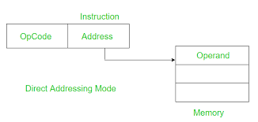

Fig. 1: Literal Addressing Mode observation

Example: MOV R0, #15

### **Register Indirect Addressing Mode**

Register indirect addressing means that the location of an operand is held in a register. It is also called indexed addressing or base addressing.

Register indirect addressing mode requires three read operations to access an operand. It is very important because the content of the register containing the pointer to the operand can be modified at runtime. Therefore, the address is a variable that allows the access to the data structure like arrays.

• Read the instruction to find the pointer register

• Read the pointer register to find the operand address

• Read memory at the operand address to find the operand

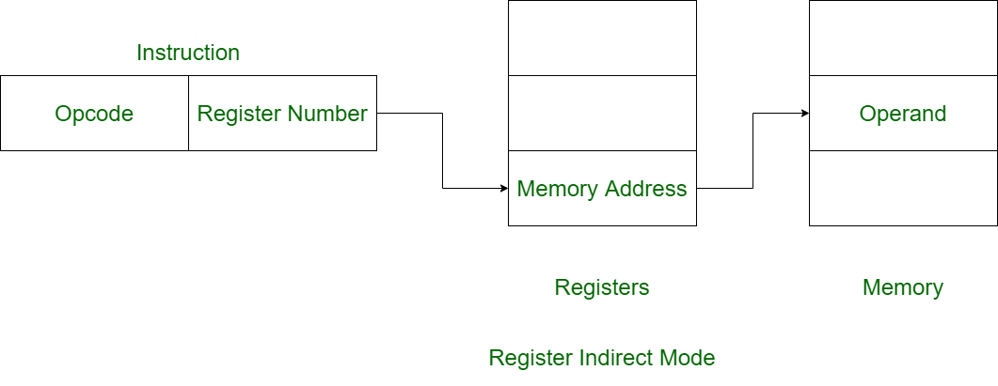

Fig. 2: Register Indirect Addressing Mode observation

Example: LDR R2, [R0]; Load R2 with the word pointed by R0

ARM supports a memory-addressing mode where the effective address of an operand is computed by adding the content of a register and a literal offset coded into load/store instruction.

Example:

LDR R0, [R1, #20]; R1 + 20; loads R0 with the word pointed at by R1+20

### **ARM's Autoindexing Pre-indexed Addressing Mode**

This is used to facilitate the reading of sequential data in structures such as arrays, tables, and vectors. A pointer register is used to hold the base address. An offset can be added to achieve the effective address.

Example:

LDR R0, [R1, #4]! R1 + 4; loads R0 with the word pointed at by R1+4; then update the pointer by adding 4 to R1

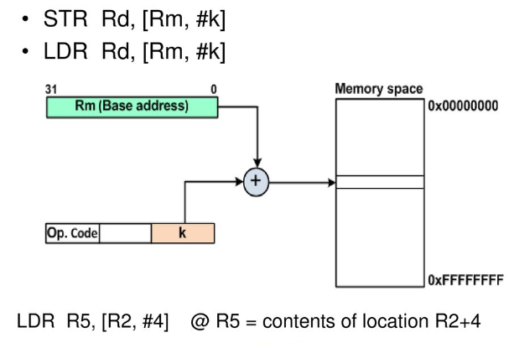

Fig. 3: Autoindexing Pre-indexed Addressing Mode observation

### **ARM's Autoindexing Post-indexing Addressing Mode**

This is similar to the above, but it first accesses the operand at the location pointed by the base register, then increments the base register.

Example:

LDR R0, [R1], #4 R1; loads R0 with the word pointed at by R1; then update the pointer by adding 4 to R1

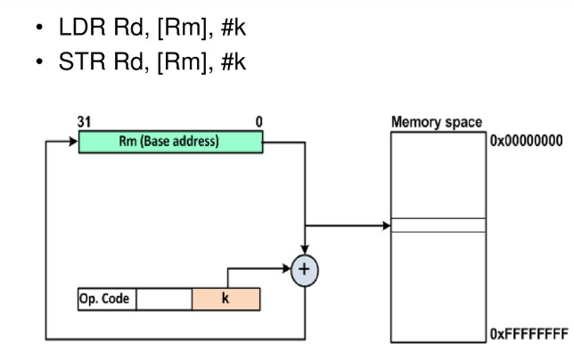

Fig. 4: Autoindexing Post-indexing Addressing Mode observation

### **Program Counter Relative (PC Relative) Addressing Mode**

Register R15 is the program counter. If you use R15 as a pointer register to access operand, the resulting addressing mode is called PC relative addressing. The operand is specified with respect to the current code location.

Example:

LDR R0, [R15, #24] R15 + 24; loads R0 with the word pointed at by R15+24

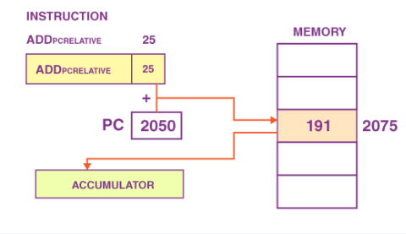

Fig. 5: **(PC Relative) Addressing Mode**

## **ARM's Load and Store Encoding Format**

The following picture illustrates the encoding format of the ARM's load and store instructions, which is included in the lab material for your reference. Memory access operations have a conditional execution field in bit 31, 03, 29, and 28. The load and store instructions can be conditionally executed depending on a condition specified in the instruction.

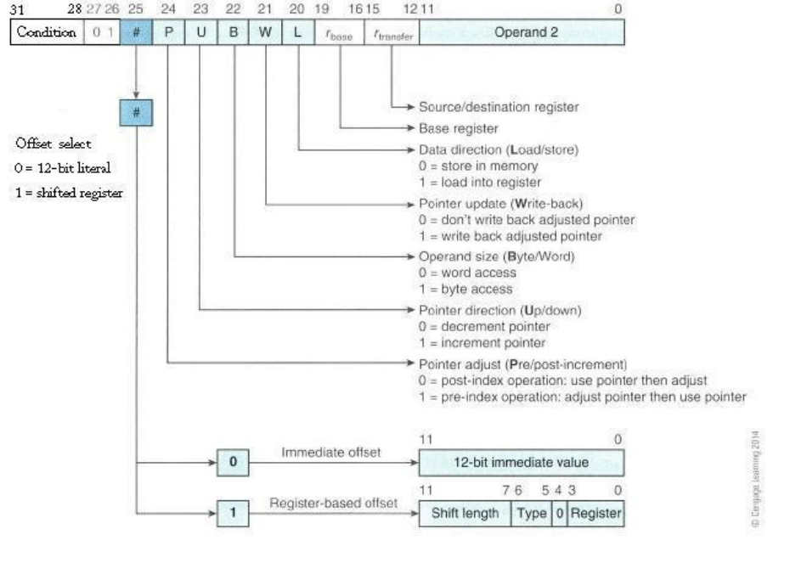

Fig. 6**: ARM’s load and store encoding format**

# **2. Procedure and Discussion:**

## **2.1 An Example Program of Using Post-indexing Mode**

### **2.1.1 Code:**

**Code Snippet 1:** ARM Assemble Code for Using Post-indexing Mode

PRESERVE8

THUMB

AREA RESET, DATA, READONLY

EXPORT __Vectors

__Vectors

DCD 0x20001000

DCD Reset_Handler

ALIGN

SUMP DCD SUM

N DCD 5

NUM1 DCD 3, -7, 2, -2, 10

POINTER DCD NUM1

AREA MYRAM, DATA, READWRITE

SUM DCD 0

AREA MYCODE, CODE, READONLY

ENTRY

EXPORT Reset_Handler

Reset_Handler

LDR R1, N

LDR R2, POINTER

MOV R0, #0

LOOP

LDR R3, [R2], #4

ADD R0, R0, R3

SUBS R1, R1, #1

BGT LOOP

LDR R4, SUMP

STR R0, [R4]

LDR R6, [R4]

STOP

B STOP

END

### **2.1.2 Results:**

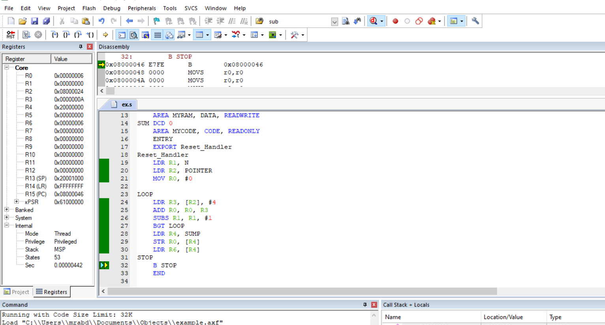

Fig. 7 example 1 Result

### **2.1.3 Result’s Discussion:**

The code calculates the sum of elements in the array NUM1 using a loop. The result is stored in memory, specifically at the location pointed to by SUMP.

## **2.2 An example to count the number of chars in a string**

### **2.2.1 Code:**

**Code Snippet 2**:  ARM Assemble Code for counting the number of chars in a string

PRESERVE8

THUMB

AREA RESET, DATA, READONLY

EXPORT __Vectors

__Vectors

DCD 0x20001000

DCD Reset_Handler

ALIGN

string1

DCB "Hello world!",0

AREA MYCODE, CODE, READONLY

ENTRY

EXPORT Reset_Handler

Reset_Handler

LDR R0, = string1

MOV R1, #0

loopCount

LDRB R2, [R0], #1

CBZ R2, countDone

ADD R1, #1;

B loopCount

countDone

B countDone

END

### **2.2.2 Results:**

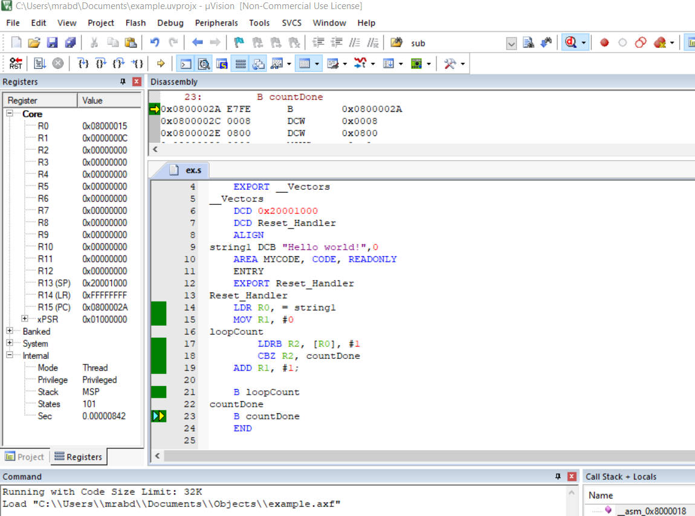

Fig. 8 example 2 Result

### **2.2.3 Result’s Discussion:**

The code initializes a string, "Hello world!", and counts the number of characters in the string. The result is stored in register R1.

## **2.3 Lab Work Exercises:**

### **2.3.1 Exercise 1:**

### Write an ARM assembly language program AddGT.s to add up all the numbers that are great than 5 in the number array NUM1.

### **2.3.2 code:**

**Code Snippet 3**  : ARM Assemble Code for to add up all the numbers that are great than 5 in the number array

PRESERVE8

THUMB

AREA RESET, DATA, READONLY

EXPORT __Vectors

__Vectors

DCD 0x20001000 ; stack pointer value when stack is empty

DCD Reset_Handler ; reset vector

ALIGN

SUM DCD 0

SUMP DCD SUM

N DCD 7

NUM1 DCD 3, -7, 2, -2, 10, 20, 30

POINTER DCD NUM1

AREA MYCODE, CODE, READONLY

ENTRY

EXPORT Reset_Handler

sub_Add PROC

ADD R4,R4,R3 ; R4+=R3

BX LR ; branch to LR

Reset_Handler

MOV R4,#0; R4 to save the sum

LDR R0, = NUM1 ; R0 holds the array

MOV R1,#7 ; R1 hold the array's size

loop ;{ loop to iterate along the array

LDR R3,[R0],#4 ; R3=R1[i]

CMP R3,#5 ; R3>5?

BLGT sub_Add ;if (R3 > 5 ) sub_ADD

SUBS R1,R1,#1 ; i-- , s: change zero flag

BNE loop ; (if R1==0) branch to loop

STOP

B STOP

END

### **2.3.3 Results:**

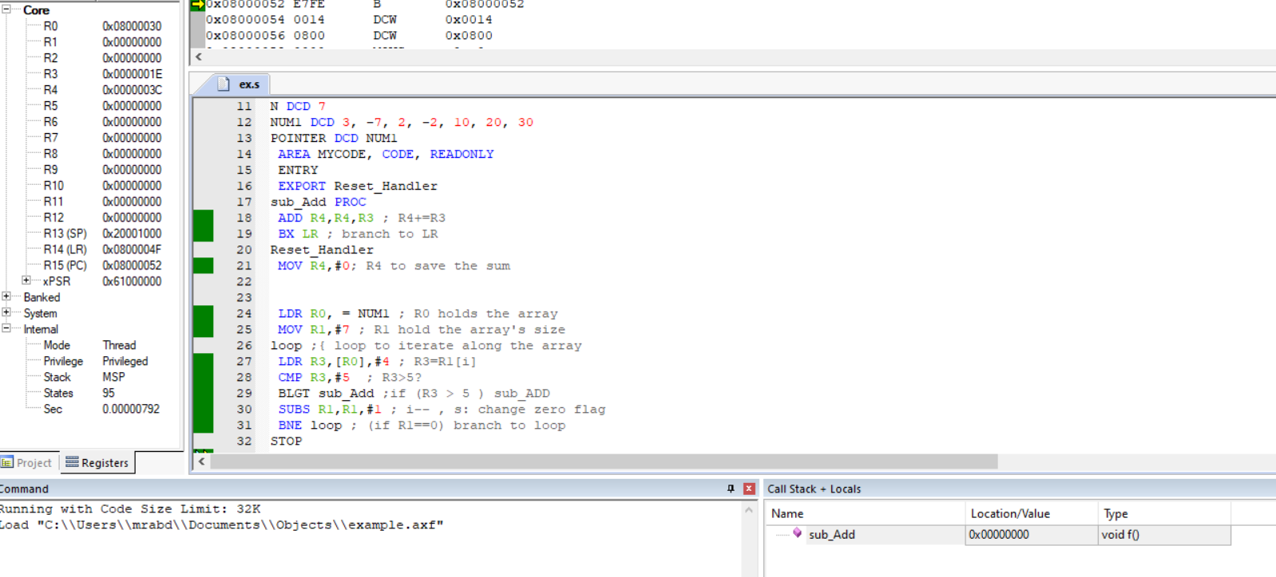

Fig. 9 lap work 1 Result

### **2.3.4 Result’s Discussion:**

The code initializes a sum variable, iterates through an array, and accumulates elements greater than 5 using a subroutine. The sum is stored in memory, providing a specialized arithmetic operation for qualifying array elements. Verification involves inspecting the memory location specified by SUMP or the final sum. The code structure indicates a controlled arithmetic operation tailored to specific conditions within the array.

As you can see the result in R4 = to 16*3 + 12 = 60

And if you add 10 + 20 + 30 which equals 60 you will see that the code works properly.

### **2.4.1 Exercise 2:**

Write an ARM assembly language program Min-Max.s to find the maximum value and the minimum value in the number array NUM1.

### **2.4.2 code:**

**Code Snippet 4**: ARM Assemble Code for to find min and max in an array

PRESERVE8

THUMB

AREA RESET, DATA, READONLY

EXPORT __Vectors

__Vectors

DCD 0x20001000 ; stack pointer value when stack is empty

DCD Reset_Handler ; reset vector

ALIGN

SUM DCD 0

SUMP DCD SUM

N DCD 7

NUM1 DCD 3, -7, 2, -2, 10, 20, 30

POINTER DCD NUM1

AREA MYCODE, CODE, READONLY

ENTRY

EXPORT Reset_Handler

Reset_Handler

MOV R4,#0; R4 to save the min

MOV R5,#0; R5 to save the max

LDR R0, = NUM1 ; R0 holds the array

MOV R1,#7 ; R1 hold the array's size

LDR R3,[R0],#4 ; R3=arr[0]

MOV R4,R3; R4 = arr[0]

MOV R5,R3; R5 = arr[0]

SUBS R1,R1,#1

loop ;{ loop to iterate along the array

LDR R3,[R0],#4 ; R3=arr[i]

CMP R3,R4;

MOVLT R4,R3; if (arr[i] < R4 ) R4 = arr[i];

CMP R3,R5;

MOVGT R5,R3; if (arr[i] > R5) R5 = arr[i]

SUBS R1,R1,#1 ; i-- , s: change zero flag

BNE loop ; (if R1==0) branch to loop

STOP

B STOP

END

### **2.4.3 Results:**

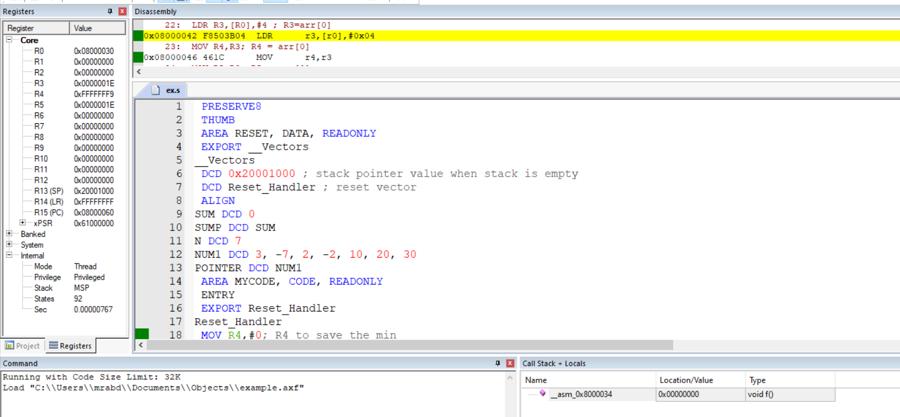

Fig. 10 lap work 2 Result

### **2.4.4 Result’s Discussion:**

The ARM assembly code finds the minimum and maximum values in the array NUM1. It initializes variables (R4 for min ,R5 for max) and iterates through the array, updating min and max values accordingly. The final min and max are stored in memory, providing an efficient algorithm for array extremum identification. Verification involves inspecting the memory location specified by Sump for the min and max values. The code structure showcases a systematic approach to identifying extremum values in an array.

As you can see the minimum value is -7 and it’s saved in R4

And the maximum value is 30 and it’s saved in R5

## **2.5.1 Exercise to Do:**

Write an ARM assembly program to sort an array of integers. The sorted array should be stored in memory.

### **2.5.2 code :**

PRESERVE8

THUMB

AREA RESET, DATA, READONLY

EXPORT __Vectors

__Vectors

DCD 0x20001000 ; stack pointer value when stack is empty

DCD Reset_Handler ; reset vector

ALIGN

size DCD 6

AREA RESET,DATA,READWRITE

array DCD 3,5,4,12,7,9

AREA MYCODE, CODE, READONLY

ENTRY

EXPORT Reset_Handler

Reset_Handler

LDR R0, =array

LDR R1, =size

LDR R1, [R1]

loop1

MOV R2, #0

MOV R3, R1

loop2

LDR R4, [R0]

LDR R5, [R0, #4]

CMP R4, R5

BLE noSwap

; Swap elements

STR R5, [R0]

STR R4, [R0, #4]

MOV R2, #1

noSwap

ADD R0, R0, #4

SUBS R3, R3, #1

BNE loop2

SUBS R1, R1, #1

TST R2, #1

BNE loop1

STOP

B STOP

END

### **2.5.3 Results:**

### 

**Fig. 11 to do result**

### **2.5.4 Result’s Discussion:**

The provided ARM assembly code employs the Bubble Sort algorithm to arrange an array in ascending order. Utilizing nested loops, it compares adjacent elements and swaps them if necessary. The process iterates until the entire array is sorted, with the result visible in the memory.

But the problem that I not able to see a reason why the memory array elements are not changing

This problem caused to the array not the get sorted.

# **Conclusion:**

In the exploration of addressing modes, we delved into the mechanisms by which processors access operands during instruction execution. Direct addressing involved specifying the memory address directly in the instruction, offering simplicity but limiting flexibility. Register addressing utilized processor registers for operand storage, enhancing speed. Indirect addressing allowed referencing memory locations indirectly through pointers, enabling dynamic data manipulation. Additionally, immediate and indexed addressing modes offered distinct advantages. This experiment illuminated the nuanced choices in addressing modes, showcasing their impact on program efficiency, adaptability, and the intricate balance between simplicity and complexity in designing effective instruction sets for diverse computing tasks.

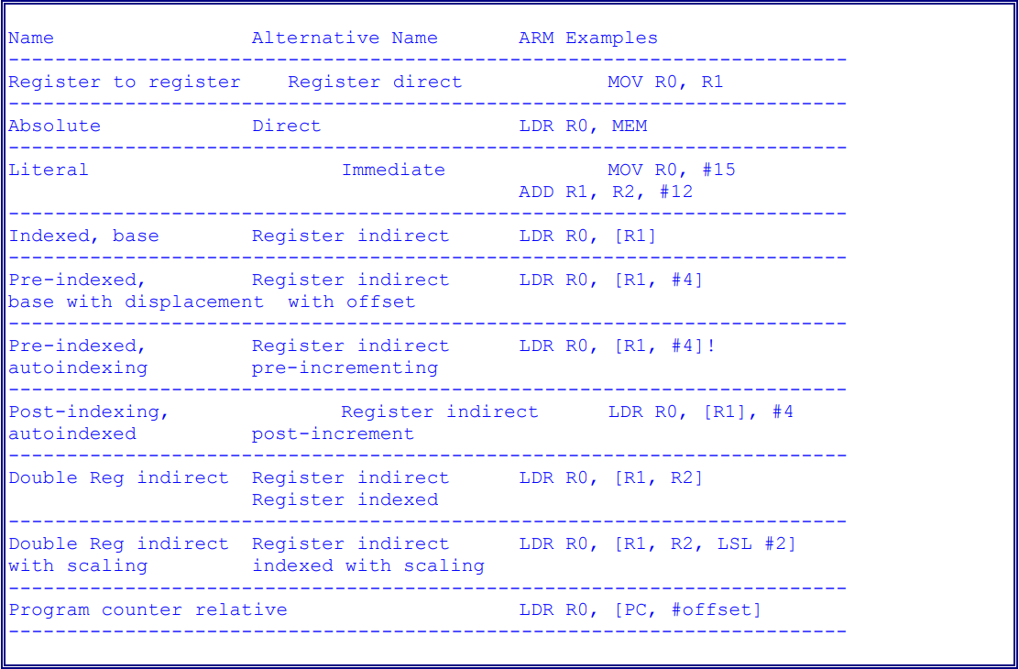

Fig. 12 a summary for the addressing modes

**References:**

[1]: Manual for Computer Design Lab, 2023, Birzeit University.