

**Faculty of Engineering and Technology**

**Electrical and Computer Engineering Department**

**Computer Communication Lab**

**ENEE 4113**

**Experiment No. 1 pre-lab**

**Normal Amplitude Modulation**

Prepared by:

**Abdel Rahman Shahen** **1211753**

Partners:

 Mahmoud Awad

Instructor: Dr. Ashraf Rimawi

Section: 2

Date: 3/6/2024

# **Title: Theoretical Analysis of** **Normal Amplitude Modulation and Demodulation**

## **Introduction:**

This prelab report delves into the theoretical foundations of Normal Amplitude Modulation (AM) and Demodulation, pivotal techniques in the realm of communications for transmitting and retrieving information over varying distances

## **Objective:**

To explore and articulate the theoretical and mathematical concepts of Normal Amplitude Modulation and Demodulation, elucidating the principles and equations that define their operation.

## **Theoretical Background:**

### **Normal Amplitude Modulation (AM):**

#### **Definition and Principles:**

AM is a technique used in electronic communication, primarily for transmitting audio and video signals through a carrier wave. The basic principle involves varying the strength (amplitude) of the carrier wave in direct proportion to that of the signal wave, without altering the carrier's frequency.

#### **Mathematical Representation:**

The mathematical formula for a modulated signal can be represented as:

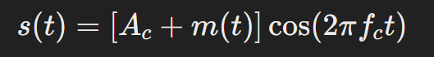

where:

s(t) is the AM signal,

Ac is the amplitude of the carrier wave,

m(t) represents the message or information signal,

fc is the frequency of the carrier wave, t is time.

#### **Spectrum of AM Wave:**

An AM wave consists of a carrier and two sidebands. The spectrum can be analyzed to show these components, with the sidebands containing the actual information being transmitted.

#### **Modulation Index:**

The modulation index (m) is a key concept in AM, defined as the measure of the extent of modulation applied to the carrier wave.

#### **Power Distribution in AM:**

The total power of an AM signal is distributed among the carrier and the sidebands.

### **Demodulation of AM Waves:**

#### **Envelope Detector:**

The envelope detector is a simple, commonly used method for demodulating AM signals. It captures the variations in the envelope of the modulated signal, which corresponds to the original message signal.

#### **Coherent demodulation:**

Coherent demodulation is a technique used to decode information from a modulated carrier wave by leveraging a reference signal that is phase-locked to the carrier.

#### **Mathematical Principle of Demodulation:**

Coherent demodulation retrieves m(t) from S(t) = [A + m(t)] cos(2 Pi Fc t) using a synchronized carrier for high-fidelity signal recovery.

An envelope detector extracts m(t) from S(t) = [A + m(t)] cos(2 Pi Fc t) by rectifying the signal and smoothing it with a low-pass filter.

# **Title: practical Analysis of Normal Amplitude Modulation and Demodulation**

## **Circuit design:**

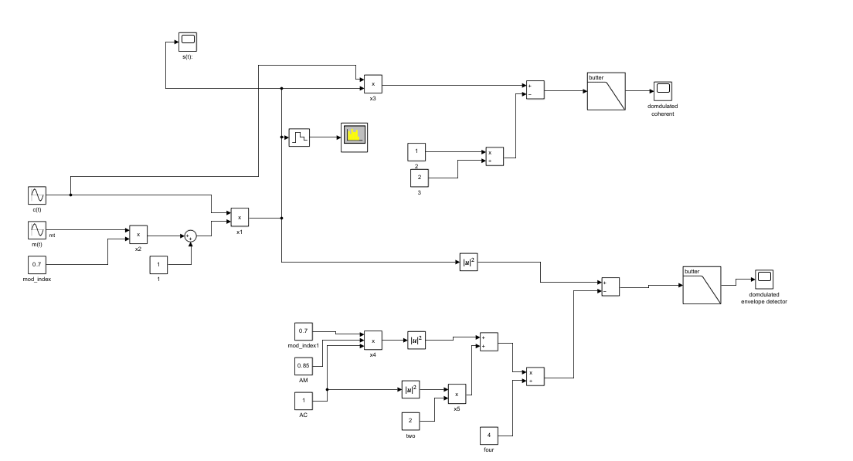

The whole circuit design including all about AM communication

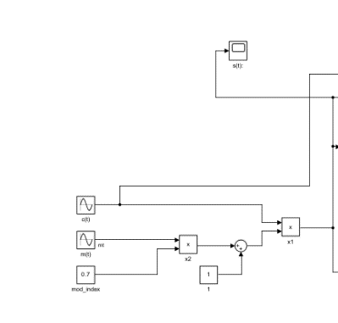 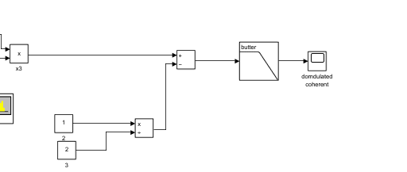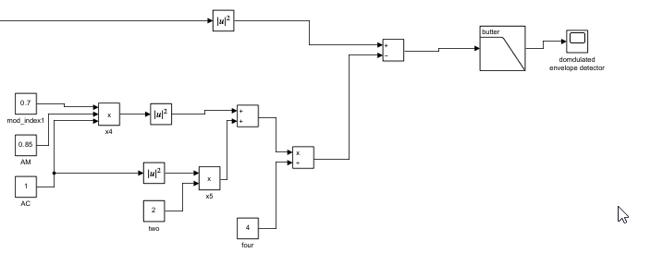

Normal Am modulation coherent demodulation envelop detector demodulation

## **Results:**

Note: stop time = 10.

### **@ k < 1 = 0.7:**

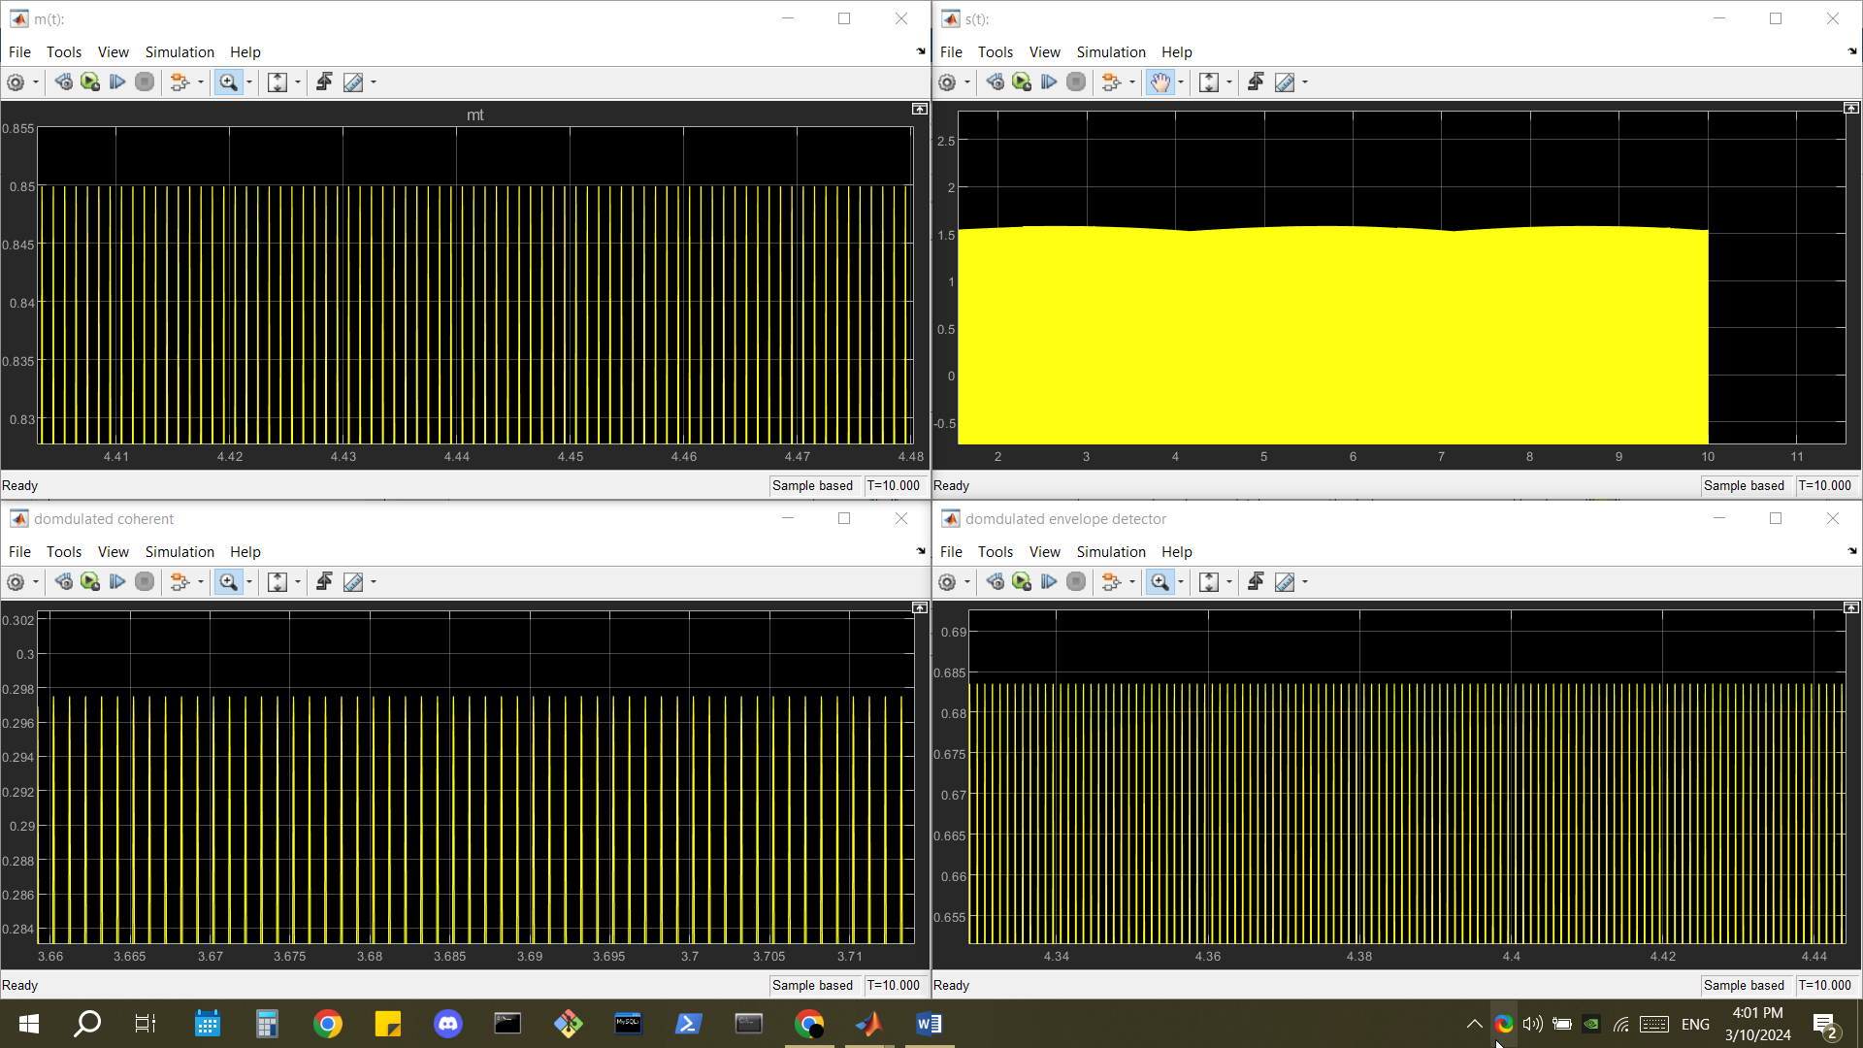

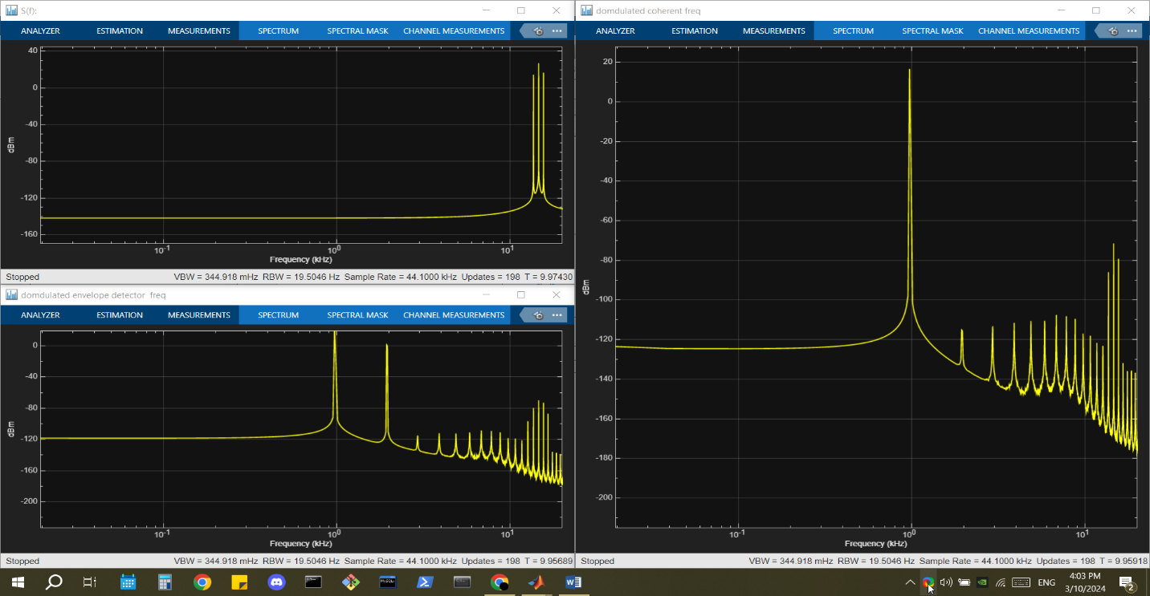

### **@ k = 1:**

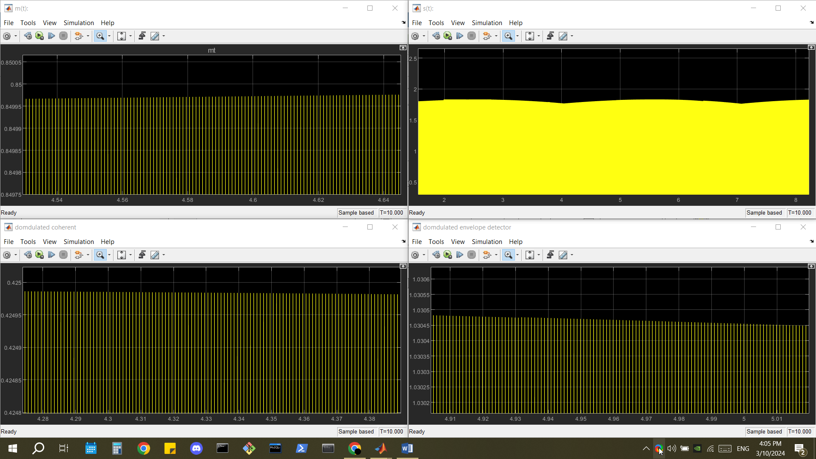

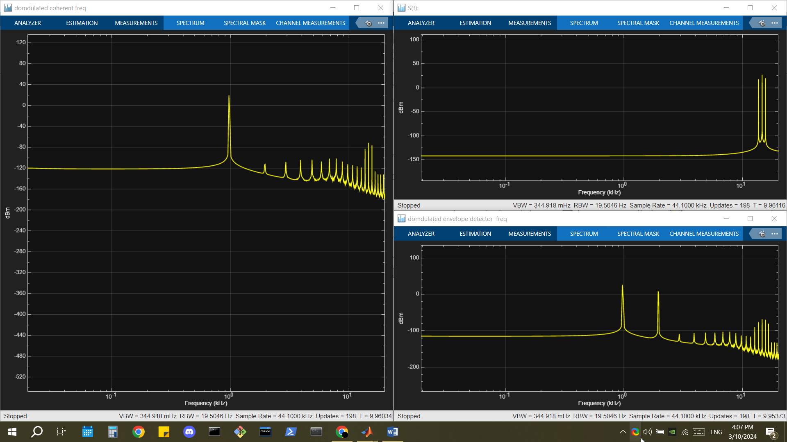

### **@ k > 1 = 4:**

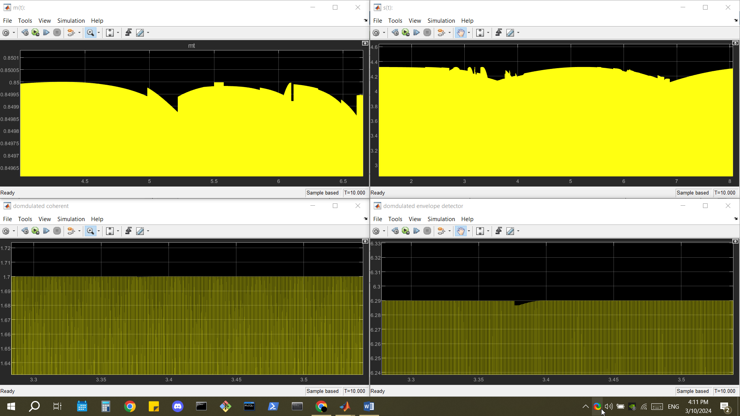

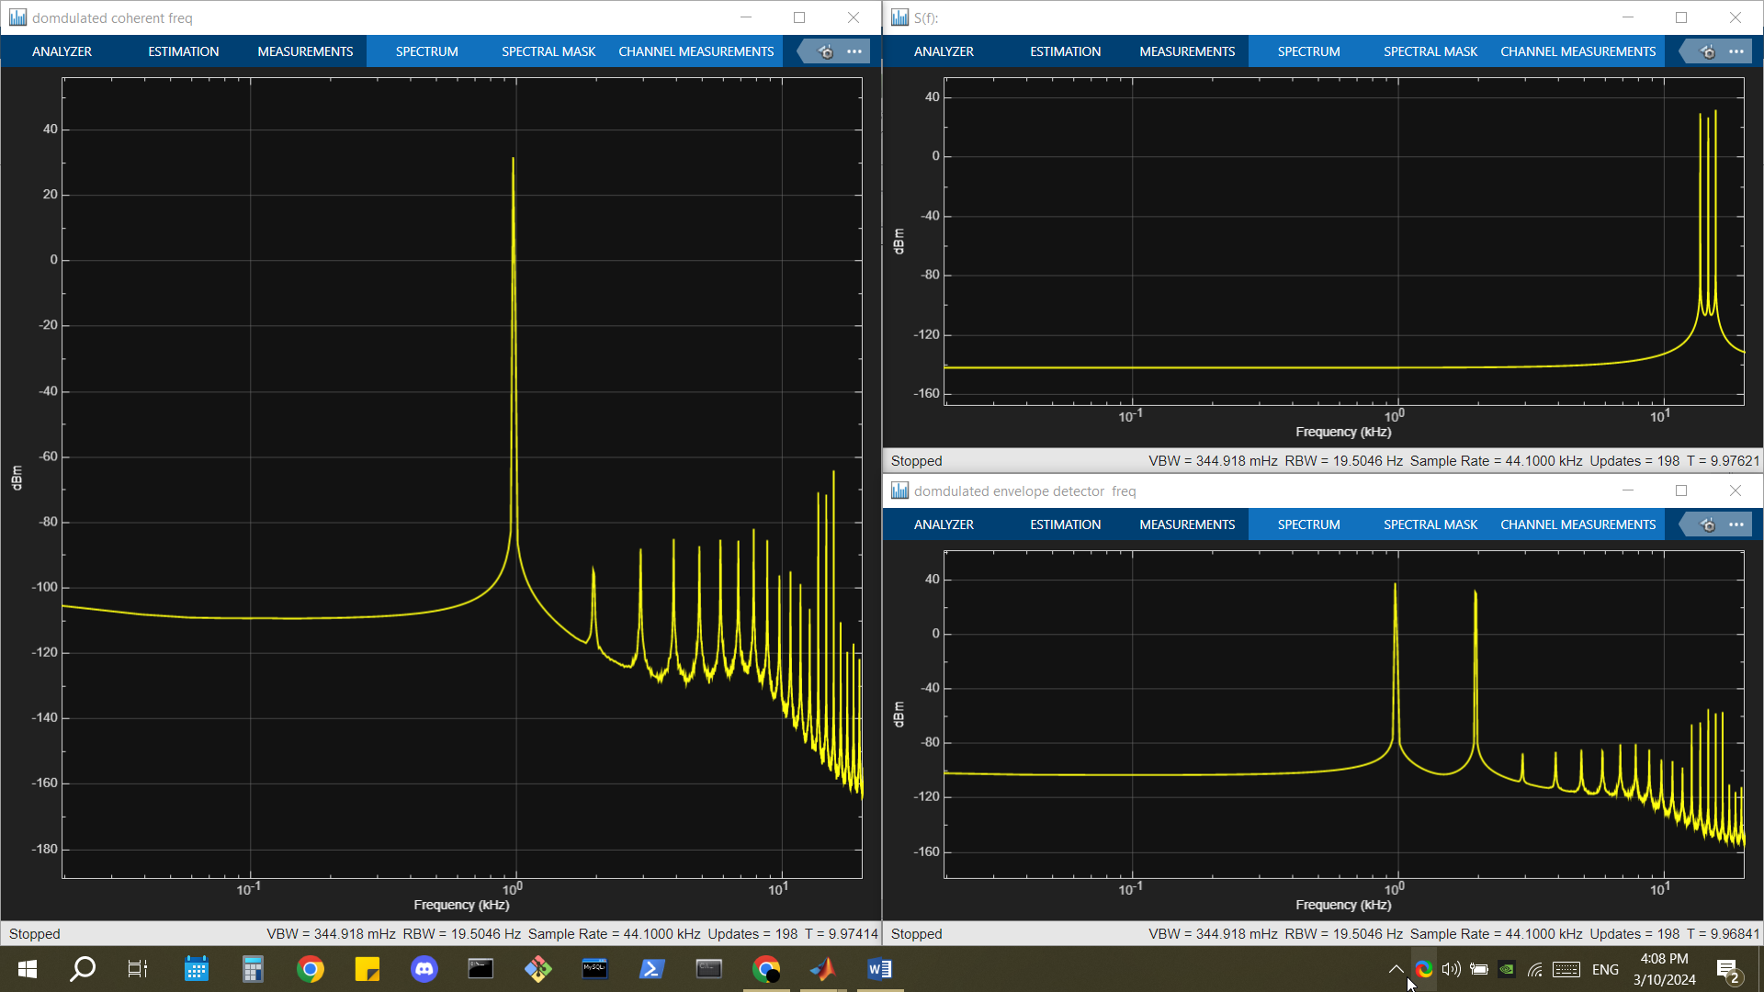

Note: m(t) got a lot of noise I tried to look for a reason but I couldn’t find any