

**Faculty of Engineering and Technology**

**Electrical and Computer Engineering Department**

**Computer Communication Lab**

**ENEE 4113**

**Experiment No. 2 pre-lab**

**SSB DSB Amplitude Modulation**

Prepared by:

**Abdel Rahman Shahen** **1211753**

Partners:

 Mahmoud Awad

Instructor: Dr. Ashraf Rimawi

Section: 2

Date: 3/6/2024

# **Title: Theoretical Analysis of Amplitude Modulation and Demodulation: DSB-SC and SSB Methods**

## **Introduction**

Amplitude modulation (AM) stands as a cornerstone in the realm of communication systems, facilitating the transmission of audio and video signals across various mediums. This paper introduces the nuanced techniques of Double Sideband Suppressed Carrier (DSB-SC) and Single Sideband (SSB) modulation, elucidating their pivotal roles and diverse applications in modern communications.

## **Objective**

The study aims to dissect and elucidate the mathematical intricacies and theoretical constructs underpinning AM, DSB-SC, and SSB modulation and demodulation processes, enhancing the comprehension of their operational principles and efficiency.

## **Theoretical Background**

### **Amplitude Modulation (AM)**

Amplitude modulation is characterized by the variation of a carrier signal's amplitude in accordance with the message signal, denoted mathematically as m(t)cos(Wc t), where m(t) is the message signal and Wc is the angular carrier frequency.

### **Double-Sideband Suppressed Carrier (DSB-SC)**

#### DSB-SC modulation, a variant of AM, diverges from the classical approach by eliminating the carrier frequency, conserving power and bandwidth. The modulated signal is mathematically depicted as s(t)=m(t) cos (Wc)

#### **Spectrum Analysis:**

The DSB-SC spectrum conspicuously lacks the central carrier component, featuring only the sidebands bearing the message information.

#### **Mathematical Representation:**

The output of a DSB-SC modulated signal can be represented as s(t) = m(t) cos (Wct)

### **Single-Sideband (SSB)**

SSB modulation refines the DSB-SC technique by further omitting one of the sidebands, resulting in either an Upper Sideband (USB) or a Lower Sideband (LSB) transmission. The USB, for instance, is represented as S(t)=Re {m^(t) e^ (j Wc t)}, where m^(t) is the Hilbert transform signal.

#### **Spectrum Analysis:**

SSB showcases superior spectral efficiency by occupying only half the bandwidth of DSB-SC and traditional AM, thereby enabling more economical use of the frequency spectrum.

#### **Mathematical Representation:**

The SSB signal can be derived by filtering one sideband from a DSB-SC signal. Two forms exist, USB (Upper Sideband) and LSB (Lower Sideband).

Equation for USB: S(t) = Re{m^(t) e^ (j Wc t)}, where m^(t) is the Hilbert transform

# **Title: practical Analysis of Amplitude Modulation and Demodulation:**

## **SSBSC:**

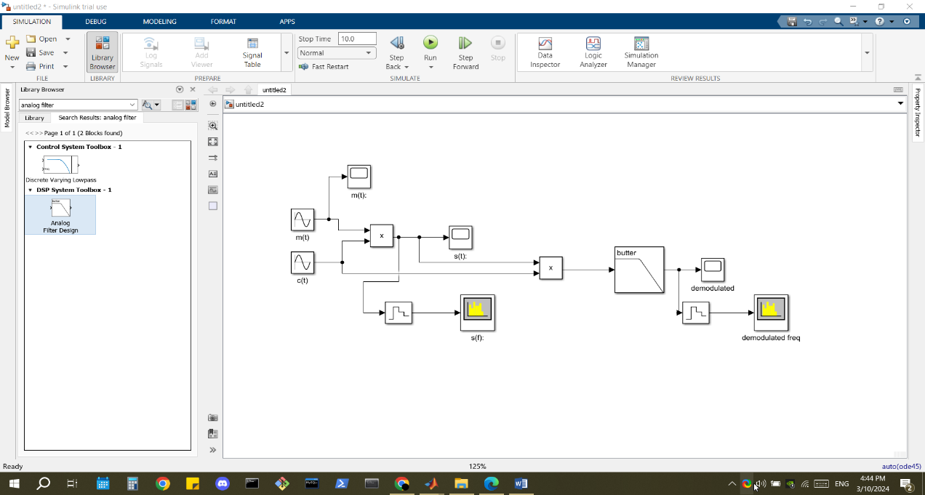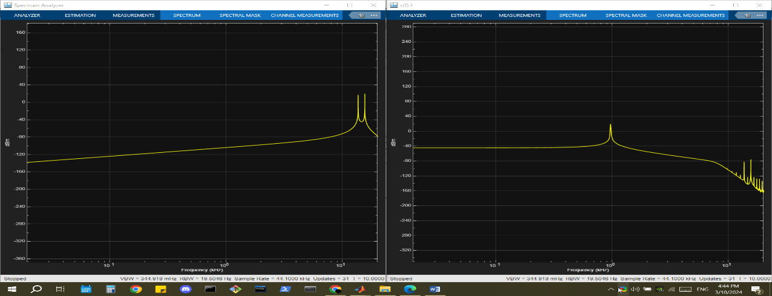

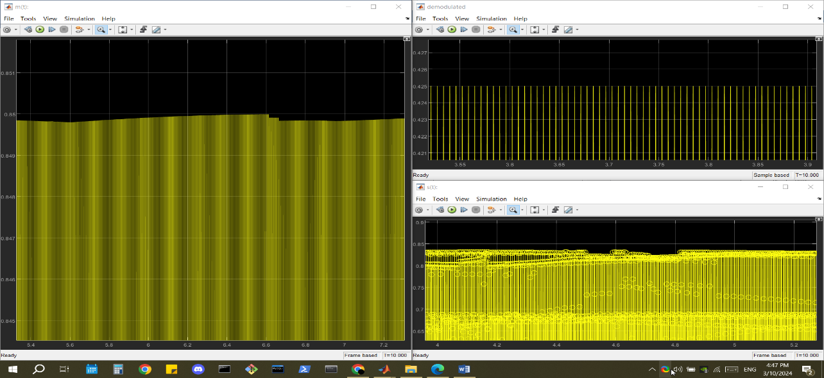

## **SSBSCL:**



 

