

**Faculty of Engineering and Technology**

**Electrical and Computer Engineering Department**

**Computer Communication Lab**

**ENEE 4113**

**Experiment No. 4 pre-lab**

**Normal Amplitude Modulation**

Prepared by:

**Abdel Rahman Shahen** **1211753**

Partners:

 Mahmoud Awad

Instructor: Dr. Ashraf Rimawi

Section: 2

Date: 3/10/2024

# **Title: Theoretical Analysis of** **Frequency Modulation**

Frequency Modulation (FM) is a method of modulating a carrier wave in which the frequency of the carrier wave is varied according to the amplitude of the message signal. This method of modulation is widely used for radio broadcasting, two-way radio systems, and other forms of communication for its advantages in noise reduction and bandwidth efficiency over amplitude modulation (AM).

## **FM Modulated Signal Equation**

The equation for an FM modulated signal can be given by:

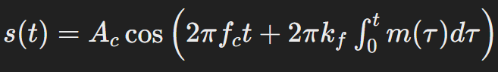

where:

S(t) is the FM modulated signal,

Ac is the amplitude of the carrier wave,

Fc is the frequency of the carrier wave,

Kf is the frequency sensitivity of the modulator (in Hz per volt if m(t) is in volts),

m(t) is the message signal,

**∫**t🡪0 m(τ) dτ represents the integral of the message signal from 0 to t

## **Extracting the Message Signal from the Modulated Signal Theoretically**

The process of demodulating an FM signal to retrieve the message signal m(t) can be outlined as follows:

Differentiate the FM Signal: By differentiating the FM signal, we can convert frequency variations back into amplitude variations, which are proportional to the original message signal.

Envelope Detector: The envelope of the differentiated signal represents the amplitude variations that are proportional to the original message signal.

Subtract the DC Value: Finally, by subtracting the DC component from the envelope, we isolate the message signal.

# **Title: Practical Analysis of Frequency Modulation**

