

**Faculty of Engineering and Technology**

**Electrical and Computer Engineering Department**

**Computer Communication Lab**

**ENEE 4113**

**Experiment No. 5 pre-lab**

**Phase Modulation**

Prepared by:

**Abdel Rahman Shahen** **1211753**

Partners:

 Mahmoud Awad

Instructor: Dr. Ashraf Rimawi

Section: 2

Date: 3/20/2024

# **Theory**

Pulse modulation (PM) is a technique in telecommunications where the amplitude of a series of pulses is varied based on the amplitude of the modulating signal. In PM modulation, the width or position of the pulses remains constant, but the amplitude changes. This method efficiently encodes analog information into digital pulses for transmission, commonly used in digital communication systems for its simplicity and robustness against noise.

# **Connections**

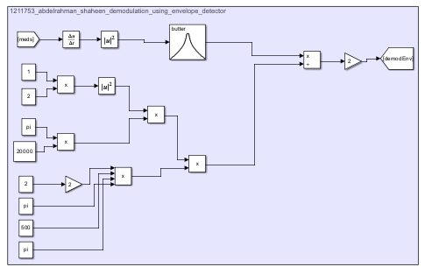

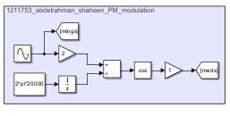

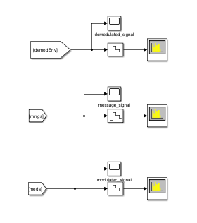

# **Results**

**Time domain results:**

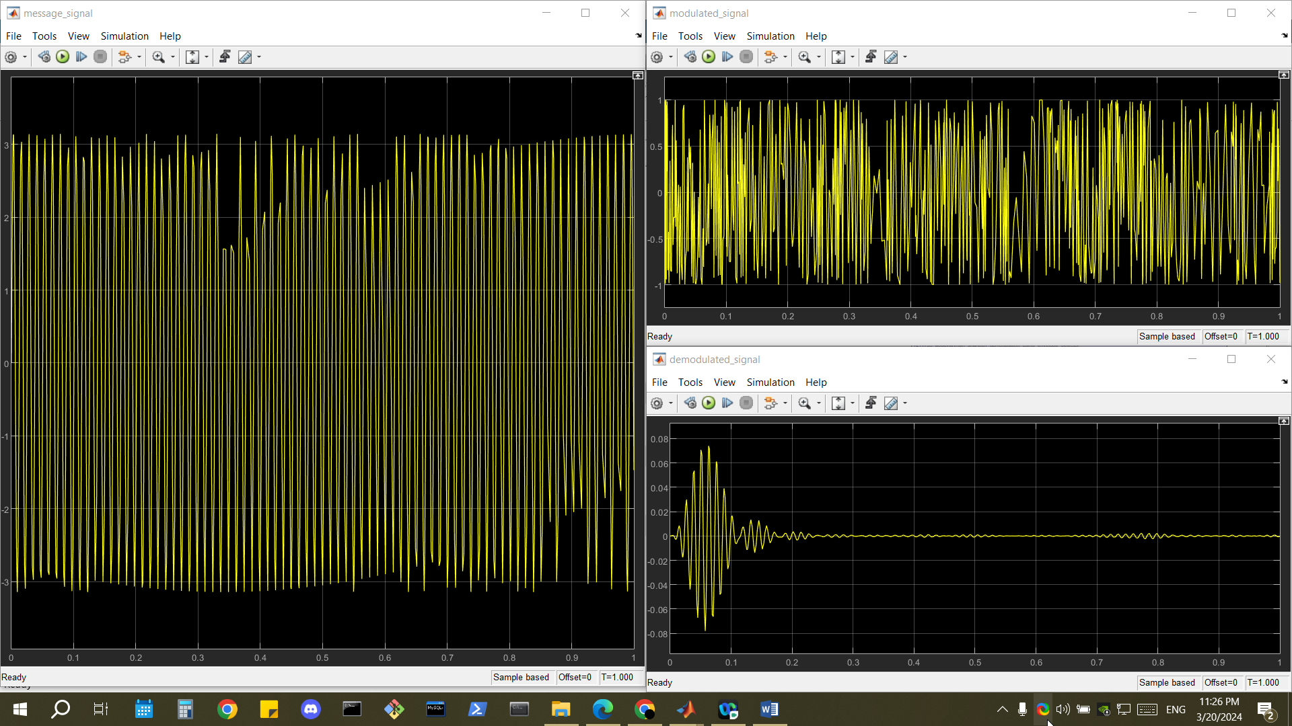

**Frequency domain results:**

