**Synopsis**

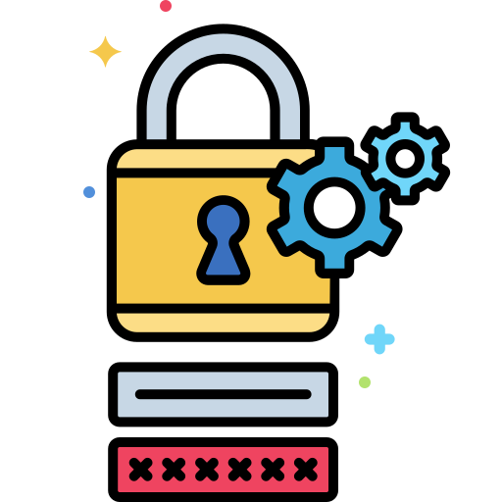

**Secure Password Manager 🔐**



**Submitted By**

**Abhay**

**Roll No.: 210830822001**

**Branch : Diploma CSE**

**Year/Semester : 5th Semester**

**Table of Contents**

Introduction

Need of a Secure Password Manager

References:

Feature of Password Manager:

### Introduction

In today's world, where we have countless online accounts for different services, it has become very difficult to remember passwords. If we use, weak and repetitive passwords that can put our sensitive information at risk. This is where password managers come in handy.

### Need of Secure Password Manager

A password manager is a digital tool that securely stores all your login credentials and generates strong, unique passwords for each account. It allows users to store and access all your accounts with just one master password. In modern world, a secure password manager is a must-have tool that offers end-to-end encryption, multi-factor authentication, and other advanced security features to ensure your passwords are safe from hackers eyes.

**PRIMARY OBJECTIVE:**

The need for a secure password manager arises due to the increasing number of online accounts and the risk of identity theft and data breaches.

**SECONDARY OBJECTIVES:**

* A secure password manager helps address these issues by providing a convenient and secure way to manage passwords. It stores all your login credentials in an encrypted database, making it difficult for hackers to access your information.
* It generates strong and unique passwords for each account, reducing the risk of password reuse and making it more difficult for attackers to crack your passwords.
* Another important feature of a secure password manager is multi-factor authentication. This adds an extra layer of security by requiring additional authentication methods, such as biometric scans or one-time codes, to access your password manager account.
* Overall, a secure password manager is an essential tool for anyone who wants to protect their online identity and personal information from cybercriminals.

### ****References:****

**Password Manager (**[**Wikipedia**](https://en.wikipedia.org/wiki/Password_manager)**)**

### Features of Password Manager

A secure password manager typically offers several key features to ensure the protection of your passwords and personal information. Here are some of the main features you should look for:

1. End-to-end encryption: The password manager should use strong encryption to protect your passwords and personal data.

2. Multi-factor authentication: The password manager should offer multi-factor authentication, which adds an extra layer of security by requiring additional forms of authentication, such as biometric scans or one-time codes.

3. Password generator: The password manager should have a built-in password generator that creates strong and unique passwords for each of your accounts.

4. Auto-fill and auto-login: The password manager should allow you to easily fill in login information and automatically log you into websites and apps.

5. Secure sharing: The password manager should allow you to securely share passwords with others, such as family members or co-workers, without compromising the security of your passwords.

6.Support: The password manager should have support team to help users for easy access to their passwords on-the-go.