Solution:

KPI Requirment

**1. TOTAL SALES:**

select cast (sum(total_sales / 1000000.0) as decimal(11,2))

as Total_sales_million from goods;

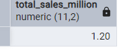

**2. AVERAGE SALES**

**select round(avg(total_sales) )**

**as avg_sales from goods;**

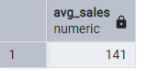

**3. Number of Items**

**select distinct(count(item_identifier) )**

**as items from goods;**

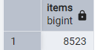

**4. Average Rating**

**select cast (avg(rating) as decimal (5,1))**

**as Avg_rating from goods;**

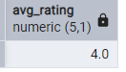

**Granular requirement**

1. **TOTAL SALES BY FAT CONTENT**

**select item_fat_content , cast (sum(total_sales) as decimal (10,2))**

**as Item_Fat_Sales**

**from goods**

**group by item_fat_content ;**

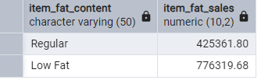

1. **Total Sales by Item Type**

**select item_type , cast (sum(total_sales) as decimal (10))**

**as Total_Sales from goods**

**group by item_type**

**order by Total_Sales**

**desc**

**;**

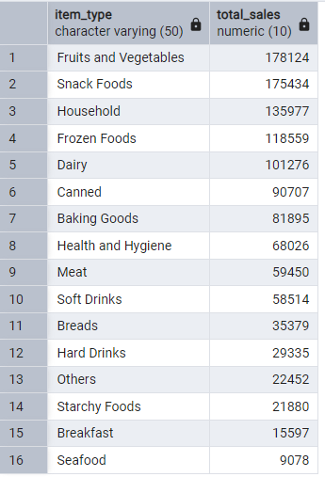

1. **Fat Content by Outlet for Total Sales**

**select item_fat_content, outlet_location_type , cast (sum(total_sales) as decimal (10))from goods**

**group by outlet_location_type, item_fat_content**

**order by outlet_location_type;**

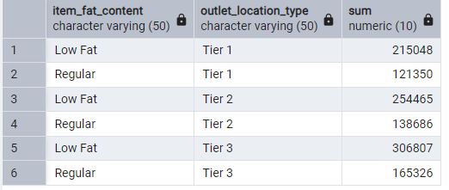

1. **Total Sales by Outlet Establishment**

**SELECT outlet_establishment_year , cast (sum(total_sales) as decimal (10)) from goods**

**group by outlet_establishment_year**

**order by outlet_establishment_year**

**;**

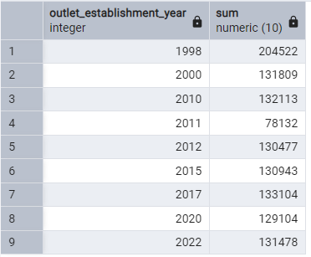

1. **Percentage of Sales by Outlet Size**

**SELECT**

**outlet_size, cast (sum(total_sales) as decimal (10)) as overall_sales,**

**cast ((sum(total_sales) * 100.0 / sum(sum(total_sales)) over()) as decimal (10)) as sales_percent**

**from goods**

**group by outlet_size , order by sales_percent desc ;**

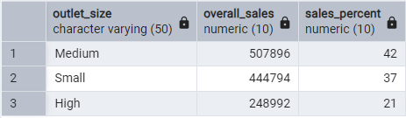

1. **Sales by Outlet Location**

**select outlet_location_type, cast (sum(total_sales) as decimal (10)) as sales**

**from goods**

**group by outlet_location_type**

**order by sales**

**desc;**

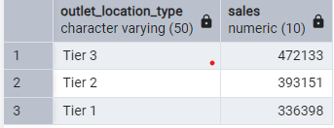

1. **All Metrics by Outlet Type**

**select**

**outlet_type,**

**cast(sum(total_sales) as decimal (10)) as Sales,**

**cast(avg(total_sales) as decimal (10)) as Avg_Sales,**

**count(item_identifier) as No_of_items,**

**cast(avg(rating) as decimal (4,2)) as Rating,**

**cast (avg(item_visibility) as decimal (6,2)) as Items_visibility**

**from goods**

**group by outlet_type**

**;**

