Q1. Analyse sales trends over time to identify seasonal patterns or growth opportunities.

Solution :
1. Monthly Trend Analysis
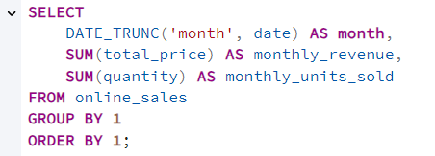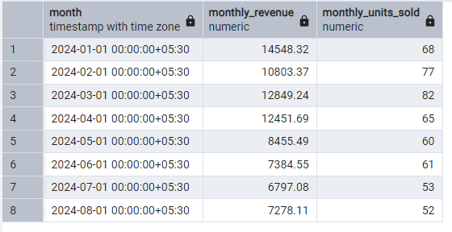

2. Seasonal Pattern Analysis (Month-to-Month across years)

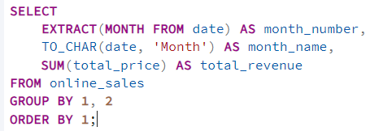
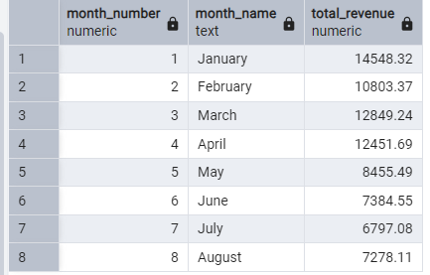x
3 . Growth Opportunity Analysis
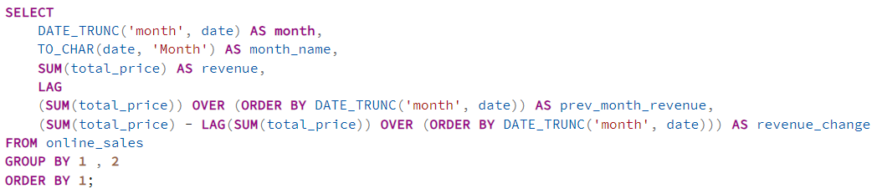
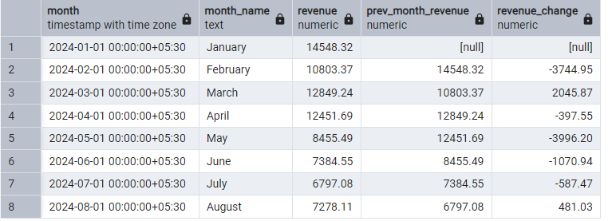
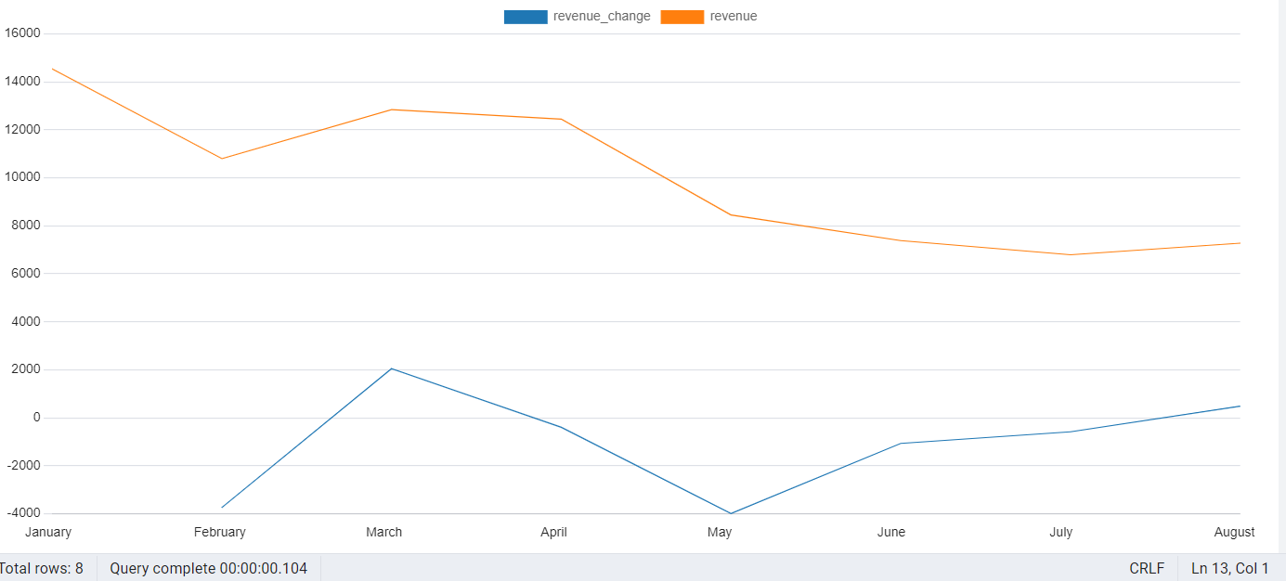
What insight I get?
- Sales spikes due to festivals, holidays, or seasonal demand (Jan, Feb, Mar, April)
- Off-season low months (May to August)
- Plan marketing or inventory accordingly (Declined in May after May sales were average)
- Plan promotions to boost slow months

Q2. Explore the popularity of different product categories across regions.

You can use three levels of analysis:
- Total popularity by region
- Region-wise ranking of categories
- Percentage share of each category in every region
A) Total popularity by region
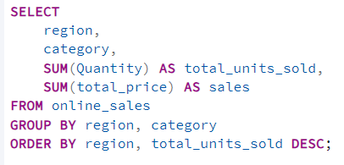
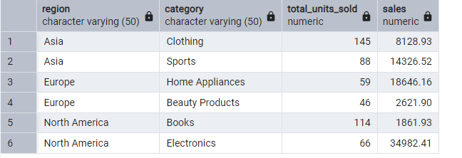

B) Region-wise ranking of categories
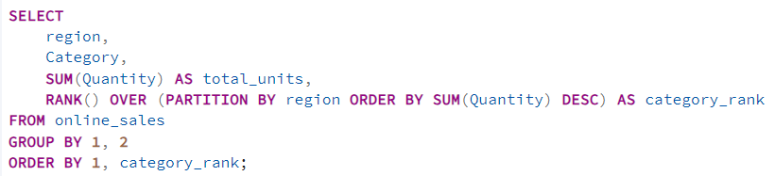
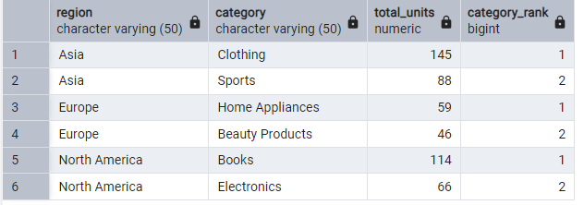
C) Percentage share of each category in every region
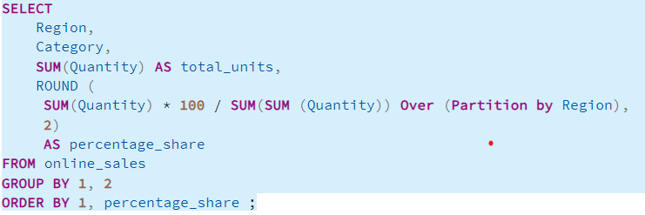
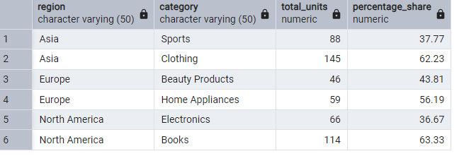

Q3. Investigate the impact of payment methods on sales volume or revenue.
A) Percentage share of each category in every region
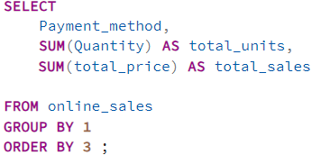
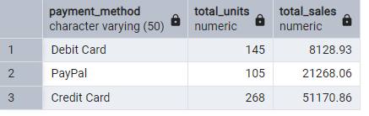
Credit Card payment method brings the highest revenue
B) Average Order Value per Payment Method
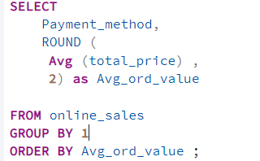

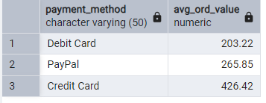

C) Monthly Trend of Payment Method Usage
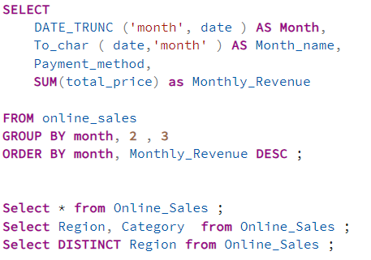

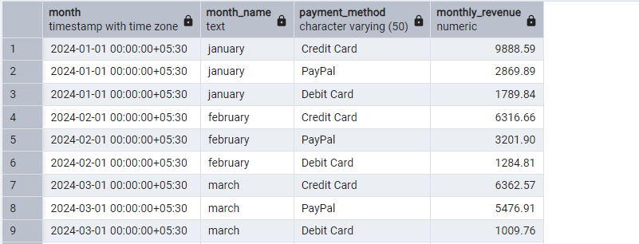
Festival season preferences are cards
D) Percentage Share of Each Payment Method
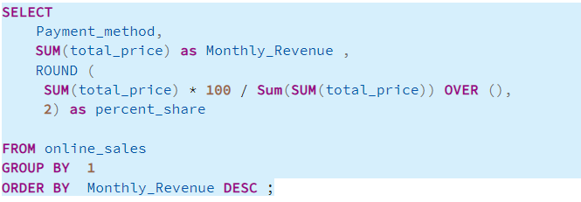

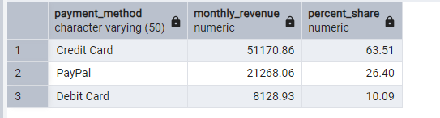

INSIGHTS
- Credit card users are typically more comfortable spending on electronics, appliances, premium products.
- Debit card usage indicates budget-conscious customers making smaller purchases.
- Discount campaigns targeted at credit card users can increase high-value sales.
- Increasing offers for debit card users may help improve adoption.

Q4. Identify top-selling products within each category to optimize inventory and marketing strategies.

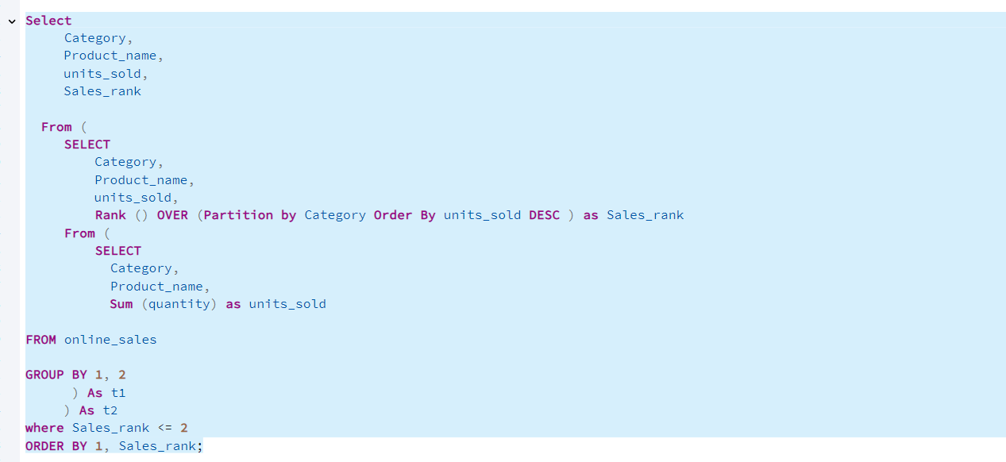

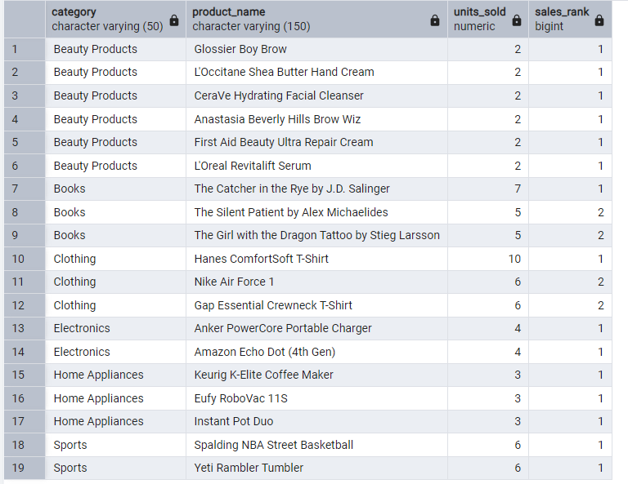

1. Optimize Inventory Levels
When you know which products sell the most:
- You stock more of the high-selling items so they never go out of stock.
- You reduce inventory investment in slow-moving products.
- You plan seasonal reorders more accurately.
- You identify products that may need safety stock or buffer inventory
2. Reduce Stockouts & Lost Sales of Top products
3. Improve Warehouse Space Allocation for Top products
(Place closer to dispatch area, Give more storage space, Prioritize in picking, Manage with efficient replenishment cycles)
4. Optimize Marketing Focus
6. Better Supplier Negotiation (bulk discounts , priority delivery)

Q5. Evaluate the performance of specific products or categories in different regions to tailor marketing campaigns

This analysis helps you understand which product performs best in which region, so marketing teams can run region-wise targeted campaigns instead of generic ones.

A) Category performance by region
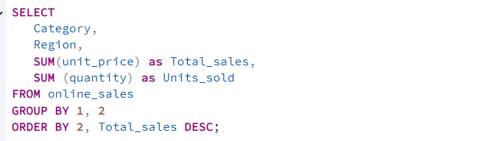
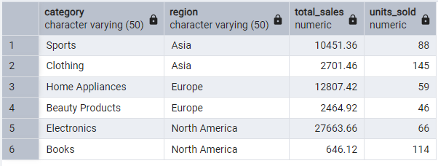

B) Find top product per region using RANK()
