- Identify the Recency, Frequency, and Monetary (RFM) value of each customer

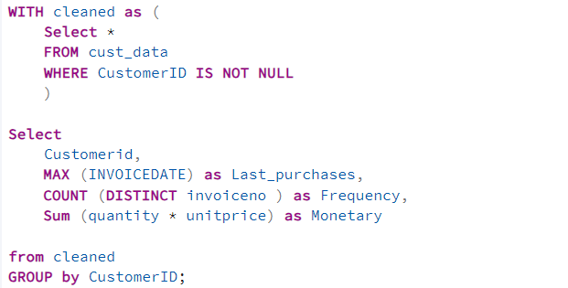

Frequent Customer:
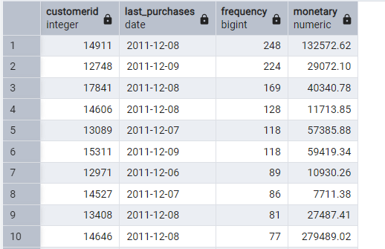
Recent purchases:
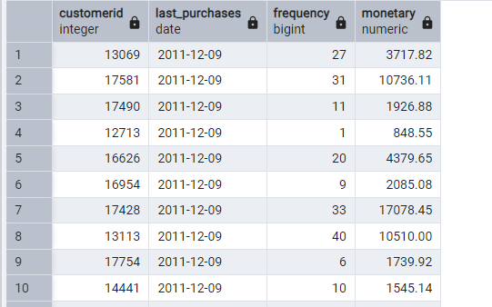

Customer who has not shopped for a while their Last purchases:
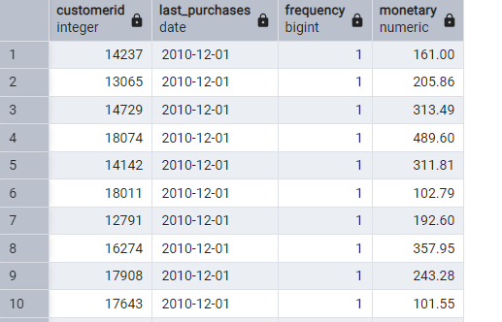
Monetary (Top Customer with Max Purchases) :
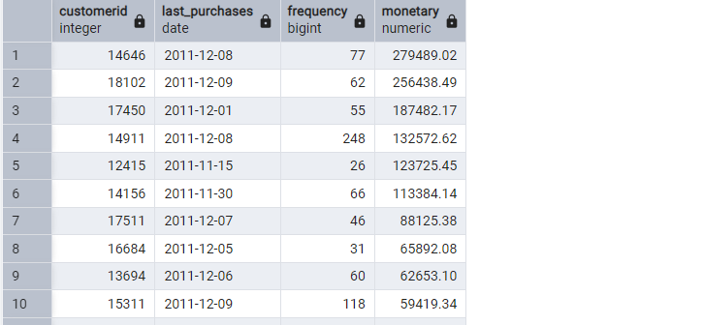

- Create RFM Scores (1–5) for each customer
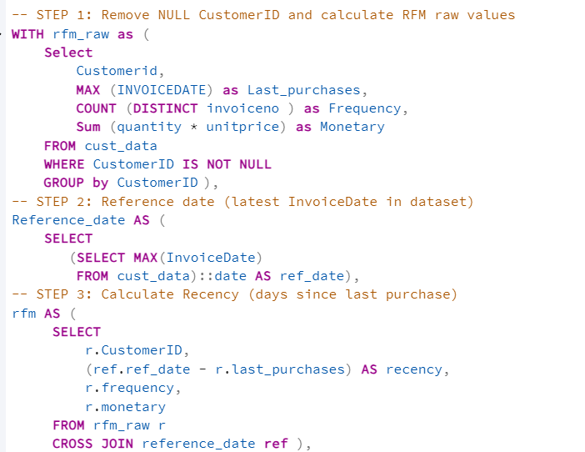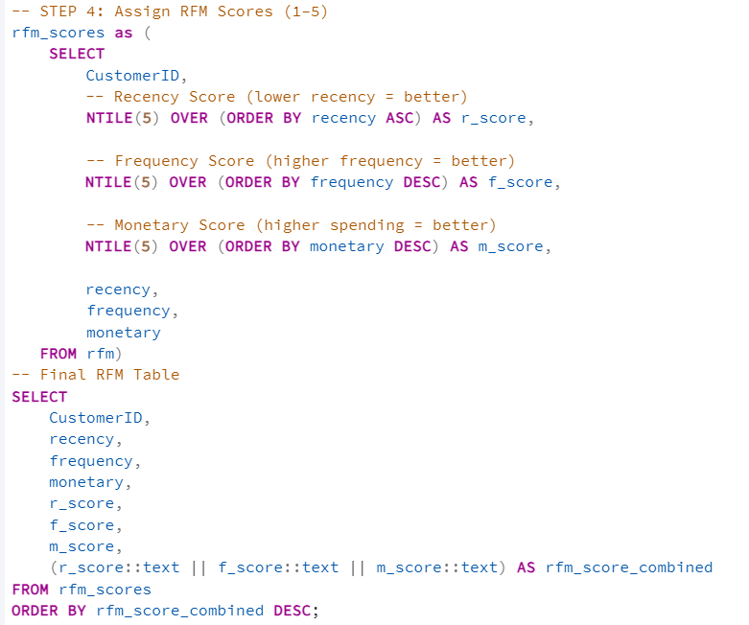

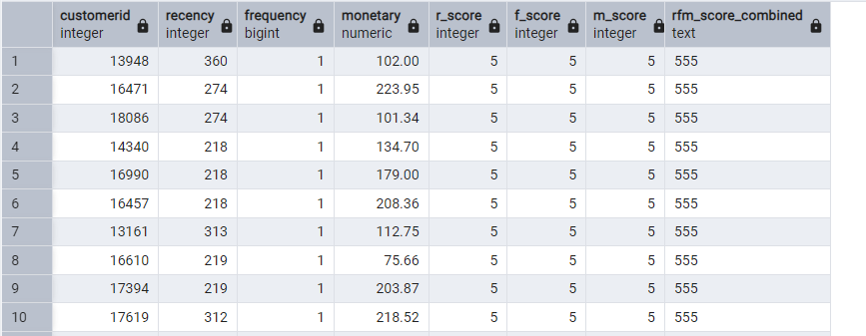

3. Segment customers into meaningful groups using RFM Score
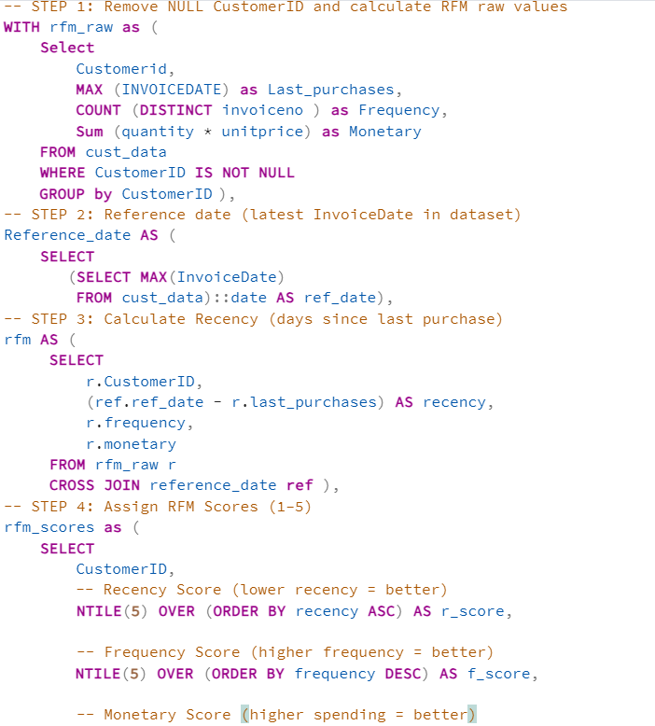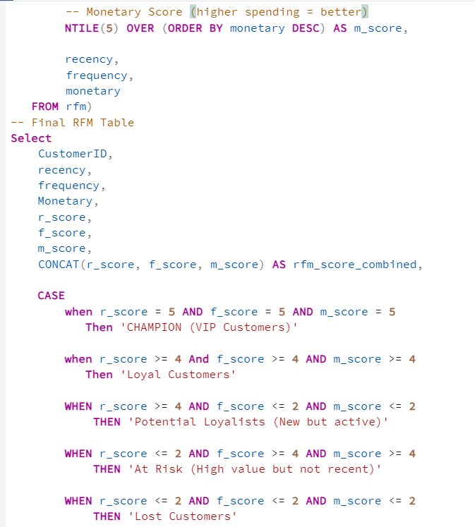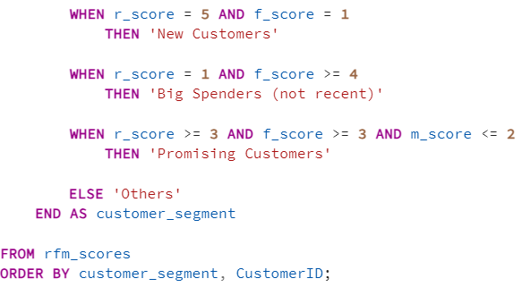

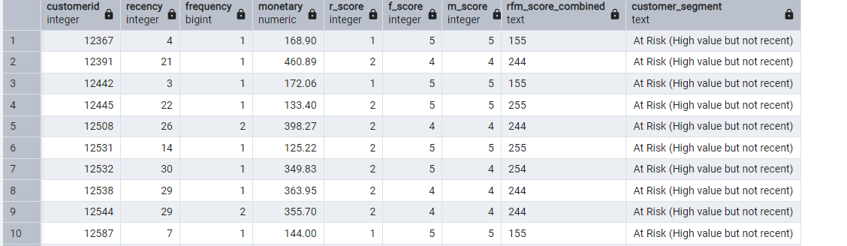

Segment | Meaning
Champions | Best of best. Recent, frequent, highest spenders.
Loyal | Buy often. Good for upselling and rewards.
New Customers | Very recent buyers with low history. Need nurturing.
Potential Loyalists | Showing good interest, not spending much yet.
Big Spenders | Spend a lot but do not buy often or recently.
At Risk | High spenders who stopped buying recently.
Promising | Average scores but can grow with marketing.
Lost | Not recent, do not buy, low spend.

- Identify the top 10% highest-value customers
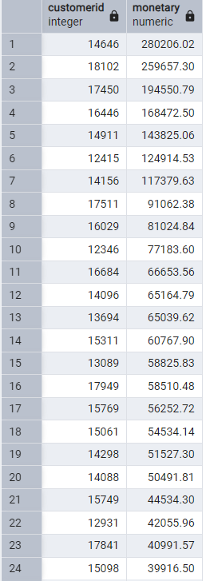

- Identify customers at risk of churn
Problem Statement:
Find customers who have not purchased recently (high Recency days) but previously had high Frequency or Monetary.

