1. select sum (price*quantity) as total_revenue from sales;  
 251505794.25

2. select category , sum(price * quantity) as revenue from sales

group by category

order by revenue desc

limit 1

;

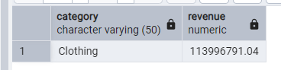

3.

select shopping_mall, Round(sum(quantity * price)) as sales_revenue from sales

group by shopping_mall

order by sales_revenue desc

limit 3

;

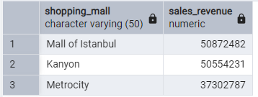

4.

Step 1 - Inner join table

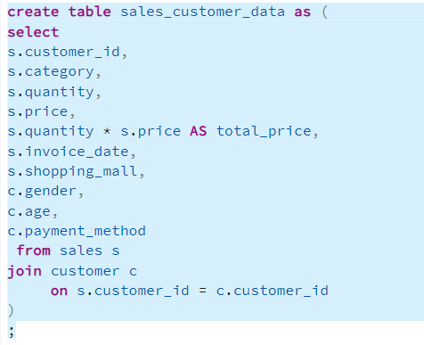

Step 2 – group by

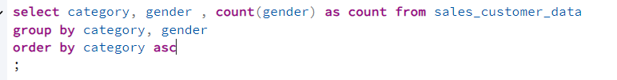

Result

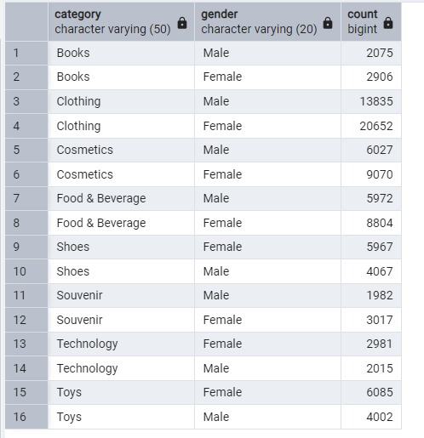

5.

code

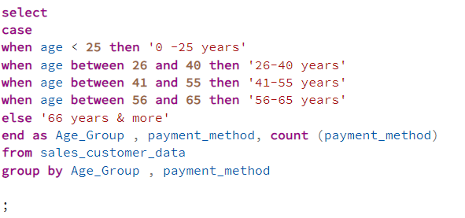

Result

