
DBMS COURSE PROJECT
Design and Implementation of a Database Management System for
Canteen Food Ordering and
Billing Management System
Project 07
Submitted by
Abhiuday Singh | 25WU0101006
Aryaman Jain | 25WU0101017
Harsh Jha | 25WU0101046
Course: Database Management Systems
Faculty Mentor: Dr. Kiran Mayee
School of Technology, Woxsen University
Academic Year: 2025–2029

Abstract
The Canteen Food Ordering and Billing Management System is a database-driven web application that lets students order food from the campus canteen in advance and lets canteen staff run orders, stock and billing from one place. It addresses common canteen problems: long queues, orders written on paper, repeated entry of the same details, no visibility of order status, mistakes while preparing bills, and ingredients running out without warning.
The logical design is an Entity–Relationship model of ten entities — CUSTOMER, STAFF, CATEGORY, FOOD_ITEM, MENU_ITEM, INVENTORY, FOOD_ORDER, ORDER_ITEM, BILL and PAYMENT — mapped to a relational schema of eleven relations using the standard mapping rules, including an associative relation for the many-to-many “uses” relationship. The physical database, canteen_db, is implemented in MySQL 8 as ten InnoDB tables and one view. Primary keys, foreign keys with explicit delete rules, UNIQUE and CHECK constraints and ENUM domains enforce entity, referential and domain integrity inside the database, and the implemented schema is in Third Normal Form (3NF).
The application uses Node.js and Express on the server and plain HTML, CSS and JavaScript in the browser, connected to MySQL through the mysql2 driver with parameterized queries. Placing an order is a single ACID transaction that records the order and its lines at the current price, deducts ingredient stock using each item’s recipe, generates a bill with 5% GST and records the payment; if any step fails, nothing is saved. This report documents the design, the SQL used (DDL, DML, joins, aggregates, subqueries and a view) with outputs captured from the running database, screenshots of the working application, and 24 integrity and functional tests, all of which passed.
Keywords: relational database, MySQL, ER model, normalization, 3NF, primary key, foreign key, transactions, canteen management, billing, SQL, CRUD, Node.js, Express.

Table of Contents
Abstract i
1. Introduction and Problem Statement 1
1.1 Introduction 1
1.2 Problem Statement 1
1.3 Intended Users 2
2. Objectives and Scope 3
2.1 Objectives 3
2.2 Scope 3
3. Software and Hardware Requirements 4
3.1 Software Requirements 4
3.2 Hardware Requirements 4
3.3 Functional Requirements 5
4. ER Diagram 6
4.1 Entities and Key Attributes 7
4.2 Relationships, Cardinality and Participation 8
4.3 Design Notes 8
5. Relational Schema and Normalization 9
5.1 Relational Schema 9
5.2 Functional Dependencies 11
5.3 Normalization to Third Normal Form 12
5.4 Result 12
5.5 From Logical Design to Physical Implementation 13
6. Data Dictionary 14
6.1 CUSTOMER 14
6.2 STAFF 14
6.3 CATEGORY 14
6.4 MENU_ITEM 15
6.5 FOOD_ITEM 15
6.6 INVENTORY 16
6.7 MENU_ITEM_INVENTORY 16
6.8 FOOD_ORDER 16
6.9 ORDER_ITEM 17
6.10 BILL 17
6.11 PAYMENT 17
7. SQL Commands Used (DDL and DML) with Sample Outputs 19
7.1 Physical Schema Overview 19
7.2 Data Definition Language (DDL) 20
7.3 Data Manipulation Language (DML) 25
7.4 Transactional Order Placement 28
7.5 Sample Data Overview 29
8. Queries with Outputs 30
8.1 Join query: customer order history 30
8.2 Aggregate query: revenue by category 30
8.3 Aggregate query: paid bills, revenue and average bill value 31
8.4 Popular food items 31
8.5 Active (not yet collected) orders 32
8.6 Ingredients at or below reorder level 32
8.7 Payment attempts by method and status 33
8.8 Recipe of a menu item (M:N join through MENU_ITEM_INGREDIENTS) 33
8.9 Subquery: menu items priced above the average menu price 34
8.10 View: v_order_summary 34
9. UI Design and Screenshots 36
9.1 Design Approach 36
9.2 Screens 36
9.3 Insert, Update, View and Delete — Reflected in the Database 41
10. Implementation Details 48
10.1 Technology Stack and Architecture 48
10.2 Database Connectivity 48
10.3 Key Code Snippets 49
10.4 REST API 52
10.5 Order Processing Flow 53
10.6 Integrity and Security Measures 53
11. Testing 55
11.1 Testing Approach 55
11.2 Database Integrity Test Cases 55
11.3 Functional Test Cases 56
12. Conclusion and Future Enhancements 57
12.1 Conclusion 57
12.2 Future Enhancements 57
13. References 58
14. Contribution of Each Member 59
Appendix A: GitHub Repository 60
Appendix B: How to Run the Project 61

List of Figures
Figure 1: Entity–Relationship diagram of the Canteen Food Ordering and Billing Management System 6
Figure 2: Relational schema diagram: arrows run from each foreign key to the primary key it references 10
Figure 3: Physical database schema of canteen_db as implemented in database.sql 19
Figure 4: Login screen with sample accounts for each role 36
Figure 5: Student menu: categories, search, prices, preparation time and ratings 37
Figure 6: Tray and checkout: line totals, 5% GST, pickup point and payment method; sold-out items cannot be added 37
Figure 7: My orders: pickup token, lane, status progress and payment state after placing an order 38
Figure 8: Bill generated for the order, with GST, total and UPI transaction reference 38
Figure 9: Staff / admin dashboard: revenue, active orders, low stock, best sellers and sales by category 39
Figure 10: Order management: active orders with payment state and the next status action 39
Figure 11: Menu management (admin): items with availability toggle, edit and delete; categories below 40
Figure 12: Inventory: stock and reorder levels, with ingredients below the reorder level flagged 40
Figure 13: Billing: every bill with GST, discount, payment state, reference and cash collection 41
Figure 14: Registration form: a new student account is created 42
Figure 15: Staff moved the order to “Preparing”; the confirmation message is shown 44
Figure 16: Add menu item form filled in by the administrator 45
Figure 17: The new item appears in the menu table (highlighted) with the “Item added” message 46
Figure 18: Deleting Chicken Biryani is refused because the item appears in past orders 46
Figure 19: The test item is deleted and no longer listed 47
Figure 20: System architecture 48
Figure 21: Order placement transaction: the six steps and how it ends 53
Figure 22: Order status lifecycle implemented in the application 53

List of Tables
Table 1: Intended users and their roles 2
Table 2: Project scope 3
Table 3: Software requirements 4
Table 4: Hardware requirements 4
Table 5: Functional requirements 5
Table 6: Entities and key attributes 7
Table 7: Relationships, cardinality and participation 8
Table 8: Foreign keys of the relational schema 11
Table 9: Functional dependencies 11
Table 10: Normalization result 12
Table 11: Mapping from the logical schema to the physical tables 13
Table 12: Data dictionary: CUSTOMER 14
Table 13: Data dictionary: STAFF 14
Table 14: Data dictionary: CATEGORY 15
Table 15: Data dictionary: MENU_ITEM 15
Table 16: Data dictionary: FOOD_ITEM 15
Table 17: Data dictionary: INVENTORY 16
Table 18: Data dictionary: MENU_ITEM_INVENTORY 16
Table 19: Data dictionary: FOOD_ORDER 16
Table 20: Data dictionary: ORDER_ITEM 17
Table 21: Data dictionary: BILL 17
Table 22: Data dictionary: PAYMENT 18
Table 23: Rows loaded by database.sql 29
Table 24: Output of Query 1 30
Table 25: Output of Query 2 31
Table 26: Output of Query 3 31
Table 27: Output of Query 4 32
Table 28: Output of Query 5 32
Table 29: Output of Query 6 33
Table 30: Output of Query 7 33
Table 31: Output of Query 8 34
Table 32: Output of Query 9 34
Table 33: Output of Query 10 35
Table 34: Technology stack 48
Table 35: REST API endpoints 52
Table 36: Database integrity test cases 55
Table 37: Functional test cases 56
Table 38: Contribution of each member 59
Table 39: Repository details 60
Table 40: Sample login accounts 61

1. Introduction and Problem Statement

1.1 Introduction
A campus canteen handles a continuous stream of small but related transactions. A customer chooses one or more items, the order is recorded, the kitchen prepares the items using ingredients from stock, the order status changes, and a bill is settled through a payment method. When these activities are managed on paper or in disconnected records, the same information is entered repeatedly, stock runs out without warning, and it becomes hard to answer simple questions such as which items are available, how many orders a customer placed, or how much revenue a category generated.
A database management system provides a single structured source of truth for these activities. This project designs that database from an Entity–Relationship model, maps it to a normalized relational schema, implements it in MySQL 8 with integrity constraints, and builds a working web application on top of it. Students order from their browser and receive a pickup token; canteen staff move orders through the kitchen, collect cash, maintain stock and view bills; administrators also maintain the menu. Every screen reads from and writes to the same MySQL database.

1.2 Problem Statement
Design and implement a database management system for canteen food ordering and billing that maintains user and menu information, records orders and their individual items at the price charged, tracks order status, keeps ingredient stock in step with orders, generates bills, records payment attempts, and supports operational reporting through SQL queries.
The system must ensure that:
- each order belongs to an existing registered user, and each menu item to an existing category;
- each order line refers to a valid order and a valid menu item and stores the price at the time of ordering;
- an order cannot contain the same menu item twice;
- quantities, prices, stock levels and bill amounts cannot be negative, and a bill total always equals subtotal + tax − discount;
- every bill belongs to exactly one order, and every payment to an existing bill;
- ingredient stock is reduced when an order is placed and restored when it is cancelled, and an order is refused if stock is insufficient;
- only canteen staff and administrators can manage orders, stock and billing, and only administrators can change the menu.

1.3 Intended Users
Table 1: Intended users and their roles
User | Role in the database | What they do in the system
Student / Customer | STUDENT | Registers, browses the menu, places orders and pays (UPI, campus wallet or cash), tracks the order token, views and prints the bill, cancels an order before preparation starts.
Faculty / other campus users | STUDENT | Order through the same customer workflow as students.
Canteen Staff | STAFF | Views the dashboard, moves orders through the kitchen, collects cash payments, updates stock and reorder levels, views all bills.
Administrator | ADMIN | Everything staff can do, plus adding, editing and deleting menu items and categories and marking items sold out.

2. Objectives and Scope

2.1 Objectives
- Model canteen ordering, kitchen stock and billing as a clear Entity–Relationship design.
- Map the ER model to a relational schema and normalize it to Third Normal Form (3NF).
- Implement the schema in MySQL 8 with primary keys, foreign keys with explicit delete rules, UNIQUE, CHECK and ENUM constraints.
- Record every order as one ACID transaction covering the order, its lines, stock deduction, bill and payment.
- Keep a traceable order → bill → payment chain, including failed and pending payment attempts.
- Provide a web interface for inserting, viewing, updating and deleting records, with role-based access.
- Answer operational questions with JOIN, aggregate, subquery and view-based SQL queries.

2.2 Scope
Table 2: Project scope
In scope | Out of scope
Student registration and login (bcrypt-hashed passwords) | Raw-material procurement and supplier management
Category and menu management, sold-out toggle | Payroll and employee scheduling
Order placement, tracking, status flow and cancellation | External food-delivery logistics
Recipe-based ingredient stock and low-stock alerts | Full accounting / GST filing integration
Bill generation (5% GST, discount) and payment recording | Real payment-gateway processing (UPI / wallet are simulated)
Dashboard reports and SQL queries | Native mobile application

3. Software and Hardware Requirements

3.1 Software Requirements
Table 3: Software requirements
Component | Used in the project | Purpose
Database server | MySQL 8.0 (InnoDB, utf8mb4) | Stores the data and enforces keys, constraints and transactions.
Runtime | Node.js 18 or later | Runs the application server.
Web framework | Express 5 | REST API routes and static file serving (server.js).
Database driver | mysql2 (promise API) | Connection pool and parameterized queries between Node.js and MySQL.
Password hashing | bcryptjs | Hashes passwords at registration and verifies them at login.
Frontend | HTML5, CSS3, JavaScript (no framework) | Menu, tray, orders, bill, dashboard, menu, inventory and billing screens.
Operating system | Windows / Linux / macOS | Runs MySQL, Node.js and the browser.
Browser | Chrome / Edge / Firefox | Runs the web interface.
Development tools | VS Code, MySQL Workbench / CLI, Git, GitHub | Coding, database inspection and version control.

3.2 Hardware Requirements
Table 4: Hardware requirements
Component | Minimum | Recommended
Processor | Dual-core 64-bit CPU | Quad-core or better
RAM | 4 GB | 8 GB or more
Storage | 1 GB free | 2 GB or more
Display | 1280 × 720 | 1440 × 900 or larger
Network | Not required for a local setup | Stable network for a shared / hosted demo

3.3 Functional Requirements
Table 5: Functional requirements
ID | Requirement
FR-01 | Students can register; all users log in with email and password; access depends on role (STUDENT, STAFF, ADMIN).
FR-02 | Administrators can add, edit and delete categories and menu items; staff and administrators can mark items sold out.
FR-03 | Only available items can be ordered; quantity per item is 1–20.
FR-04 | A student can place an order with one or more items, choose a pickup point and a payment method.
FR-05 | Order lines store quantity and the unit price at the time of ordering.
FR-06 | Placing an order deducts ingredient stock using each item’s recipe; the order is refused if stock is insufficient.
FR-07 | Every order gets one bill with subtotal, 5% GST, discount and total.
FR-08 | Each bill can have several payment attempts (PENDING, SUCCESS, FAILED); staff can record cash payments.
FR-09 | Order status moves PENDING → CONFIRMED → PREPARING → READY → COMPLETED, or to CANCELLED; cancelling restores stock.
FR-10 | Staff can view and edit stock and reorder levels; items at or below the reorder level are flagged.
FR-11 | The dashboard shows revenue, order counts, best sellers, sales by category and payment-method totals.
FR-12 | Every insert, update and delete made in the UI is stored in MySQL and visible through SELECT queries.

4. ER Diagram
The conceptual design is expressed as an Entity–Relationship diagram with ten entities and nine relationships. Main entities (green) hold the people and items the canteen deals with, transaction / associative entities (blue) record what happens, master / lookup entities (yellow) classify and describe items, and diamonds show the relationships with their cardinalities.
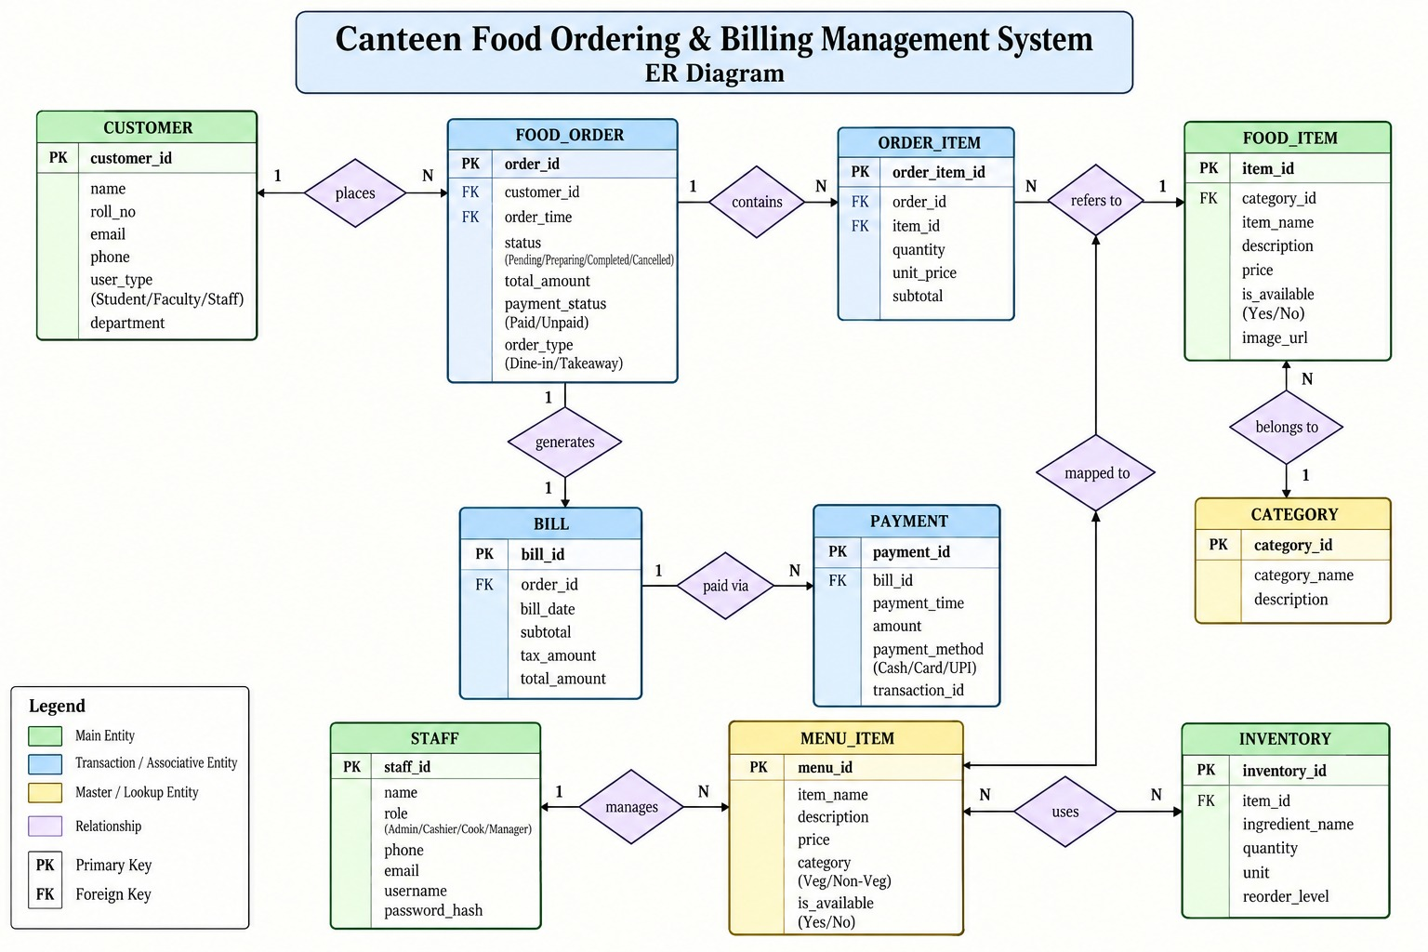
Figure 1: Entity–Relationship diagram of the Canteen Food Ordering and Billing Management System

4.1 Entities and Key Attributes
Table 6: Entities and key attributes
Entity | Type | Primary key | Attributes
CUSTOMER | Main | customer_id | name, roll_no, email, phone, user_type (Student / Faculty / Staff), department
STAFF | Main | staff_id | name, role (Admin / Cashier / Cook / Manager), phone, email, username, password_hash
CATEGORY | Master / lookup | category_id | category_name, description
FOOD_ITEM | Main | item_id | category_id (FK), item_name, description, price, is_available, image_url
MENU_ITEM | Master / lookup | menu_id | item_name, description, price, category (Veg / Non-Veg), is_available
INVENTORY | Main | inventory_id | item_id (FK), ingredient_name, quantity, unit, reorder_level
FOOD_ORDER | Transaction | order_id | customer_id (FK), order_time, status (Pending / Preparing / Completed / Cancelled), total_amount, payment_status (Paid / Unpaid), order_type (Dine-in / Takeaway)
ORDER_ITEM | Associative | order_item_id | order_id (FK), item_id (FK), quantity, unit_price, subtotal
BILL | Transaction | bill_id | order_id (FK), bill_date, subtotal, tax_amount, total_amount
PAYMENT | Transaction | payment_id | bill_id (FK), payment_time, amount, payment_method (Cash / Card / UPI), transaction_id

4.2 Relationships, Cardinality and Participation
Table 7: Relationships, cardinality and participation
Relationship | Entities | Cardinality | Participation / meaning
places | CUSTOMER – FOOD_ORDER | 1 : N | Every order is placed by exactly one customer; a customer may place many orders (or none yet).
contains | FOOD_ORDER – ORDER_ITEM | 1 : N | Every order contains at least one order line; each line belongs to one order.
refers to | ORDER_ITEM – FOOD_ITEM | N : 1 | Each order line refers to one food item; a food item may appear in many orders.
belongs to | FOOD_ITEM – CATEGORY | N : 1 | Every food item belongs to one category; a category groups many items.
generates | FOOD_ORDER – BILL | 1 : 1 | Each order generates one bill; each bill is for exactly one order.
paid via | BILL – PAYMENT | 1 : N | A bill can have several payment attempts, e.g. a failed UPI attempt followed by cash.
manages | STAFF – MENU_ITEM | 1 : N | A staff member manages many menu items; each menu item is managed by one staff member.
uses | MENU_ITEM – INVENTORY | M : N | A menu item uses many stock items and a stock item is used by many menu items.
mapped to | MENU_ITEM – FOOD_ITEM | 1 : N | Each food item sold to customers is mapped to the kitchen menu item that produces it.

ORDER_ITEM is the associative entity that resolves the many-to-many relationship between orders and food items, while capturing the quantity and the price charged. The combination (order_id, item_id) is unique, so the same food item cannot appear as two separate lines in one order.

4.3 Design Notes
- Derived attributes. ORDER_ITEM.subtotal (quantity × unit_price), BILL.total_amount (subtotal + tax_amount), FOOD_ORDER.total_amount and FOOD_ORDER.payment_status can be calculated from other data. They are kept in the conceptual model for readability and handled explicitly during normalization (Section 5.4).
- Relationship attributes. The M : N “uses” relationship becomes its own relation in the schema; the quantity of each stock item used per serving belongs to that relation.
- “mapped to”. In the diagram this relationship is drawn towards the “refers to” relationship. During mapping it is treated as a relationship between MENU_ITEM and FOOD_ITEM (1 : N), which is the only reading that can be represented with a foreign key.
- order_time is a descriptive attribute of FOOD_ORDER (the time the order was placed), not a foreign key.

5. Relational Schema and Normalization

5.1 Relational Schema
The ER model is converted to relations with the standard mapping rules: each entity becomes a relation with its key as the primary key; for each 1 : N relationship the primary key of the “1” side becomes a foreign key on the “N” side; the 1 : 1 relationship becomes a foreign key with a UNIQUE constraint; and the M : N relationship becomes a new relation whose primary key combines both foreign keys. Primary keys are shown bold and underlined, foreign keys in italics, and attributes added by the mapping rules are marked with an asterisk (*).
CUSTOMER ( customer_id, name, roll_no, email, phone, user_type, department )
STAFF ( staff_id, name, role, phone, email, username, password_hash )
CATEGORY ( category_id, category_name, description )
MENU_ITEM ( menu_id, staff_id*, item_name, description, price, category, is_available )
FOOD_ITEM ( item_id, category_id, menu_id*, item_name, description, price, is_available, image_url )
INVENTORY ( inventory_id, item_id, ingredient_name, quantity, unit, reorder_level )
MENU_ITEM_INVENTORY* ( menu_id, inventory_id )
FOOD_ORDER ( order_id, customer_id, order_time, status, total_amount, payment_status, order_type )
ORDER_ITEM ( order_item_id, order_id, item_id, quantity, unit_price, subtotal )
BILL ( bill_id, order_id, bill_date, subtotal, tax_amount, total_amount )
PAYMENT ( payment_id, bill_id, payment_time, amount, payment_method, transaction_id )
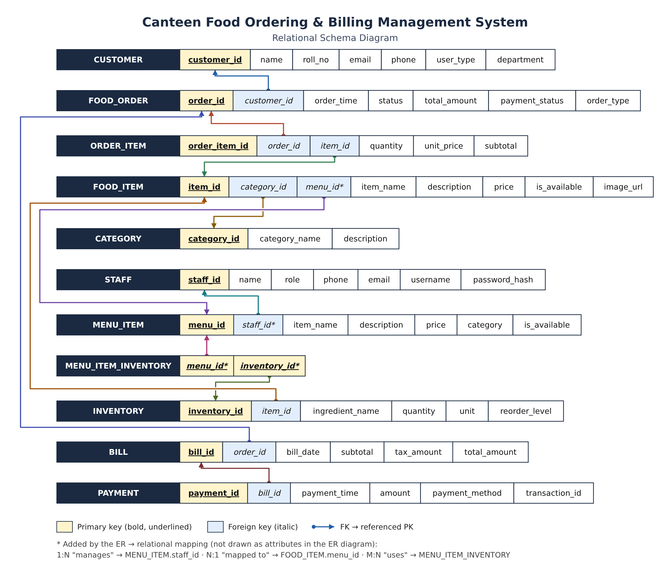
Figure 2: Relational schema diagram: arrows run from each foreign key to the primary key it references
Table 8: Foreign keys of the relational schema
Foreign key | References | Implements relationship
FOOD_ORDER.customer_id | CUSTOMER.customer_id | places (1 : N)
ORDER_ITEM.order_id | FOOD_ORDER.order_id | contains (1 : N)
ORDER_ITEM.item_id | FOOD_ITEM.item_id | refers to (N : 1)
FOOD_ITEM.category_id | CATEGORY.category_id | belongs to (N : 1)
FOOD_ITEM.menu_id | MENU_ITEM.menu_id | mapped to (1 : N)
MENU_ITEM.staff_id | STAFF.staff_id | manages (1 : N)
MENU_ITEM_INVENTORY.menu_id | MENU_ITEM.menu_id | uses (M : N)
MENU_ITEM_INVENTORY.inventory_id | INVENTORY.inventory_id | uses (M : N)
INVENTORY.item_id | FOOD_ITEM.item_id | stock item linked to a food item
BILL.order_id (UNIQUE) | FOOD_ORDER.order_id | generates (1 : 1)
PAYMENT.bill_id | BILL.bill_id | paid via (1 : N)

5.2 Functional Dependencies
Table 9: Functional dependencies
Relation | Functional dependencies
CUSTOMER | customer_id → name, roll_no, email, phone, user_type, department; email → customer_id; roll_no → customer_id
STAFF | staff_id → name, role, phone, email, username, password_hash; email → staff_id; username → staff_id
CATEGORY | category_id → category_name, description; category_name → category_id
MENU_ITEM | menu_id → staff_id, item_name, description, price, category, is_available; item_name → menu_id
FOOD_ITEM | item_id → category_id, menu_id, item_name, description, price, is_available, image_url; item_name → item_id
INVENTORY | inventory_id → item_id, ingredient_name, quantity, unit, reorder_level; ingredient_name → inventory_id
MENU_ITEM_INVENTORY | {menu_id, inventory_id} is the whole key (all-key relation, no non-trivial dependencies)
FOOD_ORDER | order_id → customer_id, order_time, status, total_amount, payment_status, order_type
ORDER_ITEM | order_item_id → order_id, item_id, quantity, unit_price, subtotal; {order_id, item_id} → order_item_id; {quantity, unit_price} → subtotal
BILL | bill_id → order_id, bill_date, subtotal, tax_amount, total_amount; order_id → bill_id; {subtotal, tax_amount} → total_amount
PAYMENT | payment_id → bill_id, payment_time, amount, payment_method, transaction_id; transaction_id → payment_id

5.3 Normalization to Third Normal Form

First Normal Form (1NF)
A flat canteen record might store several ordered items in one field, such as “Chicken Biryani ×1, Masala Chai ×2”, or several ingredients in one column of a menu record. The design removes these repeating groups: each item in an order is a separate ORDER_ITEM row, and each stock item used by a dish is a separate MENU_ITEM_INVENTORY row. Every attribute holds a single atomic value.

Second Normal Form (2NF)
2NF requires that no non-key attribute depends on only part of a composite key. The only composite primary key is {menu_id, inventory_id} in MENU_ITEM_INVENTORY, which has no non-key attributes, and every other relation has a single-attribute primary key. Attributes describing an order stay in FOOD_ORDER and attributes describing an item stay in FOOD_ITEM, so there are no partial dependencies.

Third Normal Form (3NF)
3NF requires that no non-key attribute depends on another non-key attribute. Customer, category, staff and stock details are stored once in their own relations and referenced by key instead of being repeated in every order row. Two stored values are exceptions because they are calculated: ORDER_ITEM.subtotal depends on {quantity, unit_price}, and BILL.total_amount depends on {subtotal, tax_amount}. These transitive dependencies are resolved in the implementation as described below.

5.4 Result
Table 10: Normalization result
Relation | 1NF | 2NF | 3NF | Reason
CUSTOMER | Yes | Yes | Yes | All attributes depend only on customer_id (email and roll_no are candidate keys).
STAFF | Yes | Yes | Yes | All attributes depend only on staff_id.
CATEGORY | Yes | Yes | Yes | Category name is stored once.
MENU_ITEM | Yes | Yes | Yes | Staff details are referenced through staff_id, not copied.
FOOD_ITEM | Yes | Yes | Yes | Category and menu-item details are referenced through foreign keys.
INVENTORY | Yes | Yes | Yes | Stock data depends only on inventory_id.
MENU_ITEM_INVENTORY | Yes | Yes | Yes | All-key relation.
FOOD_ORDER | Yes | Yes | Yes* | total_amount and payment_status repeat data held in BILL and PAYMENT.
ORDER_ITEM | Yes | Yes | Yes* | subtotal is derived from quantity × unit_price.
BILL | Yes | Yes | Yes* | total_amount is derived from subtotal + tax_amount.
PAYMENT | Yes | Yes | Yes | Payment data depends only on payment_id.

* In the implemented database (Chapter 7) these derived values are handled so that the stored schema is in 3NF: the order-line total is not stored and is calculated as quantity × unit_price in queries and in the view v_order_summary; the order’s amount and payment status are not stored on the order but read from the bill and its payments; and the bill keeps total_amount as a financial snapshot that is guarded by the constraint CHECK (total_amount = subtotal + tax - discount), so it can never disagree with its parts. unit_price is deliberately stored, because it records the price at the time of ordering and cannot be derived once the menu price changes.

5.5 From Logical Design to Physical Implementation
The physical database in the project repository (database.sql) implements this design with some practical consolidations. Customers and staff share one users table with a role column, because both log in the same way; FOOD_ITEM and MENU_ITEM are combined into menu_items; and stock is split into ingredients (what an ingredient is) and inventory (how much is in stock), with menu_item_ingredients holding each recipe.
Table 11: Mapping from the logical schema to the physical tables
Logical relation | Physical table(s) | Notes
CUSTOMER, STAFF | users | One table; role = STUDENT, STAFF or ADMIN; bcrypt password_hash for every user.
CATEGORY | categories | Same structure.
FOOD_ITEM, MENU_ITEM | menu_items | One table with price, availability, preparation_time, rating and image_url.
INVENTORY | ingredients, inventory | Ingredient details and stock levels in two tables linked 1 : 1.
MENU_ITEM_INVENTORY | menu_item_ingredients | Junction table with quantity_required per serving.
FOOD_ORDER | orders | Adds pickup_location and pickup_lane; money lives in bills.
ORDER_ITEM | order_items | Line total computed, not stored.
BILL | bills | Adds discount; CHECK keeps total_amount = subtotal + tax − discount.
PAYMENT | payments | Adds payment_status (PENDING / SUCCESS / FAILED) to record every attempt.

6. Data Dictionary
The data dictionary documents each relation of the logical schema: column, data type (MySQL 8), key, whether NULL is allowed, constraints and meaning. Columns marked * are added by the ER-to-relational mapping.

6.1 CUSTOMER
Stores people who order food: students, faculty and other campus users.
Table 12: Data dictionary: CUSTOMER
Column | Data type | Key | Null | Constraints | Description
customer_id | INT UNSIGNED | PK | No | AUTO_INCREMENT | Unique customer identifier
name | VARCHAR(100) | — | No | — | Full name
roll_no | VARCHAR(20) | UNIQUE | Yes | NULL for non-students | University roll number
email | VARCHAR(150) | UNIQUE | No | Valid email format | Login / contact email
phone | VARCHAR(15) | UNIQUE | Yes | 10–15 digits | Mobile number
user_type | ENUM | — | No | 'Student','Faculty','Staff' | Customer classification
department | VARCHAR(100) | — | Yes | — | Department or school

6.2 STAFF
Stores canteen employees who run the system.
Table 13: Data dictionary: STAFF
Column | Data type | Key | Null | Constraints | Description
staff_id | INT UNSIGNED | PK | No | AUTO_INCREMENT | Unique staff identifier
name | VARCHAR(100) | — | No | — | Full name
role | ENUM | — | No | 'Admin','Cashier','Cook','Manager' | Job role
phone | VARCHAR(15) | UNIQUE | Yes | 10–15 digits | Mobile number
email | VARCHAR(150) | UNIQUE | No | Valid email format | Work email
username | VARCHAR(50) | UNIQUE | No | — | Login name
password_hash | VARCHAR(255) | — | No | bcrypt hash only | Hashed password

6.3 CATEGORY
Groups food items on the menu.
Table 14: Data dictionary: CATEGORY
Column | Data type | Key | Null | Constraints | Description
category_id | INT UNSIGNED | PK | No | AUTO_INCREMENT | Unique category identifier
category_name | VARCHAR(50) | UNIQUE | No | — | Category name
description | VARCHAR(255) | — | Yes | — | Short description

6.4 MENU_ITEM
Kitchen dishes managed by staff; each uses stock items.
Table 15: Data dictionary: MENU_ITEM
Column | Data type | Key | Null | Constraints | Description
menu_id | INT UNSIGNED | PK | No | AUTO_INCREMENT | Unique menu-item identifier
staff_id* | INT UNSIGNED | FK | Yes | → STAFF; ON DELETE SET NULL | Staff member who manages it
item_name | VARCHAR(100) | UNIQUE | No | Not blank | Dish name
description | VARCHAR(255) | — | Yes | — | Short description
price | DECIMAL(8,2) | — | No | CHECK ≥ 0 | Price
category | ENUM | — | No | 'Veg','Non-Veg' | Dietary category
is_available | BOOLEAN | — | No | DEFAULT TRUE | Whether it can be prepared

6.5 FOOD_ITEM
Items customers can order, with category, price and availability.
Table 16: Data dictionary: FOOD_ITEM
Column | Data type | Key | Null | Constraints | Description
item_id | INT UNSIGNED | PK | No | AUTO_INCREMENT | Unique food-item identifier
category_id | INT UNSIGNED | FK | No | → CATEGORY; ON DELETE RESTRICT | Category of the item
menu_id* | INT UNSIGNED | FK | Yes | → MENU_ITEM; ON DELETE SET NULL | Kitchen dish it maps to
item_name | VARCHAR(100) | UNIQUE | No | Not blank | Name shown on the menu
description | VARCHAR(255) | — | Yes | — | Short description
price | DECIMAL(8,2) | — | No | CHECK ≥ 0 | Current menu price
is_available | BOOLEAN | — | No | DEFAULT TRUE | Whether it can be ordered
image_url | VARCHAR(255) | — | Yes | — | Picture of the item

6.6 INVENTORY
Stock items (ingredients) with quantity and reorder level.
Table 17: Data dictionary: INVENTORY
Column | Data type | Key | Null | Constraints | Description
inventory_id | INT UNSIGNED | PK | No | AUTO_INCREMENT | Unique stock-item identifier
item_id | INT UNSIGNED | FK | Yes | → FOOD_ITEM; ON DELETE SET NULL | Related food item
ingredient_name | VARCHAR(100) | UNIQUE | No | — | Ingredient name
quantity | DECIMAL(12,3) | — | No | CHECK ≥ 0 | Quantity in stock
unit | ENUM | — | No | 'g','kg','ml','l','pcs' | Unit of measure
reorder_level | DECIMAL(12,3) | — | No | CHECK ≥ 0 | Low-stock threshold

6.7 MENU_ITEM_INVENTORY
Associative relation for the M : N “uses” relationship.
Table 18: Data dictionary: MENU_ITEM_INVENTORY
Column | Data type | Key | Null | Constraints | Description
menu_id* | INT UNSIGNED | PK, FK | No | → MENU_ITEM; ON DELETE CASCADE | Menu item
inventory_id* | INT UNSIGNED | PK, FK | No | → INVENTORY; ON DELETE RESTRICT | Stock item used

6.8 FOOD_ORDER
Order header: who ordered, when, its status and type.
Table 19: Data dictionary: FOOD_ORDER
Column | Data type | Key | Null | Constraints | Description
order_id | INT UNSIGNED | PK | No | AUTO_INCREMENT | Order / token number
customer_id | INT UNSIGNED | FK | No | → CUSTOMER; ON DELETE RESTRICT | Customer who placed it
order_time | DATETIME | — | No | DEFAULT CURRENT_TIMESTAMP | When the order was placed
status | ENUM | — | No | 'Pending','Preparing','Completed','Cancelled' | Current order state
total_amount | DECIMAL(10,2) | — | No | CHECK ≥ 0 | Order amount (derived)
payment_status | ENUM | — | No | 'Paid','Unpaid' | Payment state (derived)
order_type | ENUM | — | No | 'Dine-in','Takeaway' | Service type

6.9 ORDER_ITEM
One row per food item in an order.
Table 20: Data dictionary: ORDER_ITEM
Column | Data type | Key | Null | Constraints | Description
order_item_id | INT UNSIGNED | PK | No | AUTO_INCREMENT | Line identifier
order_id | INT UNSIGNED | FK | No | → FOOD_ORDER; ON DELETE CASCADE; UNIQUE with item_id | Order the line belongs to
item_id | INT UNSIGNED | FK | No | → FOOD_ITEM; ON DELETE RESTRICT | Item ordered
quantity | SMALLINT UNSIGNED | — | No | CHECK > 0 | Units ordered
unit_price | DECIMAL(8,2) | — | No | CHECK ≥ 0 | Price at order time
subtotal | DECIMAL(10,2) | — | No | = quantity × unit_price | Line total (derived)

6.10 BILL
One bill per order with tax and total.
Table 21: Data dictionary: BILL
Column | Data type | Key | Null | Constraints | Description
bill_id | INT UNSIGNED | PK | No | AUTO_INCREMENT | Bill number
order_id | INT UNSIGNED | FK, UNIQUE | No | → FOOD_ORDER; ON DELETE RESTRICT | Order being billed
bill_date | DATETIME | — | No | DEFAULT CURRENT_TIMESTAMP | Bill date and time
subtotal | DECIMAL(10,2) | — | No | CHECK ≥ 0 | Sum of order lines
tax_amount | DECIMAL(10,2) | — | No | CHECK ≥ 0 | GST
total_amount | DECIMAL(10,2) | — | No | CHECK = subtotal + tax_amount | Amount payable

6.11 PAYMENT
Payment attempts against a bill.
Table 22: Data dictionary: PAYMENT
Column | Data type | Key | Null | Constraints | Description
payment_id | INT UNSIGNED | PK | No | AUTO_INCREMENT | Payment identifier
bill_id | INT UNSIGNED | FK | No | → BILL; ON DELETE RESTRICT | Bill being paid
payment_time | DATETIME | — | No | DEFAULT CURRENT_TIMESTAMP | When the payment was made
amount | DECIMAL(10,2) | — | No | CHECK > 0 | Amount paid
payment_method | ENUM | — | No | 'Cash','Card','UPI' | Payment method
transaction_id | VARCHAR(64) | UNIQUE | Yes | Required unless Cash | Gateway / UPI reference

7. SQL Commands Used (DDL and DML) with Sample Outputs
The database canteen_db is created by a single script, database.sql, in the project repository. Running mysql -u root -p < database.sql drops and recreates the database, creates all tables and the view, and loads the sample data. All statements and outputs in this chapter are taken from that script and from the running MySQL 8.0 server.

7.1 Physical Schema Overview
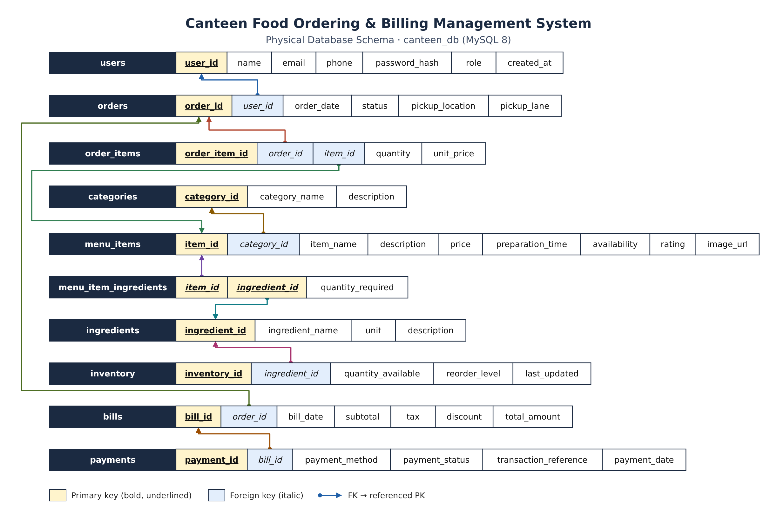
Figure 3: Physical database schema of canteen_db as implemented in database.sql
mysql> SHOW FULL TABLES;
+-----------------------+------------+
| Tables_in_canteen_db | Table_type |
+-----------------------+------------+
| bills | BASE TABLE |
| categories | BASE TABLE |
| ingredients | BASE TABLE |
| inventory | BASE TABLE |
| menu_item_ingredients | BASE TABLE |
| menu_items | BASE TABLE |
| order_items | BASE TABLE |
| orders | BASE TABLE |
| payments | BASE TABLE |
| users | BASE TABLE |
| v_order_summary | VIEW |
+-----------------------+------------+

7.2 Data Definition Language (DDL)
Each table is created with named constraints so that error messages identify exactly which rule was broken. The complete DDL from database.sql is shown below.

Creating the database
DROP DATABASE IF EXISTS canteen_db;
CREATE DATABASE canteen_db
CHARACTER SET utf8mb4
COLLATE utf8mb4_0900_ai_ci;
USE canteen_db;

Table users
CREATE TABLE users (
user_id INT UNSIGNED NOT NULL AUTO_INCREMENT,
name VARCHAR(100) NOT NULL,
email VARCHAR(150) NOT NULL,
phone VARCHAR(15) NULL,
password_hash VARCHAR(255) NOT NULL, -- bcrypt hash only, never plaintext
role ENUM('STUDENT','ADMIN','STAFF') NOT NULL DEFAULT 'STUDENT',
created_at TIMESTAMP NOT NULL DEFAULT CURRENT_TIMESTAMP,
CONSTRAINT pk_users PRIMARY KEY (user_id),
CONSTRAINT uq_users_email UNIQUE (email),
CONSTRAINT uq_users_phone UNIQUE (phone),
CONSTRAINT chk_users_email CHECK (email LIKE '%_@_%._%'),
CONSTRAINT chk_users_phone CHECK (phone IS NULL OR phone REGEXP '^[0-9+][0-9]{9,14}$'),
CONSTRAINT chk_users_hash CHECK (CHAR_LENGTH(password_hash) >= 50)
) ENGINE=InnoDB;

Table categories
CREATE TABLE categories (
category_id INT UNSIGNED NOT NULL AUTO_INCREMENT,
category_name VARCHAR(50) NOT NULL,
description VARCHAR(255) NULL,
CONSTRAINT pk_categories PRIMARY KEY (category_id),
CONSTRAINT uq_categories_name UNIQUE (category_name)
) ENGINE=InnoDB;

Table menu_items
CREATE TABLE menu_items (
item_id INT UNSIGNED NOT NULL AUTO_INCREMENT,
category_id INT UNSIGNED NOT NULL,
item_name VARCHAR(100) NOT NULL,
description VARCHAR(255) NULL,
price DECIMAL(8,2) NOT NULL,
preparation_time SMALLINT UNSIGNED NOT NULL DEFAULT 10, -- minutes
availability BOOLEAN NOT NULL DEFAULT TRUE,
rating DECIMAL(2,1) NULL,
image_url VARCHAR(255) NULL,
created_at TIMESTAMP NOT NULL DEFAULT CURRENT_TIMESTAMP,
CONSTRAINT pk_menu_items PRIMARY KEY (item_id),
CONSTRAINT uq_menu_items_name UNIQUE (item_name),
CONSTRAINT fk_menu_items_cat FOREIGN KEY (category_id)
REFERENCES categories (category_id)
ON UPDATE CASCADE ON DELETE RESTRICT,
CONSTRAINT chk_menu_price CHECK (price >= 0),
CONSTRAINT chk_menu_prep_time CHECK (preparation_time >= 0),
CONSTRAINT chk_menu_rating CHECK (rating IS NULL OR rating BETWEEN 0 AND 5),
CONSTRAINT chk_menu_name CHECK (CHAR_LENGTH(TRIM(item_name)) > 0)
) ENGINE=InnoDB;

Table ingredients
CREATE TABLE ingredients (
ingredient_id INT UNSIGNED NOT NULL AUTO_INCREMENT,
ingredient_name VARCHAR(100) NOT NULL,
unit ENUM('g','kg','ml','l','pcs') NOT NULL,
description VARCHAR(255) NULL,
CONSTRAINT pk_ingredients PRIMARY KEY (ingredient_id),
CONSTRAINT uq_ingredients_name UNIQUE (ingredient_name)
) ENGINE=InnoDB;

Table menu_item_ingredients
CREATE TABLE menu_item_ingredients (
item_id INT UNSIGNED NOT NULL,
ingredient_id INT UNSIGNED NOT NULL,
quantity_required DECIMAL(10,3) NOT NULL, -- per 1 serving, in ingredient's unit
CONSTRAINT pk_menu_item_ingredients PRIMARY KEY (item_id, ingredient_id),
CONSTRAINT fk_mii_item FOREIGN KEY (item_id)
REFERENCES menu_items (item_id)
ON UPDATE CASCADE ON DELETE CASCADE,
CONSTRAINT fk_mii_ingredient FOREIGN KEY (ingredient_id)
REFERENCES ingredients (ingredient_id)
ON UPDATE CASCADE ON DELETE RESTRICT,
CONSTRAINT chk_mii_qty CHECK (quantity_required > 0)
) ENGINE=InnoDB;

Table inventory
CREATE TABLE inventory (
inventory_id INT UNSIGNED NOT NULL AUTO_INCREMENT,
ingredient_id INT UNSIGNED NOT NULL,
quantity_available DECIMAL(12,3) NOT NULL DEFAULT 0,
reorder_level DECIMAL(12,3) NOT NULL DEFAULT 0,
last_updated TIMESTAMP NOT NULL DEFAULT CURRENT_TIMESTAMP
ON UPDATE CURRENT_TIMESTAMP,
CONSTRAINT pk_inventory PRIMARY KEY (inventory_id),
CONSTRAINT uq_inventory_ingredient UNIQUE (ingredient_id),
CONSTRAINT fk_inventory_ingredient FOREIGN KEY (ingredient_id)
REFERENCES ingredients (ingredient_id)
ON UPDATE CASCADE ON DELETE CASCADE,
CONSTRAINT chk_inventory_qty CHECK (quantity_available >= 0),
CONSTRAINT chk_inventory_reorder CHECK (reorder_level >= 0)
) ENGINE=InnoDB;

Table orders
CREATE TABLE orders (
order_id INT UNSIGNED NOT NULL AUTO_INCREMENT,
user_id INT UNSIGNED NOT NULL,
order_date TIMESTAMP NOT NULL DEFAULT CURRENT_TIMESTAMP,
status ENUM('PENDING','CONFIRMED','PREPARING','READY','COMPLETED','CANCELLED')
NOT NULL DEFAULT 'PENDING',
pickup_location VARCHAR(100) NOT NULL DEFAULT 'Main Canteen',
pickup_lane VARCHAR(20) NULL,
CONSTRAINT pk_orders PRIMARY KEY (order_id),
CONSTRAINT fk_orders_user FOREIGN KEY (user_id)
REFERENCES users (user_id)
ON UPDATE CASCADE ON DELETE RESTRICT,
INDEX idx_orders_user_date (user_id, order_date),
INDEX idx_orders_status (status)
) ENGINE=InnoDB;

Table order_items
CREATE TABLE order_items (
order_item_id INT UNSIGNED NOT NULL AUTO_INCREMENT,
order_id INT UNSIGNED NOT NULL,
item_id INT UNSIGNED NOT NULL,
quantity SMALLINT UNSIGNED NOT NULL DEFAULT 1,
unit_price DECIMAL(8,2) NOT NULL,
CONSTRAINT pk_order_items PRIMARY KEY (order_item_id),
CONSTRAINT uq_order_items_order_item UNIQUE (order_id, item_id),
CONSTRAINT fk_order_items_order FOREIGN KEY (order_id)
REFERENCES orders (order_id)
ON UPDATE CASCADE ON DELETE CASCADE,
CONSTRAINT fk_order_items_item FOREIGN KEY (item_id)
REFERENCES menu_items (item_id)
ON UPDATE CASCADE ON DELETE RESTRICT,
CONSTRAINT chk_order_items_qty CHECK (quantity > 0),
CONSTRAINT chk_order_items_price CHECK (unit_price >= 0)
) ENGINE=InnoDB;

Table bills
CREATE TABLE bills (
bill_id INT UNSIGNED NOT NULL AUTO_INCREMENT,
order_id INT UNSIGNED NOT NULL,
bill_date TIMESTAMP NOT NULL DEFAULT CURRENT_TIMESTAMP,
subtotal DECIMAL(10,2) NOT NULL,
tax DECIMAL(10,2) NOT NULL DEFAULT 0,
discount DECIMAL(10,2) NOT NULL DEFAULT 0,
total_amount DECIMAL(10,2) NOT NULL,
CONSTRAINT pk_bills PRIMARY KEY (bill_id),
CONSTRAINT uq_bills_order UNIQUE (order_id),
CONSTRAINT fk_bills_order FOREIGN KEY (order_id)
REFERENCES orders (order_id)
ON UPDATE CASCADE ON DELETE RESTRICT,
CONSTRAINT chk_bills_subtotal CHECK (subtotal >= 0),
CONSTRAINT chk_bills_tax CHECK (tax >= 0),
CONSTRAINT chk_bills_discount CHECK (discount >= 0 AND discount <= subtotal + tax),
CONSTRAINT chk_bills_total CHECK (total_amount = subtotal + tax - discount)
) ENGINE=InnoDB;

Table payments
CREATE TABLE payments (
payment_id INT UNSIGNED NOT NULL AUTO_INCREMENT,
bill_id INT UNSIGNED NOT NULL,
payment_method ENUM('UPI','CAMPUS_WALLET','CASH') NOT NULL,
payment_status ENUM('PENDING','SUCCESS','FAILED') NOT NULL DEFAULT 'PENDING',
transaction_reference VARCHAR(64) NULL, -- NULL allowed for cash
payment_date TIMESTAMP NOT NULL DEFAULT CURRENT_TIMESTAMP,
CONSTRAINT pk_payments PRIMARY KEY (payment_id),
CONSTRAINT uq_payments_txnref UNIQUE (transaction_reference),
CONSTRAINT fk_payments_bill FOREIGN KEY (bill_id)
REFERENCES bills (bill_id)
ON UPDATE CASCADE ON DELETE RESTRICT,
CONSTRAINT chk_payments_txnref CHECK (
payment_method = 'CASH' OR transaction_reference IS NOT NULL)
) ENGINE=InnoDB;

View v_order_summary
CREATE VIEW v_order_summary AS
SELECT o.order_id,
o.user_id,
o.order_date,
o.status,
o.pickup_location,
o.pickup_lane,
SUM(oi.quantity * oi.unit_price) AS items_subtotal,
b.bill_id,
b.tax,
b.discount,
b.total_amount
FROM orders o
JOIN order_items oi ON oi.order_id = o.order_id
LEFT JOIN bills b ON b.order_id = o.order_id
GROUP BY o.order_id, o.user_id, o.order_date, o.status, o.pickup_location,
o.pickup_lane, b.bill_id, b.tax, b.discount, b.total_amount;

7.3 Data Manipulation Language (DML)
Sample data is inserted with multi-row INSERT statements. Excerpts are shown below; the full statements are in database.sql.

Users (passwords stored only as bcrypt hashes)
INSERT INTO users (user_id, name, email, phone, password_hash, role, created_at) VALUES
(1, 'Rajesh Kumar', 'admin@canteen.woxsen.edu.in', '9876500001', '$2b$10$ctEBkLLS…', 'ADMIN', '2026-07-01 09:00:00'),
(2, 'Sunita Reddy', 'sunita.staff@canteen.woxsen.edu.in','9876500002', '$2b$10$3vrFxsFX…', 'STAFF', '2026-07-01 09:30:00'),
-- ... 4 more rows ('Aarav Sharma', 'Priya Iyer', 'Rohan Verma', 'Ananya Gupta')
-- (bcrypt hashes are 60 characters long; shortened here for readability)

Categories and menu items
INSERT INTO categories (category_id, category_name, description) VALUES
(1, 'Burgers & Wraps', 'Burgers, wraps and rolls'),
(2, 'Main Course', 'Biryani, rice and noodle meals'),
(3, 'South Indian', 'Dosa, idli and other South Indian dishes'),
(4, 'Snacks', 'Quick bites and fried snacks'),
(5, 'Beverages', 'Hot and cold drinks'),
(6, 'Desserts', 'Sweets and baked treats');

INSERT INTO menu_items (item_id, category_id, item_name, description, price, preparation_time, availability, rating, image_url) VALUES
(1, 1, 'Chicken Burger', 'Crispy chicken patty with lettuce and mayo', 120.00, 12, TRUE, 4.4, '/images/chicken-burger.jpg'),
(2, 1, 'Veg Burger', 'Aloo-veg patty with onion, tomato and sauce', 80.00, 10, TRUE, 4.1, '/images/veg-burger.jpg'),
(3, 1, 'Paneer Wrap', 'Tandoori paneer tikka rolled in a soft roti', 110.00, 10, TRUE, 4.5, '/images/paneer-wrap.jpg'),
-- ... 10 more rows (Brownie is inserted with availability = FALSE)

Ingredients, recipes and stock
INSERT INTO ingredients (ingredient_id, ingredient_name, unit, description) VALUES
(1, 'Chicken', 'g', 'Boneless chicken'),
(2, 'Paneer', 'g', 'Fresh cottage cheese'),
-- ... 16 more ingredients

INSERT INTO menu_item_ingredients (item_id, ingredient_id, quantity_required) VALUES
(1, 1, 120), (1, 3, 1), (1, 6, 20), (1, 7, 20), (1, 15, 30), -- Chicken Burger
(2, 5, 100), (2, 3, 1), (2, 6, 20), (2, 15, 30), -- Veg Burger
-- ... recipes for the remaining 11 items

INSERT INTO inventory (ingredient_id, quantity_available, reorder_level) VALUES
(1, 15000, 5000), -- Chicken (g)
(2, 6000, 2000), -- Paneer (g)
-- ... 16 more stock rows

Orders and order lines
INSERT INTO orders (order_id, user_id, order_date, status, pickup_location, pickup_lane) VALUES
(1, 3, '2026-10-01 12:45:00', 'COMPLETED', 'Main Canteen', 'Lane 1'),
(2, 4, '2026-10-01 13:10:00', 'COMPLETED', 'Main Canteen', 'Lane 2'),
(3, 5, '2026-10-02 16:30:00', 'COMPLETED', 'Food Court', 'Lane 1'),
(4, 6, '2026-10-03 09:15:00', 'CANCELLED', 'Main Canteen', 'Lane 3'),
(5, 3, '2026-10-05 13:00:00', 'READY', 'Main Canteen', 'Lane 1'),
(6, 4, '2026-10-06 12:20:00', 'PREPARING', 'Food Court', 'Lane 2'),
(7, 5, '2026-10-06 12:40:00', 'PENDING', 'Main Canteen', NULL);

INSERT INTO order_items (order_id, item_id, quantity, unit_price) VALUES
(1, 4, 1, 160.00), (1, 11, 2, 20.00), -- Aarav
(2, 3, 1, 110.00), (2, 10, 1, 60.00), (2, 9, 2, 30.00), -- Priya
(3, 1, 2, 120.00), (3, 8, 1, 60.00), (3, 12, 2, 40.00), -- Rohan
(4, 7, 1, 70.00), (4, 11, 1, 20.00), -- Ananya (cancelled)
(5, 5, 1, 120.00), (5, 13, 1, 70.00), -- Aarav
(6, 6, 2, 90.00), (6, 12, 1, 40.00), -- Priya
(7, 2, 1, 80.00), (7, 11, 1, 20.00); -- Rohan

Bills computed from the order lines (INSERT … SELECT)
Bills are not typed in by hand. The subtotal is calculated from order_items inside the INSERT, so it can never disagree with the order lines, and 5% GST is applied.
INSERT INTO bills (order_id, bill_date, subtotal, tax, discount, total_amount)
SELECT t.order_id, t.order_date, t.sub, t.tax, t.disc, t.sub + t.tax - t.disc
FROM (
SELECT o.order_id,
o.order_date,
SUM(oi.quantity * oi.unit_price) AS sub,
ROUND(SUM(oi.quantity * oi.unit_price) * 0.05, 2) AS tax,
CASE o.order_id WHEN 3 THEN 20.00 WHEN 2 THEN 10.00 ELSE 0.00 END AS disc
FROM orders o
JOIN order_items oi ON oi.order_id = o.order_id
WHERE o.status NOT IN ('CANCELLED','PENDING')
GROUP BY o.order_id, o.order_date
) t
ORDER BY t.order_id;
-- Resulting bill_ids: 1->order 1, 2->order 2, 3->order 3, 4->order 5, 5->order 6

Payments (one bill can have several attempts)
INSERT INTO payments (bill_id, payment_method, payment_status, transaction_reference, payment_date) VALUES
(1, 'UPI', 'SUCCESS', 'UPI2026100112451001', '2026-10-01 12:46:00'),
(2, 'CAMPUS_WALLET', 'SUCCESS', 'CW-2026100113100002', '2026-10-01 13:11:00'),
(3, 'UPI', 'FAILED', 'UPI2026100216300003', '2026-10-02 16:31:00'),
(3, 'CASH', 'SUCCESS', NULL, '2026-10-02 16:33:00'),
(4, 'UPI', 'SUCCESS', 'UPI2026100513000004', '2026-10-05 13:01:00'),
(5, 'CAMPUS_WALLET', 'PENDING', 'CW-2026100612200005', '2026-10-06 12:21:00');

7.4 Transactional Order Placement
Placing an order touches five tables. The application runs all of the steps on one connection inside a transaction: if any step fails (for example, not enough stock, or an item has just been marked sold out), ROLLBACK undoes everything and no partial order is stored. The statements executed for one order are:
SQL executed by POST /api/orders (server.js)
START TRANSACTION;
-- 1. prices and availability come from the database, not the browser
SELECT item_id, item_name, price, availability FROM menu_items WHERE item_id IN (?);
-- 2. order header
INSERT INTO orders (user_id, status, pickup_location, pickup_lane) VALUES (?, 'PENDING', ?, ?);
-- 3. one line per item, at the current price
INSERT INTO order_items (order_id, item_id, quantity, unit_price) VALUES (?, ?, ?, ?), ...;
-- 4. lock the stock rows this order needs, check them, then deduct
SELECT inv.inventory_id, SUM(mii.quantity_required * oi.quantity) AS needed
FROM order_items oi JOIN menu_item_ingredients mii ON ... JOIN inventory inv ON ...
WHERE oi.order_id = ? GROUP BY ... FOR UPDATE;
UPDATE inventory SET quantity_available = quantity_available - ? WHERE inventory_id = ?;
-- 5. bill with 5% GST
INSERT INTO bills (order_id, subtotal, tax, discount, total_amount) VALUES (?, ?, ?, 0, ?);
-- 6. payment attempt
INSERT INTO payments (bill_id, payment_method, payment_status, transaction_reference)
VALUES (?, ?, ?, ?);
UPDATE orders SET status = 'CONFIRMED' WHERE order_id = ?; -- UPI / campus wallet only
COMMIT; -- or ROLLBACK on any error

Cancelling an order (by the student before preparation, or by staff at any stage before completion) runs a similar transaction that sets the status to CANCELLED and adds the same ingredient quantities back to inventory.

7.5 Sample Data Overview
Table 23: Rows loaded by database.sql
Table | Rows | Notable sample data
users | 6 | 1 admin, 1 staff member, 4 students
categories | 6 | Burgers & Wraps, Main Course, South Indian, Snacks, Beverages, Desserts
menu_items | 13 | Brownie is marked sold out
ingredients | 18 | Units g, ml and pcs
menu_item_ingredients | 43 | Every menu item has a recipe
inventory | 18 | Noodles and Chocolate are below their reorder level
orders | 7 | 3 completed, 1 cancelled, 1 ready, 1 preparing, 1 pending
order_items | 16 | 2–3 lines per order
bills | 5 | Two bills carry a discount
payments | 6 | Bill 3 has a failed UPI attempt followed by a successful cash payment

8. Queries with Outputs
The following queries were executed against canteen_db immediately after loading database.sql. The outputs are the actual result sets returned by MySQL 8.0.

8.1 Join query: customer order history
Query 1
SELECT u.name AS customer, o.order_id, o.status, b.total_amount
FROM users u
JOIN orders o ON o.user_id = u.user_id
LEFT JOIN bills b ON b.order_id = o.order_id
ORDER BY o.order_id;

Table 24: Output of Query 1
customer | order_id | status | total_amount
Aarav Sharma | 1 | COMPLETED | 210.00
Priya Iyer | 2 | COMPLETED | 231.50
Rohan Verma | 3 | COMPLETED | 379.00
Ananya Gupta | 4 | CANCELLED | NULL
Aarav Sharma | 5 | READY | 199.50
Priya Iyer | 6 | PREPARING | 231.00
Rohan Verma | 7 | PENDING | NULL

An inner join with users and a left join with bills lists every order with its customer; orders without a bill (cancelled or pending) show NULL for the amount.

8.2 Aggregate query: revenue by category
Query 2
SELECT c.category_name,
SUM(oi.quantity * oi.unit_price) AS revenue
FROM categories c
JOIN menu_items m ON m.category_id = c.category_id
JOIN order_items oi ON oi.item_id = m.item_id
JOIN orders o ON o.order_id = oi.order_id
WHERE o.status <> 'CANCELLED'
GROUP BY c.category_id, c.category_name
ORDER BY revenue DESC;

Table 25: Output of Query 2
category_name | revenue
Main Course | 460.00
Burgers & Wraps | 430.00
Beverages | 240.00
Snacks | 120.00
Desserts | 70.00

Line totals are calculated from quantity × unit_price and grouped by category; cancelled orders are excluded.

8.3 Aggregate query: paid bills, revenue and average bill value
Query 3
SELECT COUNT(*) AS paid_bills,
SUM(b.total_amount) AS revenue,
ROUND(AVG(b.total_amount),2) AS average_bill
FROM bills b
WHERE EXISTS (SELECT 1 FROM payments p
WHERE p.bill_id = b.bill_id AND p.payment_status = 'SUCCESS');

Table 26: Output of Query 3
paid_bills | revenue | average_bill
4 | 1020.00 | 255.00

A correlated EXISTS subquery restricts the aggregate to bills that have at least one successful payment.

8.4 Popular food items
Query 4
SELECT m.item_name, SUM(oi.quantity) AS units_sold
FROM menu_items m
JOIN order_items oi ON oi.item_id = m.item_id
JOIN orders o ON o.order_id = oi.order_id
WHERE o.status <> 'CANCELLED'
GROUP BY m.item_id, m.item_name
ORDER BY units_sold DESC, m.item_name
LIMIT 8;

Table 27: Output of Query 4
item_name | units_sold
Lime Soda | 3
Masala Chai | 3
Chicken Burger | 2
Hakka Noodles | 2
Samosa | 2
Brownie | 1
Chicken Biryani | 1
Cold Coffee | 1

Units sold per item across all non-cancelled orders.

8.5 Active (not yet collected) orders
Query 5
SELECT o.order_id, u.name AS customer, o.status,
o.pickup_location, o.pickup_lane
FROM orders o
JOIN users u ON u.user_id = o.user_id
WHERE o.status IN ('PENDING','CONFIRMED','PREPARING','READY')
ORDER BY o.order_date;

Table 28: Output of Query 5
order_id | customer | status | pickup_location | pickup_lane
5 | Aarav Sharma | READY | Main Canteen | Lane 1
6 | Priya Iyer | PREPARING | Food Court | Lane 2
7 | Rohan Verma | PENDING | Main Canteen | NULL

Orders the kitchen still has to finish, oldest first.

8.6 Ingredients at or below reorder level
Query 6
SELECT ing.ingredient_name, inv.quantity_available,
inv.reorder_level, ing.unit
FROM inventory inv
JOIN ingredients ing ON ing.ingredient_id = inv.ingredient_id
WHERE inv.quantity_available <= inv.reorder_level;

Table 29: Output of Query 6
ingredient_name | quantity_available | reorder_level | unit
Noodles | 1800.000 | 2000.000 | g
Chocolate | 300.000 | 500.000 | g

The low-stock rule used by the dashboard and the inventory screen.

8.7 Payment attempts by method and status
Query 7
SELECT payment_method, payment_status, COUNT(*) AS attempts
FROM payments
GROUP BY payment_method, payment_status
ORDER BY payment_method, payment_status;

Table 30: Output of Query 7
payment_method | payment_status | attempts
UPI | SUCCESS | 2
UPI | FAILED | 1
CAMPUS_WALLET | PENDING | 1
CAMPUS_WALLET | SUCCESS | 1
CASH | SUCCESS | 1

Every payment attempt is kept, so failed and pending attempts are visible alongside successful ones.

8.8 Recipe of a menu item (M:N join through MENU_ITEM_INGREDIENTS)
Query 8
SELECT m.item_name, ing.ingredient_name,
mii.quantity_required, ing.unit
FROM menu_item_ingredients mii
JOIN menu_items m ON m.item_id = mii.item_id
JOIN ingredients ing ON ing.ingredient_id = mii.ingredient_id
WHERE m.item_name = 'Chicken Biryani';

Table 31: Output of Query 8
item_name | ingredient_name | quantity_required | unit
Chicken Biryani | Chicken | 150.000 | g
Chicken Biryani | Basmati Rice | 200.000 | g
Chicken Biryani | Onion | 50.000 | g
Chicken Biryani | Cooking Oil | 20.000 | ml

A three-table join through the junction table shows the recipe used for stock deduction.

8.9 Subquery: menu items priced above the average menu price
Query 9
SELECT item_name, price
FROM menu_items
WHERE price > (SELECT AVG(price) FROM menu_items)
ORDER BY price DESC;

Table 32: Output of Query 9
item_name | price
Chicken Biryani | 160.00
Chicken Burger | 120.00
Veg Biryani | 120.00
Paneer Wrap | 110.00
Hakka Noodles | 90.00
Veg Burger | 80.00

A scalar subquery computes the average menu price, which the outer query compares against.

8.10 View: v_order_summary
Query 10
SELECT order_id, status, items_subtotal, tax, discount, total_amount
FROM v_order_summary
ORDER BY order_id;

Table 33: Output of Query 10
order_id | status | items_subtotal | tax | discount | total_amount
1 | COMPLETED | 200.00 | 10.00 | 0.00 | 210.00
2 | COMPLETED | 230.00 | 11.50 | 10.00 | 231.50
3 | COMPLETED | 380.00 | 19.00 | 20.00 | 379.00
4 | CANCELLED | 90.00 | NULL | NULL | NULL
5 | READY | 190.00 | 9.50 | 0.00 | 199.50
6 | PREPARING | 220.00 | 11.00 | 0.00 | 231.00
7 | PENDING | 100.00 | NULL | NULL | NULL

The view combines orders, their computed subtotal and their bill, without storing any line totals.

9. UI Design and Screenshots

9.1 Design Approach
The interface is a single-page browser application written in plain HTML, CSS and JavaScript. After login, the navigation shows only the screens a user’s role allows: students see Menu and My orders; staff see Dashboard, Orders, Inventory and Billing; administrators additionally see Menu management. Validation messages appear next to the form that caused them, destructive actions ask for confirmation, and every action ends with a short success or error message.
The most important DBMS principle shown by the UI is persistence: every screen is rendered from data returned by the API, which reads from MySQL, and every insert, update or delete made in the UI is written to MySQL. Section 9.3 shows the same records in the UI and in the database. All screenshots in this chapter were captured from the running application connected to canteen_db.

9.2 Screens
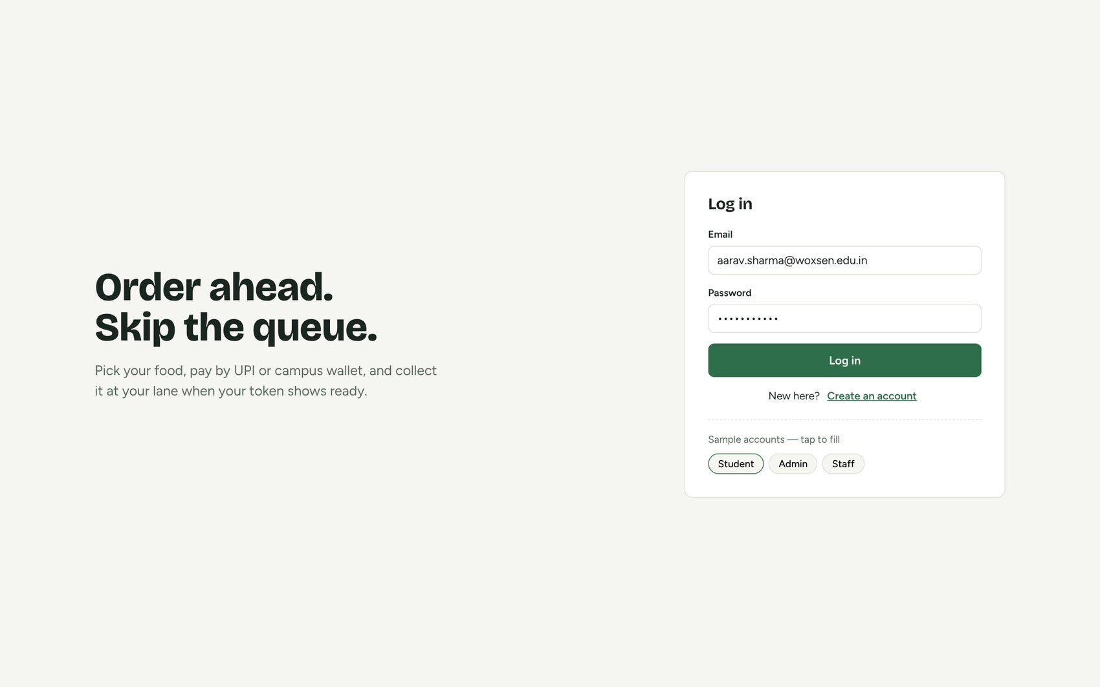
Figure 4: Login screen with sample accounts for each role
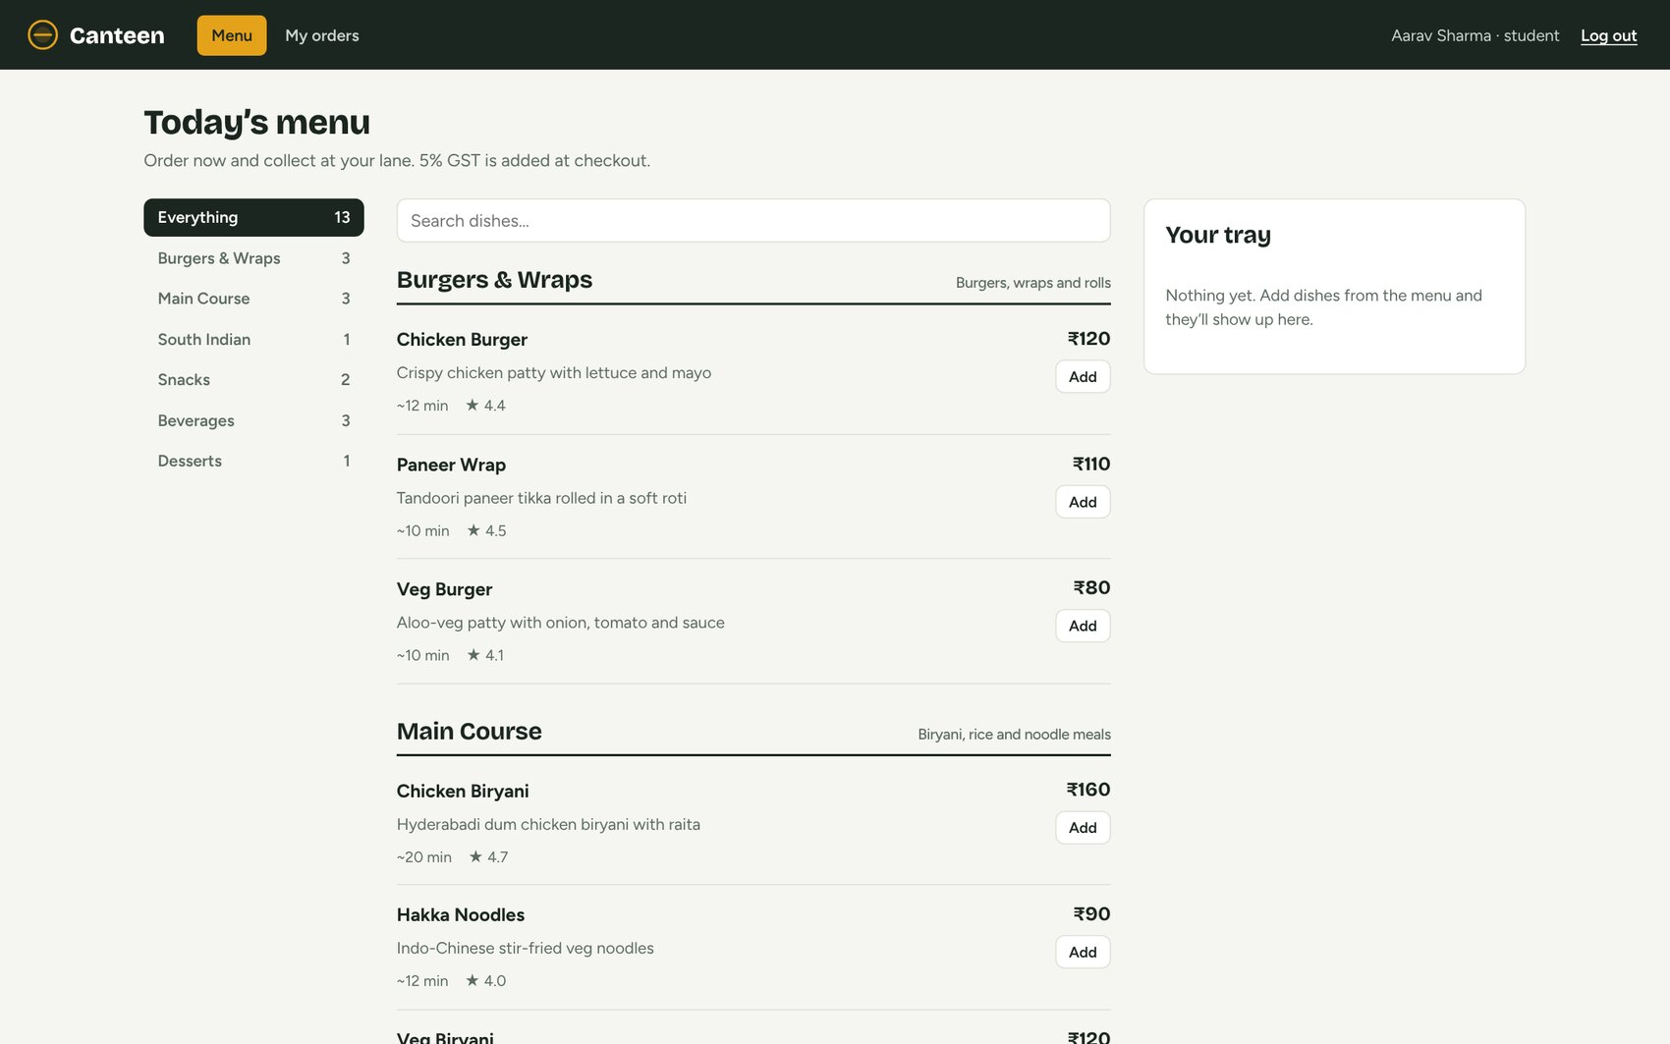
Figure 5: Student menu: categories, search, prices, preparation time and ratings
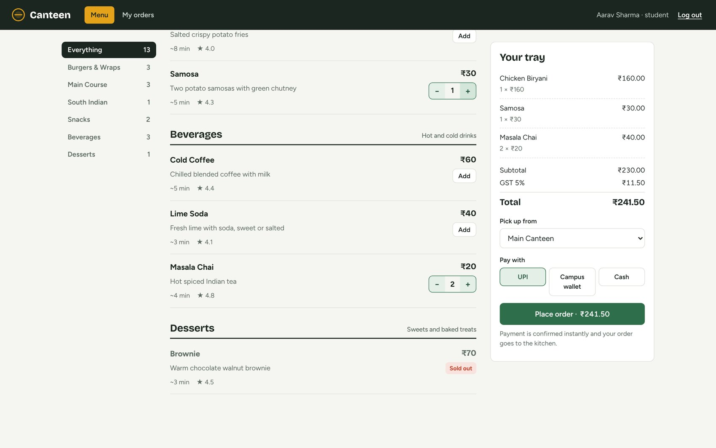
Figure 6: Tray and checkout: line totals, 5% GST, pickup point and payment method; sold-out items cannot be added
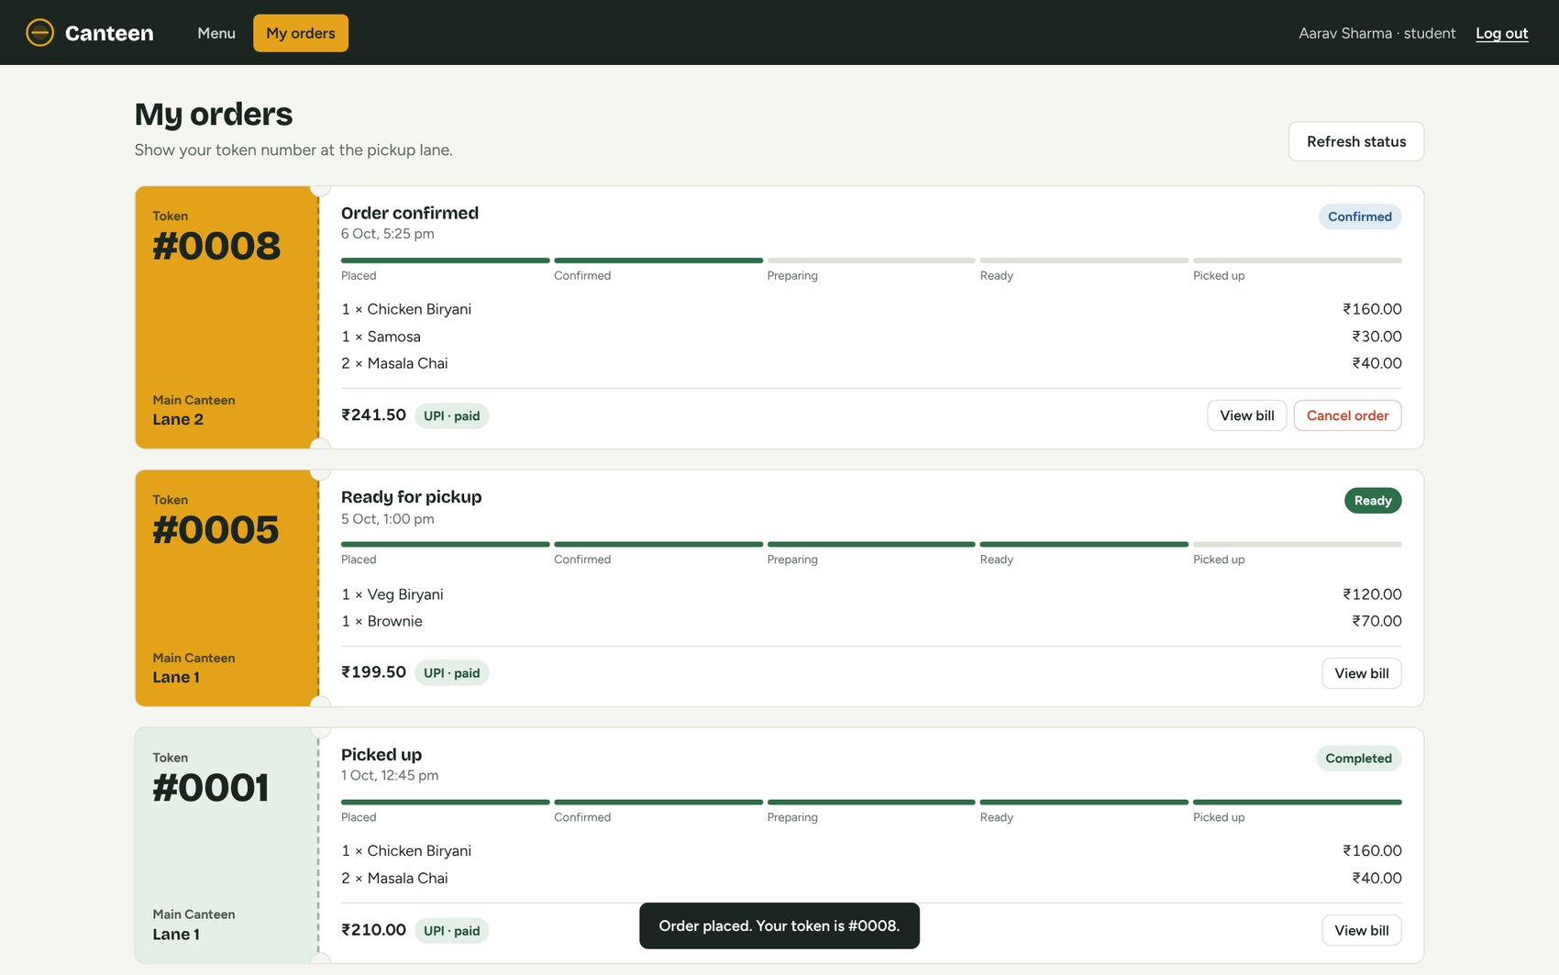
Figure 7: My orders: pickup token, lane, status progress and payment state after placing an order
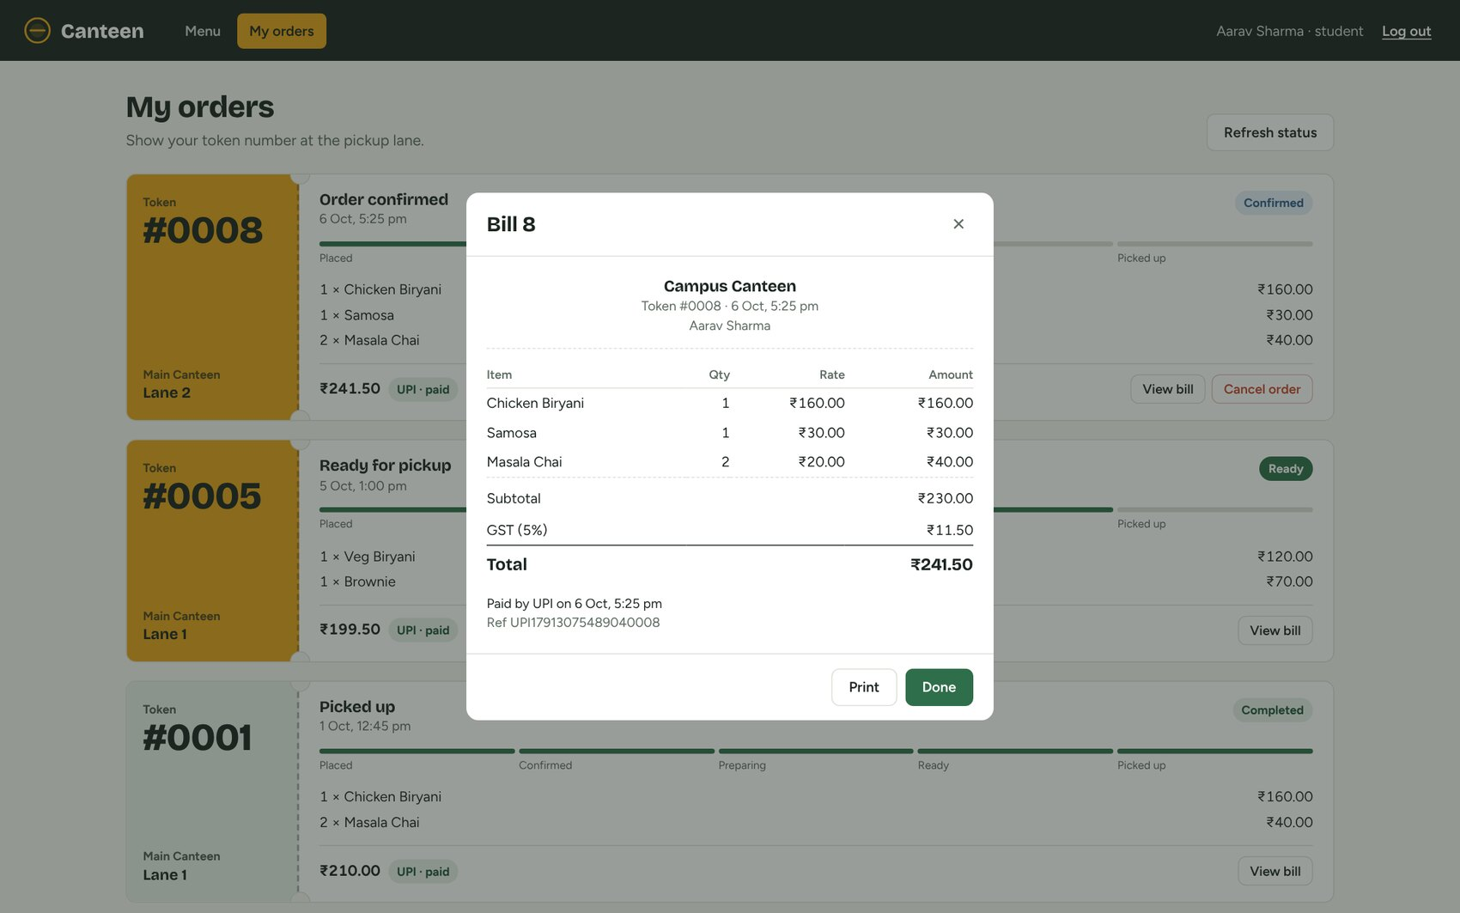
Figure 8: Bill generated for the order, with GST, total and UPI transaction reference
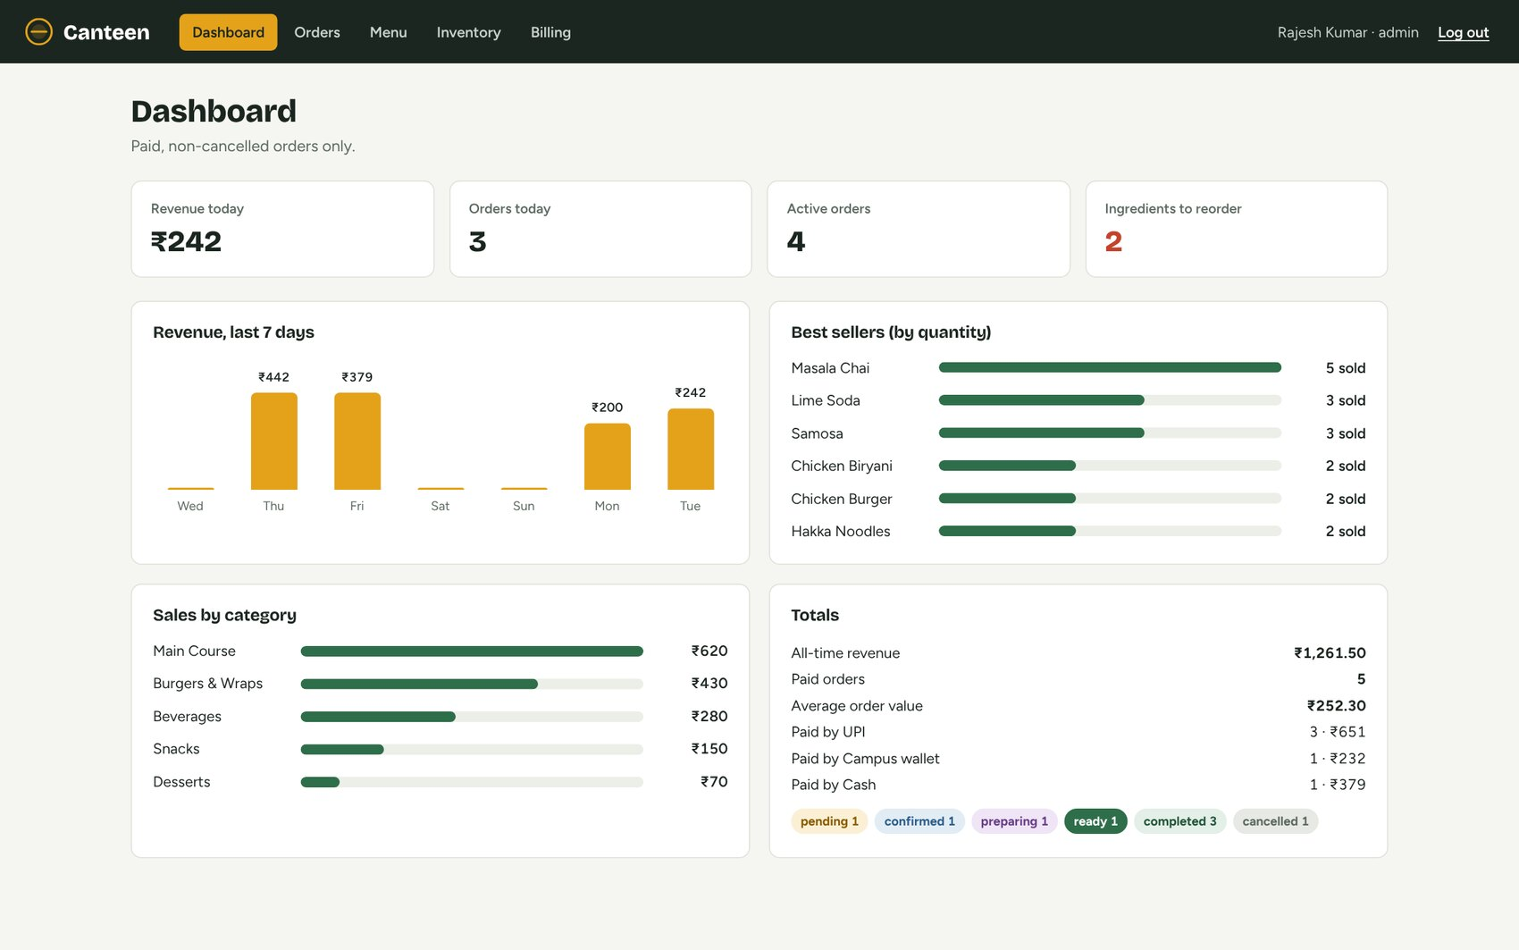
Figure 9: Staff / admin dashboard: revenue, active orders, low stock, best sellers and sales by category
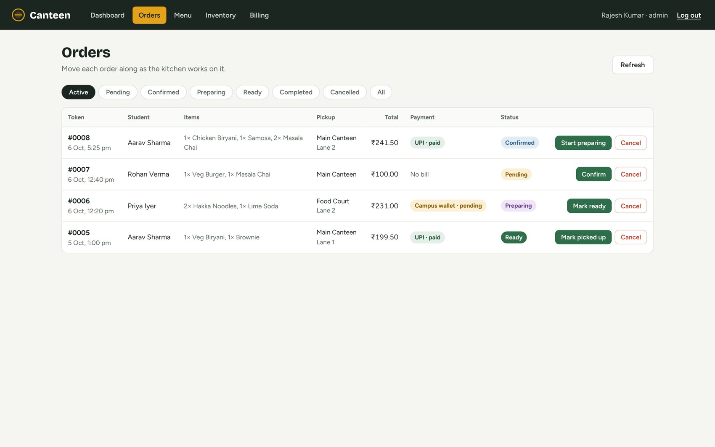
Figure 10: Order management: active orders with payment state and the next status action
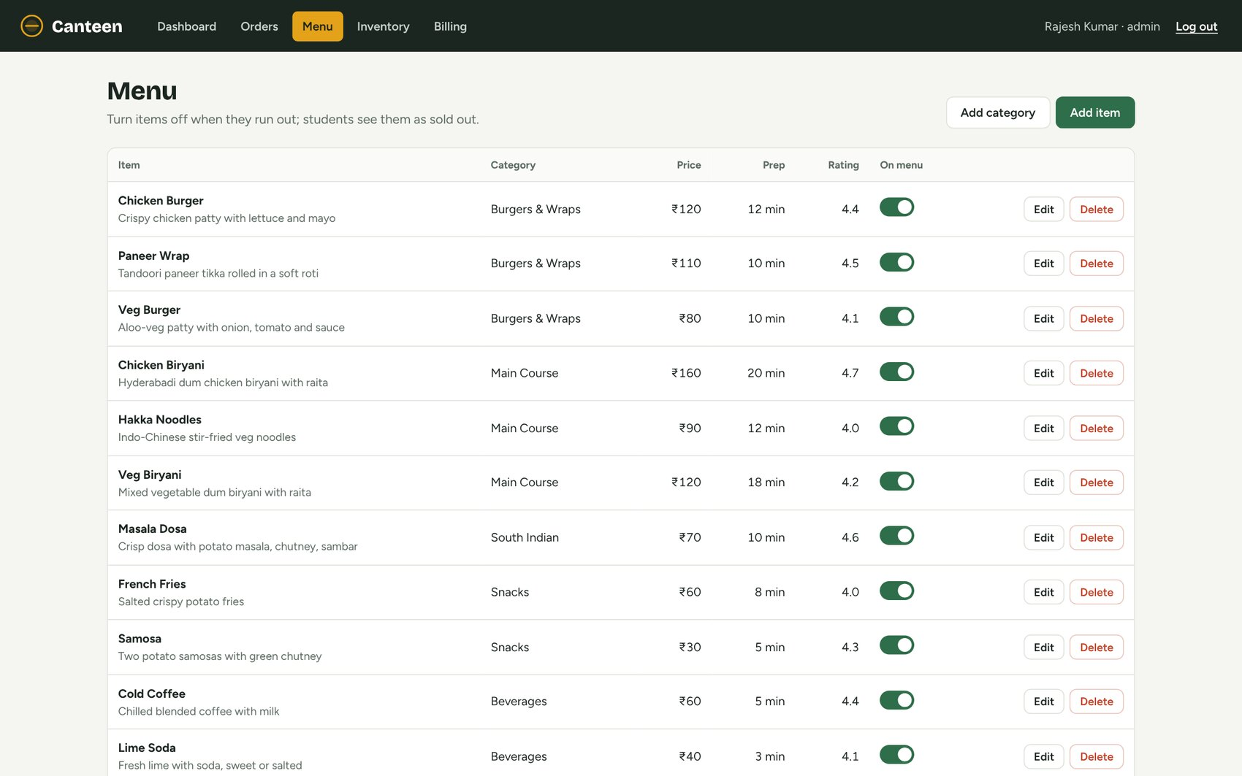
Figure 11: Menu management (admin): items with availability toggle, edit and delete; categories below
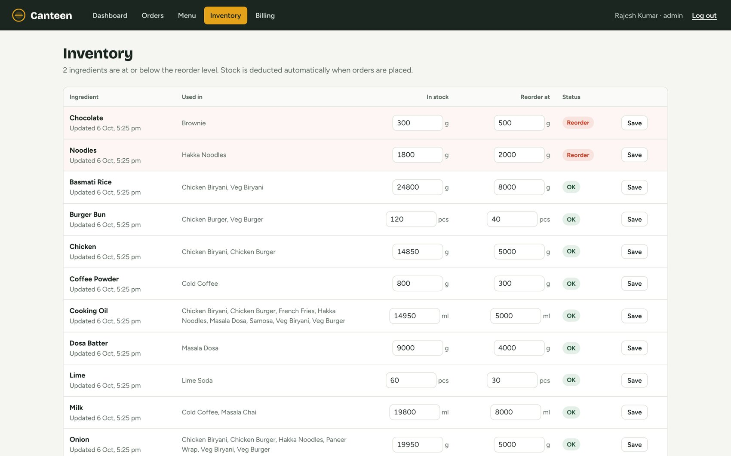
Figure 12: Inventory: stock and reorder levels, with ingredients below the reorder level flagged
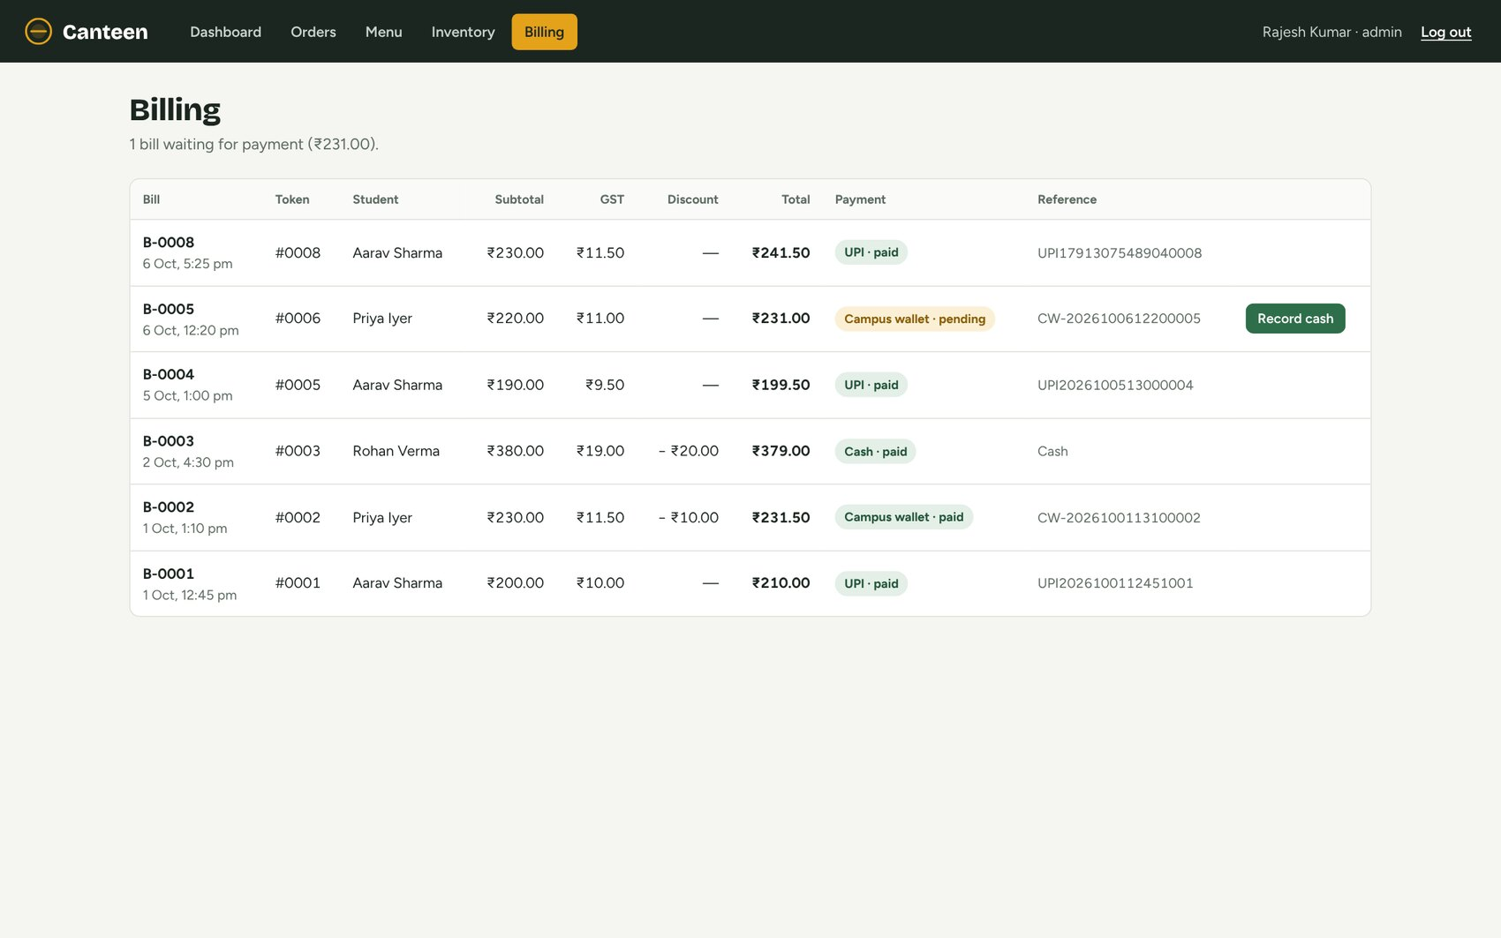
Figure 13: Billing: every bill with GST, discount, payment state, reference and cash collection

9.3 Insert, Update, View and Delete — Reflected in the Database
Each operation below was performed in the UI and then checked with a SELECT query in MySQL.

Insert: registering a new student
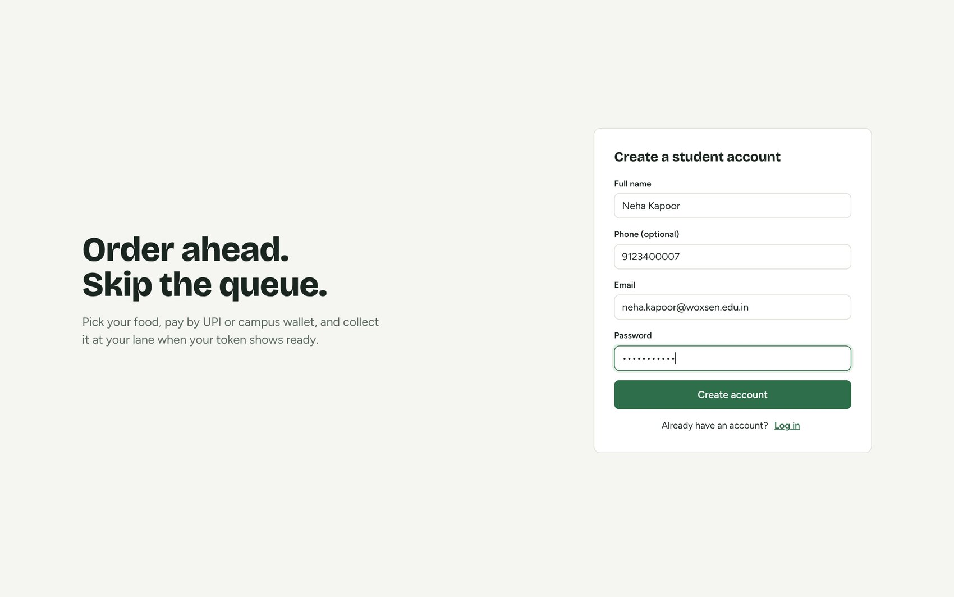
Figure 14: Registration form: a new student account is created
mysql> SELECT user_id, name, email, phone, role, LEFT(password_hash,7) AS hash_prefix FROM users WHERE email = 'neha.kapoor@woxsen.edu.in';
+---------+-------------+---------------------------+------------+---------+-------------+
| user_id | name | email | phone | role | hash_prefix |
+---------+-------------+---------------------------+------------+---------+-------------+
| 7 | Neha Kapoor | neha.kapoor@woxsen.edu.in | 9123400007 | STUDENT | $2b$10$ |
+---------+-------------+---------------------------+------------+---------+-------------+

The new row appears in users with role STUDENT. Only the bcrypt hash (prefix $2b$10$) is stored, never the password.

Insert across five tables: placing an order
Aarav Sharma placed the order shown in Figures 6–7 (1 × Chicken Biryani, 1 × Samosa, 2 × Masala Chai, paid by UPI). The transaction created the following rows:
mysql> SELECT order_id, user_id, order_date, status, pickup_location, pickup_lane FROM orders WHERE order_id = 8;
+----------+---------+---------------------+-----------+-----------------+-------------+
| order_id | user_id | order_date | status | pickup_location | pickup_lane |
+----------+---------+---------------------+-----------+-----------------+-------------+
| 8 | 3 | 2026-10-06 17:25:48 | CONFIRMED | Main Canteen | Lane 2 |
+----------+---------+---------------------+-----------+-----------------+-------------+

mysql> SELECT order_item_id, order_id, item_id, quantity, unit_price, quantity*unit_price AS line_total FROM order_items WHERE order_id = 8;
+---------------+----------+---------+----------+------------+------------+
| order_item_id | order_id | item_id | quantity | unit_price | line_total |
+---------------+----------+---------+----------+------------+------------+
| 17 | 8 | 4 | 1 | 160.00 | 160.00 |
| 18 | 8 | 9 | 1 | 30.00 | 30.00 |
| 19 | 8 | 11 | 2 | 20.00 | 40.00 |
+---------------+----------+---------+----------+------------+------------+

mysql> SELECT bill_id, order_id, subtotal, tax, discount, total_amount FROM bills WHERE order_id = 8;
+---------+----------+----------+-------+----------+--------------+
| bill_id | order_id | subtotal | tax | discount | total_amount |
+---------+----------+----------+-------+----------+--------------+
| 8 | 8 | 230.00 | 11.50 | 0.00 | 241.50 |
+---------+----------+----------+-------+----------+--------------+

mysql> SELECT p.payment_id, p.bill_id, p.payment_method, p.payment_status, p.transaction_reference FROM payments p JOIN bills b ON b.bill_id = p.bill_id WHERE b.order_id = 8;
+------------+---------+----------------+----------------+-----------------------+
| payment_id | bill_id | payment_method | payment_status | transaction_reference |
+------------+---------+----------------+----------------+-----------------------+
| 7 | 8 | UPI | SUCCESS | UPI17913075489040008 |
+------------+---------+----------------+----------------+-----------------------+

The same transaction deducted ingredients according to the recipes (Chicken Biryani uses 150 g chicken and 200 g rice; Samosa 60 g potato; each Masala Chai 100 ml milk and 3 g tea leaves):
Stock before the order
+-----------------+--------------------+------+
| ingredient_name | quantity_available | unit |
+-----------------+--------------------+------+
| Chicken | 15000.000 | g |
| Basmati Rice | 25000.000 | g |
| Potato | 30000.000 | g |
| Milk | 20000.000 | ml |
| Tea Leaves | 1500.000 | g |
+-----------------+--------------------+------+

Stock after the order
+-----------------+--------------------+------+
| ingredient_name | quantity_available | unit |
+-----------------+--------------------+------+
| Chicken | 14850.000 | g |
| Basmati Rice | 24800.000 | g |
| Potato | 29940.000 | g |
| Milk | 19800.000 | ml |
| Tea Leaves | 1494.000 | g |
+-----------------+--------------------+------+

Update: moving the order through the kitchen
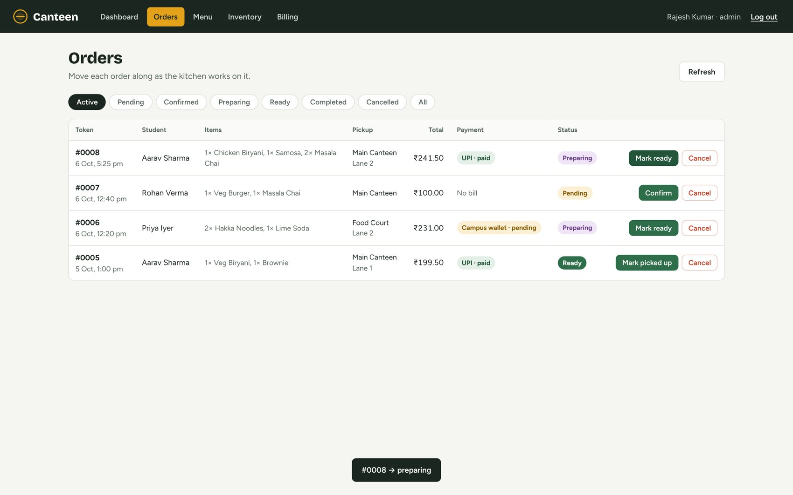
Figure 15: Staff moved the order to “Preparing”; the confirmation message is shown
mysql> SELECT order_id, status FROM orders WHERE order_id = 8;
+----------+-----------+
| order_id | status |
+----------+-----------+
| 8 | PREPARING |
+----------+-----------+

Insert: adding a menu item
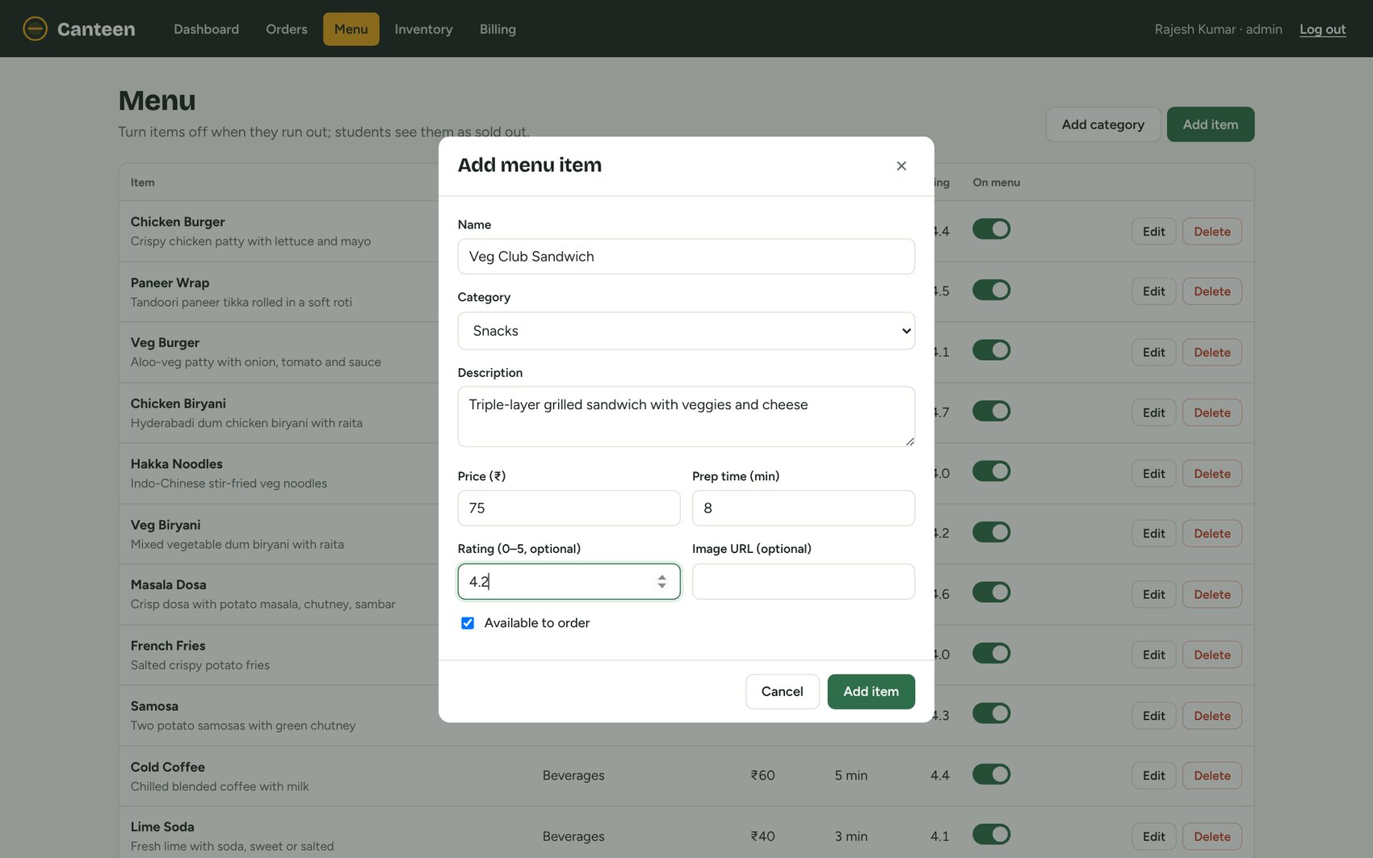
Figure 16: Add menu item form filled in by the administrator
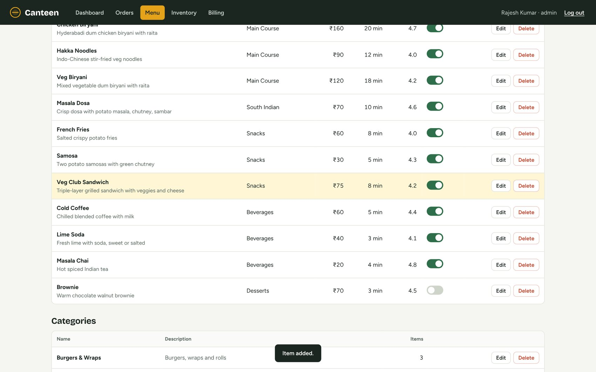
Figure 17: The new item appears in the menu table (highlighted) with the “Item added” message
mysql> SELECT item_id, category_id, item_name, price, preparation_time, availability, rating FROM menu_items WHERE item_name = 'Veg Club Sandwich';
+---------+-------------+-------------------+-------+------------------+--------------+--------+
| item_id | category_id | item_name | price | preparation_time | availability | rating |
+---------+-------------+-------------------+-------+------------------+--------------+--------+
| 14 | 4 | Veg Club Sandwich | 75.00 | 8 | 1 | 4.2 |
+---------+-------------+-------------------+-------+------------------+--------------+--------+

Delete blocked by referential integrity
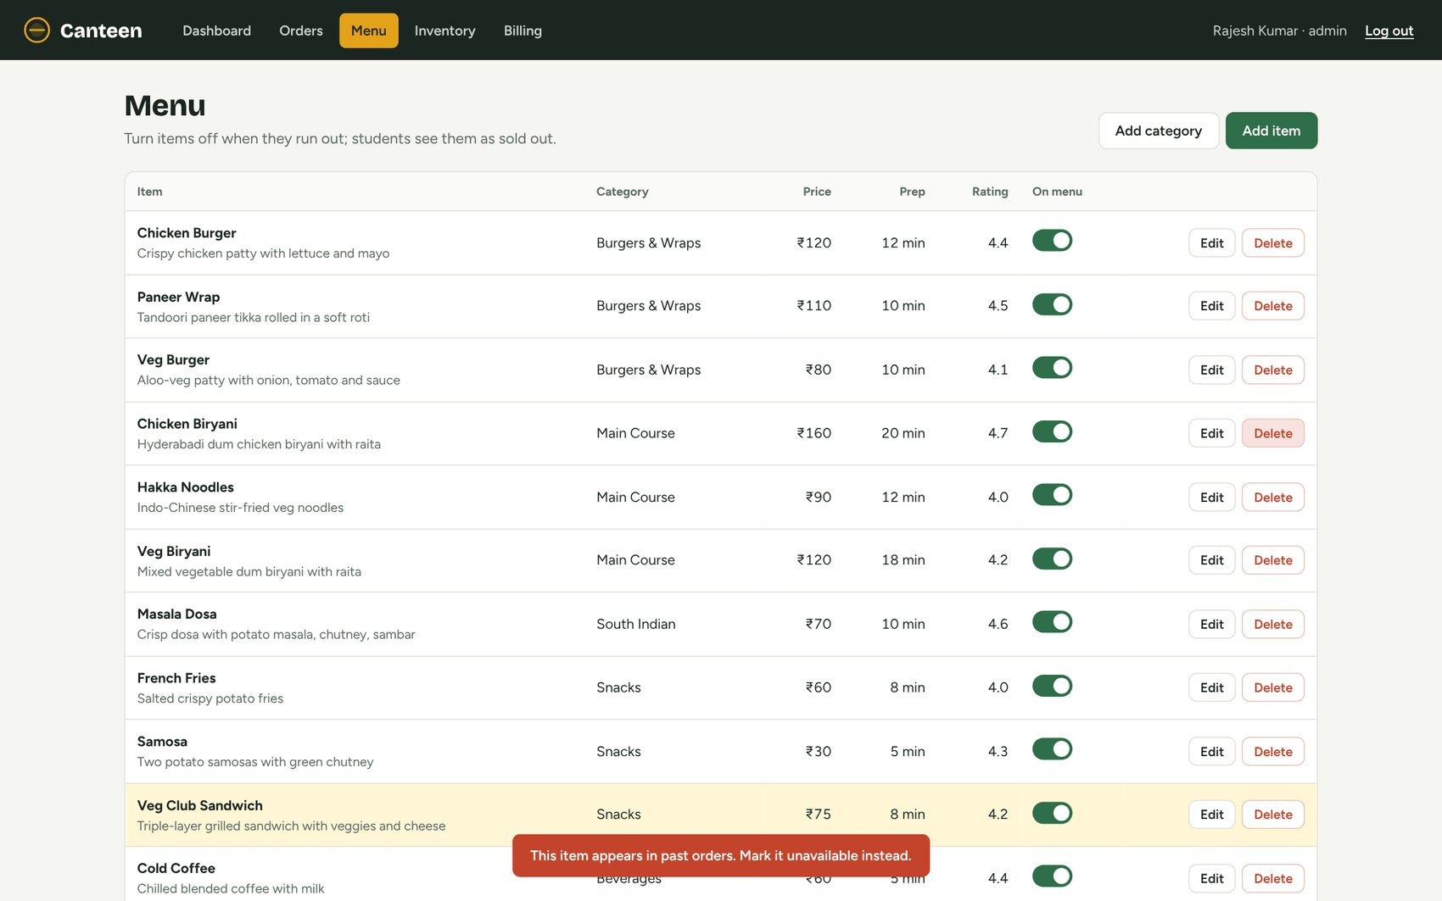
Figure 18: Deleting Chicken Biryani is refused because the item appears in past orders
The application tried DELETE FROM menu_items WHERE item_id = 4. MySQL rejected it because order_items.item_id references the item with ON DELETE RESTRICT (error 1451), and the API turned the error into the message shown. Order history is therefore never broken; the item can be marked unavailable instead.

Delete: removing the test item
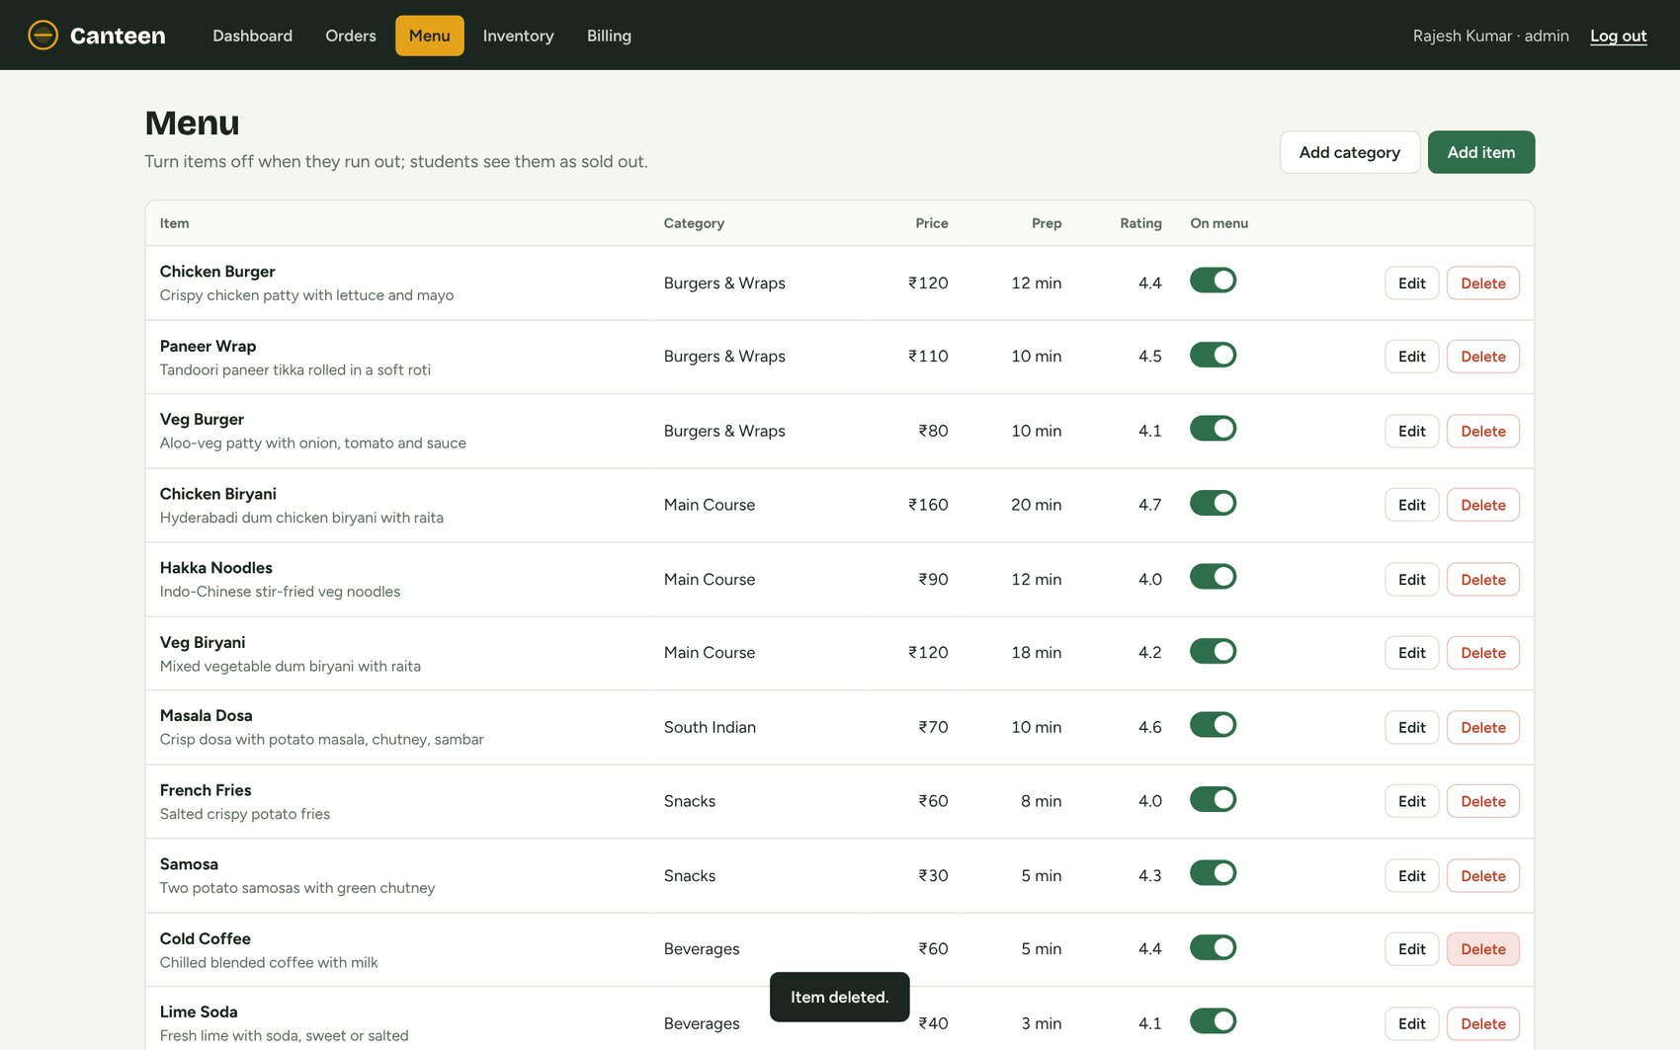
Figure 19: The test item is deleted and no longer listed
mysql> SELECT COUNT(*) AS rows_found FROM menu_items WHERE item_name = 'Veg Club Sandwich';
+------------+
| rows_found |
+------------+
| 0 |
+------------+

10. Implementation Details

10.1 Technology Stack and Architecture
The system follows a three-tier architecture. The browser runs the single-page UI, the Node.js / Express server exposes a JSON REST API and serves the static files, and MySQL stores the data and enforces the integrity rules.
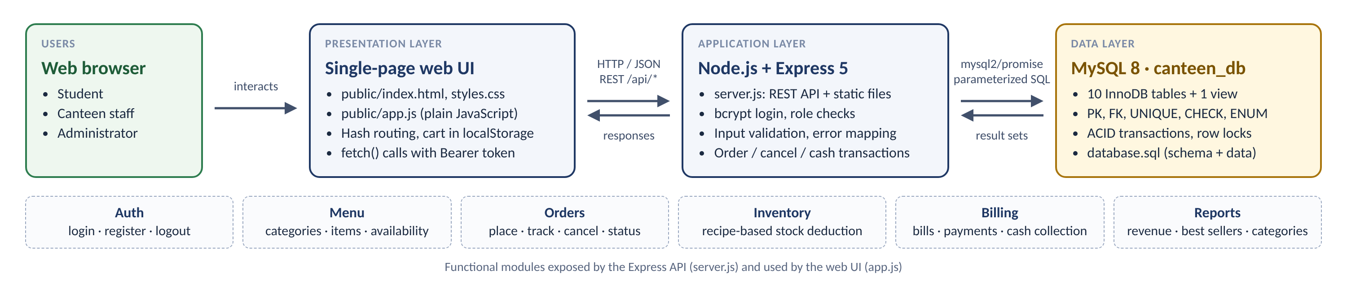
Figure 20: System architecture
Table 34: Technology stack
Layer | Technology | Role
Presentation | HTML5, CSS3, JavaScript | public/index.html, styles.css and app.js: menu, tray, orders, bill, dashboard and staff screens; hash-based routing.
Application | Node.js, Express 5 | server.js: authentication, role checks, validation, transactions and reports.
Connectivity | mysql2/promise | Connection pool (10 connections) with parameterized queries.
Security | bcryptjs, random tokens | Password hashing; 48-character session tokens sent as Bearer headers.
Database | MySQL 8.0, InnoDB | 10 tables and 1 view with PK, FK, UNIQUE, CHECK and ENUM constraints.
Version control | Git, GitHub | Source code, database.sql and documentation.

10.2 Database Connectivity
Connection settings are read from a .env file (not committed to Git) and a connection pool is created once when the server starts:
server.js — configuration and connection pool
// ---- tiny .env loader (no extra dependency) ----
const envFile = path.join(__dirname, '.env');
if (fs.existsSync(envFile)) {
for (const line of fs.readFileSync(envFile, 'utf8').split(/\r?\n/)) {
const m = line.match(/^\s*([A-Z_]+)\s*=\s*(.*)\s*$/);
if (m && process.env[m[1]] === undefined) process.env[m[1]] = m[2];
}
}

const pool = mysql.createPool({
host: process.env.DB_HOST || 'localhost',
port: Number(process.env.DB_PORT || 3306),
user: process.env.DB_USER || 'root',
password: process.env.DB_PASSWORD || '',
database: process.env.DB_NAME || 'canteen_db',
dateStrings: true,
decimalNumbers: true,
connectionLimit: 10,
});

10.3 Key Code Snippets

Login with bcrypt and parameterized SQL
app.post('/api/login', wrap(async (req, res) => {
const { email, password } = req.body || {};
if (!email || !password) throw new ApiError(400, 'Enter your email and password.');
const [[user]] = await pool.query('SELECT * FROM users WHERE email = ?', [email.trim()]);
if (!user || !(await bcrypt.compare(password, user.password_hash)))
throw new ApiError(401, 'Email or password is incorrect.');
const token = crypto.randomBytes(24).toString('hex');
const safe = { user_id: user.user_id, name: user.name, email: user.email, role: user.role };
sessions.set(token, safe);
res.json({ token, user: safe });
}));

Role-based access control
function auth(...roles) {
return (req, res, next) => {
const token = (req.headers.authorization || '').replace('Bearer ', '');
const user = sessions.get(token);
if (!user) return res.status(401).json({ error: 'Please log in again.' });
if (roles.length && !roles.includes(user.role))
return res.status(403).json({ error: 'You do not have access to this.' });
req.user = user;
next();
};
}
const STAFF = ['ADMIN', 'STAFF'];

Recipe-based stock adjustment (used when placing and cancelling orders)
// Adjust ingredient stock for an order. sign = -1 deduct, +1 restore.
async function adjustStock(conn, orderId, sign) {
const [needs] = await conn.query(
`SELECT inv.inventory_id, ing.ingredient_name, ing.unit, inv.quantity_available,
SUM(mii.quantity_required * oi.quantity) AS needed
FROM order_items oi
JOIN menu_item_ingredients mii ON mii.item_id = oi.item_id
JOIN ingredients ing ON ing.ingredient_id = mii.ingredient_id
JOIN inventory inv ON inv.ingredient_id = ing.ingredient_id
WHERE oi.order_id = ?
GROUP BY inv.inventory_id, ing.ingredient_name, ing.unit, inv.quantity_available
FOR UPDATE`, [orderId]);
for (const n of needs) {
if (sign < 0 && n.quantity_available < n.needed)
throw new ApiError(409, `Not enough ${n.ingredient_name} in stock for this order.`);
await conn.query(
'UPDATE inventory SET quantity_available = quantity_available + ? WHERE inventory_id = ?',
[sign * n.needed, n.inventory_id]);
}
}

Placing an order as one transaction
app.post('/api/orders', auth(), wrap(async (req, res) => {
const { items, pickup_location, payment_method } = req.body || {};
if (!Array.isArray(items) || !items.length) throw new ApiError(400, 'Your cart is empty.');
if (!['UPI', 'CAMPUS_WALLET', 'CASH'].includes(payment_method)) throw new ApiError(400, 'Choose a payment method.');

const conn = await pool.getConnection();
try {
await conn.beginTransaction();
const ids = items.map((i) => Number(i.item_id));
const [menu] = await conn.query(
'SELECT item_id, item_name, price, availability FROM menu_items WHERE item_id IN (?)', [ids]);
let subtotal = 0;
for (const it of items) {
const m = menu.find((x) => x.item_id === Number(it.item_id));
const qty = Number(it.quantity);
if (!m) throw new ApiError(400, 'One of the items is no longer on the menu.');
if (!m.availability) throw new ApiError(409, `${m.item_name} is sold out right now.`);
if (!Number.isInteger(qty) || qty < 1 || qty > 20) throw new ApiError(400, 'Quantity must be between 1 and 20.');
it.unit_price = m.price;
subtotal += m.price * qty;
}
// simple lane assignment: lanes 1–3 rotate
const [[{ n }]] = await conn.query('SELECT COUNT(*) AS n FROM orders');
const lane = `Lane ${(n % 3) + 1}`;
const [o] = await conn.query(
'INSERT INTO orders (user_id, status, pickup_location, pickup_lane) VALUES (?, ?, ?, ?)',
[req.user.user_id, 'PENDING', pickup_location || 'Main Canteen', lane]);
const orderId = o.insertId;
await conn.query('INSERT INTO order_items (order_id, item_id, quantity, unit_price) VALUES ?',
[items.map((i) => [orderId, Number(i.item_id), Number(i.quantity), i.unit_price])]);

await adjustStock(conn, orderId, -1);

subtotal = money(subtotal);
const tax = money(subtotal * TAX_RATE);
const [b] = await conn.query(
'INSERT INTO bills (order_id, subtotal, tax, discount, total_amount) VALUES (?, ?, ?, 0, ?)',
[orderId, subtotal, tax, money(subtotal + tax)]);

// UPI / wallet are simulated as instant success; cash is paid at the counter.
const online = payment_method !== 'CASH';
const ref = online
? `${payment_method === 'UPI' ? 'UPI' : 'CW-'}${Date.now()}${String(orderId).padStart(4, '0')}` : null;
await conn.query(
'INSERT INTO payments (bill_id, payment_method, payment_status, transaction_reference) VALUES (?, ?, ?, ?)',
[b.insertId, payment_method, online ? 'SUCCESS' : 'PENDING', ref]);
if (online) await conn.query("UPDATE orders SET status = 'CONFIRMED' WHERE order_id = ?", [orderId]);

await conn.commit();
res.status(201).json({ order_id: orderId });
} catch (e) {
await conn.rollback();
throw e;
} finally {
conn.release();
}
}));

The prices used for the order and the bill are read from menu_items inside the transaction, so a total sent by the browser is never trusted. Constraint violations raised by MySQL (error numbers 1062, 1451, 1452 and 3819) are converted into clear messages for the user.

10.4 REST API
Table 35: REST API endpoints
Method & endpoint | Access | Tables used
POST /api/login | Public | users
POST /api/register | Public | users (INSERT, role STUDENT)
POST /api/logout | Logged in | —
GET /api/categories | Public | categories, menu_items
POST | PUT | DELETE /api/categories | Admin | categories
GET /api/menu | Public | menu_items, categories
POST | PUT | DELETE /api/menu | Admin | menu_items
PATCH /api/menu/:id/availability | Staff, admin | menu_items
POST /api/orders | Logged in | menu_items, orders, order_items, inventory, bills, payments
GET /api/my/orders | Logged in | orders, order_items, bills, payments
POST /api/my/orders/:id/cancel | Order owner | orders, inventory
GET /api/orders | Staff, admin | orders, users, order_items, bills, payments
PATCH /api/orders/:id/status | Staff, admin | orders, inventory (on cancel)
GET | PATCH /api/inventory | Staff, admin | inventory, ingredients, menu_item_ingredients
GET /api/bills | Staff, admin | bills, orders, users, payments
POST /api/bills/:id/collect-cash | Staff, admin | bills, payments, orders
GET /api/reports | Staff, admin | all ordering and billing tables

10.5 Order Processing Flow
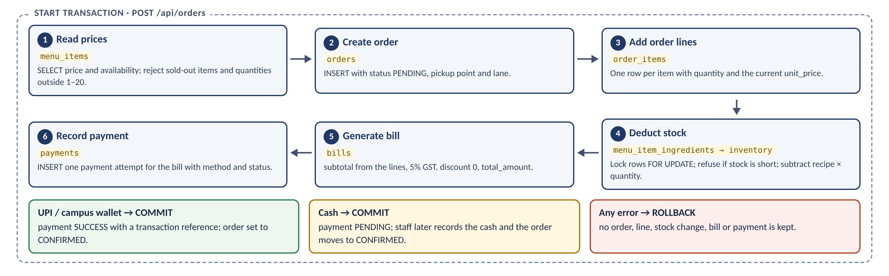
Figure 21: Order placement transaction: the six steps and how it ends
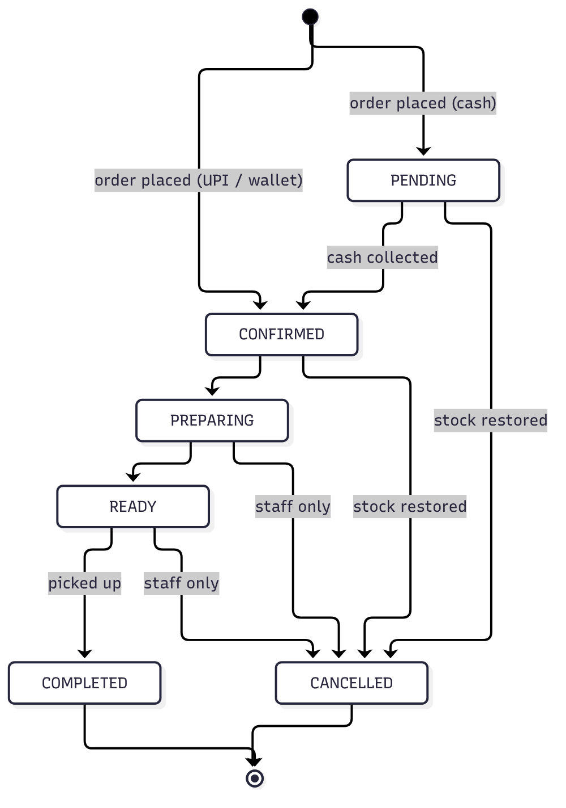
Figure 22: Order status lifecycle implemented in the application

10.6 Integrity and Security Measures
- Integrity in the database: named PRIMARY KEY, FOREIGN KEY, UNIQUE and CHECK constraints and ENUM domains apply even when data is changed directly in MySQL.
- Atomic transactions: order placement, cancellation, status changes and cash collection each run in a transaction with SELECT … FOR UPDATE row locks.
- No SQL injection: every query uses ? placeholders filled by the mysql2 driver.
- Passwords: stored only as bcrypt hashes; a CHECK constraint rejects anything shorter than a hash.
- Authorization: every API route declares which roles may call it; the UI also hides screens a role cannot use.
- Trusted totals: prices and totals are computed on the server from the database.

11. Testing

11.1 Testing Approach
Testing covered two levels. Database integrity tests ran invalid statements directly against MySQL to confirm that each constraint rejects bad data. Functional tests used the running application in a browser and verified the result in MySQL. All results below were observed on MySQL 8.0 with the sample data from database.sql.

11.2 Database Integrity Test Cases
Table 36: Database integrity test cases
ID | Test case | Expected result | Actual MySQL result | Status
TC-01 | Duplicate email | UNIQUE uq_users_email rejects the row | ERROR 1062: Duplicate entry 'aarav.sharma@woxsen.edu.in' for key 'users.uq_users_email' | Pass
TC-02 | Invalid phone number | CHECK chk_users_phone rejects the row | ERROR 3819: Check constraint 'chk_users_phone' is violated. | Pass
TC-03 | Invalid role | ENUM domain rejects the value | ERROR 1265: Data truncated for column 'role' at row 1 | Pass
TC-04 | Negative menu price | CHECK chk_menu_price rejects the row | ERROR 3819: Check constraint 'chk_menu_price' is violated. | Pass
TC-05 | Rating above 5 | CHECK chk_menu_rating rejects the row | ERROR 3819: Check constraint 'chk_menu_rating' is violated. | Pass
TC-06 | Menu item with unknown category | FK fk_menu_items_cat rejects the row | ERROR 1452: Cannot add or update a child row: foreign key constraint fails | Pass
TC-07 | Delete category that still has items | ON DELETE RESTRICT blocks the delete | ERROR 1451: Cannot delete or update a parent row: foreign key constraint fails | Pass
TC-08 | Delete menu item that appears in past orders | ON DELETE RESTRICT blocks the delete | ERROR 1451: Cannot delete or update a parent row: foreign key constraint fails | Pass
TC-09 | Same item twice in one order | UNIQUE (order_id,item_id) rejects duplicate line | ERROR 1062: Duplicate entry '1-4' for key 'order_items.uq_order_items_order_item' | Pass
TC-10 | Zero quantity | CHECK chk_order_items_qty rejects the row | ERROR 3819: Check constraint 'chk_order_items_qty' is violated. | Pass
TC-11 | Second bill for the same order | UNIQUE uq_bills_order rejects the row | ERROR 1062: Duplicate entry '1' for key 'bills.uq_bills_order' | Pass
TC-12 | Bill total that does not add up | CHECK chk_bills_total rejects the row | ERROR 3819: Check constraint 'chk_bills_total' is violated. | Pass
TC-13 | UPI payment without a transaction reference | CHECK chk_payments_txnref rejects the row | ERROR 3819: Check constraint 'chk_payments_txnref' is violated. | Pass
TC-14 | Negative stock | CHECK chk_inventory_qty rejects the update | ERROR 3819: Check constraint 'chk_inventory_qty' is violated. | Pass

Example statements used in these tests:
-- TC-01: Duplicate email
INSERT INTO users (name,email,phone,password_hash,role) VALUES ('Test User','aarav.sharma@woxsen.edu.in',NULL,REPEAT('x',60),'STUDENT');
-- TC-07: Delete category that still has items
DELETE FROM categories WHERE category_id = 1;
-- TC-12: Bill total that does not add up
INSERT INTO bills (order_id,subtotal,tax,discount,total_amount) VALUES (7,100,5,0,999);
-- TC-13: UPI payment without a transaction reference
INSERT INTO payments (bill_id,payment_method,payment_status) VALUES (5,'UPI','SUCCESS');

11.3 Functional Test Cases
Table 37: Functional test cases
ID | Test case | Action | Observed result | Status
TC-15 | Student registration | Register Neha Kapoor via the UI | Row created in users with a bcrypt hash (Figure 14) | Pass
TC-16 | Role-based login | Log in as student, then as admin | Student sees Menu / My orders; admin sees staff screens | Pass
TC-17 | Sold-out item | Open the menu as a student | Brownie shows “Sold out” and cannot be added (Figure 6) | Pass
TC-18 | Place order (UPI) | 3 items, pay by UPI | orders, order_items, bills, payments rows created; status CONFIRMED | Pass
TC-19 | Stock deduction | Compare stock before and after TC-18 | Each ingredient reduced by recipe × quantity | Pass
TC-20 | Bill calculation | Open the bill for TC-18 | ₹230.00 + 5% GST ₹11.50 = ₹241.50 | Pass
TC-21 | Status update | Staff clicks “Start preparing” | orders.status = PREPARING | Pass
TC-22 | Add menu item | Admin adds Veg Club Sandwich | Row present in menu_items | Pass
TC-23 | Delete protected item | Admin deletes Chicken Biryani | Refused (FK RESTRICT); clear message shown | Pass
TC-24 | Delete menu item | Admin deletes the test item | Row no longer in menu_items | Pass

All 24 test cases passed. The integrity tests confirm that invalid data is rejected by the database itself, independently of the application, and the functional tests confirm that the UI and the database stay in step.

12. Conclusion and Future Enhancements

12.1 Conclusion
The Canteen Food Ordering and Billing Management System shows how a relational database can model a real campus workflow end to end. Starting from an ER model, the design was mapped to a normalized relational schema and implemented in MySQL 8 as ten tables and a view, with the integrity rules enforced by primary keys, foreign keys, UNIQUE, CHECK and ENUM constraints. A working web application built with Node.js and Express uses the database for every screen.
Separating users, categories, menu items, ingredients, stock, orders, order lines, bills and payments removes duplication and makes the data easy to update and query. Transactions keep orders, stock and bills consistent even when something fails halfway, and the SQL queries in this report provide the summaries the canteen needs every day: order history, revenue by category, best sellers, low stock and payment breakdowns.

12.2 Future Enhancements
- Integration with a real UPI / payment gateway instead of simulated online payments.
- QR-code ordering at tables and digital receipts by email.
- Order-ready and payment notifications (SMS, email or push).
- A status-history table or trigger to audit every order status change and enforce the allowed transitions in the database.
- Coupons and discount rules managed from the admin screens.
- Persistent sessions (for example JWT or a sessions table) so logins survive a server restart.
- Kitchen display screen and support for multiple counters.
- Supplier management and automatic purchase orders for low-stock ingredients.

13. References
- Woxsen University. DBMS Course Project – Final Presentation (Groups of Three), 2026. Course handout and assessment instructions.
- Elmasri, R. and Navathe, S. B. Fundamentals of Database Systems, 7th Edition, Pearson.
- Silberschatz, A., Korth, H. F. and Sudarshan, S. Database System Concepts, 7th Edition, McGraw-Hill.
- Oracle Corporation. MySQL 8.0 Reference Manual — SQL statements, constraints, InnoDB transactions and locking.
- OpenJS Foundation. Node.js Documentation.
- Express. Express 5.x API Reference.
- mysql2. MySQL client for Node.js — documentation (promise API, prepared statements, pooling).
- bcrypt.js. Optimized bcrypt in JavaScript — documentation.
- MDN Web Docs. HTML, CSS and JavaScript references (Fetch API, Web Storage, dialog element).

14. Contribution of Each Member
The group has three members. Abhiuday Singh is the Team Lead. The responsibilities below match the work performed and the commit history of the project repository.
Table 38: Contribution of each member
Member | Roll number | Role | Contribution
Abhiuday Singh | 25WU0101006 | Team Lead | Project coordination, integration oversight, DBMS design review, task allocation, final presentation coordination and repository consolidation.
Aryaman Jain | 25WU0101017 | Database & SQL | Relational schema support, normalization documentation, SQL DDL / DML, query preparation and report drafting.
Harsh Jha | 25WU0101046 | Application & Testing | UI / application support, CRUD workflow testing, screenshot preparation and final verification support.

All three members can explain the complete project, including the ER diagram, relational schema, normalization, SQL queries and the UI-to-database flow.

Appendix A: GitHub Repository
Table 39: Repository details
Field | Details
Repository URL | https://github.com/MrAbhiudaySingh/Canteen
Language / stack | JavaScript (Node.js, Express), HTML, CSS, SQL (MySQL 8)
Database script | database.sql — creates canteen_db with all tables, the view and sample data
Configuration | .env.example — copy to .env and set the MySQL password

Repository structure
Canteen/
├── server.js REST API + static file server (Express, mysql2, bcryptjs)
├── database.sql schema, constraints, view and sample data for canteen_db
├── package.json dependencies and the "npm start" script
├── .env.example database connection settings template
├── README.md setup instructions and sample logins
└── public/
├── index.html page shell
├── styles.css styles
└── app.js all screens (student + staff/admin)

Appendix B: How to Run the Project
- Install MySQL 8 and Node.js 18 or later.
- Load the database (this resets it to the sample data): mysql -u root -p < database.sql
- Copy .env.example to .env and set DB_PASSWORD to your MySQL password.
- Install dependencies and start the server: npm install then npm start
- Open http://localhost:3000 in a browser.
Table 40: Sample login accounts
Role | Email | Password
Student | aarav.sharma@woxsen.edu.in | Student@123
Admin | admin@canteen.woxsen.edu.in | Admin@123
Staff | sunita.staff@canteen.woxsen.edu.in | Staff@123

