OTP Portal User Guide
This guide explains how business users, administrators, and RPA developers use the OTP Portal to work with shared time based one time password codes.

Purpose
Some vendor, finance, HR, and enterprise websites request a new six digit code during sign in. The OTP Portal gives teams one internal place to register the provider TOTP secret, view the changing code in a browser, or request it from an approved automation flow.
Use it when a shared business account is accessed by more than one person or an RPA bot. The service removes the need to manually read an authenticator app and relay the code between people.

Who uses the portal
Role | Main responsibility
Administrator | Adds portal entries, creates users, and disables portal entries or user accounts when access is no longer needed.
Business user | Signs in to view current OTP codes on the dashboard.
RPA developer | Calls the protected portal endpoint during an automation run.
Bot owner | Maintains the bot credential and confirms the route name used by the automation.

How the portal works
- An administrator registers a provider portal and supplies its TOTP secret.
- The administrator assigns a clear display name and route name, such as northstar vendor.
- A business user opens the dashboard or a bot calls the matching API route.
- The server creates the current six digit OTP from the stored secret.
- The user or bot enters the code in the provider website before the countdown reaches zero.
The code changes on the provider configured schedule, usually every 30 seconds.

Business user steps
- Open the portal login page and sign in with the account supplied by an administrator.
- Open the Live OTP Dashboard after sign in.
- Find the provider card required for the business task.
- Enter the displayed code in the provider website before the countdown ends.
- Wait for the next code if only a few seconds remain, or select Refresh to reload current data.
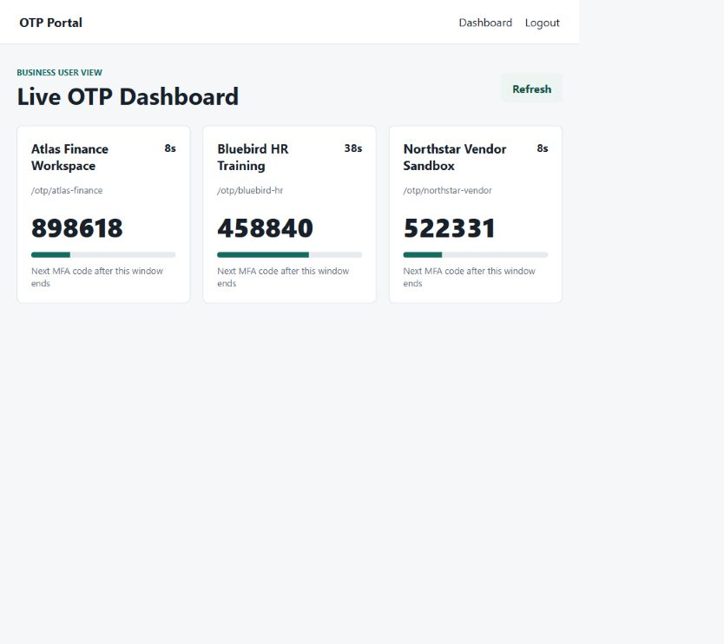
Business user dashboard using fictional test providers and test only codes
Current testing boundary: this version is designed for private network testing. Every signed in business user can currently see every active portal. Individual or team specific portal permissions are not yet available.

Administrator steps
Administrators sign in at the same login page and are taken to Manage OTP Access.

Add a provider portal
Field | What to enter | Example
Portal route name | Stable API friendly provider name. Use lowercase letters, numbers, and hyphens. | northstar-vendor
Display name | Name shown to business users in the dashboard. | Northstar Vendor Sandbox
TOTP secret | Base32 secret issued when the provider authenticator MFA was enrolled. | Provider setup value
MFA period | How often the provider changes its code. The supported range is 10 to 120 seconds. | 30 seconds

After saving, the portal list shows a masked secret. The route name is used in the bot API call.

Add or manage users
Create a business user for dashboard access. Create an admin only for a person who must manage portal entries or users. The application prevents the final active administrator from being disabled.

Disable or delete a portal
- Disable removes the portal from the dashboard and blocks its API route while keeping the record.
- Delete removes the portal record when it is no longer required.
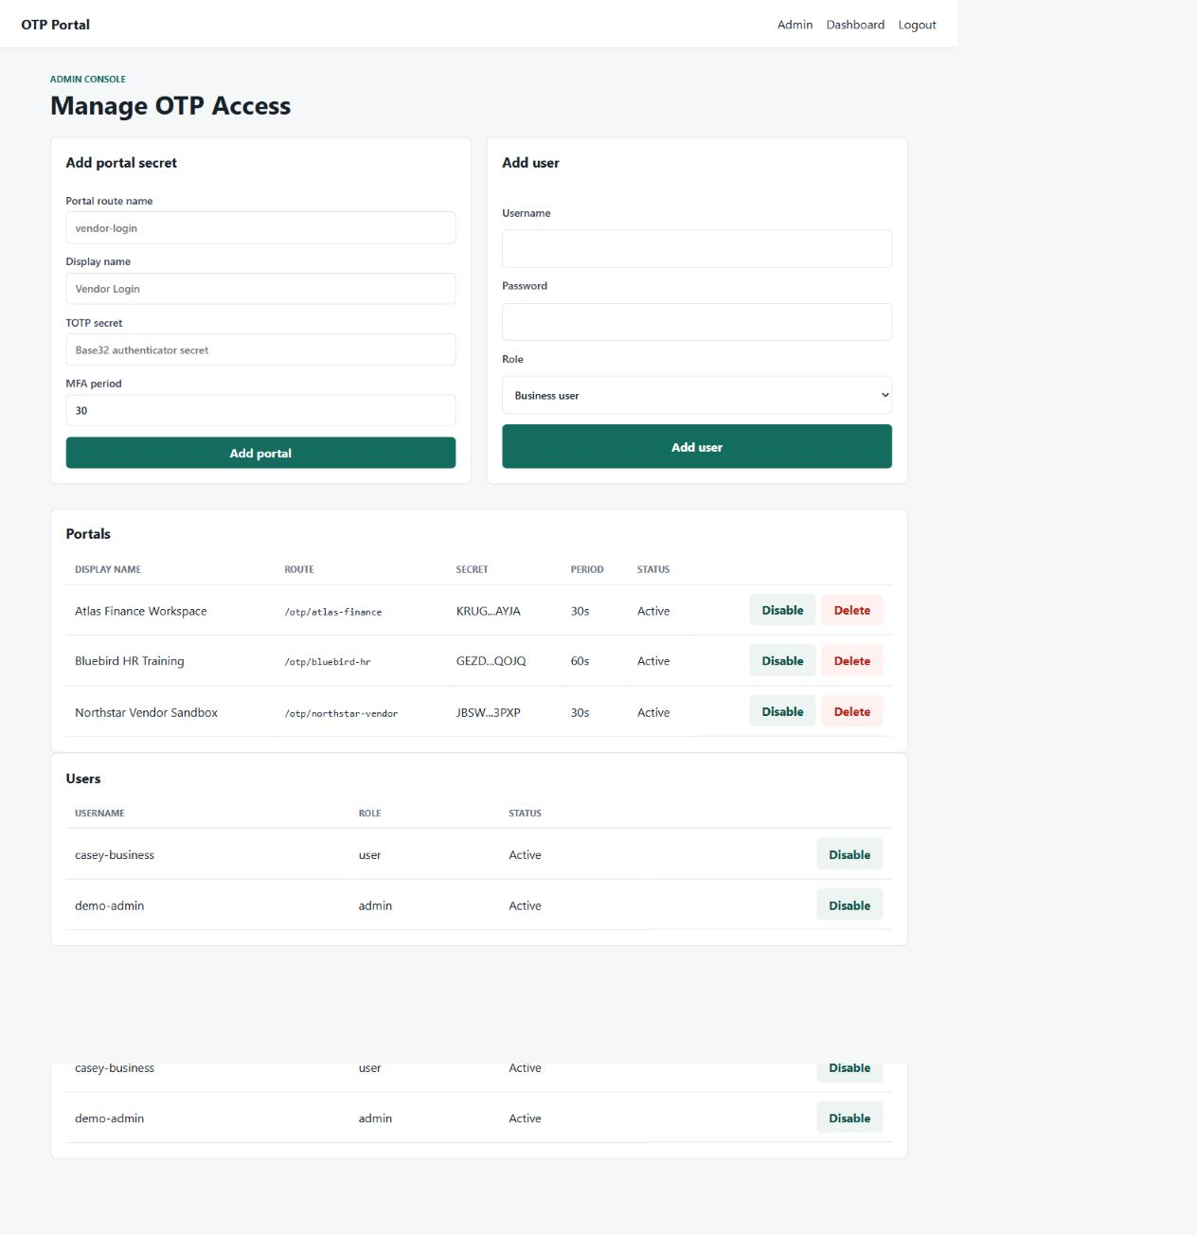
Administrator console using fictional providers, users, and test only secrets

RPA developer steps
Use the portal specific endpoint when a bot needs a code. The bot requests the current code by route name and does not need the underlying TOTP secret.
GET /otp/{portal_name}
Header: X-API-Key: your-api-key
Python example:
import requests
response = requests.get(
"http://localhost:8000/otp/northstar-vendor",
headers={"X-API-Key": "your-api-key"},
timeout=10,
)
response.raise_for_status()
payload = response.json()
otp = payload["otp"]
seconds_left = payload["valid_for_seconds"]
Treat otp as a string because a valid code can start with zero. Check valid for seconds before submitting it. If fewer than 10 seconds remain, wait for the next code and make a new request within the bot timeout policy.

Automation Anywhere A360 helper
The repository includes totp a360.py for existing command line based A360 integrations. It prints a current OTP to standard output.
python totp_a360.py YOUR_BASE32_TOTP_SECRET
For multiple portals, prefer the server endpoint. Passing a real seed as a command line argument can expose it in process monitoring or execution logs.

Safe daily use
- Use the portal through the approved private network or HTTPS deployment.
- Do not share TOTP secrets, API keys, passwords, or current OTP codes in chat, tickets, or email.
- Do not share administrator accounts.
- Use clear provider names that identify the business system and environment.
- Disable users or portals as soon as access is no longer needed.
- Report unfamiliar portal entries, unexpected codes, or failed logins to an administrator.

Common questions

The provider rejected the code
Confirm that the correct provider card was used and that the code was entered before expiry. Refresh the dashboard or wait for the next MFA window. If it continues, ask an administrator to check the secret, period, and provider account setup.

A provider card is missing
The portal may be disabled, deleted, or not yet configured. Contact an administrator.

The dashboard has no cards
No active portal entries are configured. An administrator must add or reactivate a provider portal.

The bot receives 401 or 403
Confirm that the bot sends the X API Key header and that the configured key matches the server setting. Store the key in the automation platform credential store instead of source code.

The bot receives 404
Confirm that the route name exactly matches the administrator portal route, such as northstar-vendor.

Quick technical reference
Endpoint | Used by | Authentication
GET /health | Monitoring and setup checks | None
GET /otp | Existing single secret automations | X API Key
GET /otp/{portal_name} | Portal specific RPA flows | X API Key
POST /otp/verify | Existing single secret validation | X API Key
GET /otp/secure | Existing signed integrations | API key, timestamp, signature
GET /api/ui/otps | Browser dashboard | Signed login session

For local setup, Docker use, environment values, and the complete API reference, see the repository README.

