**Question 1**

Add screenshots of the completed parts of two notebooks (in step 3) in a word file.

**Gridworld**

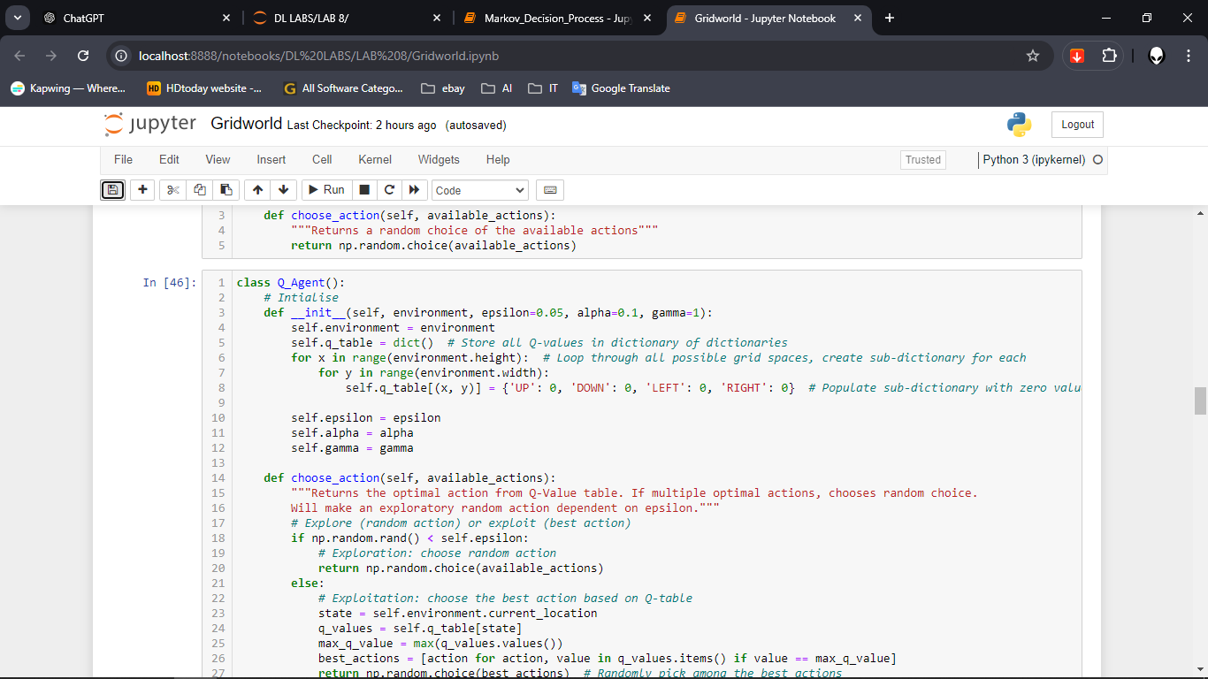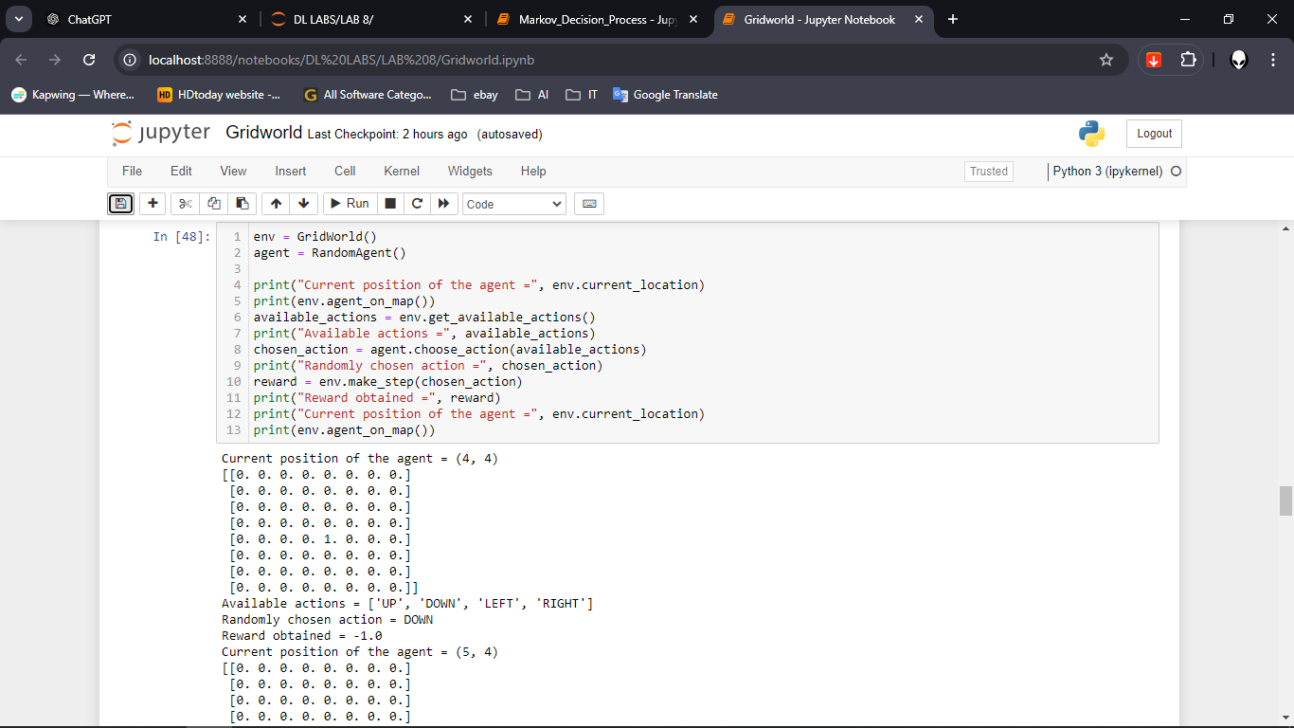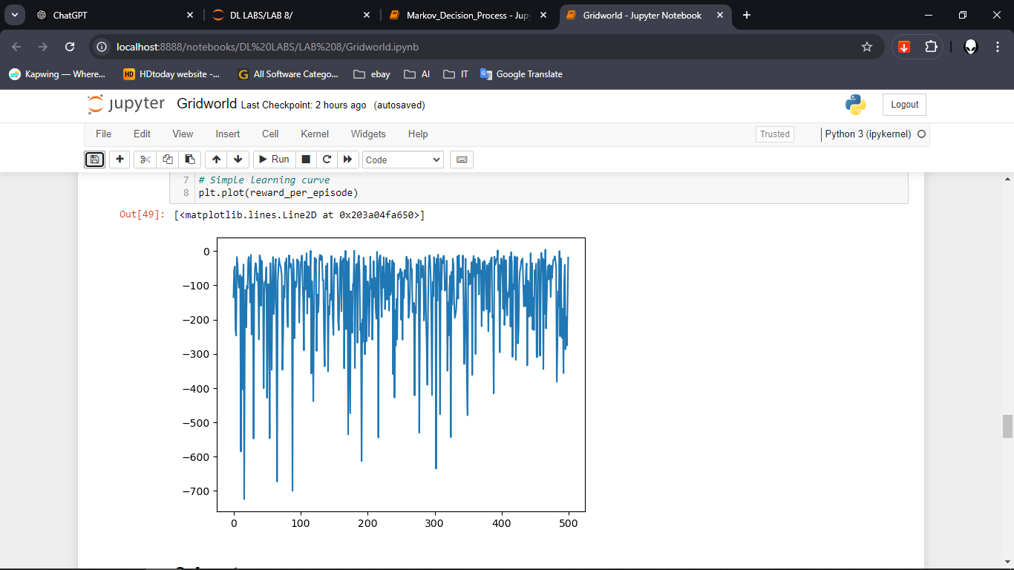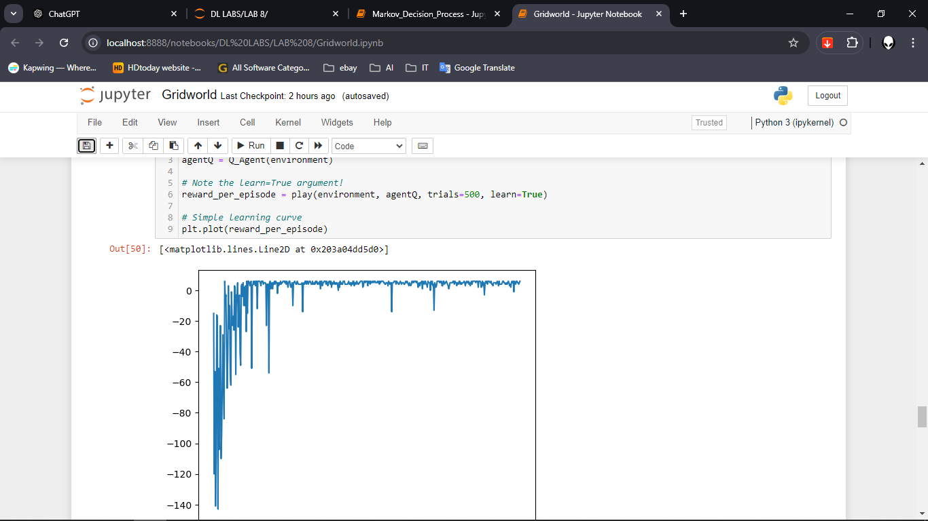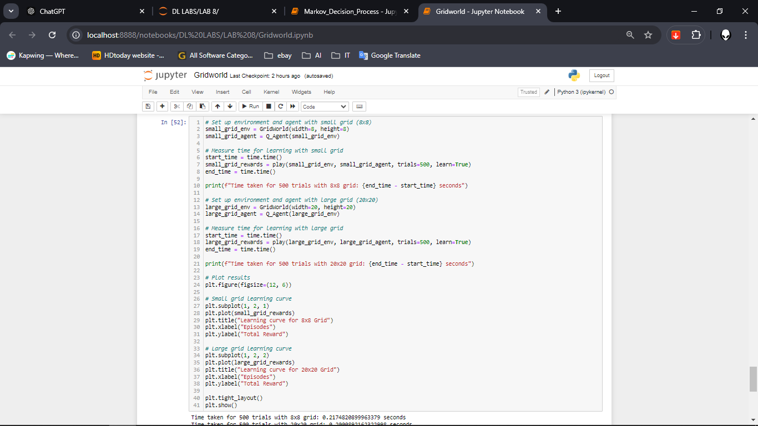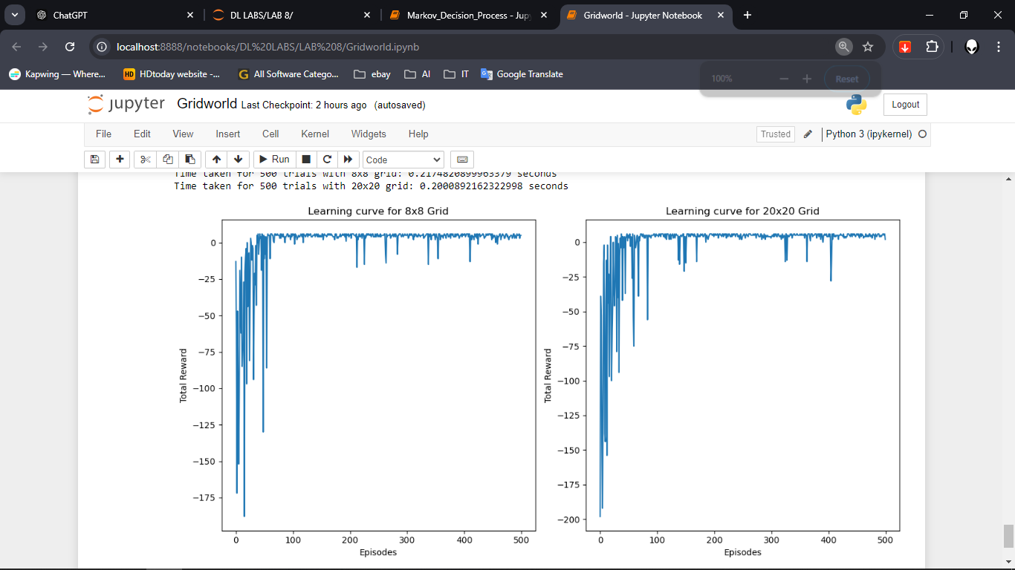

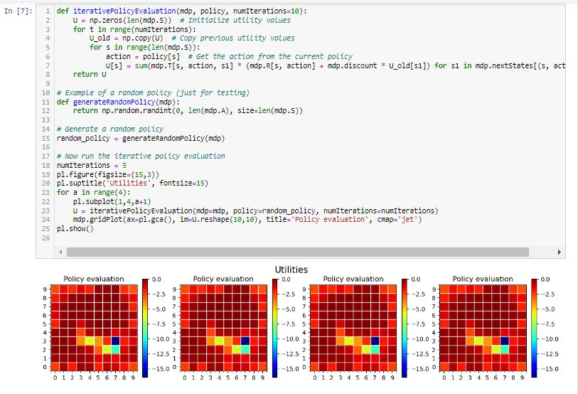**Markov_Decision_Process**

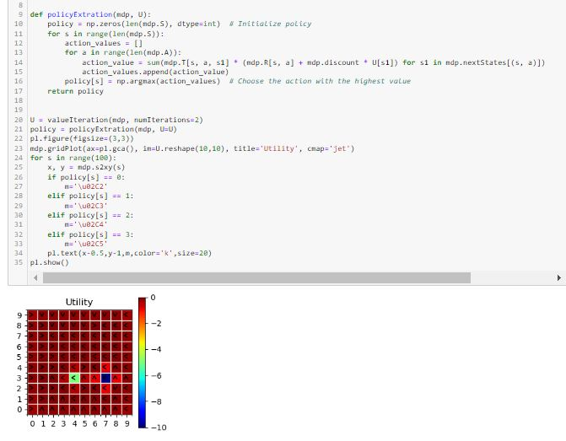

**Question 2**

Explain the difference between Model-Based and Model-Free algorithms briefly

Model-Based and Model-Free algorithms are two distinct approaches in reinforcement learning, differing in how they interact with the environment. Model-Based algorithms rely on a complete understanding of the environment's transition dynamics and reward structure, allowing them to plan optimal actions by simulating future outcomes. Examples include Policy Iteration and Value Iteration, which use the known model to compute optimal strategies efficiently. However, this approach requires full knowledge of the environment, which may not always be available. In contrast, Model-Free algorithms, such as Q-Learning and SARSA, learn directly from experience by interacting with the environment through trial and error. They adjust their value estimates based on observed rewards and state transitions, without needing prior knowledge of the environment. This makes them more flexible, especially in unknown or dynamic environments, but they generally take longer to converge since they learn purely from exploration.

