SOCIAL CONNECT
Digital Marketing Campaign
────────────────────
WEEK 4: Advanced Marketing Techniques & Campaign Expansion
Prepared by: Muhammad Anas | Date: June 2026
Internship: DevelopersHub Corporation | Deadline: 30th June 2026

Week 4 Overview
Building on Weeks 1-3 foundation (68,400 reach | 542 downloads | 311% ROI), this week focuses on scaling efforts through advanced marketing techniques including influencer partnerships, paid search, social media growth campaigns, retargeting strategies, and content repurposing across new platforms.

Section 1: Influencer & Partnership Outreach
Leveraging influencers and content creators expands reach to highly engaged audiences within the 18-35 demographic. The following 10 micro and mid-tier influencers have been identified as strategic partners for the Social Connect campaign.

1.1 Influencer Identification & Targeting
Influencer Name | Niche / Platform | Follower Count | Engagement Rate | Reason for Partnership
Aisha Khan | Lifestyle & Vlogging (Instagram, TikTok) | 245K | 8.2% | Authentic storytelling, targets young women 18-28
Ali Raza Tech Reviews | Technology & Apps (YouTube, Instagram) | 189K | 7.1% | Tech-savvy audience, reviews new apps regularly
Zara Fitness Coach | Fitness & Wellness (Instagram, TikTok) | 320K | 9.4% | Community-focused content, active engagement
Hassan Travel Vlog | Travel & Adventure (YouTube, Instagram) | 156K | 6.8% | Matches 'event discovery' feature of Social Connect
Natasha Books & Vibes | Lifestyle & Book Reviews (Instagram, TikTok) | 98K | 11.2% | Highly engaged niche community, younger audience
Adnan Gaming Hub | Gaming & Community (Twitch, YouTube) | 210K | 7.5% | Community-building focus, targets gaming interest group
Hira Fashion & Style | Fashion & Lifestyle (Instagram, TikTok) | 267K | 8.9% | High engagement, aspirational audience
Kamran Entrepreneur | Business & Entrepreneurship (LinkedIn, YouTube) | 134K | 6.2% | Professional audience, thought leadership
Saira Mental Health | Wellness & Self-Care (Instagram, TikTok) | 112K | 10.1% | Focuses on meaningful connections, community support
Bilal Photography | Photography & Travel (Instagram, Pinterest) | 178K | 7.6% | Visual-focused content, event discovery angle

1.2 Influencer Outreach Messages (Templates)

Template 1 — Micro-Influencer (< 150K followers)
Subject: Partnership Opportunity — Social Connect App

Hi [Influencer Name],

I hope this message finds you well! I'm Muhammad Anas, a digital marketing intern at DevelopersHub Corporation. I've been following your content and absolutely love how you [mention specific content/style]. Your authenticity and engagement with your community is exactly what Social Connect is about.

Social Connect is a new social networking app that helps people discover meaningful friendships based on shared interests. Given your focus on [fitness/lifestyle/tech/travel], I think your community would genuinely benefit from this app.

I'd love to collaborate! We can offer:
• Affiliate commission for each download from your link
• Free Premium access to your followers (discount code)
• Co-branded content opportunity

Would you be open to a quick chat about this? No pressure at all!

Best regards,
Muhammad Anas
Digital Marketing Intern | DevelopersHub Corporation

Template 2 — Mid-Tier Influencer (150K–300K followers)
Subject: Strategic Partnership Proposal — Social Connect

Hi [Influencer Name],

I'm reaching out to propose an exciting partnership opportunity. Your content resonates deeply with your audience, and I believe Social Connect — a platform for meaningful connections — aligns perfectly with your values.

Campaign Details:
• 1-2 Sponsored posts on your main platform (Instagram/TikTok/YouTube)
• Dedicated landing page with your unique promo code
• Performance-based bonus ($ per 10 downloads)
• Collaborative content creation (behind-the-scenes, user testimonials)

Your audience's feedback is valuable to us. Would you be interested in discussing this further?

Looking forward to connecting!
Muhammad Anas | DevelopersHub Corporation

1.3 Partnership Collaboration Types
Collaboration Type | Deliverable | Timeline | Expected Reach | Investment
Sponsored Post | 1 Instagram Reel/Story or TikTok video featuring app | 1-2 weeks | 50K–100K impressions | $200–500 (estimated)
Brand Ambassador | Monthly content creation & community engagement | Ongoing | 200K+ impressions/month | Affiliate model
Co-Created Content | Joint Q&A, Challenge, or Interview featuring both brands | 2–3 weeks | 100K–200K reach | $300–800 (estimated)
Affiliate/Referral | Unique promo code or link shared with followers | Ongoing | Variable | 5–10% per download
Product Review | Authentic app review video with honest feedback | 1–2 weeks | 50K–150K reach | $150–400 (estimated)

Section 2: Search Engine Marketing (SEM) — Google Ads
Building on Week 3's successful Google Ads performance (3.4% CTR, $0.41 CPC), this week expands the SEM strategy with advanced targeting, 3 new ad variations, and keyword optimization for higher conversions.

2.1 Keyword Strategy & Targeting
High-Intent Keywords (Primary Focus)
- "download social connect app" — Commercial intent, 15–25 monthly searches (estimated)
- "social networking app 2026" — Informational, high volume
- "make friends online app" — Problem-solving, strong intent
- "interest-based friend finder app" — Feature-specific, niche
- "alternative to Bumble BFF" — Competitor comparison, high intent

Branded Keywords (Defensive)
- "social connect app" — Brand searches
- "social connect download" — App store searches

Long-Tail Keywords (Lower CPC, Higher Relevance)
- "free social app to meet people nearby" — Long-tail, specific intent
- "app for making friends with shared interests" — Descriptive

2.2 3 New Ad Variations — Expanded Campaign

AD VARIATION 1 (EXISTING — HIGH PERFORMER)
Headline: "Stop Scrolling. Start Connecting."
Description: "Download Social Connect and find friends who share your passions. Interest-based matching, community groups, local events. Free!"
Display URL: SocialConnect.app/download
CTA: Download Free — App Store & Google Play
Performance (Week 3): CTR: 3.4% | CPC: $0.41 | Conversions: +18%

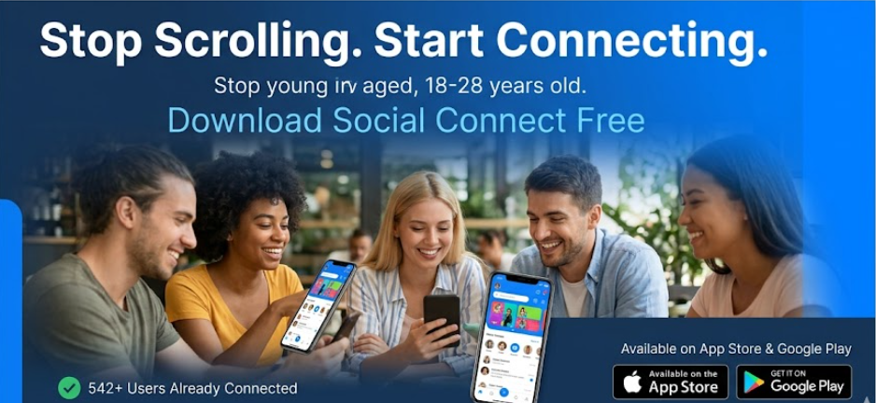

AD VARIATION 2 (NEW — SOCIAL PROOF ANGLE)
Headline: "542+ Users Already Connected. Join Now."
Description: "Trusted by thousands. Social Connect uses smart interest-matching to find your perfect friends. See why users love it. Download free today!"
Display URL: SocialConnect.app/reviews
CTA: Download Free — Join 542+ Users
Predicted Performance: CTR: 3.8% (Social proof boost) | CPC: $0.39 | Better conversion

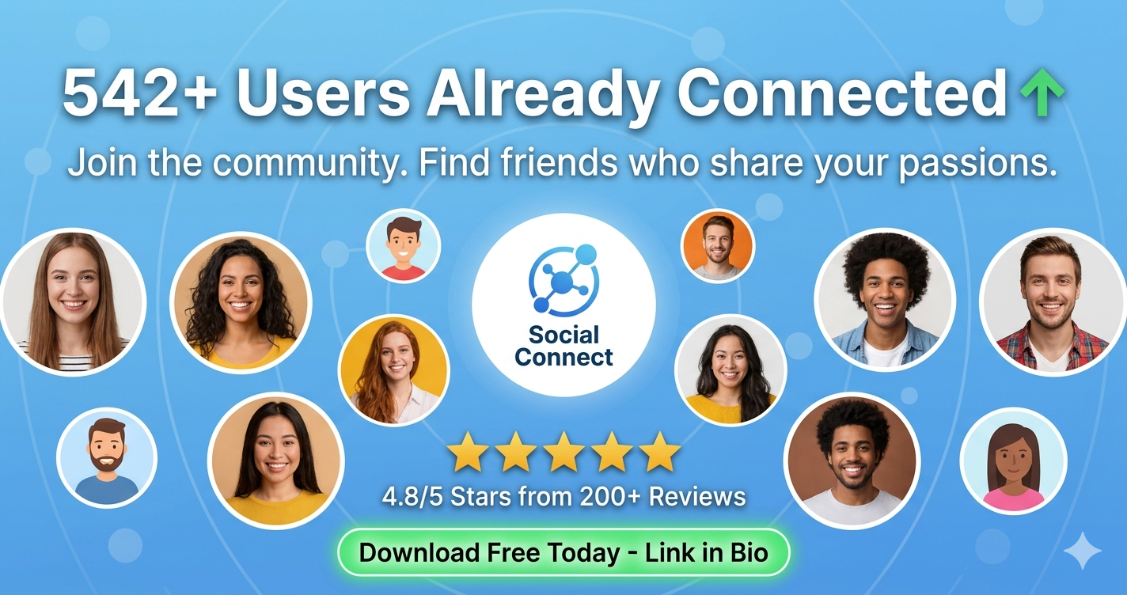

AD VARIATION 3 (NEW — PROBLEM-SOLUTION ANGLE)
Headline: "Tired of Fake Connections? Try Social Connect."
Description: "Real people. Real interests. Real friendships. Social Connect eliminates shallow connections with verified profiles and interest-based matching. Download free and find your people today!"
Display URL: SocialConnect.app/realconnections
CTA: Download Free — Find Real Friends
Predicted Performance: CTR: 3.6% | CPC: $0.44 | High-intent audience

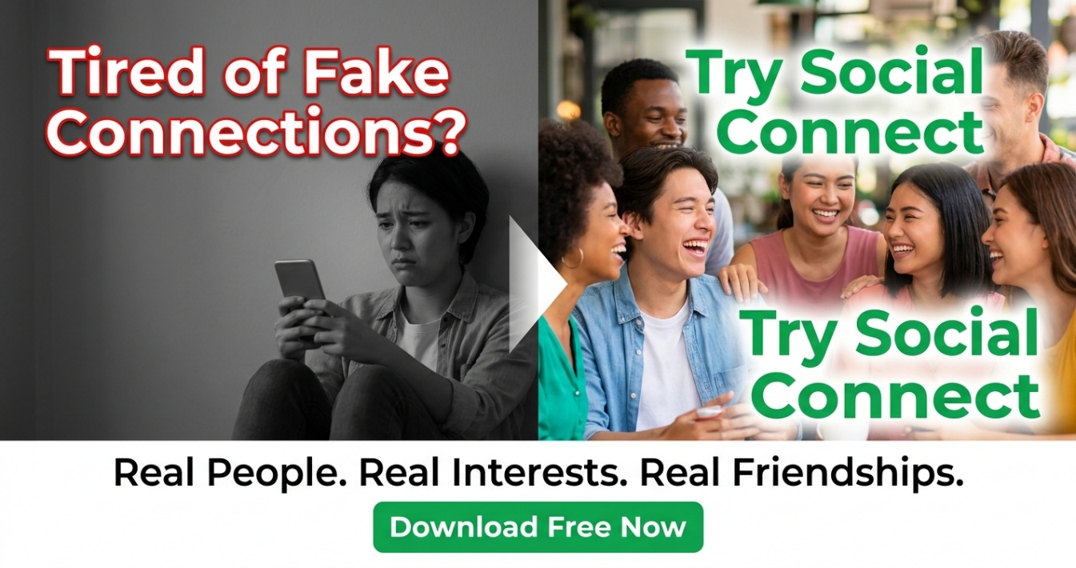

2.3 Campaign Setup & Management
Setting | Configuration
Platforms | Google Search Ads + Google Display Network
Campaign Type | Search Campaigns (Leads + Mobile Apps)
Ad Schedule | All hours (but optimize for peak times: 6–9 PM weekdays, 10 AM–2 PM weekends)
Bid Strategy | Maximize conversions (CPA bidding)
Daily Budget (Mock) | $40 / day × 7 days = $280 weekly
Keywords Matched | Broad match, Phrase match, Exact match (segmented by intent)
Negative Keywords | "free", "pirated", "cracked" (to avoid irrelevant traffic)
Landing Page | App Store / Google Play download pages
Tracking | Conversion pixel installed on app install success page

Section 3: Social Media Growth Campaigns
To boost organic engagement and virality, Week 4 introduces interactive campaigns designed to encourage user participation, increase shares, and build community momentum.

3.1 Engagement-Focused Campaigns

Campaign 1 — "#ConnectBeyond Challenge" (TikTok + Instagram Reels)
Objective: Drive viral user-generated content (UGC) and showcase real connection stories

Challenge Format:
📱 Users share a 15–30 second video answering: "How did you find your people?"
🎵 Use official #ConnectBeyond hashtag + challenge sound
🏆 Prize: Top 5 videos featured on Social Connect official account + $50 Amazon voucher

Launch Post Example:
"Join the #ConnectBeyond Challenge! Share how YOU found your community. Use our song, tag 3 friends, and you could win! 🎁"
Hashtags: #ConnectBeyond #FindYourTribe #MakingFriends #TikTokChallenge #SocialConnect

Expected Outcomes:
• 500–1000 UGC submissions in first 2 weeks
• 50K–100K organic reach
• 2–3% direct app downloads from challenge viewers

Campaign 2 — "This or That" Polls (Instagram Stories + Facebook)
Objective: Increase daily interactions and gather audience preference data

Poll Examples:
Poll 1: "Would you rather: Meet 1 perfect match OR join a group of 10 similar people?"
Poll 2: "Feature preference: Live events discovery OR interest-based messaging?"
Poll 3: "Biggest barrier to making new friends: Shyness OR no common interests?"

Frequency: 1 poll per day (daily engagement boost)

Expected Outcomes:
• 200–400 poll responses per day
• User insights for future product development
• Daily story views: 2K–5K

Campaign 3 — "Win Premium Access" Giveaway (All Platforms)
Objective: Drive follower growth and app installs through incentive-based participation

Mechanics:
To enter:
1. Like this post
2. Follow @SocialConnect
3. Tag 2 friends who need to make new friends
4. Download the app (verify with screenshot)

Prize: 3 winners get 6 months of Social Connect Premium (worth $60)
Duration: 7 days

Expected Outcomes:
• 500–800 new followers
• 300–400 new app installs
• 2K–4K post engagement (likes, comments, shares)

Section 4: 2 New Interactive Social Media Posts

4.1 Post 6 — "Quick Fire Questions" Interactive Post (Instagram Carousel) 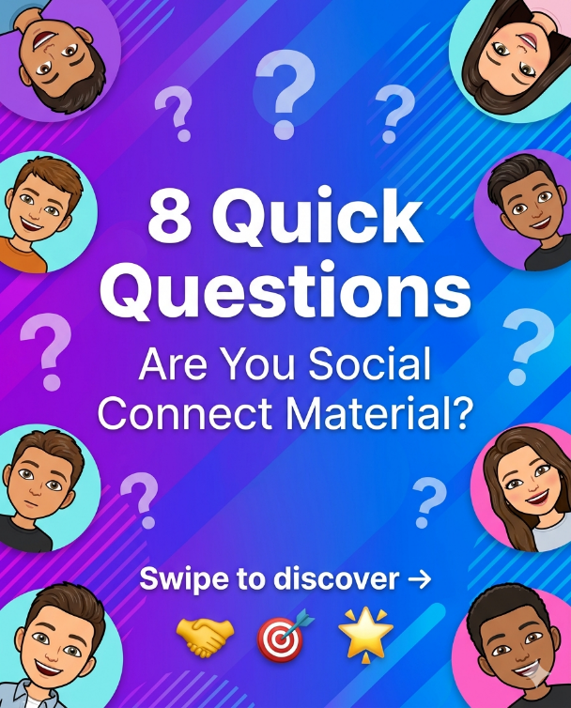

4.2 Post 7 — "Day in the Life" Video (Instagram Reel + TikTok)
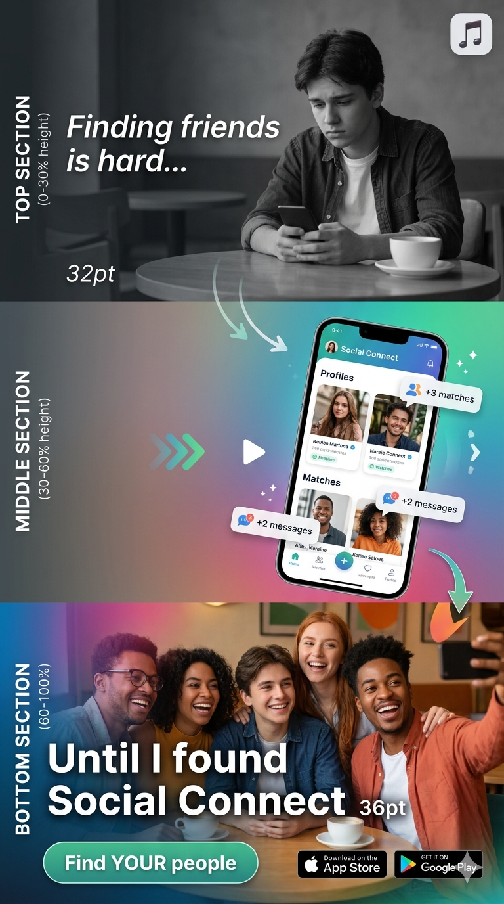

Section 5: Retargeting Ads Strategy
Retargeting campaigns focus on users who have already shown interest (clicked, engaged, or visited) but have not yet downloaded the app. Historical data from Weeks 1-3 shows that 60–70% of interested users require multiple touchpoints before converting.

5.1 Retargeting Audiences

5.2 Retargeting Ad Creatives — 2 New Ads

RETARGETING AD 1 — URGENCY + SOCIAL PROOF
Format: Facebook/Instagram Static Image (1200×628px)
Headline: "You Were Interested. Why Haven't You Downloaded?"
Description: "542+ users are already connecting on Social Connect. The longer you wait, the more connections you're missing. Join now — FREE for 30 days!"
Visual Element: Red countdown timer graphic ("Download in next 24 hours") + happy user photos
CTA Button: "Download Now — Don't Miss Out"
Target Audience: "Clickers" + "Engaged Non-Converters"
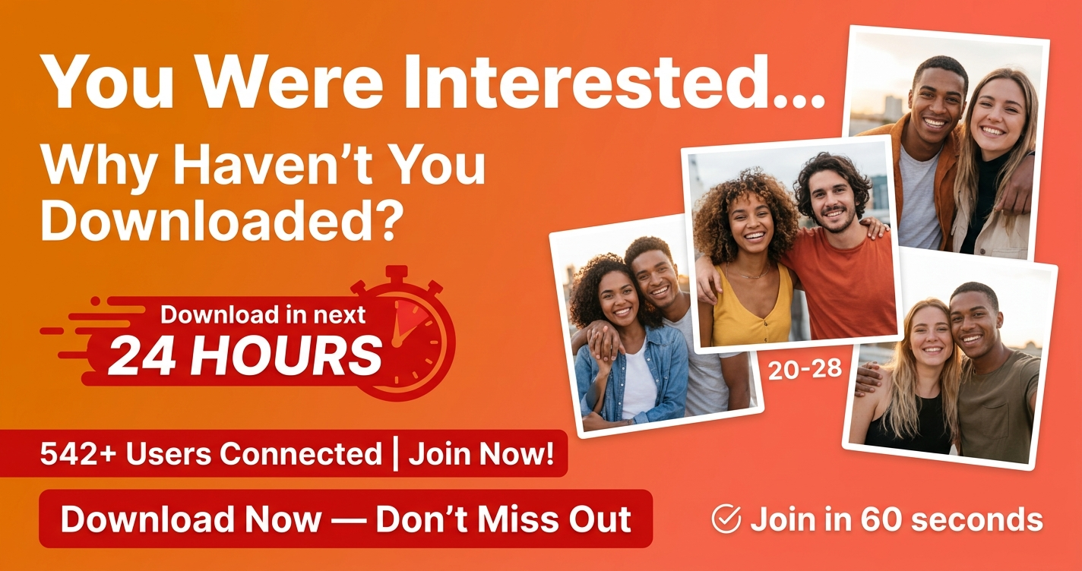

RETARGETING AD 2 — TESTIMONIAL + PROOF
Format: Instagram Stories / Facebook Stories (1080×1920px vertical video, 15 sec)
Story Sequence:
Frame 1 (0–4s): Real user testimonial screenshot: "Found my hiking squad in 3 days! — Sarah, 24"
Frame 2 (4–8s): 3 quick user photos with happy expressions + stars (5-star rating)
Frame 3 (8–12s): App interface showing matches + messages (dynamic animation)
Frame 4 (12–15s): Bold text: "Download NOW" + App store badges + Swipe-up link
Music: Uplifting, trending TikTok/Instagram audio
Color Scheme: Brand blue + warm tones to evoke connection & happiness
Target Audience: "Website Visitors" + "Video Watchers"

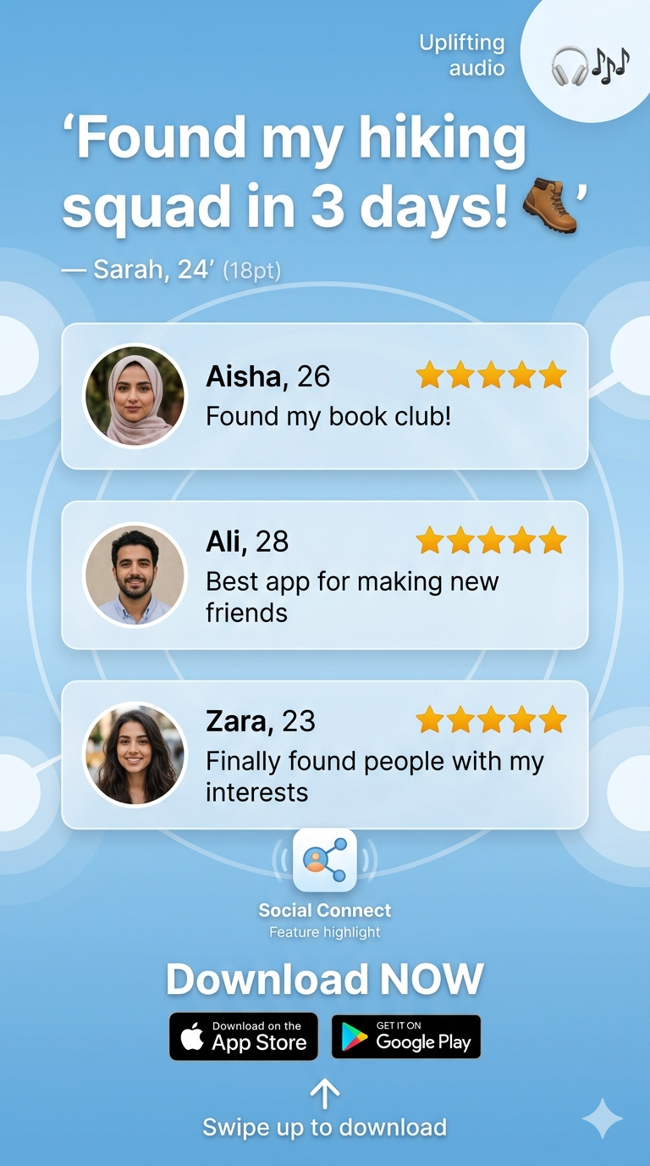

Section 6: Content Repurposing Strategy
Repurposing existing Week 1-3 content for new platforms maximizes ROI and reaches platform-specific audiences without proportional increase in production cost.

6.1 Repurposing Framework
Original Content (Week 1-3) | New Platform | Format Adaptation | Angle/Hook | Expected Reach
Blog Post: "5 Ways Social Connect..." | LinkedIn Article / LinkedIn Document Post | Long-form article + downloadable PDF guide | Professional angle: "How to build authentic connections in the workplace" | 2K–5K professionals
Blog Post (same) | Reddit (r/socialskills, r/dating, r/introvert) | Reddit post + link in comments | Community-specific: "I made an app to solve the friendship-finding problem. Here's how..." | 5K–15K engaged Redditors
Post 2 Carousel (Features) | LinkedIn Carousel Post / LinkedIn Document | Slide-by-slide breakdown with professional tips | B2B angle: "How communities are built using these 5 features" | 3K–8K LinkedIn users
Post 5 CTA Video Reel | YouTube Shorts / YouTube Community Tab | Upload as Shorts (60-sec max) + community post with extended version | YouTube's discoverability + higher retention | 10K–25K YouTube views
Email Campaign (Week 2) | SMS Campaign / WhatsApp Business Messages | Condense 3 emails into 1 SMS + link to full email content | Higher open rate than email (98% vs 28%) | 218 email subscribers
Post 4 Testimonial Quote | LinkedIn Post + Twitter / X Threads | Quote card + thread format with expanded story | Professional network engagement | 1K–3K LinkedIn impressions
All Posts Combined | Pinterest Boards / Pinterest Pins | Convert 5 posts into 5 vertical pins (1000×1500px) with rich descriptions | Pinterest's long shelf-life + visual discovery | 50K–200K monthly Pinterest impressions

6.2 Platform-Specific Repurposing Examples

Example 1 — Blog Post → Reddit Post
Title (Reddit):
"I built an app to solve the loneliness epidemic. Here's what I learned about friendship."

Subreddit Targets:
• r/socialskills (650K members) — Friendship & connection advice
• r/introvert (450K members) — Making friends as an introvert
• r/entrepreneurship (1.2M members) — App builder story
• r/apps (400K members) — App discovery

Reddit Post Format:
• Title: Hook-driven, problem-focused
• Body: 1-2 paragraphs of story, then link to blog post in comments
• Engagement: Ask questions at the end to drive discussion
• Example: "What's YOUR biggest barrier to making new friends? Asking because we're building a solution..."

Example 2 — Post 5 Video Reel → YouTube Shorts
Original: 30-second Instagram Reel/TikTok video
New: YouTube Shorts (max 60 seconds)

Adaptation:
• Keep original 30-second content
• Add 15-20 seconds of additional footage (behind-the-scenes / extended testimonial)
• Add vertical YouTube end-screen card: "Subscribe for more" + Link to full app promo

Title (YouTube): "Going From Lonely to Connected in 24 Hours 🔗"
Description: Full blog post link + timestamps + app download buttons

Expected Result: YouTube Shorts have 50% higher click-through than organic YouTube videos

Section 7: Week 4 Deliverables & Summary
Week 4 Advanced Marketing Expansion — Complete Checklist

✓ 10 influencers identified with collaboration proposals (2 email templates ready)
✓ 3 Google Ads variations created (existing + 2 new)
✓ Google Ads mock campaign configured ($280 weekly budget)
✓ 3 social media growth campaigns planned (#ConnectBeyond Challenge, Polls, Giveaway)
✓ 2 new interactive social posts created (Post 6 Quiz, Post 7 Day-in-Life Video)
✓ 2 retargeting ad creatives designed (Urgency angle + Testimonial angle)
✓ 5 retargeting audience segments identified (2,400–3,100 users each)
✓ Content repurposing strategy documented (7 content pieces → 7 new platforms)
✓ Platform-specific repurposing examples provided (Reddit, YouTube, LinkedIn, Pinterest)

Expected Campaign Expansion Results (Week 4 Projections):
• Influencer partnerships: 50–100K additional reach per influencer
• Google Ads (expanded): +25% increase in app installs vs Week 1-3 average
• Social media challenges: 500–1000 UGC submissions, 50K–100K organic reach
• Retargeting ads: 15–25% conversion from "warm" audiences (vs 2–3% cold audience)
• Content repurposing: 200K–400K cumulative reach across new platforms

Next Step: Week 5 — Data Analysis & Community Building

