CREATING ACCOUNT
- Go to Official website of GitHub https://github.com/ and Click on Sign up button
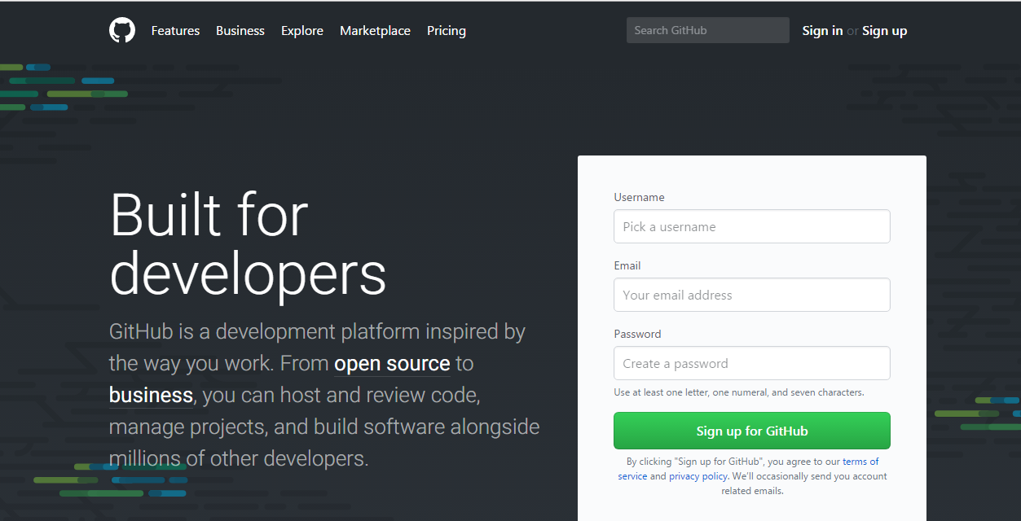
- A Signup window opens like below:
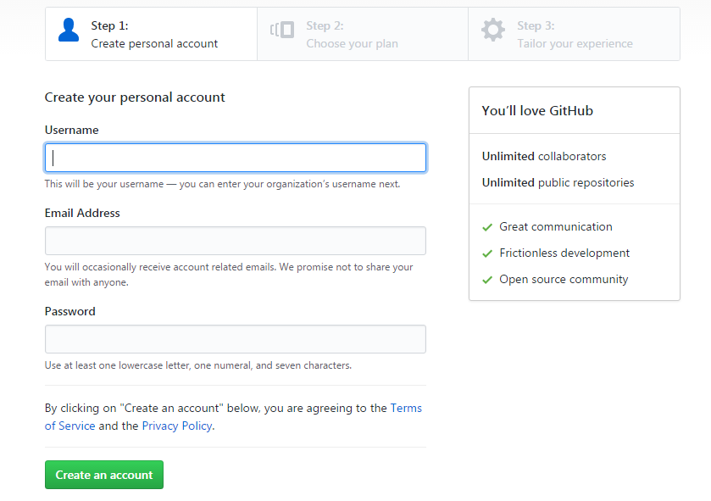
- Fill the details in create personal account section:
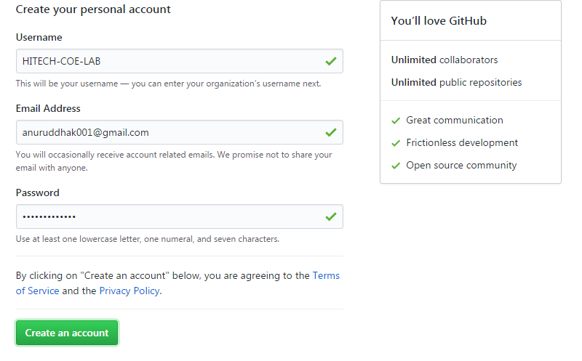

- Then click on Create an account button
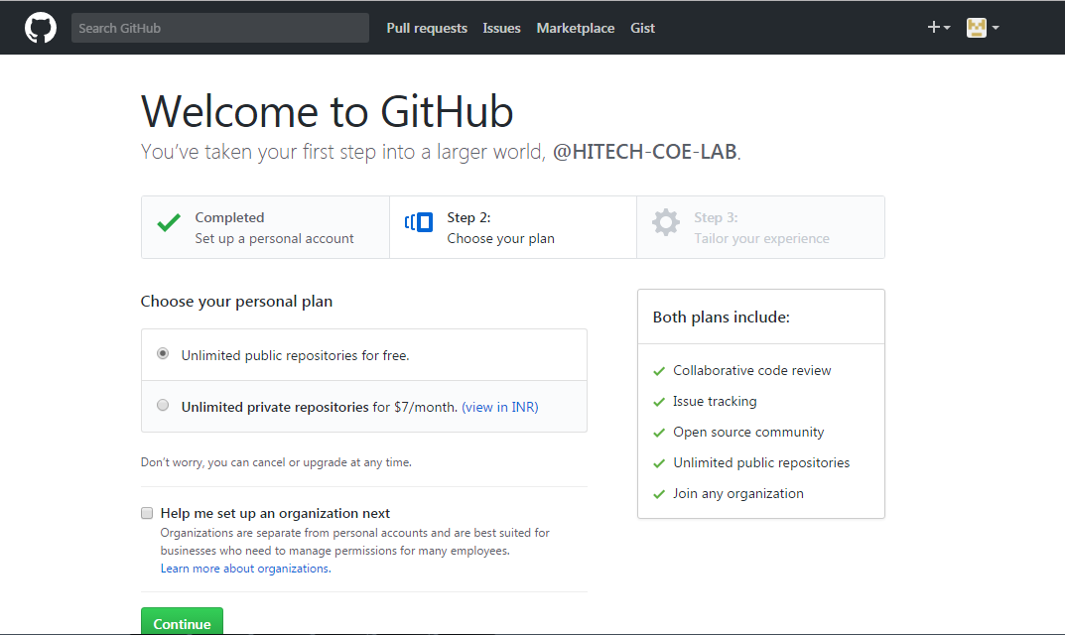

- Select public repository and Click on continue

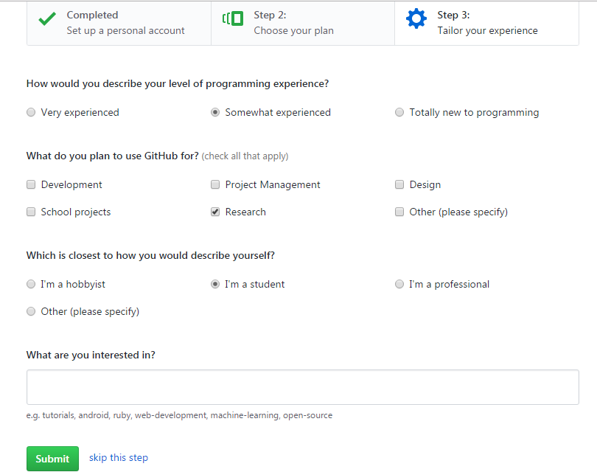

- Then you can fill feedback or skip this step an click on submit and a dashboard screen will open as:
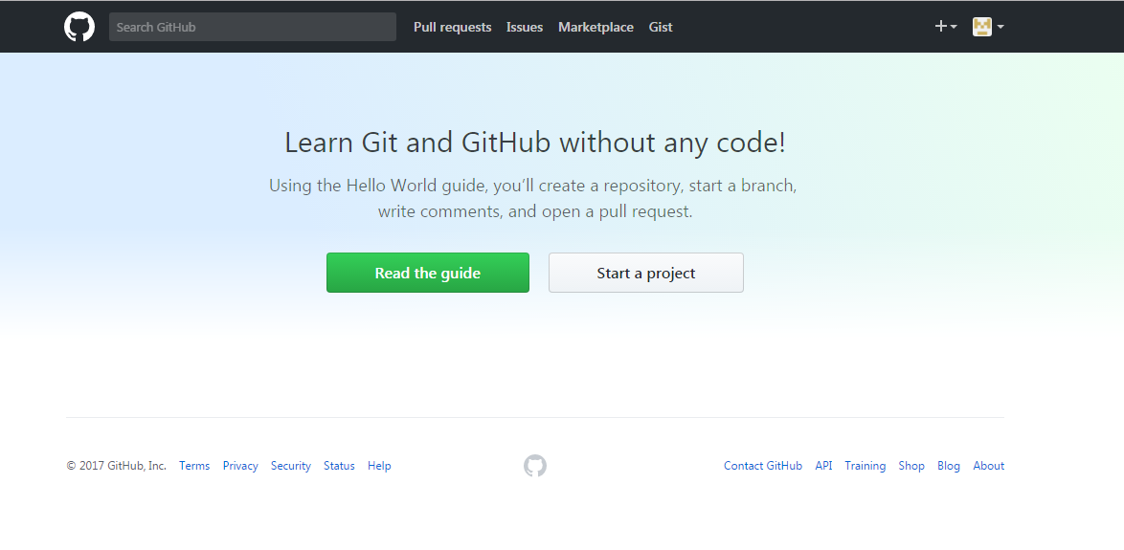

CREATING A REPOSITORY

- Login to your GitHub account from the Sign in button on https://github.com/login by filling your credentials.
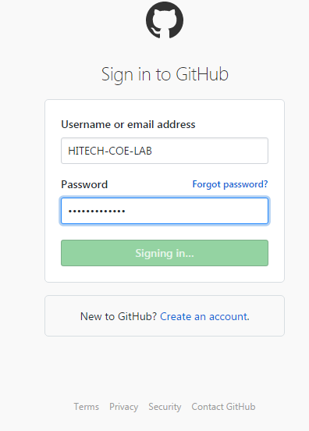

- After login on Dashboard screen choose create a new repository option from dropdown menu as
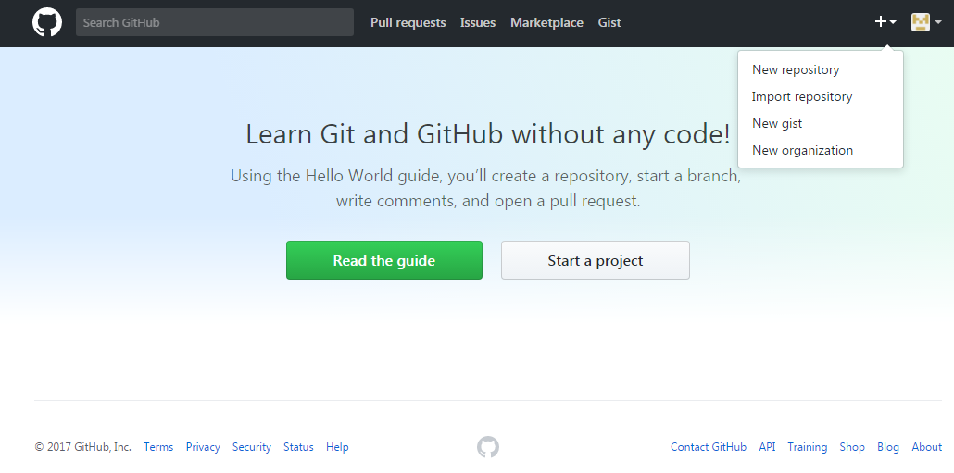
- By clicking on it you have to verify your registered email.
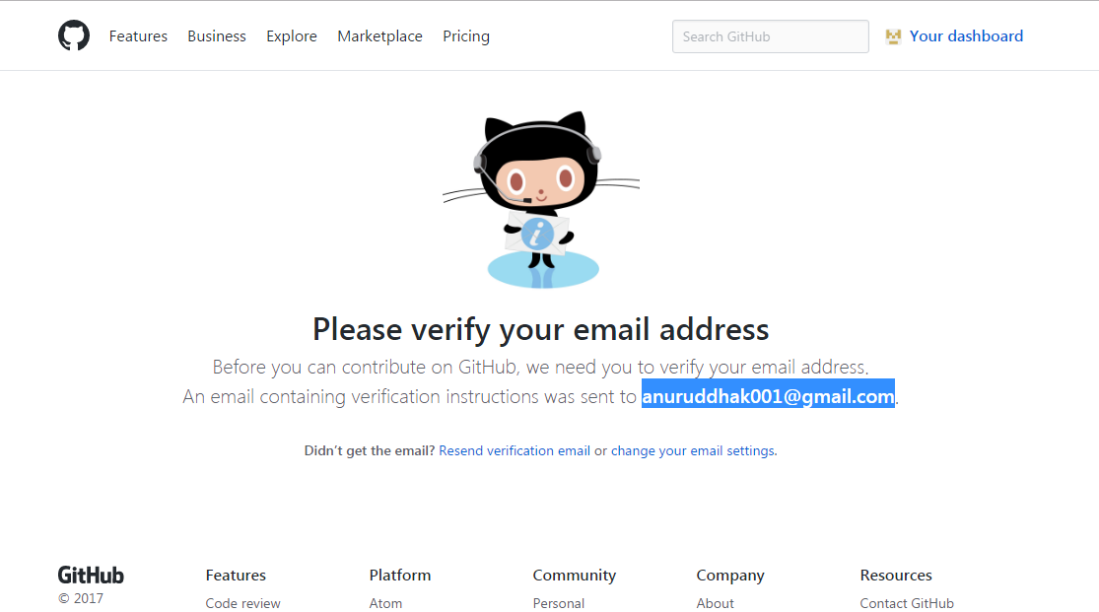

- After that dashboard again open then click on new repository and fill the required details and click on create repository:

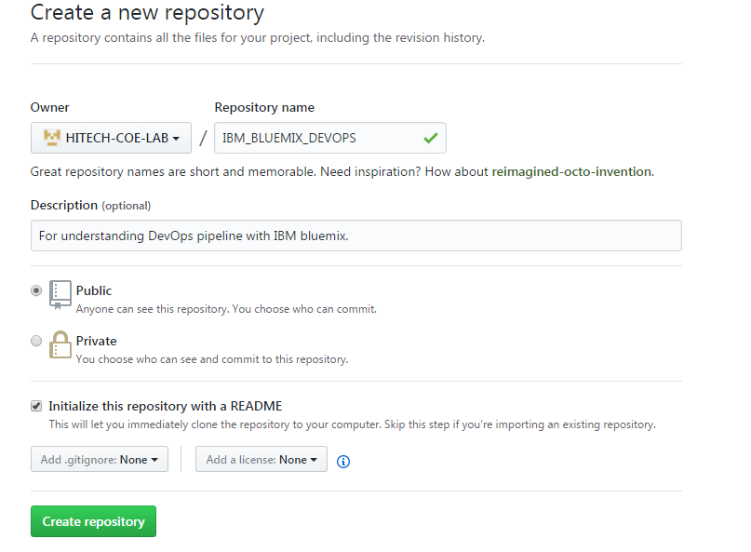

- Finally the repository will created as:
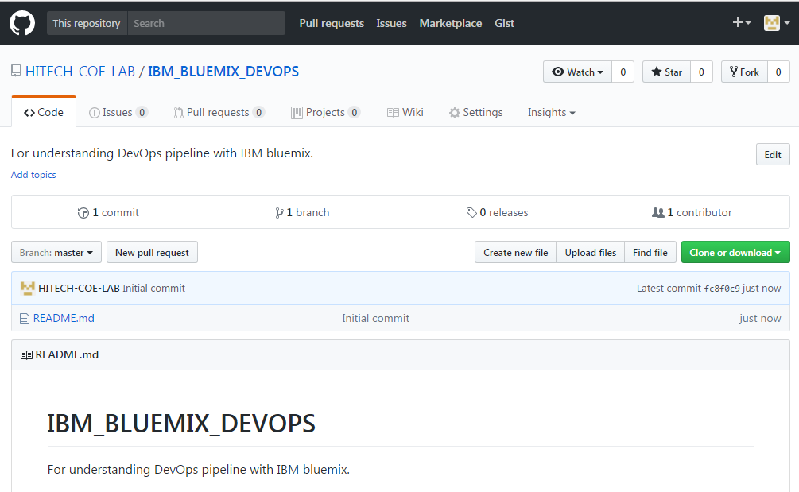

CHECKIN /CHECKOUT

- Integration of eclipse with GitHub
Step1:
- Click on window option, and then click on Show view and then click on others as
- Then click on GIT, now click on GIT REPOSITORY then click on OK.

- A view is created with names Git Repository, having three options as

- Click on above any three options according to your availability. I am working with second option: Clone a GIT REPOSITORY
- Click on Clone a Git repository. A dialog box is opened and set url of your GitHub repository and authentication details then click on next.
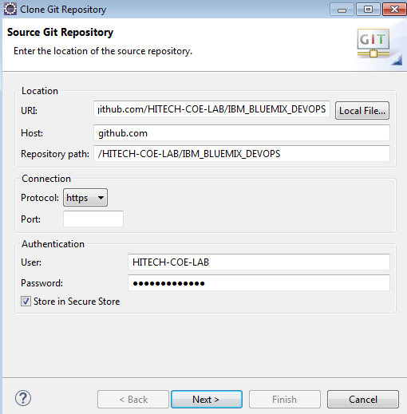
- your Branch selection screen open, now select preferred branch and click on next:
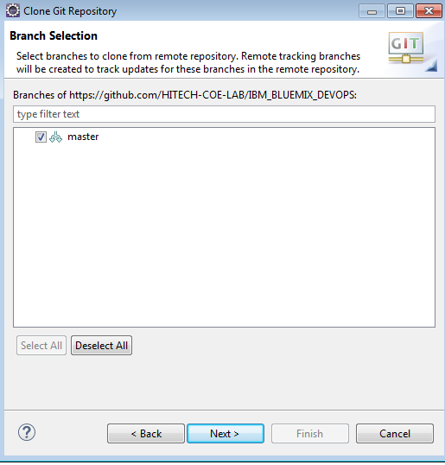
- Now set up your local destination for storage and click on Finish:

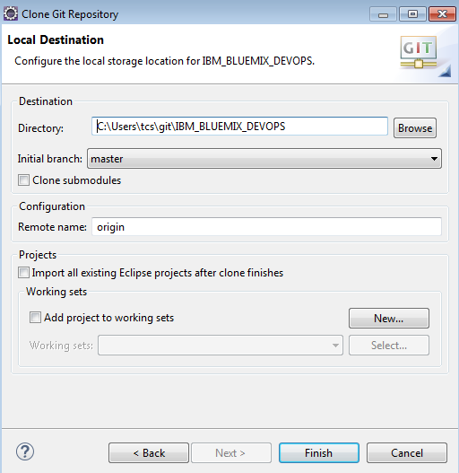

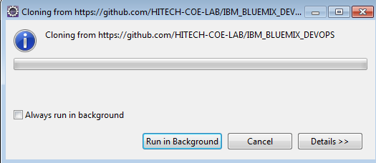
If you want then secure your password or skip this step.
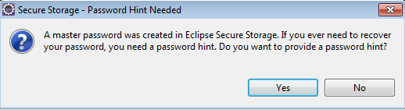
Step2:
- Right click on your project and then click on TEAM and then click on SHARE PROJECT as:
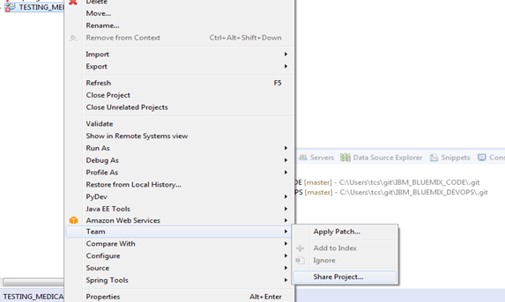

- A dialog box is open into which select repository and then clicks on finish.
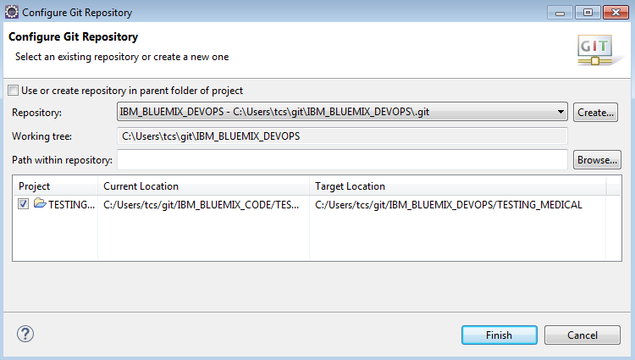
Step 3:
- Right click on Project and select Team then Click on Commit.

- After click on Commit, Commit Change dialog box appear, write some commit message and check on file then click on commit and push.

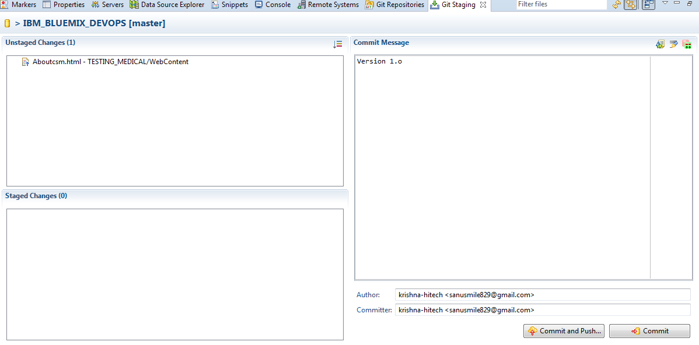
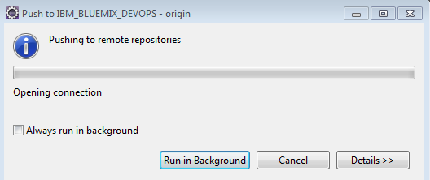
- A Push Result dialog box is appeared into which we click on ok.
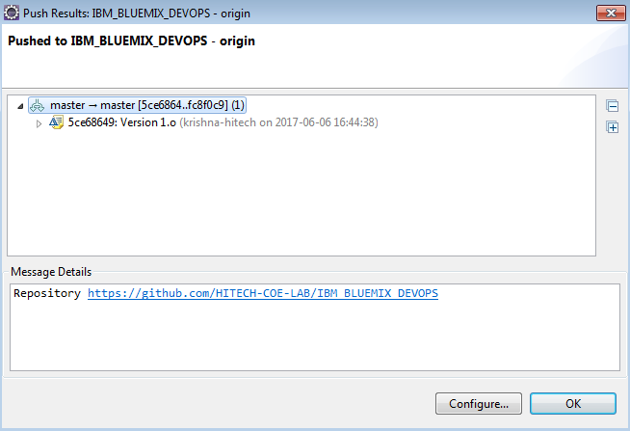
Check the repository where the code is check in
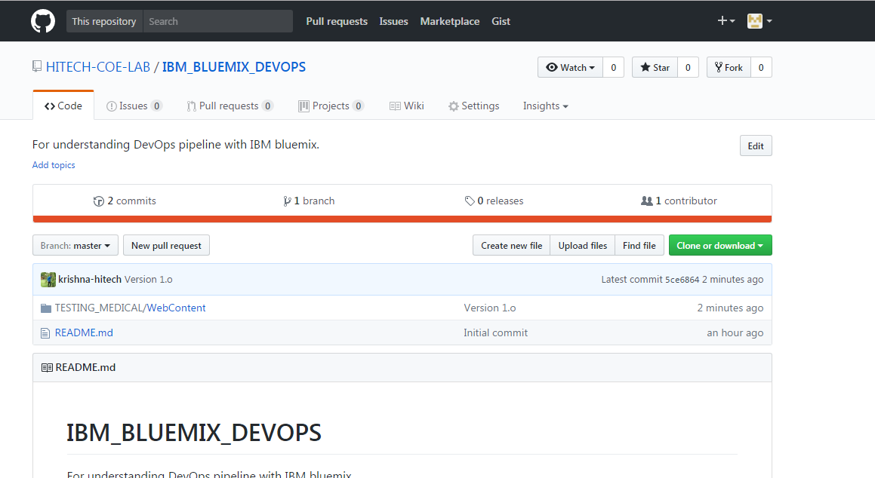
- Integration of TortoiseSVN with GitHub
Step 1: Create a folder which contains project in your local machine.
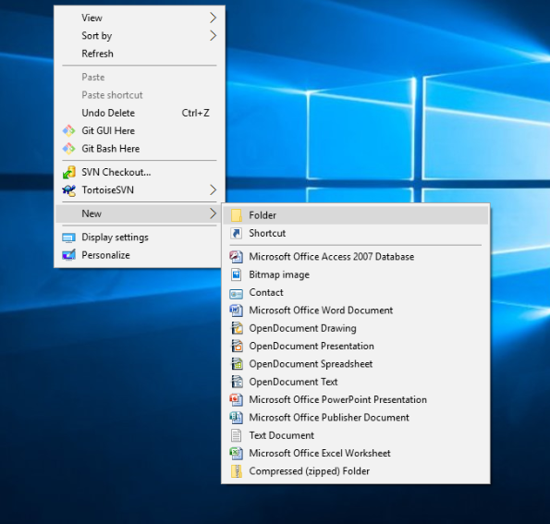
Step 2: Copy the Url of repository from which you want the checkin/checkout to be done.
- Login to your GitHub account from the Sign in button on https://github.com/login by filling your
credentials.
- Click on the desired repository from where you want the check in/ checkout.
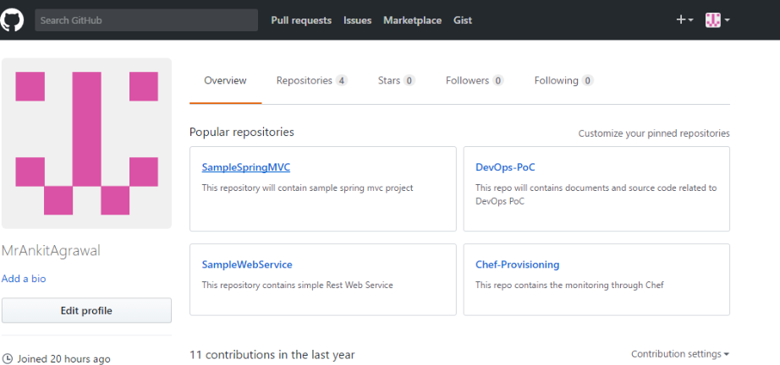
- Click on clone repository button on the right side of screen, copy the https url and save it for furture use in next step.
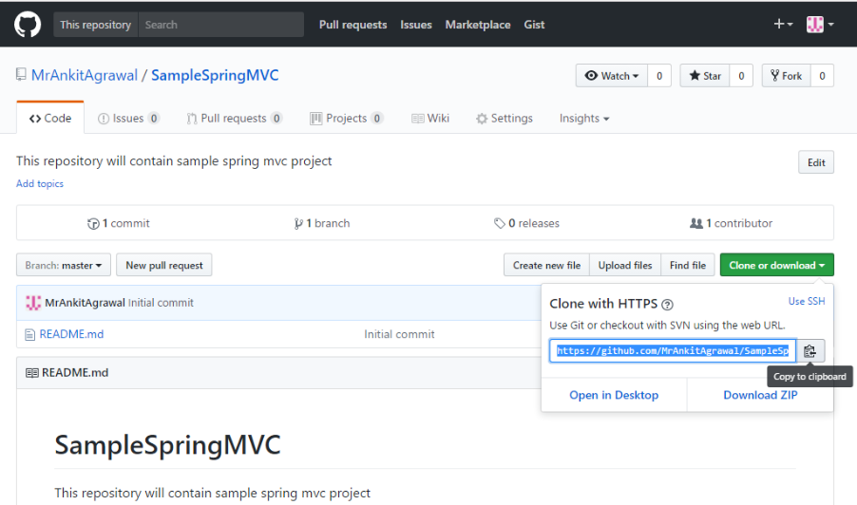
Step 3: For CheckOut
- Open the folder that you created in previous step, right click on window screen and click on SVN Checkout option:
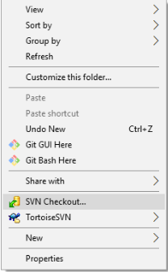
- A popup screen will open as:
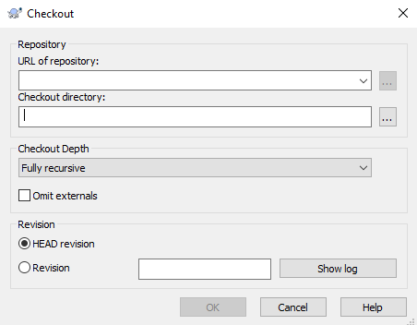
    - Paste the Url of repository Copied in Step 2.
    - Select HEAD revision and click on Ok
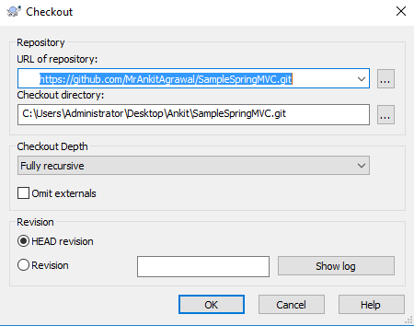
- After Click on ok the Checkout will begins:
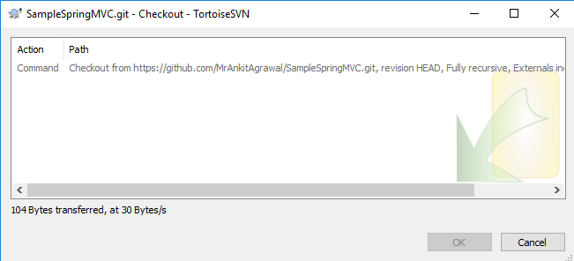
- After that a confermation Screen will open , click on ok
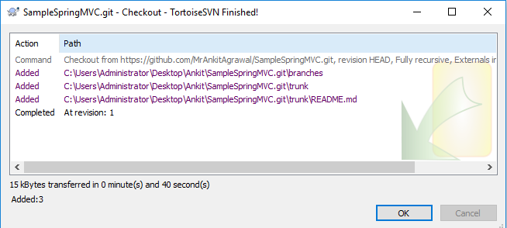
- Now Check your folder in your Local machine, the complete project inside it and checkout is completed successfully.
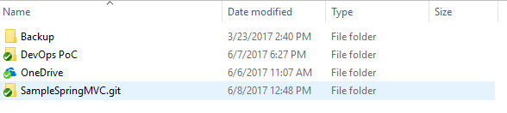

Step 4: For Checkin
- Goto the truck folder inside folder where you checkout the repository and open it.
e.g. Ankit--> SampleSpringMVC--> trunk
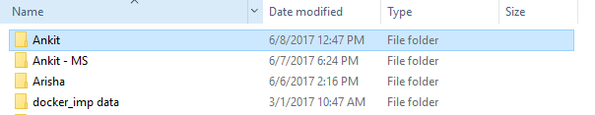
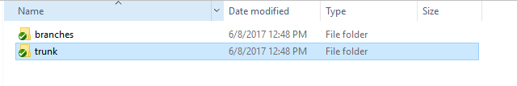
- Create any file or paste your file here.
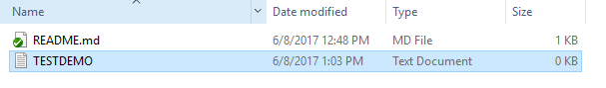
- Now right click anywhere on window screen inside this folder,and select SVN Commit option
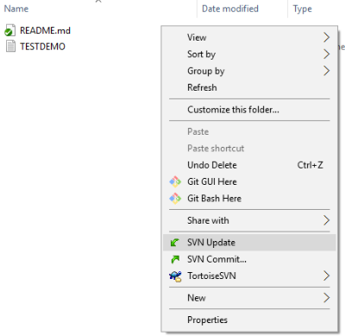
- Now a commit screen will open , fill your commit message, select the file to be commited and click on Ok button.
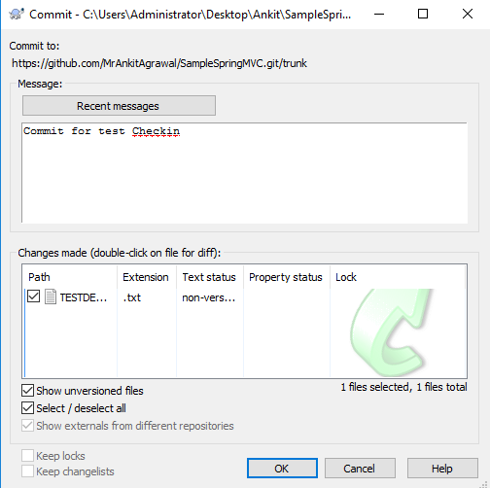
- An Authentication screen will Popup, fill the credentials for GitHub account and click on OK button.

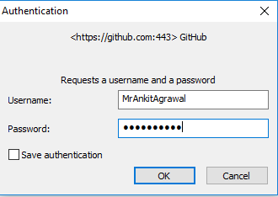
- The Chekin will start , after completion click on ok button.
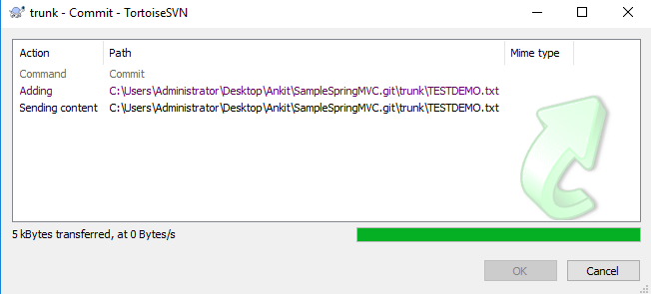

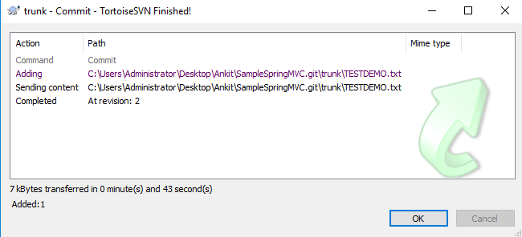
- Now check your repository the file is checkedin there.
