

EASY TICKETS
Documentation

Group Member | Phạm Xuân Hiếu  Trần Thế Quang  Tạ Văn Tuyển  Ngô Tuấn Hùng
Instructor





This is to certify that
Mr. Pham Xuan Hieu
has successfully designed and
developed
EasyTickets
Submitted by:

PHAM XUAN HIEU
Date of Issue: 05/25/2013
Authorized Signature: ___________

This is to certify that
Mr. Tran The Quang
has successfully designed and
developed
EasyTickets
Submitted by:

TRAN THE QUANG
Date of Issue: 05/25/2013
Authorized Signature: ___________

This is to certify that
Mr. Ta Van Tuyen
has successfully designed and
developed
EasyTickets
Submitted by:

TA VAN TUYEN
Date of Issue: 05/25/2013
Authorized Signature: ___________

This is to certify that
Mr. Ngo Tuan Hung
has successfully designed and
developed
EasyTickets
Submitted by:

NGO TUAN HUNG
Date of Issue: 05/25/2013
Authorized Signature: ___________

TABLE OF CONTENT

PROBLEM DEFINITION

In today’s busy world, people find it hard to find the time for entertainment. It is really pretty time consuming to find out the various entertainment shows/movies and any other such shows in and around the city. And on the top of it is more irritating to go physically and book the ticket.
E-commerce can be thought as the best solution for this. Due to which the people can buy the tickets right from home. No more buying in black. Moreover one can find the information just with a click and get the booking done.
Showbiz is the company is principally into ticket sales, marketing and distribution of event tickets. The services include providing information on multiple event categories, providing ticketing facilities for several leading multiplexes, arenas and stadiums. They are thinking of the concept of developing a web portal, where a customer can book movie tickets in theatres that are made available in the site. They wish to launch the website by the name www.easytickets.com where they can provide convenient, secure, and fair access to the best possible tickets offered by the clients. Showbiz aims at making events happening across the city more accessible-just a click away. Booking tickets can now an effortless, fun and exciting experience for every showbiz customer.

CUSTOMER REQUIREMENT SPECIFICATION

1. Overview:
- Build a web portal, where a customer can book movie tickets in theatres that are made available in the site.
- The website with the name www.easytickets.com where we can provide convenient, secure, and fair access to the best possible tickets offered by the clients.
- In addition there are 4 kinds of tickets as Sport Event, Music Shows, Movie, Drama.

2. Users of the System:
- Admin who manage this site
- Normal users who can visit this site, for the first time will have to create his account which can be used later on.

3. System function:
Main function:
- User management.
- Movie event management.
- Sport event management.
- Music shows event management.
- Drama event management.
- Book the ticket
- News managerment

3.1 Movie management.
Check the availability of the tickets on mentioned date and time in specified city, get the information of the shows running in theatres, knows the special offers and discounts, book the ticket.

3.2 Music shows management.
See the list of current shows along with the details (venue, day/time, artist), book the ticket.

3.3 Drama management.
See the list of available drama shows with complete details, book the ticket.

3.4 Sport event management.
See the available sport events with details, book the ticket.

3.5 User management.
Manage customer’s account.

3.6 Book the ticket
- Check the availability of tickets on mentioned date and time in specified city.
- View detail of ticket (venue, day/time, artist…).
- Book the tickets.
- The user selects a particular movie and show in a selected city, if there is availability of tickets for that show, then confirmation for ticket booking must be done. In case of non availability of tickets, the portal must display next available date & time.
- There is no cancellation of tickets once they are booked, at any cost. The provision for money transaction is provided in the same portal. This requires possession of a bank‘s credit or debit card with the customer.
- Online booking can be done only 15 days in advance.

4. Hardware and software requirement for system.
Hardware | Software
- A minimum computer system that will help you access all the tools in the courses is a Pentium 166 or better  - 128 Megabytes of RAM or better | - Java Virtual Machine/ J2EE server.  - Eclipse, tomcat 7  - Java SE runtime environment 7  - Struts2 Dev Kit .  - Java enabled web server.  - JSP / Servlets Dev. Kit .  - Subversion.

5 System Architecture

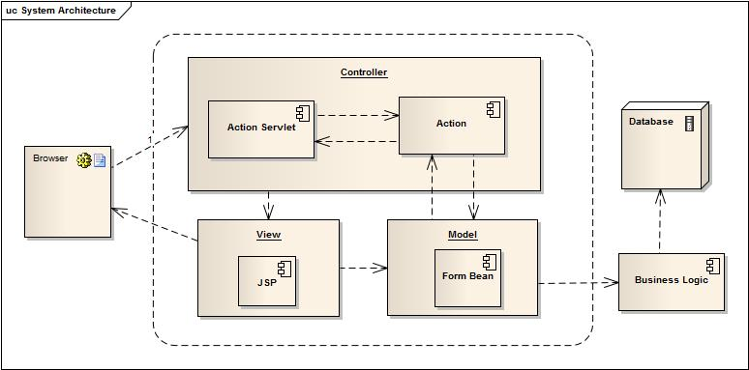
Figure 1.1 System Architecture

PROJECT PLAN

Project details

- Customer: Showbiz Company
- The Project Purpose:
- The purpose of the project is to develop an intervention program using information technology as a means of providing information about ticket booking with a program offering home visits. The evaluation of the project will yield important for developing of Showbiz Company.
- The people can buy the tickets right from home. No more buying in black. Moreover one can find the information just with a click and get the booking done.
- The Project Scope:
- Define problem.
- Define deliverables.
- Define functionality and data.
- Define technical structure.
- Design and coding on module.
- Test and Review.
- Our Understanding Of The Client Organization:
Showbiz is the company is principally into ticket sales, marketing and distribution of event tickets.
- Team Member:
Name | Role | Responsibility
Ta Van Tuyen | Team Leader | Manage group, Coding
Pham Xuan Hieu | Developer | Coding and design document.
Tran The Quang | Developer | Coding , CSS
Ngo Tuan Hung | Tester | Test , CSS

Documents from Customer
- Requirement (EasyTickets.doc file)
- Feedback form (eProject_Feeback_Form.exl file)
- Project status (eProject_Status_Report(V1).exl file)
- Project specification (ProjectSpecification.doc file)

Deliverables
- Installation Manual
- User Manual
- Document
- Application

Project Dependences
- Support from teacher.
- Good working environment.
- Members with good capacity.

Phase of Project
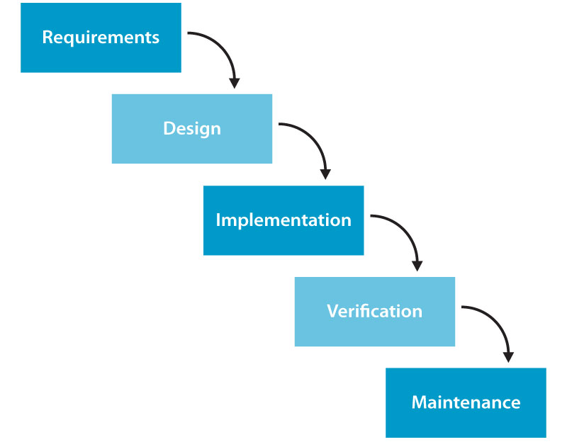

Figure 2.1 Phase of project

Quality Plan
- Review Activities (review meeting participants, and frequency).
- Testing Activities (Unit Test Plans, Integration Testing and Functionality Testing).
- Group will do something such as test links, test function every meeting.
- Backup and recovery strategies (in case of disk crash and network failures).
- After weekly, group will backup source code, database.

ENTITY RELATIONSHIP DIAGRAMS

Entity Relationship Diagram

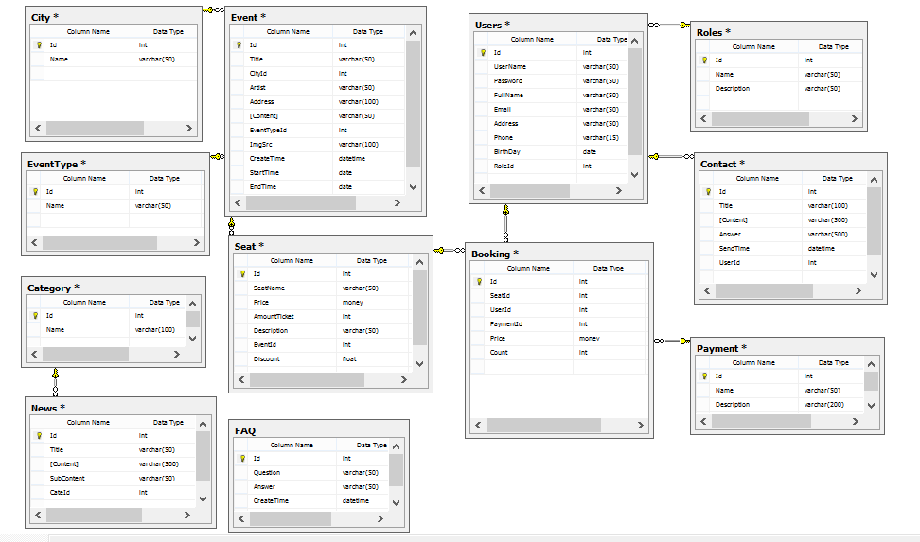
Figure 3.1 E-R Diagrams

Data Structure

Table 1: User
Column | Type | Null | Value Range | Key
Id | Integer | No | - | Primary Key
Username | Varchar(50) | No | - | -
Password | Varchar(50) | No | - | -
FullName | Nvarchar(50) | No | - | -
BirthDay | Varchar(50) | Yes | - | -
Email | Varchar(100) | Yes | - | -
Address | Varchar(50) | Yes | - | -
PhoneNumber | DameTime | Yes | - | -
CreateDate | DameTime | No | - | -
RoleID | Integer | Yes | - | Foreign Key

Table 2: City
Column | Type | Null | Value Range | Key
ID | Integer | No | - | Primary Key.
Name | Nvarchar(50) | No | - | -

Table 3: Contact
Column | Type | Null | Value Range | Key
ID | Integer | No | - | Primary Key
Title | Nvarchar(200) | No | - | -
UserID | Integer | No | - | Foreign key
Content | Nvarchar(500) | No | - | -
Answer | Nvarchar(500) | Yes | - | -
Date | DateTime | Yes | - | -

Table 4: Event
Column | Type | Null | Value Range | Key
ID | Integer | No | - | Primary Key
Title | Nvarchar(200) | No | - | -
Content | Nvarchar(100) | No | - | -
StartDate | DateTime | No | - | -
EndDate | DateTime | No | - | -
Artist | Nvarchar (200) | Yes | - | -
ImageSrc | Varchar(100) | Yes | - | -
EventTypeID | Integer | No | - | Foreign Key
Address | Varchar(100) | Yes | - | -
CityID | Integer | No | - | Foreign key
CreateTime | DateTime | No | - | -

Table 5: EventType
Column | Type | Null | Value Range | Key
ID | Integer | No | - | Primary Key
Name | Nvarchar(100) | No | - | -

Table 6: FAQ
Column | Type | Null | Value Range | Key
ID | Integer | No | - | Primary Key
Question | Nvarchar(200) | No | - | -
Answer | Nvarchar(500) | No | - | -
CreateTime | DateTime | Yes | - | -

Table 7: Payment
Column | Type | Null | Value Range | Key
ID | Integer | No | - | Primary Key
Name | Varchar(200) | No | - | -
Description | Varchar(200) | Yes | - | -

Table 8: Roles
Column | Type | Null | Value Range | Key
ID | Integer | No. | - | Primary Key
Name | Nvarchar(50) | No. | - | -
Description | Varchar(200) | Yes | - | -

Table 9: Seat
Column | Type | Null | Value Range | Key
ID | Integer | No | - | Primary Key
Seat | Varchar(300) | Yes | - | -
EventID | Integer | No | - | Foreign Key
Price | Money | No | - | -
AmountTicket | Integer | No | - | -
Description | Varchar(300) | No | - | -
Discount | Money | yes | - | -

Table 10: Booking
Column | Type | Null | Value Range | Key
Id | Integer | No | - | Primary Key
SeatId | Integer | No | - | Foreign Key
Count | Integer | Yes | - | -
Price | Money | Yes | - | -
UserID | Integer | No | - | Foreign Key
PayID | Integer | No | - | Foreign Key

Table 11: Category
Column | Type | Null | Value Range | Key
ID | Integer | No | - | Primary Key
Name | Varchar(300) | No | - | -

Table 12: News
Column | Type | Null | Value Range | Key
ID | Integer | No | - | Primary Key
Title | Varchar(100) | No | - | -
CateID | Integer | No | - | Foreign Key
Content | Varchar(500) | No | - | -

Data Flow Diagram

3.1 Customer

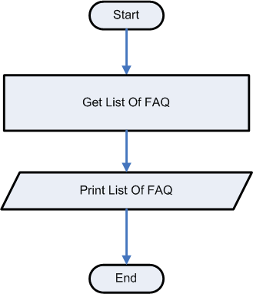
3.1.1. View FAQ

Figure 3.2 View FAQ data flow

3.1.2 Login
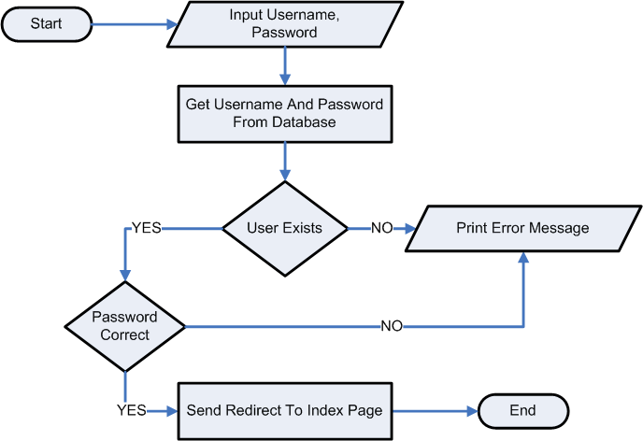

Figure 3.3 Login data flow

3.1.3 See List Ticket

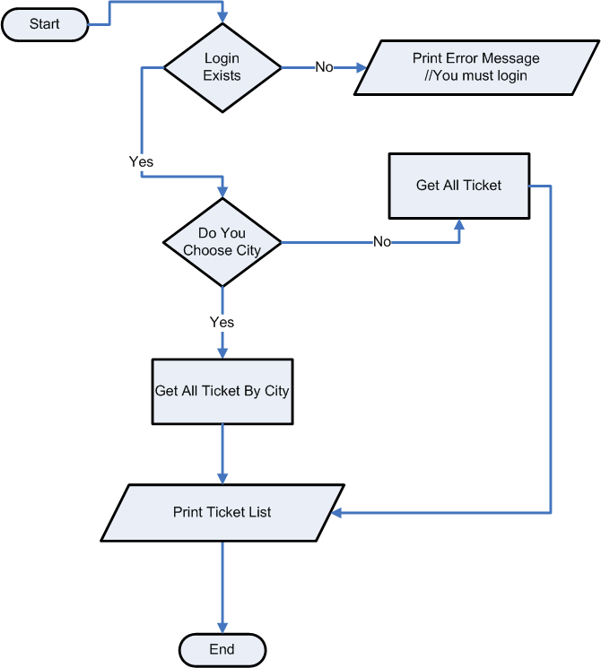

Figure 3.4 See list ticket data flow
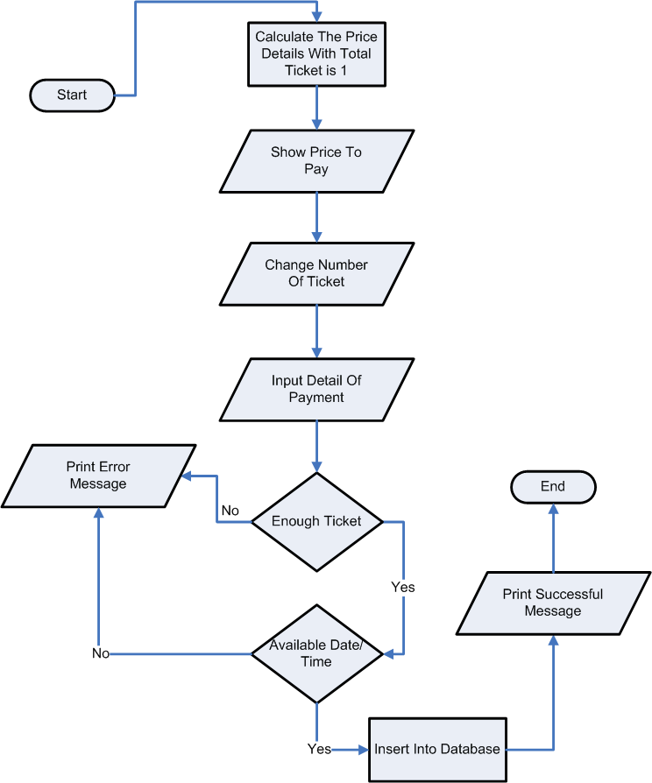

3.1.4 Book Ticket

Figure 3.5 Book ticket data flow

3.1.5 Check Available Ticket
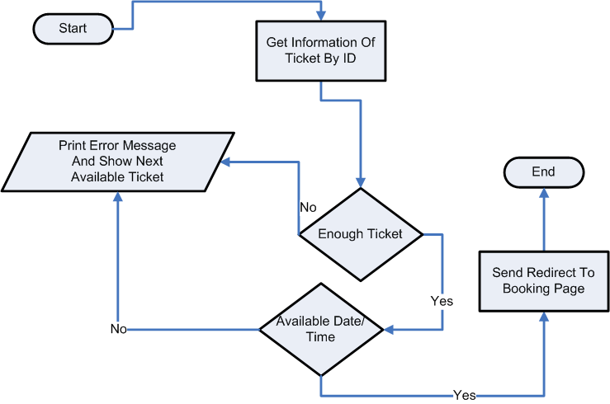

Figure 3.6 Check ticket data flow

Admin
3.2.1. Check Booking
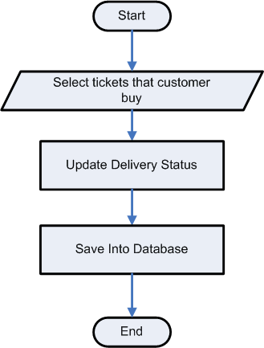

Figure 3.7 Check booking status data flow

3.2.2. Manage Ticket
3.2.2.1. Create Ticket’s Information

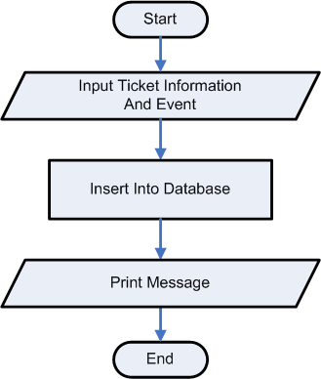

Figure 3.8 Create ticket’s information data flow

3.2.2.2. Update Ticket Information

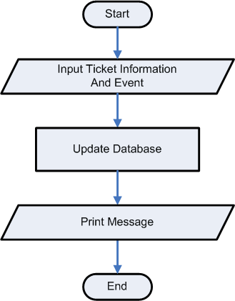

Figure 3.9 Update ticket’s information data flow

3.2.2.3. Create Event

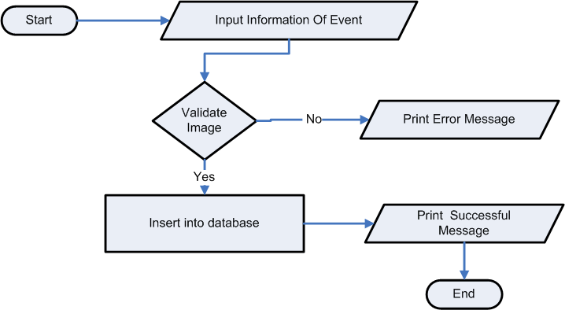

Figure 3.9 Create event data flow

3.2.3. Manage FAQ
3.2.3.1. Create FAQ Information
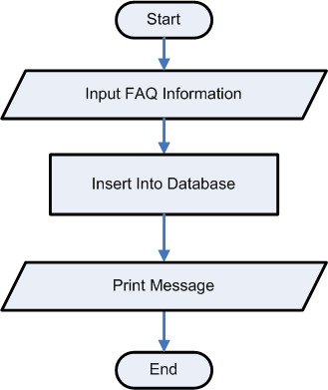

Figure 3.10 Create FAQ’s information data flow

3.2.3.2. Update FAQ Information
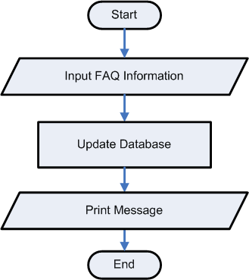

Figure 3.11 Update FAQ’s information data flow

3.2.3.3. Delete FAQ Information
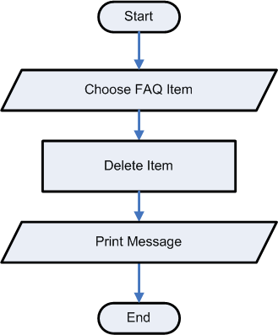

Figure 3.12 Delete FAQ’s information data flow

3.2.4. Answer question of Customer

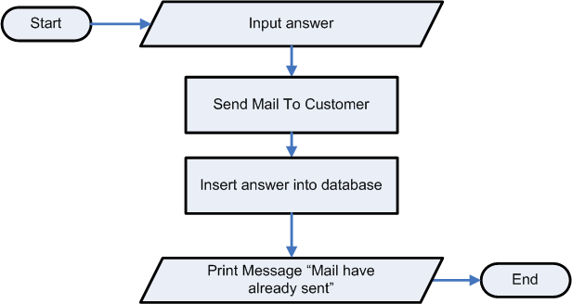

Figure 3.13 Answers the question data flow

4 Sequence Diagram

4.1 Login
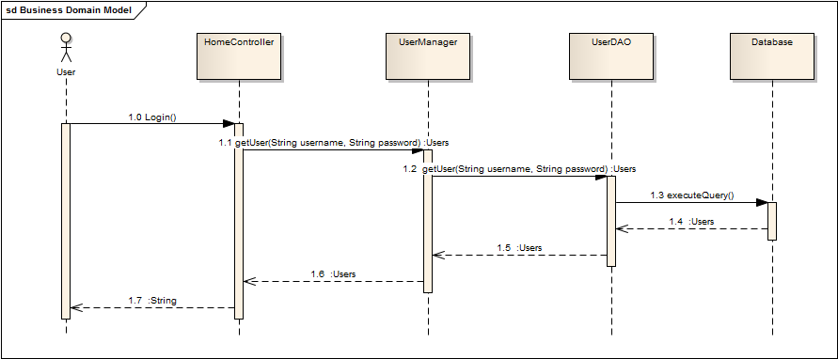
Figure 3.14 Login sequence diagram

4.2 See list event’s ticket
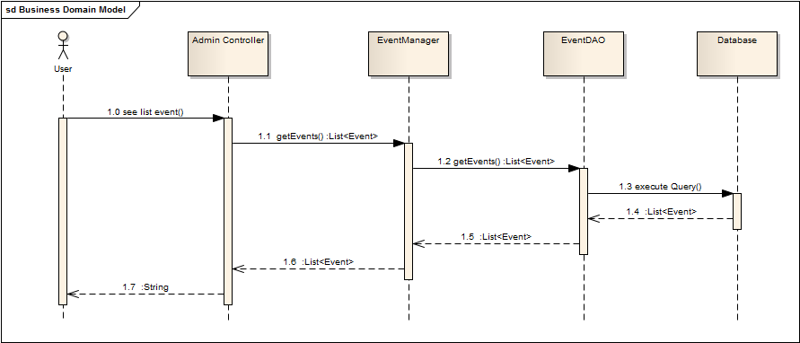

4.3 Create ticket
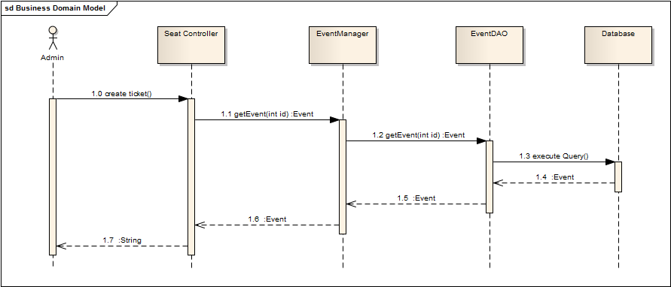

4.4 Create User account
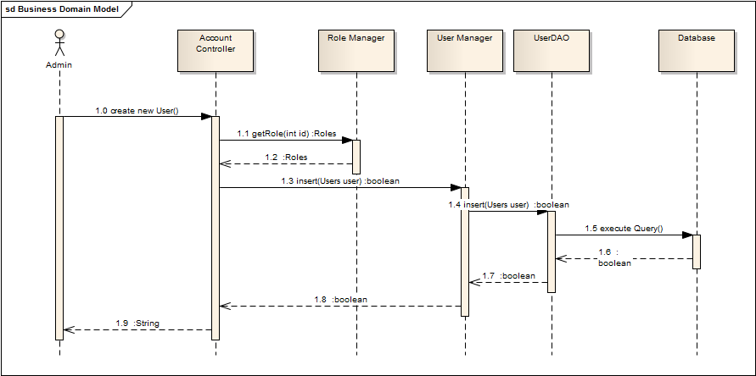

4.5 Create Event
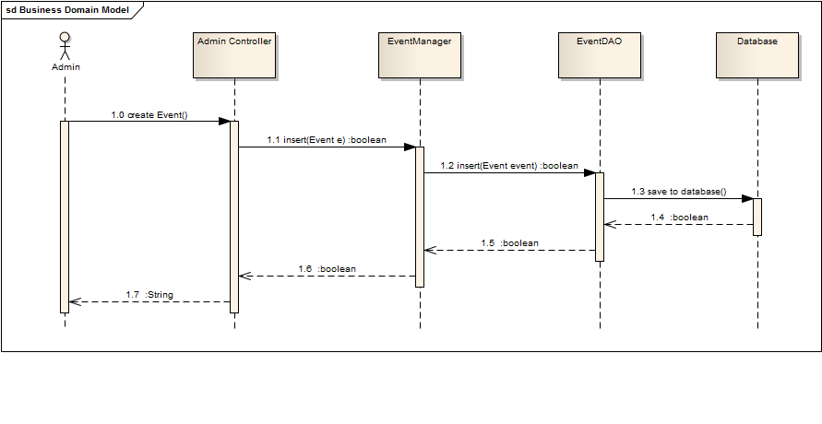

5 Site Map

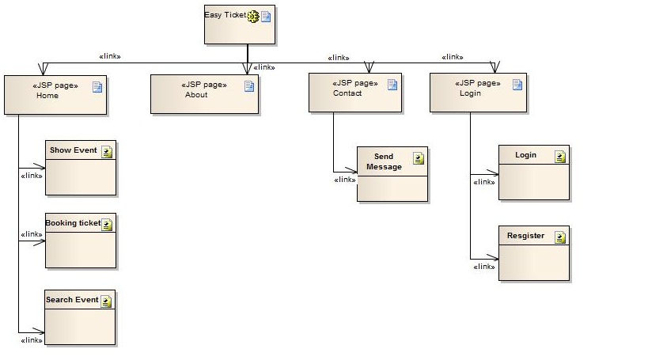
Figure 3.14 Site map

INTERFACE DESIGN DOCUMENT

Home Page
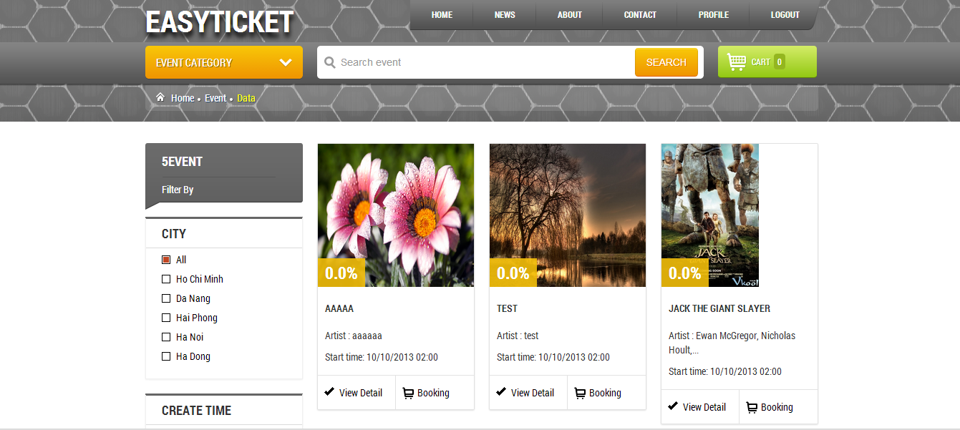
Figure 4.1 Homepage page

About us
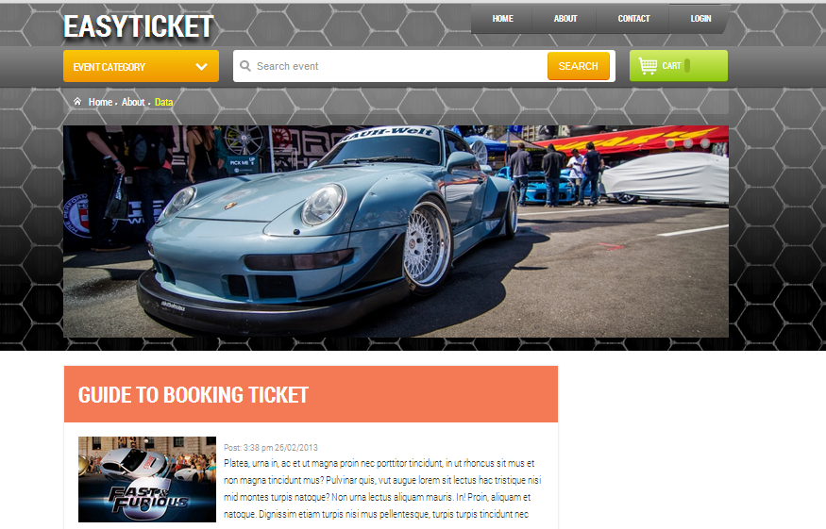
Figure 4.2 Abouts us page

Login

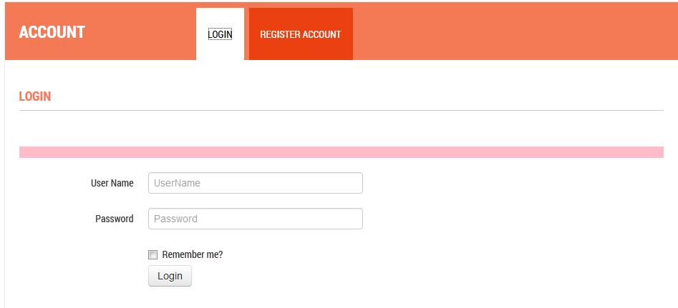
Figure 4.3 Login page

Booking ticket
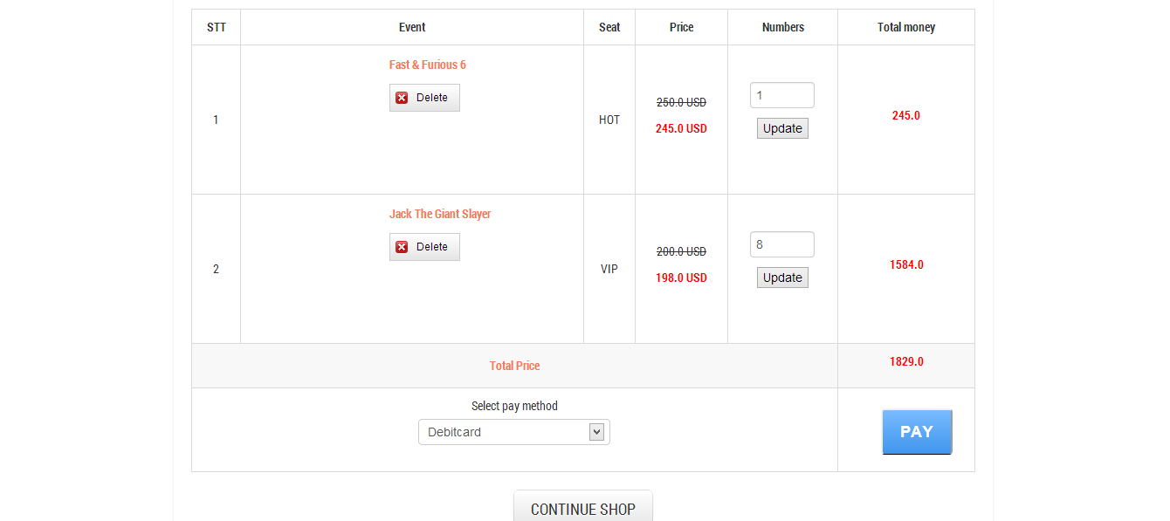
Figure 4.4 Cart page

Register

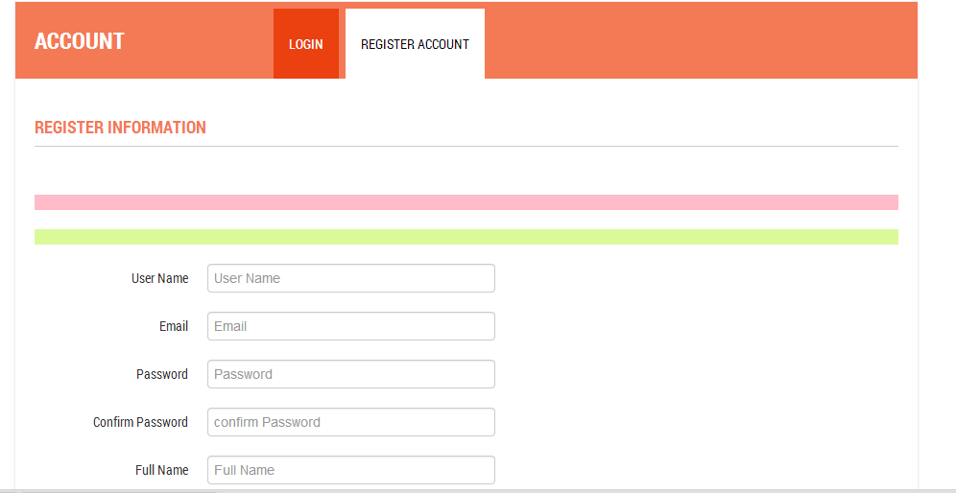

Figure 4.5 Register new account page

Admin Page

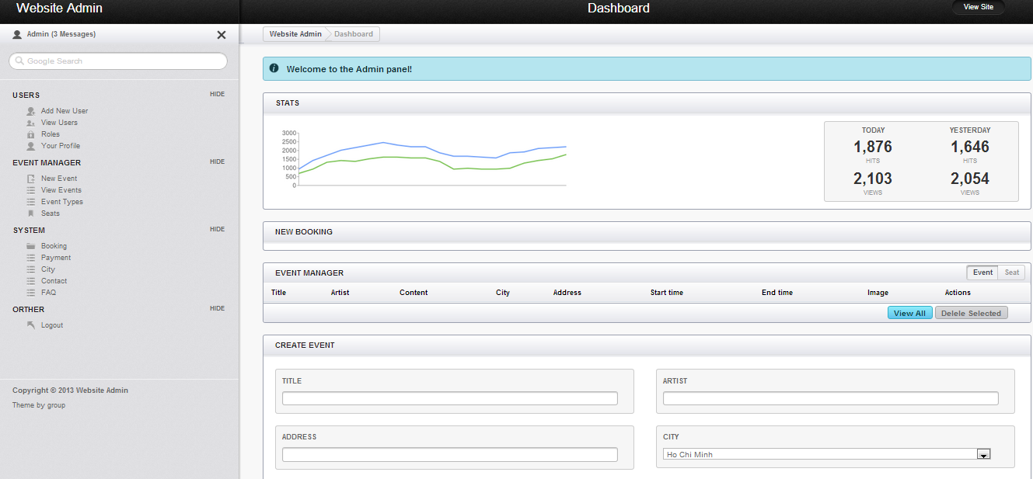

Event Management
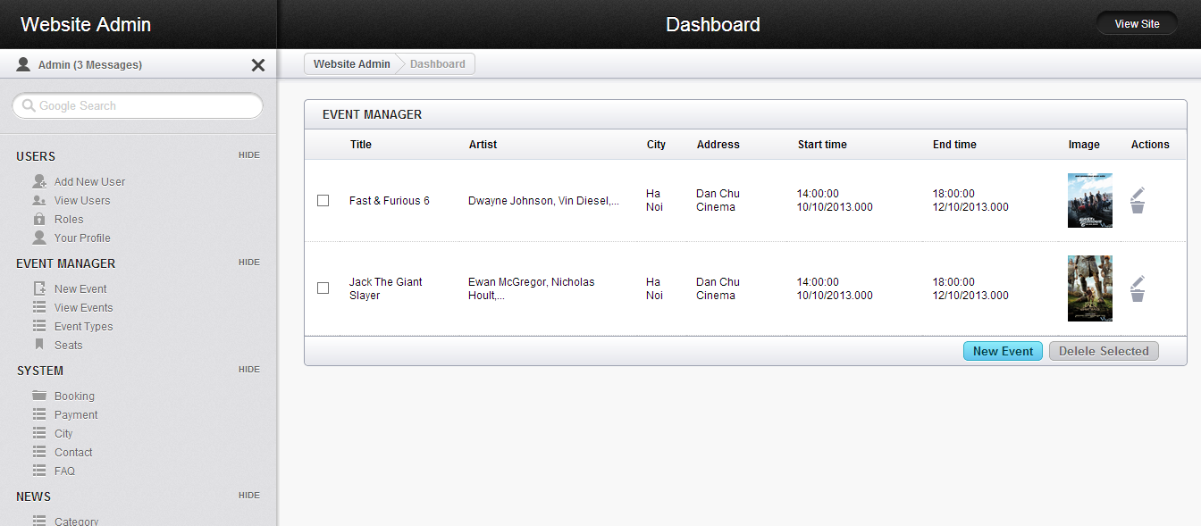

User Management Page
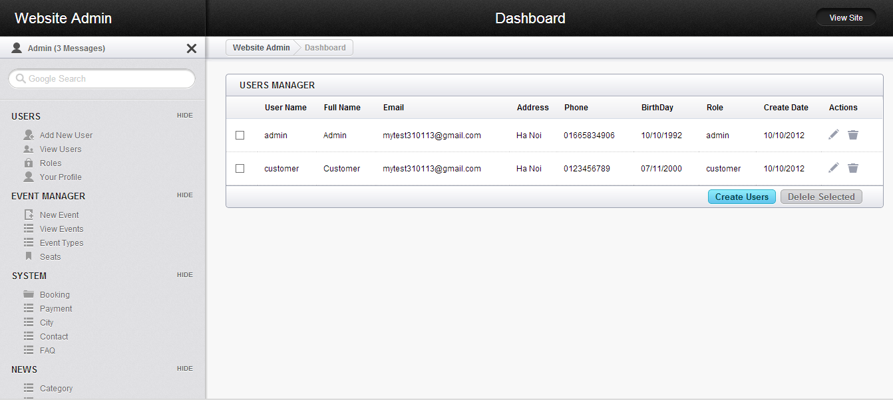
- Contact
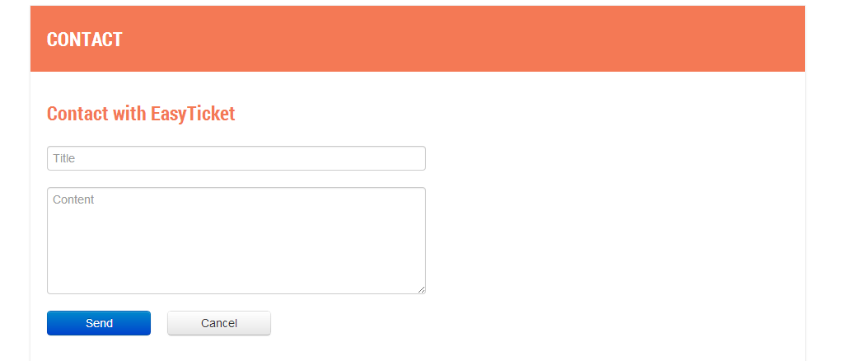
- FAQ Manager
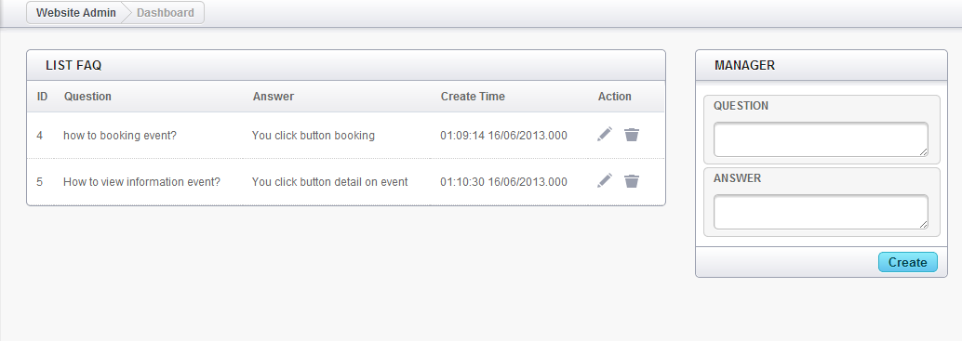
- Seat Manager
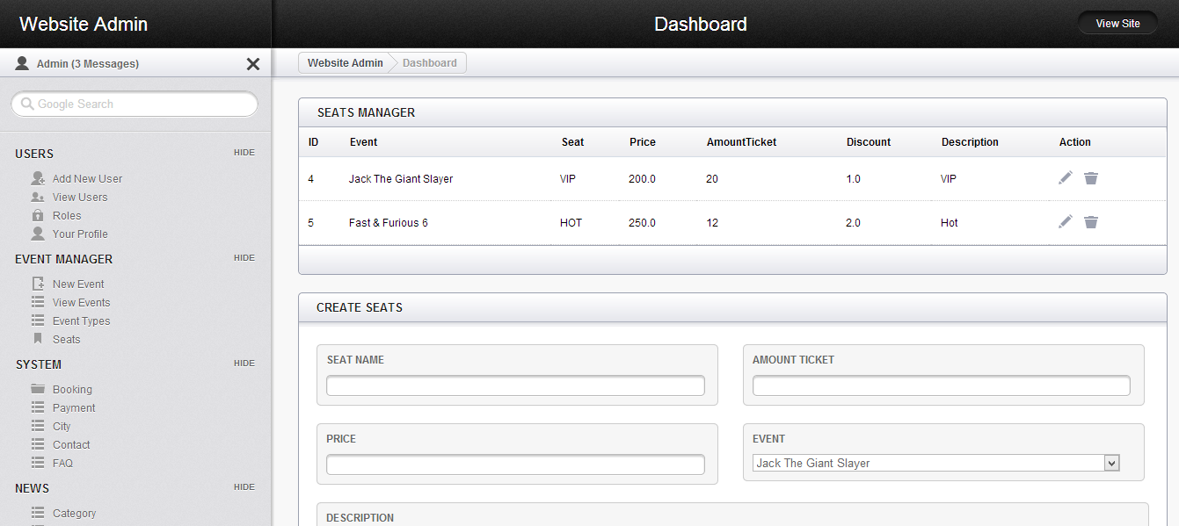
- Role
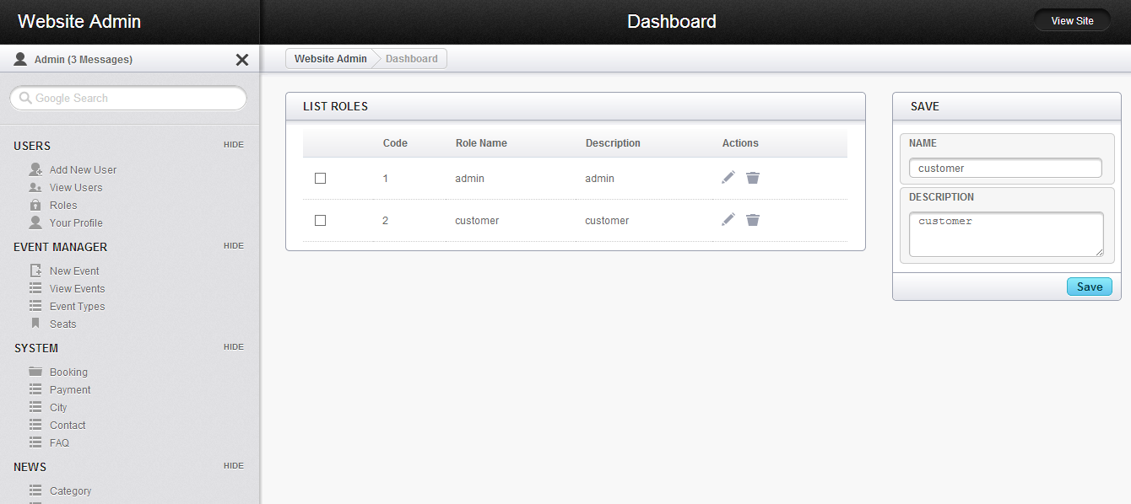

TASK SHEET

Task | Start time | End time | Name | Status
Investigate requirement | May,15 | May,20 | Team | Finished
Study requirement | May,15 | May,16 | Team | Finished
Define function of system | May,17 | May,20 | Team | Finished
Analyses System | May,21 | May,27 | Ta Van Tuyen | Finished
Get detail description about system | May,21 | May,27 |  | Finished
Design System document | May,21 | May,27 | Pham Xuan Hieu | Finished
Define the user, entity, entity relationship | May,21 | May,22 |  | Finished
Design data structure docs | May,23 | May,25 |  | Finished
Project Plan | May,25 | May,26 |  | Finished
Draw sitemap, interface design docs | May,27 | May,27 |  | Finished
Coding | May,28 | June,12 | Team | Finished
Design interface for web :  - Design HomePage interface  - Admin and normal user  - Event & Booking ticket | May,28 | June,10 | Ngo Tuan Hung | Finished
Create model , Data access layer | May,28 | June,10 | Tran The Quang | Finished
Controller layer | May,28 | June,10 | Ta Van Tuyen | Finished
Design Interface class | May,28 | June,04 | Pham Xuan Hieu | Finished
Testing | June,11 | June,15 | Team
Test interface web |  |  | Ngo Tuan Hung | Finished
Test DAO layer |  |  | Tran The Quang | Finished
Test Controller layer |  |  | Ta Van Tuyen | Finished
Integration testing |  |  | Pham Xuan Hieu | Finished
Complete documents | June,11 | June,15 | Pham Xuan Hieu | Finished

UNIT TESTING CHECKLIST

FINAL CHECK LIST

