# Components

This is the CharacterList component:

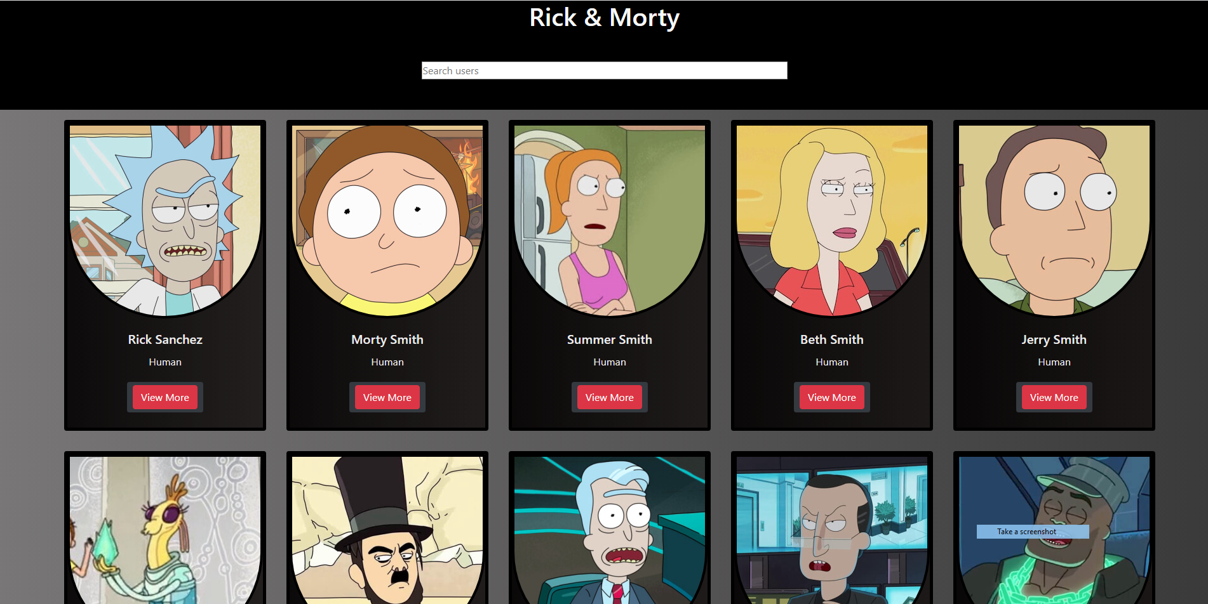

It contains a seach, a set of cards and a button for pagnation, that will load further characters from the series.  
The search will search through fetched characters.

And the button to view details for the selected character. Pressing this button will take you to the details page, that looks like this:

