

**UTTARA UNIVERSITY**

**PROJECT PROPOSAL ON**

**DESIGN & IMPLEMENTATION OF EDUCATION PORTAL SYSTEM**

**GROUP MEMBERS**

|  |  |  |
| --- | --- | --- |
| **MD RAJIB MRIDHA** | **ID 2161081100** | **BATCH (38th B DAY)** |
| **MD ARMAN HOSSAIN** | **ID 2161081117** | **BATCH (38th B DAY)** |
| **MUNIRA MUNMUN MIM** | **ID 2161081118** | **BATCH (38th B DAY)** |
| **JANNATUN NESSA RUSHNI** | **ID 2161081119** | **BATCH (38th B DAY)** |

Supervisor: Dr. Md Akhtaruzzaman

Co-supervisor: Dr. A.H.M Saifullah Sadi

SPRING 2019

BSc. In Computer Science and Engineering, Department of Computer Science and Engineering, Uttara University, Uttara, Dhaka, Bangladesh.

**ABSTRACT**

**Education portal system** means the use of computer and Internet technologies to deliver a board array of solutions to improve teaching-learning performances. Nowadays, most of the academic institutions are using education portal system because it is efficient and low cost. It helps the learners by providing new learning opportunities to achieve the ultimate goals according to their environment. Currently, learning is no longer confined to classrooms with traditional lecture delivery. The main objective of education portal is to facilitate education by using communication media through internet which made learning possible from anywhere at any time. The main purpose of this project is to design and develop of education portal system to add values in teaching-learning technology. This project will allow various stages for developing specific courses and related resources. As the project will be developed based on open source platforms, it will satisfy the user requirements and allow them to reuse, study, and distribute. The potential outcome of this project will be able to accommodate all kinds of academia and improve the teaching-learning environment through the integration of the proposed system with the traditional education system.

***Keywords:*** *Education portal system, Learning system, Teaching-learning environment, Open source platform, E-education system.*

**TABLE OF CONTENT**

ABSTRACT ii

TABLE OF CONTENT iii

**1.INTRODUCTION** 1

1.1. Document Margin 2

1.2. Header and Footer 2

*1.2.1. Header* 2

*1.2.1. Footer* 3

1.3. Cover Page 3

**2.LITERATURE REVIEW/BACKGROUND STUDY** 4

2.1. Abstract and Keywords 5

2.2. Table of Contents (TOC) Formatting Rules 6

2.3. Main Content Writing 7

*2.3.1. Main heading (level 1) 8*

*2.3.2. Sub-heading (level 2) 8*

*2.3.3. Sub-sub-heading (level 3) 9*

**3. PROBLEM STATEMENTS AND SIGNIFICANCE 9**

3.1. Paragraph Style 10

3.2. Bullets and Numbering Style 11

**4. RESEARCH/PROJECT OBJECTIVES 11**

**5. PROJECT/RESEARCH METHODOLOGY 15**

5.1. Figure/Image Style 20

5.2. Table Style 21

5.3. Reference Style 22

**6. EXPECTED OUTCOMES 15**

**7. GANTT CHART & RESEARCH MILESTONE 16**

**8.CONCLUSION 17**

REFERENCES 18

SHORT BIOGRAPHY 18

**DESIGN & IMPLEMENTATION OF EDUCATION PORTAL SYSTEM**

MD RAJIB MRIDHA, MD ARMAN HOSSAIN,

MUNIRA MUNMUN MIM and

JANNATUN NESSA RUSHNI

*ID 2161081100 (Batch 38th B Day),*

*ID 2161081117 (Batch 38th B Day),*

*ID 2161081118 (Batch 38th B Day)* and

*ID 2161081119 (Batch 38th B Day)*

**1. INTRODUCTION**

E-education means knowledge which is defined the skill acquired by a person through experience or education. Knowledge is exchanged among people, friends or family members, an organization or community through sharing knowledge activity. The current technology methods are using this knowledge and store that knowledge using repository. It is widespread use of the internet which is seen educational portal the internet & the using rapidly.

Education portal system is basically a web-based system that makes knowledge available to users or learners and disregards time restrictions although available learning has advantages over traditional face-to-face education. This project improves the quality of education technology which impacts on the teaching sectors to radically change the delivery of learning process.

**2. BACKGROUND STUDY**

In this section we compare two popular education portal systems. There are:

1. Khan academy
2. Udemy.com

Khan Academy is a non-profit educational organization created in 2008 by Salman Khan with the goal of creating a set of online tools that help educate students. The organization produces short lessons in the form of videos. Its website also includes supplementary practice exercises and materials for educators. All resources are available to users of the website. The website and its content are provided mainly in English, but is also available in other languages including Spanish, Portuguese, Hebrew, Italian, Russian, Chinese, Turkish, French, Bengali, Hindi, Georgian and German.

The main concepts of Khan Academy are:

1. Khan Academy's website aims to provide a personalized learning experience, mainly built on the videos which are hosted on YouTube.
2. The website is meant to be used as a supplement to its videos, because it includes other features such as progress tracking, practice exercises and teaching tools. The material can also be accessed through mobile applications.
3. The videos display a recording of drawings on an electronic blackboard, which are similar to the style of a teacher giving a lecture.

Another education portal system, Udemy.com, is an online learning platform. It is aimed at professional adults. Unlike academic massive open online course (MOOC) programs which are driven by traditional collegiate coursework, Udemy uses content from online content creators to sell for profit. Udemy provides tools which enable users to create a course, promote it and earn money from student tuition charges.

No Udemy courses are currently credentialed for college credit; students take courses largely as a means of improving job-related skills. Some courses generate credit toward technical certification. Udemy has made a special effort to attract corporate trainers seeking to create coursework for employees of their company. As of 2018, there are more than 100,000 courses on the website. Main features of the Udemy.com are presented below.

1. Udemy serves as a platform that allows instructors to build online courses on topics of their choosing.
2. Using Udemy's course development tools they can upload video, PowerPoint presentations, PDFs, audio, zip files and live classes to create courses. Instructors can also engage and interact with users via online discussion boards.
3. With Udemy for Business, organizations can also create custom learning portals for corporate training.

Table 1 Comparison among Khan Academy, Udemy. Com, and RAMR School

|  |  |  |
| --- | --- | --- |
| **Khan Academy** | **Udemy.com** | **RAMR School (proposed system)** |
| To provide a personalized learning experience, mainly built on the videos which are hosted on YouTube. | To build online courses on topics of their choosing. | It will provide users a point of access to various educational tools and facilities. |
| The website is meant to be used as a supplement to its videos | Udemy uses content from online content creators to sell for profit. | Through this system the students will be able to access information resources and materials. |
| They skip the lessons which will be affecting to gain the knowledge | They skip the lessons which will be affecting to gain the knowledge | They learn all the lessons one by one lessons which will be helping to gain the proper knowledge |
| The organization produces short lessons in the form of videos. | Udemy courses are currently credentialed for college credit; students take courses largely as a means of improving job-related skills. | The organization produces largely lessons in the form of resources and materials. |

**3. PROBLEM STATEMENTS**

On background study of both educational portal systems we saw that both systems are based on videos. There are no limitations to learning the courses, the users learn any lessons in any time. They skip the lessons which will be affect to gain the knowledge. The websites doesn’t have any group list and also the faculty list. Khan academy provide videos but our web sites provides all kinds of documents, references. On the other hand, Udemy.com to sell for profit but our websites are not sell. On is based on professional adults and another is for high school organization. Our web sites is based on engineering student education. We add new feature which is list of students group. It is one kind of classroom just like manual institutions. The purpose of this study is to develop a web based online Educational Portal. As a solution the problems that is faced by the students of any institution.

* Problems with traditional teaching in classroom environment
* Lack of resources to invest in teaching and learning aids
* Economic Divide in term of rural institutes
* Lacking trained teacher for the usage of technology

**4. SIGNIFICANT OF THE PROJECT**

The project will be an effective resource and knowledge sharing between teachers and students. Necessary information for students will be provided by the system to improve their academic performance and excellence. It refers to educational service to users. This portal will be a community of practice and a service to maintain the knowledge. The following significant of this project are given below:

* 1. It provides users a point of access to various educational tools and facilities.
  2. Communicating the students and teachers thus forming a network among them.
  3. Through this system the students will be able to access information resources and materials.
  4. Teachers can provide all the necessary information resource material to their students and able to get the student information from the website.
  5. This system student gain knowledge.
  6. It benefits from study for students.
  7. Time and cost benefit.
  8. Information can be accessed from anywhere and anytime through this online portal.
  9. Help students to use e-library and interactive virtual classroom free to cost.
  10. It provides students on access to learning material.
  11. Building to excellence to teachers producing interactive and attractive e-contents.
  12. It saves time, cost and efforts by adapting the e-educational correspond and archive center.
  13. Top management to be well-supported for the project therefore their decision making in this area.
  14. All educational information linked online.
  15. It is positive effect for e-lifestyle for young generation towards a learning organization.

Education portals usually dedicate a whole section to online instruction material for students. An educational portal is a gateway to educational information and services to communicate and learn from teachers to students.

**4. PROJECT OBJECTIVES:**

The main objectives of this project are given below:

1. To design user friendly GUI.
2. To design a Database with normalized entities.
3. To implement the education portal system through coding and testing.

**5. PROJECT METHODOLOGY**

In our system, we develop the new innovation of teaching and learning process which is e-education system. It provides various techniques for improving the process of human learning which is relevant information. The system has some obstacles and barriers adopting in an institution. In this project our main concept is create a web based e-education system which connect the people and build relationships across Institutions, also better knowledge exchange platform and to achieve better teaching learning process. It control and monitor the user activities.

The methods of this process are **Incremental Development Model** and the process is **Plan Driven and Agile Both Process**. Because plan is advance and then we develop the system. The system is web portal tool to help knowledge of our organization to improve their collaborative activities. This is designed the educational portal system where download the free e-education open source software (PHP) on the internet. It using by PHP and database used in My SQL.

The designed tools PHP as Front-end and Apache as middle-ware and My SQL database as Back-end. This portal the knowledge exchanges the repository of knowledge that make use of accessing lecture notes

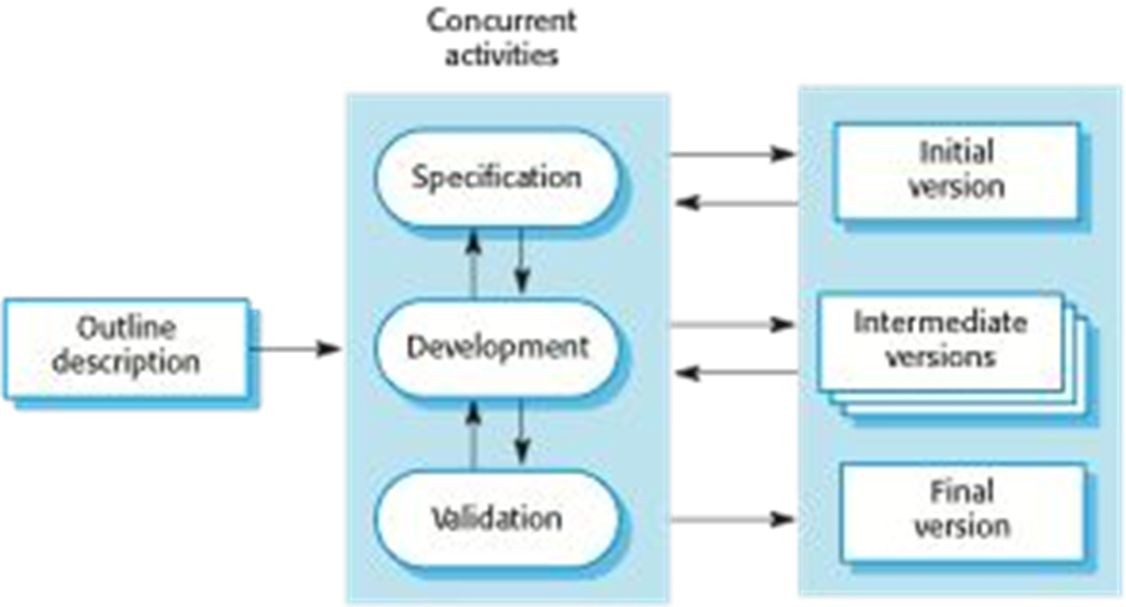

Figure 1 Incremental Model of the activities in preparing the project template

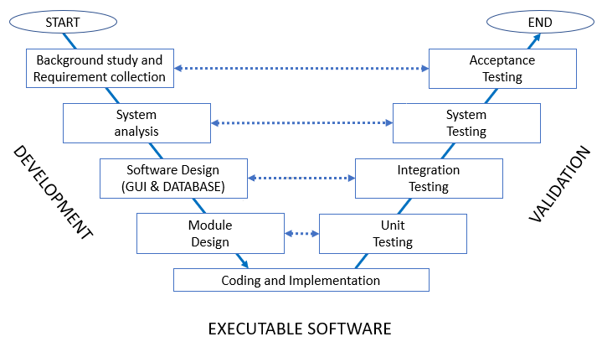

Figure 2. Executable Software (V-Model) of the proposed software.

Following ***Project Scope*** may include:

1. Online registration portal for student’s information registration.

2. Downloading the lecture, document, course details etc.

3. Building the prototype of portal.

4. Develop the educational portal system

5. Better teaching process.

6. Effectiveness education sharing and

7. Portal demonstration.

8. Multiple service.

9. Community based and user-centric.

10. Students gives the test, teacher publish the result.

11. The portal has included the common features and services of educational portal.

The scope life cycle, the organization students share the experience of learning context, publishing news and answer the Q and A. The teacher explicit the knowledge, get into discussion forums, and post questions to Q and A. This is the entity relationship for educational portal system.

It will be increase the student retention, graduation rates and able to retain the knowledge of faculty members. The faculties are participating in this portal authorized knowledge resources. By this document they share lectures, books etc through this paper. The students collect all the information by this portal. It helps to communicate the students and the teacher.

**6. EXPECTED OUTCOMES**

In this portal we designed the Web based e-educational portal system –

* We designed **GUI** and implement the system.
* We designed an online portal to provide an online registration portal **homepage**.
* It contains the **overview** about the students, staff and teachers for the organization.
* By developing the portal it **explicit knowledge** can be **shared** between the staff members and the students of an institution.
* It monitors the system shared with the faculty system which is **server** and it control them to access in internet.
* Analyze the ability of student **understanding** about the **lessons** taught by the faculty.
* As the project scope is web based, the system is **server**(Faculty) and **client**(Student).
* achieved Social & educational contribution.
* Published page& research paper.

**7. GANTT CHART & MILESTONE**

Any suitable software can be used in designing the Gantt chart and Milestone chart of the proposed project. For preparing this document template, the principal activities and milestones of this document preparation work have been identified as follows.

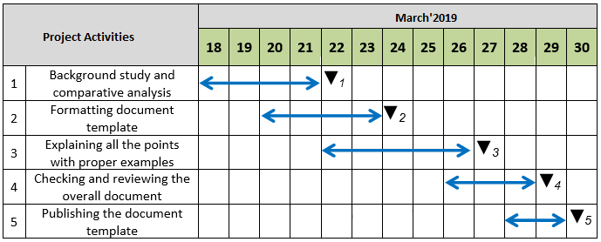

Figure 3. Gantt Chart of the Project Activities

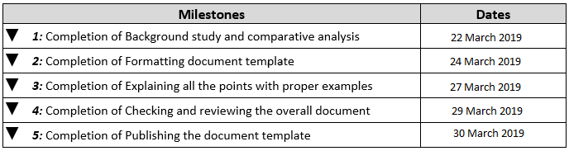

Figure 5. Project Milestones and dates

**8. CONCLUSION:**

This research has analyzed by meant of portals and education portals. It identifies the various types of portals for education which concludes that an education portal is a gateway to educational information. This portal would provide many opportunities to the visually impaired individuals for the dynamic and interactive education. The education and socializing would be common together. It has a structure which organizes the educations in the various lengths. It specifically targeted at a certain community &providing them with a virtual communication and learn from each other. Overall it is believed that this portal can help to eliminate much confusion about the concept education portal among internet users.

**REFERENCES**

The Commonwealth of Learning. Best Practice in Education Portals.

http://www.educause.edu/ir/library/html/pub5006.asp

http://en.wikipedia.orgBiagiotti L., Liu H., Hirzinger G., and Melchiorri C. (2003)

Cartesian Impedance Control for Dexterous Manipulation. Proceedings of the 2003 IEEE/RSJ Intl. Conference on Intelligent Robots and Systems Las Vegas, Nevada, October 2003. pp. 3270–3275.

Daigle, S.L. and Cuocco, P.M. (2002) ‘Portal technology opportunities,

obstacles, and options: a view from the California State University’, Web

Portals and Higher Education, Technologies to Make IT Personal,

Boulder, CO: Educause, pp.109–123, Retrieved 10 January 2005,

Katz,R.N. et al. (2002)Web Portals and Higher Education, Technologies

ToMake IT Personal, Boulder, CO: Educause, Retrieved 10 January

2005,

<http://www.educause.edu/ir/library/html/pub5006.asp>.

**SHORT BIOGRAPHY**

**Group Member One:** MD RAJIB MRIDHA,

ID:*2161081100*, Batch: *38th B Day,*

*E-mail:* [rajibhasan.cse.38c@gmail.com](mailto:rajibhasan.cse.38c@gmail.com)

**Group Member Two:** MD ARMAN HOSSAIN,

ID:*2161081117*, Batch:*38th B Day*,

E-mail: [arman.hakim49@gmail.com](mailto:arman.hakim49@gmail.com).

**Group Member Three:** MUNIRA MUNMUN MIM,

ID:*2161081118*, Batch: *38th B Day*,

E-mail: [m.munira.mim@gmail.com](mailto:m.munira.mim@gmail.com)

**Group Member Four:** JANNATUN NESSA RUSHNI,

ID: *2161081119*, Batch:*38th B Day*

E-mail*:* [jannatunrushni@gmail.com](mailto:jannatunrushni@gmail.com)