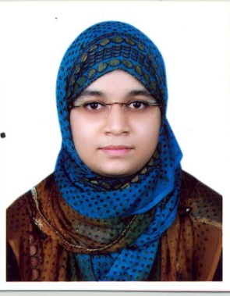 **MUNIRA MUNMUN**

**Mobile :** 01757140810

**E-mai**l : m.munira.mim@gmail.com

**Address:** 78, College road,

Auchpara, Tongi,

Gazipur City Corporation.

**Contact Information:**

**Career Objectives:**

To work in a thought-provoking and dynamic atmosphere and to keep adding value to the organization that I represent and assist, while also concurrently progressing my aids and knowledge.

* Professional **Graphics Designer**. Expert on Adobe Illustrator & Photoshop.
* Complete a Training of “**Android Mobile Application Development**” Course Under ICT division , Ministry of ICT

July’2018.

**Experience:**

**Key Skills:**

* Office applications : MS Word, Excel, PowerPoint
* Programming Language : C, C++, JAVA
* Web Developing : HTML, CSS, Javascript, PHP
* Operating System : Windows Xp, Windows vista, windows 7,8 & 10.
* Graphic Design : Adobe Photoshop & Illustrator.
* Typing : English & Bengali.
* Application : Android Mobile Apps.

**Other Skills:**

* Software Install & fixing problem.
* Good Typing Speed in Bangla & English.
* Knowledge about local Networking, Routing & IP configuration.

**Language skill**

* Good command over both verbal and written communication in English and Bengali.

|  |  |  |  |  |  |  |
| --- | --- | --- | --- | --- | --- | --- |
| No | Qualifications | Institution name | Board | Major/ Specialization | Result | Duration |
| 1 | B. Sc in Computer Science & Engineering | Uttara University | Dhaka |  | CGPA 3.95 in scale of 4.00 | 2016-2019 |
| 2 | Higher Secondary Certificate (H.S.C) | Safiuddin Sarker Academy and College | Dhaka | Science | GPA 4.50 in scale of 5.00 | 2013-2015 |
| 3 | Secondary School Certificate (S.S.C) | Safiuddin Sarker Academy and College | Dhaka | Science | GPA 4.50 in scale of 5.00 | 2011-2013 |

**Educational Background**

**Extracurricular Activities:**

I’m interested to take new challenges & like to do something creative. During leisure, enjoying time doing image editing, designing, watching movie, reading books. Always curious about learning new things.

**Personal Information:**

Father’s Name : Md. Mohshin Patwary.

Mother’s Name : Nargis Begum.

Permanent Address : 78, Auchpara, College road, Tongi, Gazipur City Corp.

Gazipur.

Date of Birth : 20-10-1998

Marital Status : Single

Nationality : Bangladeshi (By Birth).

Religion : Islam.

Height : 5’-4”

Blood Group : A (**+**ve)

Sex : Female.

|  |
| --- |
| **Prof. Dr. Md Mijanur Rahman**  Head of depertment  Department of Computer Science & Engineering  Uttara University  Mobile: 01778949274  Uttara, Dhaka-1230 |

**Reference**



(Signature)

Md. Mahadi Hasan