Part A
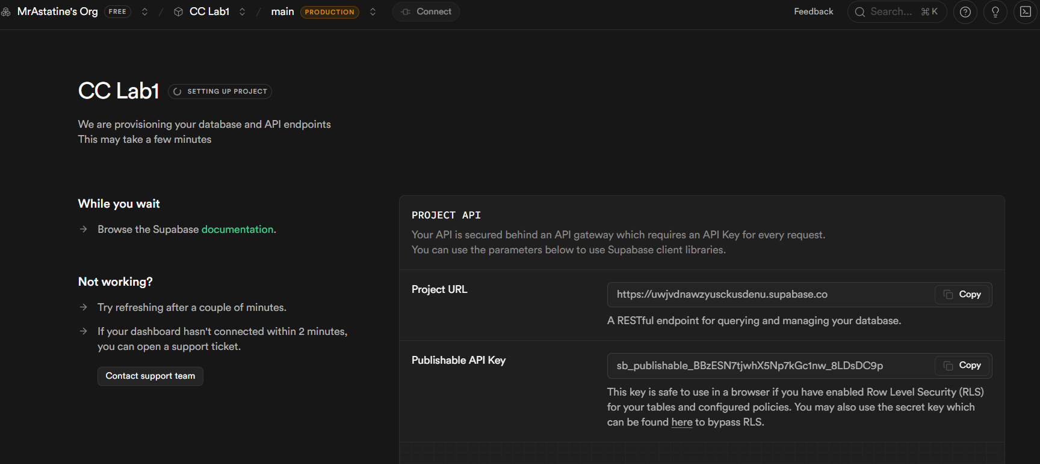
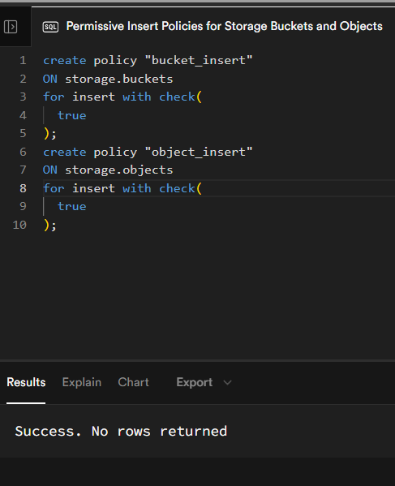
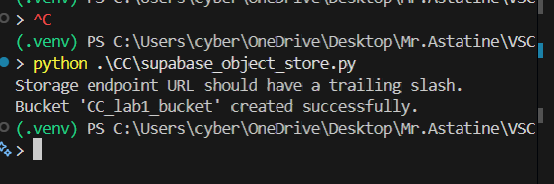
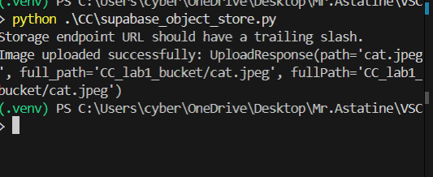

https://uwjvdnawzyusckusdenu.supabase.co/storage/v1/object/public/CC_lab1_bucket/CC/cat.jpeg
Part B
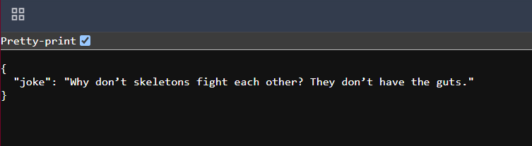
https://pes1ug23am036.npkn.net/516b93/

Part C
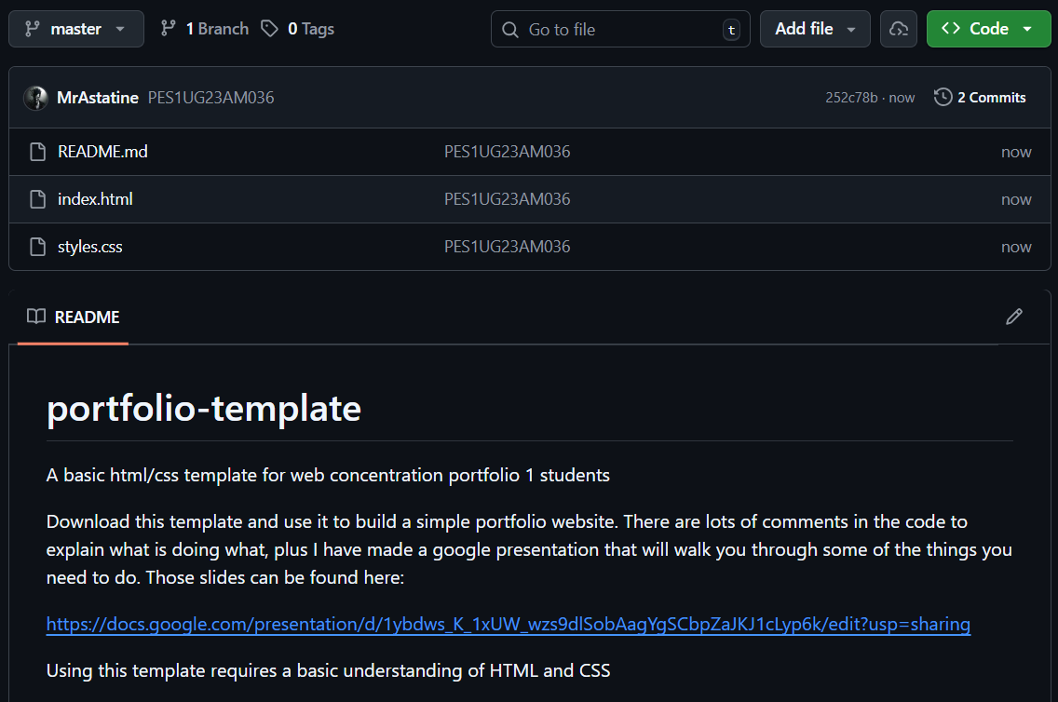
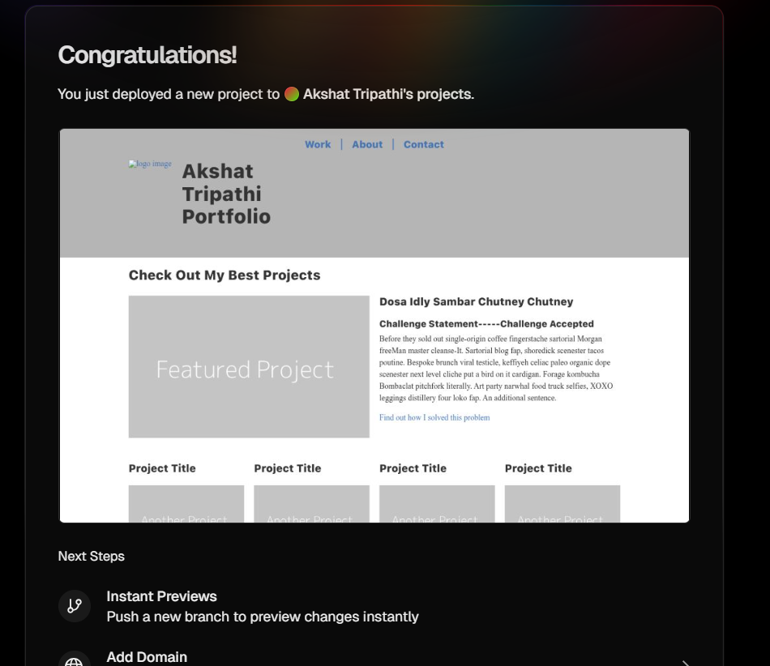
https://cc-lab-brown.vercel.app/

