Event Page
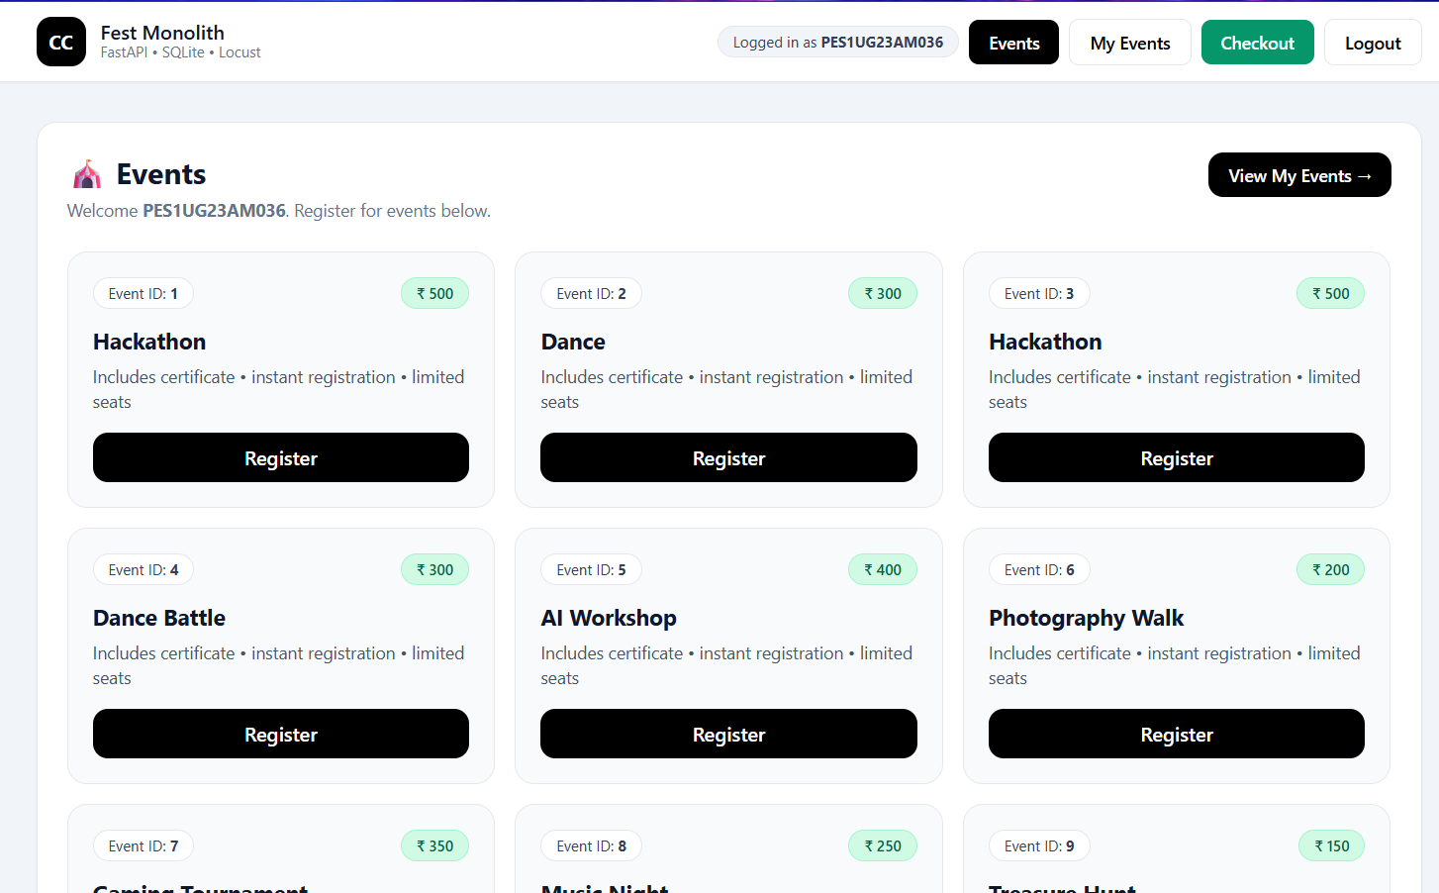
Checkout Crash
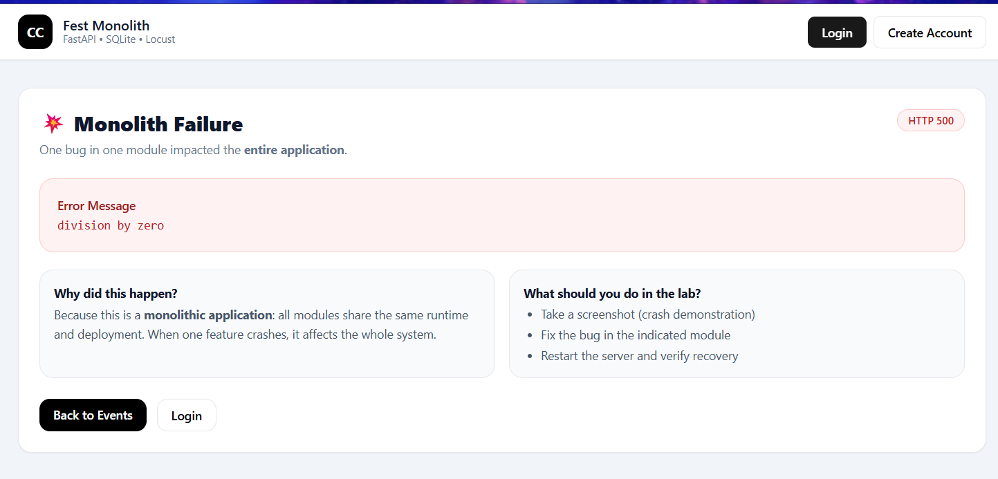
Checkout Page working
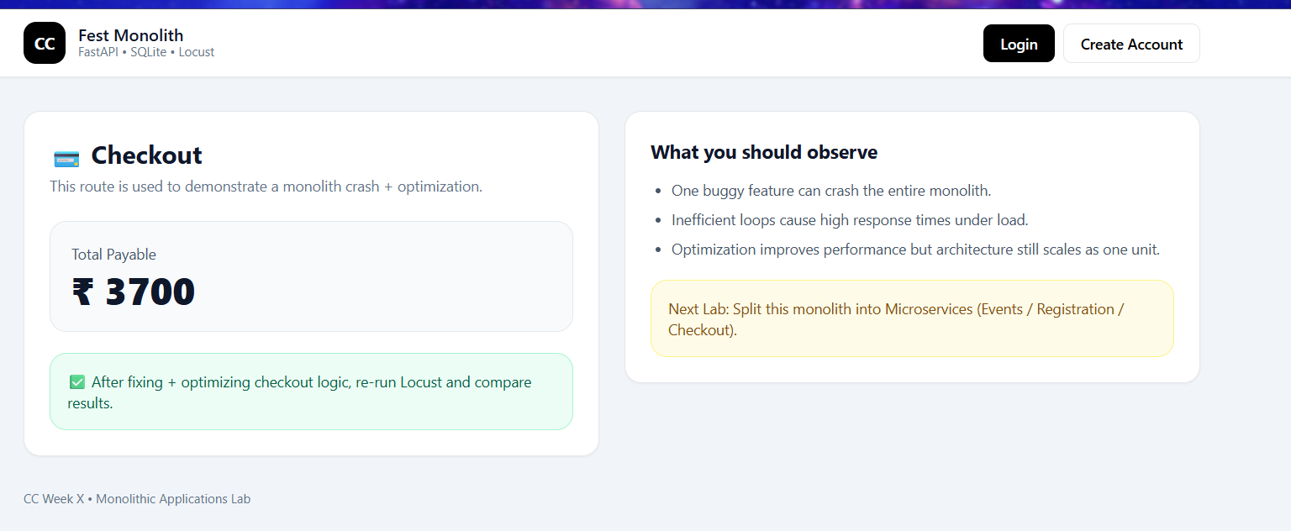

Locust on Unoptimized code
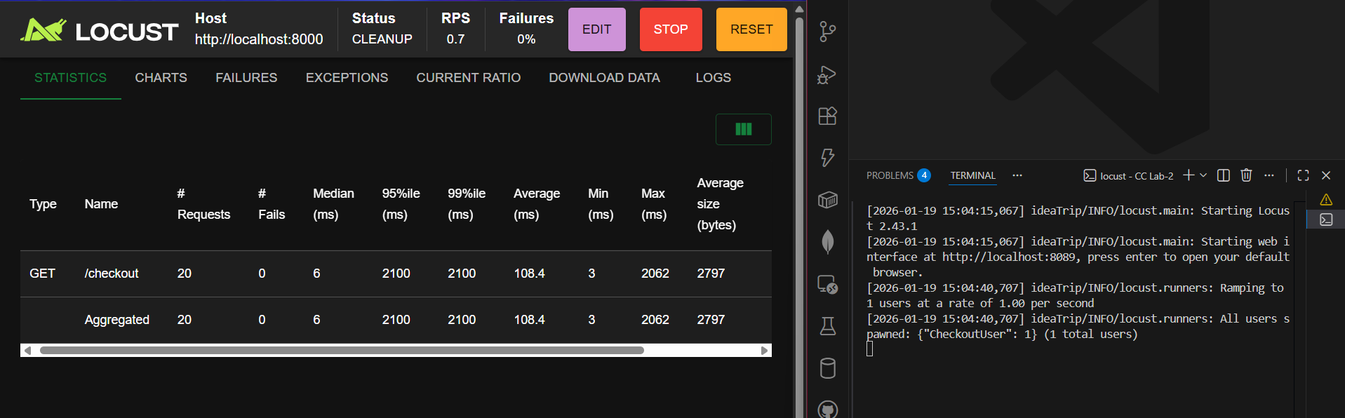
Locust on Optimized code
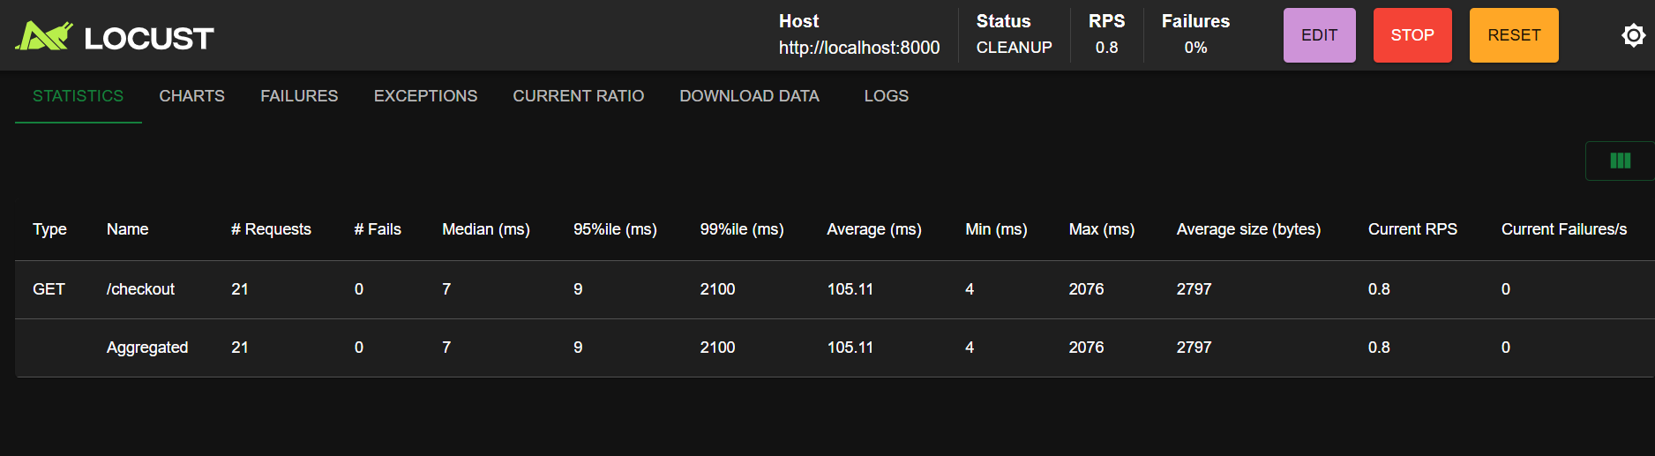
Locust on Unoptimized Event Code
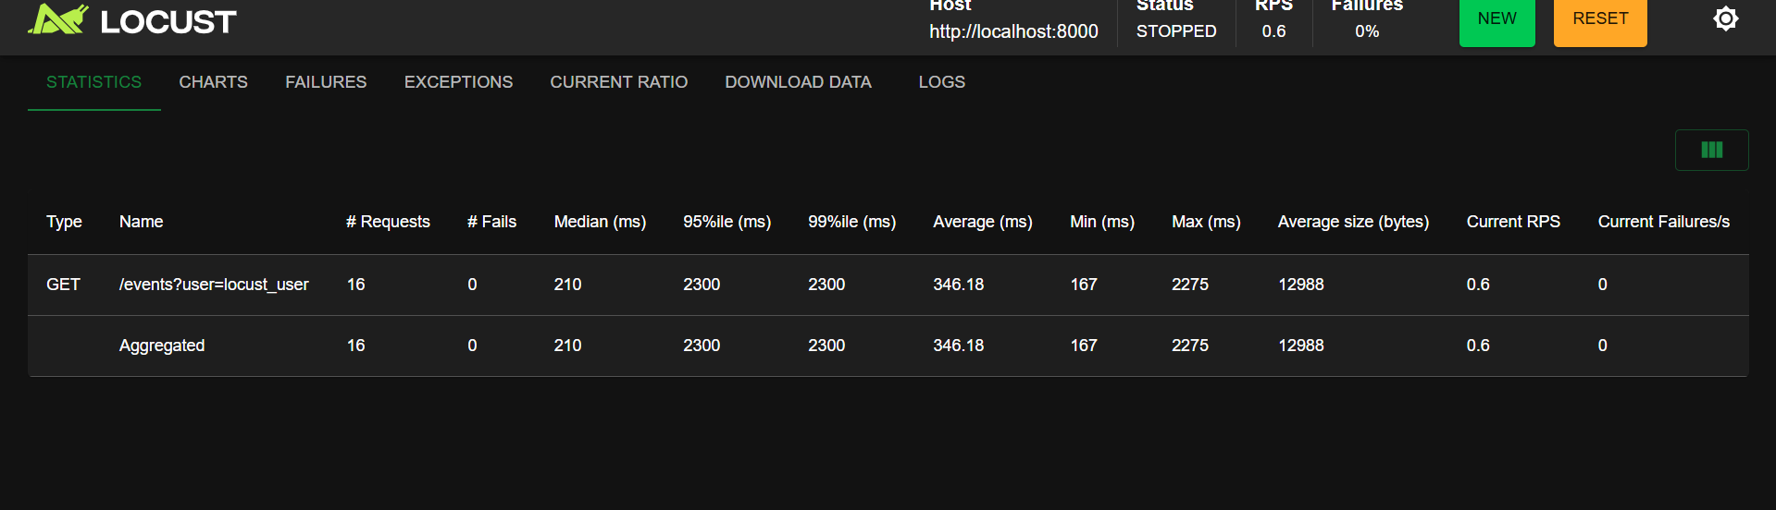
Optimized code
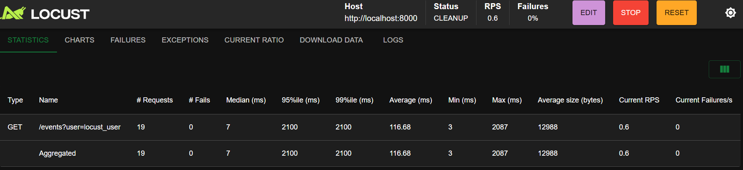

Unoptimized Events route
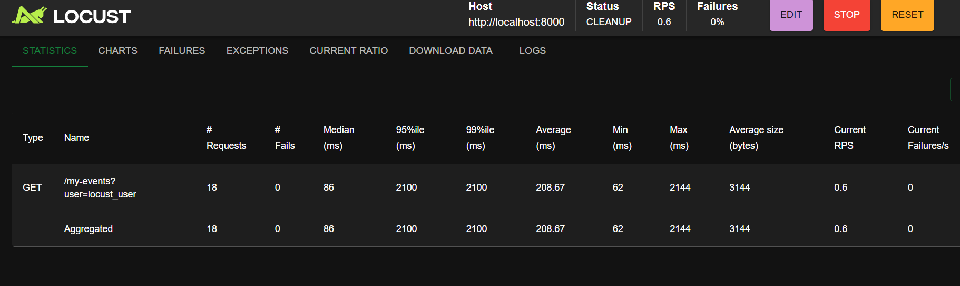
Optimized code
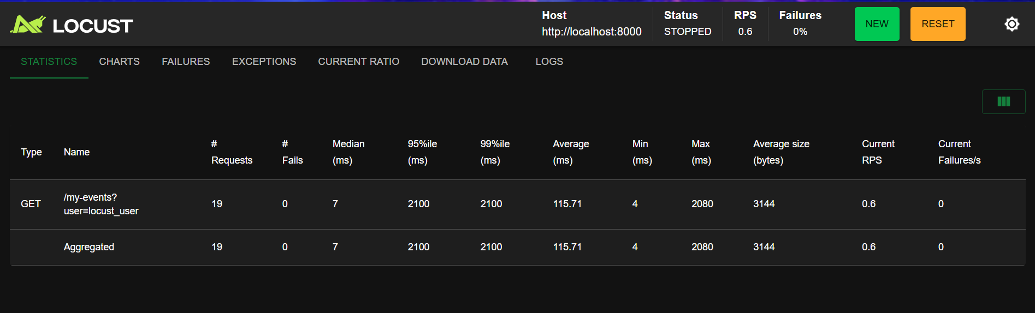
The FastAPI application was optimized by removing artificial delays and inefficient code that caused high response times. In the /events and /my-events routes, unnecessary loops performing millions of calculations were deleted, resulting in much faster endpoint responses and improved handling of user requests during load testing with Locust.
Additionally, the checkout logic was enhanced by replacing a slow Python loop with a direct database aggregation. Instead of summing event fees in Python, a SQL query (SELECT SUM(fee) FROM events) is now used to calculate the total instantly within the database. These changes make the application more responsive and scalable, ensuring minimal latency even under heavy load.

