SERVICENOW HELP DESK LAB
IT Service Management on a Personal Developer Instance
Users and Roles · Incident Priority · SLAs · Knowledge Base · CMDB and Impact Analysis

Project Title | ServiceNow Help Desk Lab: ITSM on a Personal Developer Instance
Date | October 9, 2026
Analyst | Bryan Sykes
Platform | ServiceNow Personal Developer Instance (PDI), Australia release
Interface | Classic UI, reached through direct table URLs
Modules Built | Users and Groups, Incident Categories and Priority, SLA Definitions, Knowledge Base, CMDB
Evidence | 36 numbered screenshots in the repository, plus a troubleshooting log
GitHub | github.com/MrBSykes/servicenow-help-desk-lab
Coverage | Business problem, lab design, configuration walkthrough, components built, troubleshooting log, business alignment

Analyst: Bryan Sykes | Home Lab Portfolio Project

1. The Business Problem
A service desk is judged on consistency. In federal IT and enterprise support environments, the same questions come up on every ticket: who is allowed to work it, how urgent it is, how fast it must be answered, whether the fix has been seen before, and what else breaks if the affected system is down. When those answers live in people’s heads or in spreadsheets, three critical problems emerge:
- Inconsistent triage: Two agents rate the same outage differently. Without a rules-driven priority, urgent tickets wait and minor ones jump the queue. On a contract with measured service levels, inconsistency becomes missed targets.
- No measurable service levels: Without SLA clocks that start, pause and stop automatically, “we responded quickly” is an opinion. Managers and auditors cannot show response and resolution performance.
- Lost knowledge and unknown blast radius: Fixes are re-diagnosed from scratch each time, and nobody can say quickly which services depend on a failed system.
An IT service management (ITSM) platform solves these together. Access is granted by group, priority is calculated from impact and urgency, SLAs are tracked on every ticket, fixes are published as knowledge articles, and a configuration management database (CMDB) records what depends on what.
This project builds a small service desk on ServiceNow, a platform widely used across federal contracts, and tests it with a realistic outage. It is modeled on my earlier osTicket Help Desk Lab and uses fictional personas to simulate a multi-person team.

1.1 Real-World Applicability
Scenario | Without ITSM Tooling | With This Configuration
New agent joins the desk | Permissions granted one user at a time | Add the user to the group; the itil role is inherited
A user reports an outage | Priority is a judgement call | Impact and Urgency produce the priority automatically
Is a critical ticket being answered in time? | Memory, spreadsheets, manual checks | Response and Resolution SLA clocks start, pause and stop on their own
The same problem comes back | Re-diagnosed from scratch | A published knowledge article is attached to the ticket
A core service goes down | Tribal knowledge about what is affected | CMDB dependency map shows connected services and devices
New engineer joins the team | Verbal walkthrough | Read the documentation and the rebuild checklist

2. Lab Design

2.1 Team and Roles
The lab runs on one instance with three fictional personas, so the ticket workflow reads like a real multi-person desk.
Persona | User ID | Role in the Lab
Bryan Sykes | bsykes.admin | System administrator and group manager
Sam Okafor | sam.okafor | Tier 1 Support Agent; inherits the itil role through group membership
Kate Olsen | kate.olsen | End user who submits tickets

2.2 Design Principles
- Roles at the group level. The itil role is attached to the Home Lab Help Desk group with Inherits on, so any agent added later gets incident access without individual role grants.
- Dependency order. Reference fields need their target records first: users before group managers, and CIs before relationships.
- Extend, don’t replace. Custom incident categories are added alongside the built-in choices.
- Verify defaults. The priority lookup rules were checked on the instance instead of assumed, and the SLA targets were adjusted to match.
- Prove outcomes, not configuration. SLA behavior was judged from Task SLA stages and stop times, not from the incident’s activity log.
- Keep sensitive data out of a public repository. Users are fictional with .local placeholder emails, and no IP addresses or serial numbers are entered on CIs.

2.3 Priority Matrix
ServiceNow calculates Priority from Impact and Urgency using Priority Data Lookup rules. The matrix below was verified against the rules table on this instance.
 | Urgency 1 (High) | Urgency 2 (Medium) | Urgency 3 (Low)
Impact 1 (High) | 1 - Critical | 2 - High | 3 - Moderate
Impact 2 (Medium) | 2 - High | 3 - Moderate | 4 - Low
Impact 3 (Low) | 3 - Moderate | 4 - Low | 4 - Low

Impact 3 with Urgency 3 resolves to 4 - Low on this release, so incidents never reach Priority 5 and the SLA plan covers priorities 1 to 4.

2.4 SLA Targets
Priority | Response | Resolution | Schedule
1 - Critical | 1 hour | 4 hours | 24x7
2 - High | 2 hours | 8 hours | 24x7
3 - Moderate | 8 hours | 3 business days | Business hours (8-5 weekdays)
4 - Low | 8 hours | 5 business days | Business hours (8-5 weekdays)

These are lab-defined targets chosen to be realistic for a help desk. Priority 5 is not used.

3. Configuration Walkthrough

3.1 Users, Group and Role
Three users were created with a User ID, first and last name, a placeholder email and a title. The Home Lab Help Desk group has Bryan Sykes as manager and Sam Okafor as its member, and the itil role is attached to the group with Inherits set to true. The Manager field is a reference to a User record, so the users had to exist before the manager could be set (see Issue 2).
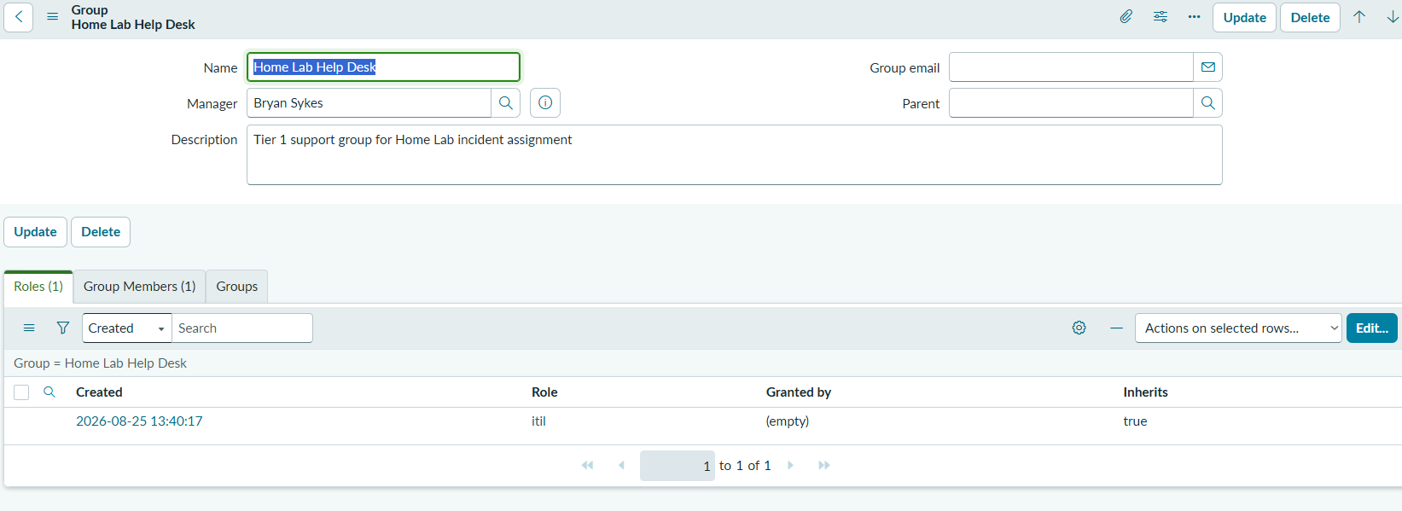
Figure 1 — Home Lab Help Desk group with the itil role (Inherits = true). Captured during the original August 2026 build; the October rebuild used the same configuration.

3.2 Incident Categories
The default Category choices did not cover the services in my lab, so four custom choices were added to the incident Category list. Each is a record in the Choices table (Table incident, Element category).
Label | Value | Sequence | Covers
Home Server | home_server | 200 | Docker and VM host issues
Network/DNS | network_dns | 210 | Pi-hole, router, connectivity
Penetration Testing | pen_testing | 220 | The Kali/Ubuntu test machine
Account Access | account_access | 230 | Logins, lockouts, resets

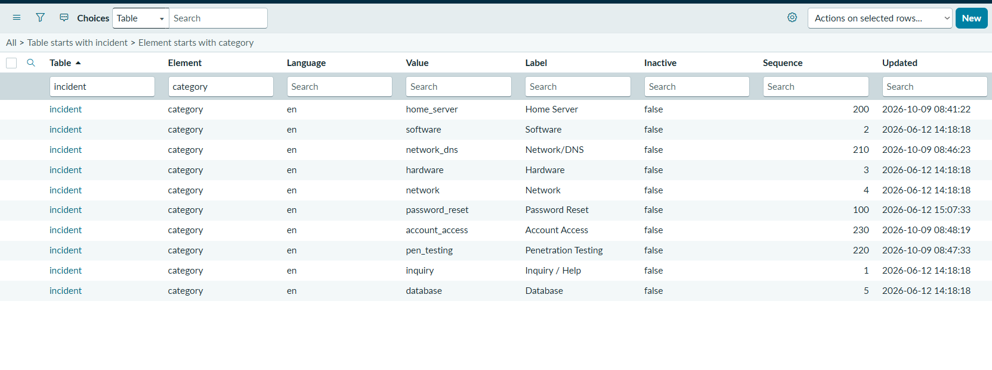
Figure 2 — All incident category choices, defaults and custom, in the Choices table.

3.3 Priority Matrix Verification
Rather than assume the documented defaults, I opened the Priority Data Lookups table and checked every row. Then I tested the top cell on a new incident form: Impact 1 - High with Urgency 1 - High resolves to Priority 1 - Critical, and the Priority field is read-only.
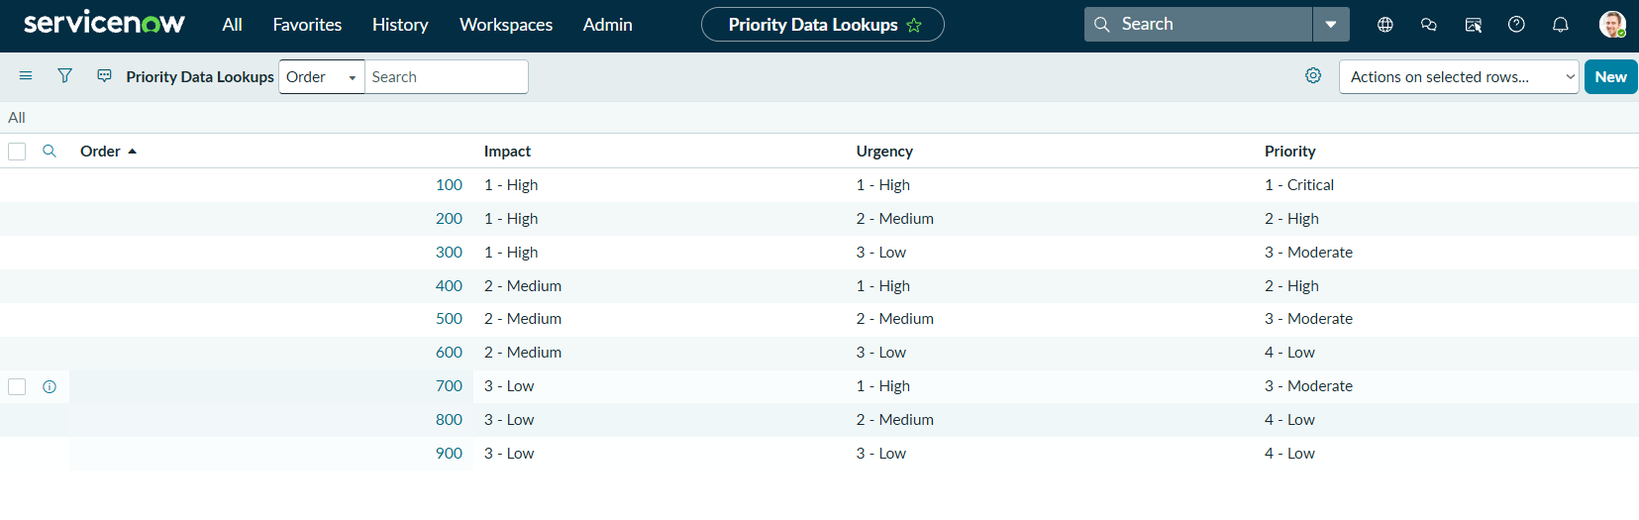
Figure 3 — Priority Data Lookup rules on the instance. Impact 3 with Urgency 3 maps to 4 - Low.
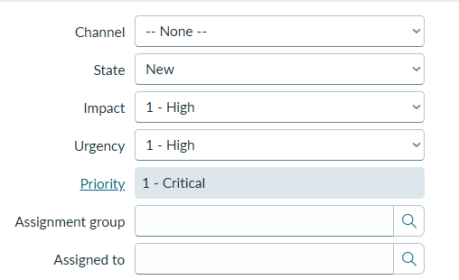
Figure 4 — Impact 1 and Urgency 1 produce Priority 1 - Critical on a new incident.

3.4 SLA Schedule and Definitions
SLA definitions require a schedule, and this release has no built-in 24x7 option. I created a schedule named 24x7 in the US/Eastern time zone with a single all-day entry that repeats every day, so the clock never pauses outside business hours.
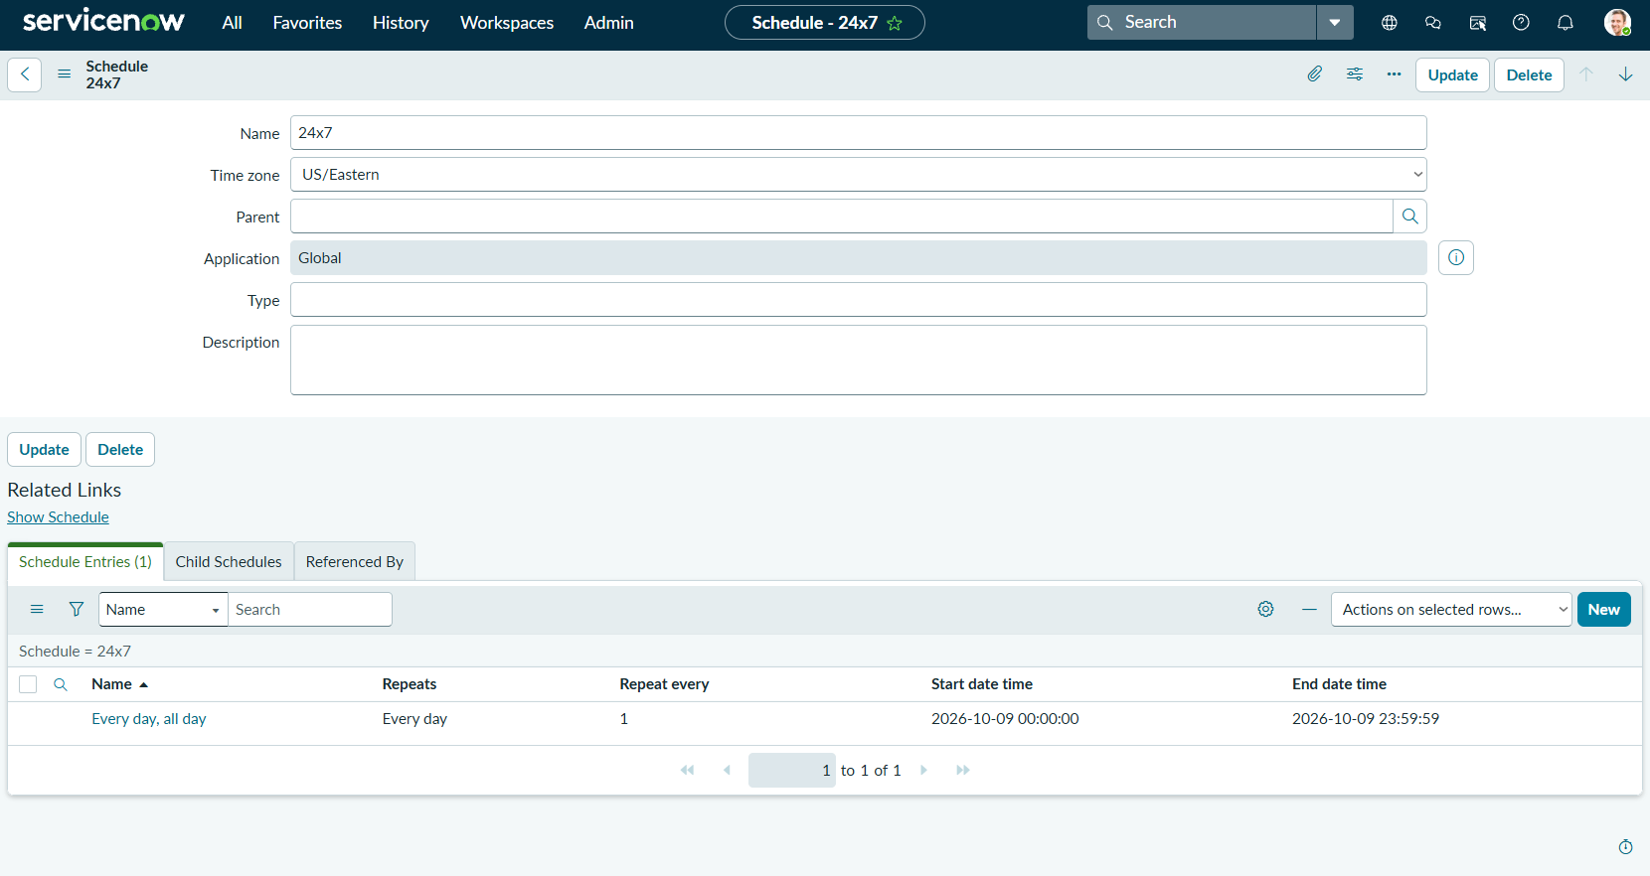
Figure 5 — The 24x7 schedule with one entry that repeats every day.
Eight SLA definitions were built on the incident table, one Response and one Resolution for each of priorities 1 to 4. The conditions follow one pattern:
Setting | Response Definitions | Resolution Definitions
Table | Incident | Incident
Start condition | Priority is the matching priority (1 to 4) | Priority is the matching priority (1 to 4)
Pause condition | State is On Hold | State is On Hold
Stop condition | Assigned to is not empty | State is Resolved
Schedule | P1 and P2: 24x7. P3 and P4: business hours | P1 and P2: 24x7. P3 and P4: business hours

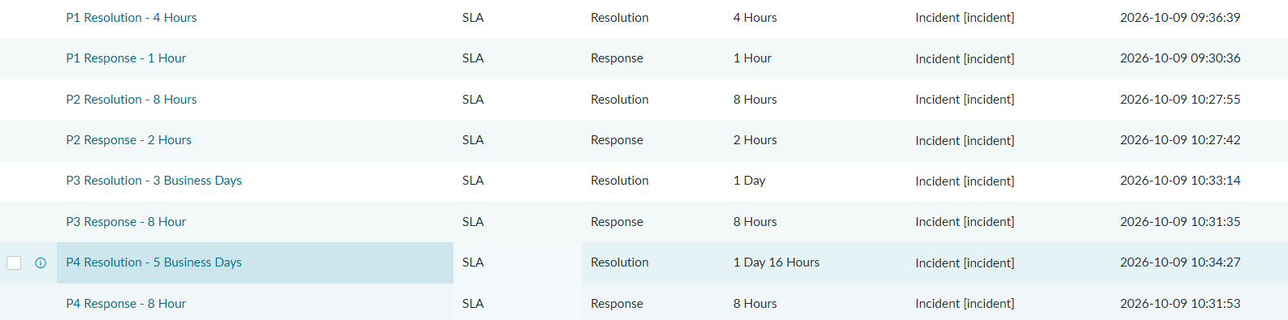
Figure 6 — All eight SLA definitions. P3 and P4 durations display as 1 Day and 1 Day 16 Hours, which are 24 and 40 schedule hours.

3.5 SLA Test: A P1 Incident from Creation to Resolution
To prove the SLAs work, I simulated the DNS outage from the knowledge base: caller Kate Olsen, category Network/DNS, Impact 1 and Urgency 1, giving Priority 1 - Critical, assigned to Sam Okafor. The figures below are from the corrected second run, incident INC0010006.
Step | Action | Observed Result
1 | Save the P1 incident | My P1 Response and P1 Resolution SLAs attach and start, together with a built-in demo SLA, Priority 1 resolution (1 hour)
2 | Assign to Sam Okafor | P1 Response completes in 32 seconds; P1 Resolution keeps running
3 | Set State to On Hold | P1 Resolution moves to Paused and its clock stops
4 | Resolve the incident | P1 Resolution completes with 1 minute elapsed against the 4-hour target; no breach

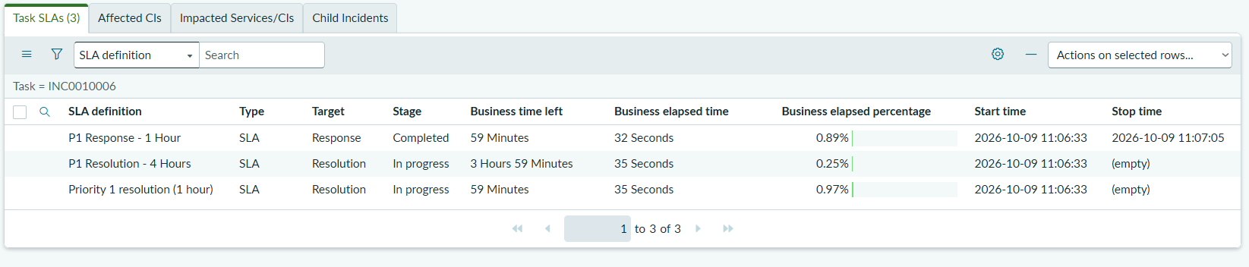
Figure 7 — Assigned to Sam: the P1 Response SLA is Completed (32 seconds) and Resolution is In progress.
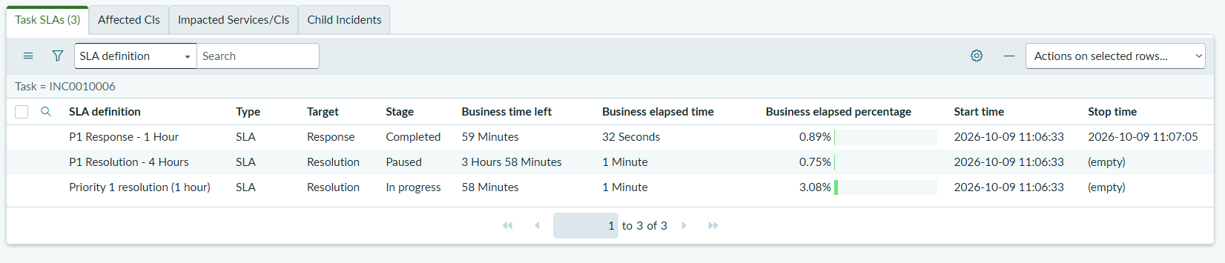
Figure 8 — On Hold: the P1 Resolution SLA is Paused.
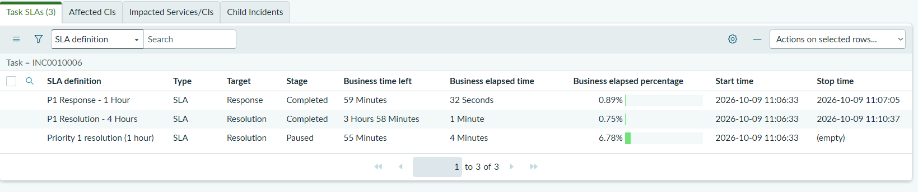
Figure 9 — Resolved: the P1 Resolution SLA is Completed with 1 minute elapsed.
A defect found by testing. The first run, INC0010002, looked correct in the incident’s activity log, but the Task SLA showed the P1 Resolution SLA completing as soon as the incident was assigned. Its stop condition was wrong. I corrected it to State is Resolved on all four Resolution definitions and re-ran the test as INC0010006, which produced the results above.
Scope note: only Priority 1 was tested end to end. The P2 to P4 definitions exist but were not exercised. The 50, 75 and 100 percent escalation notifications and a deliberate breach test were planned but not built. The built-in demo SLA also attaches to P1 incidents and still shows Paused after resolution; it is not part of my design.

3.6 Knowledge Base
I created the Home Lab IT Knowledge Base with Bryan Sykes as owner, Bryan Sykes and Sam Okafor as managers, and the Instant Publish flow so articles go live when saved. Four categories were added: Network & DNS, Hardware, Operating Systems and Security.
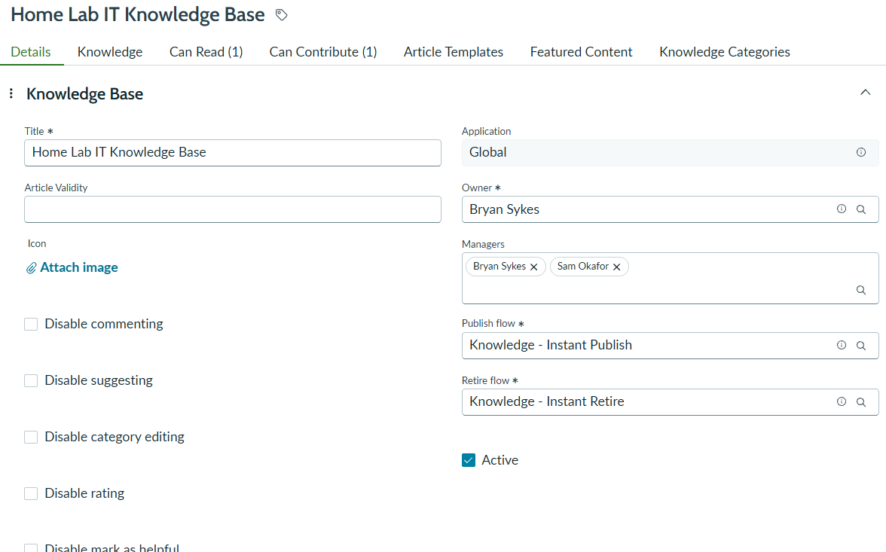
Figure 10 — Knowledge base record: owner, managers and the Instant Publish flow.
Five articles were written from real problems I solved in my home lab, each in a Symptoms, Cause, Resolution, Verification format that a Tier 1 agent can follow. All five show Workflow = Published.
Article | Title | Category
KB0010001 | Network-wide internet outage after a static IP change (Pi-hole DNS) | Network & DNS
KB0010002 | A website or deal link is blocked or breaks when using Pi-hole | Network & DNS
KB0010004 | Bootable USB won’t create or won’t boot in UEFI mode | Operating Systems
KB0010005 | Random blue screens (MEMORY_MANAGEMENT) after a BIOS update | Hardware
KB0010006 | Triage for a suspected ransomware infection and drive health check | Security

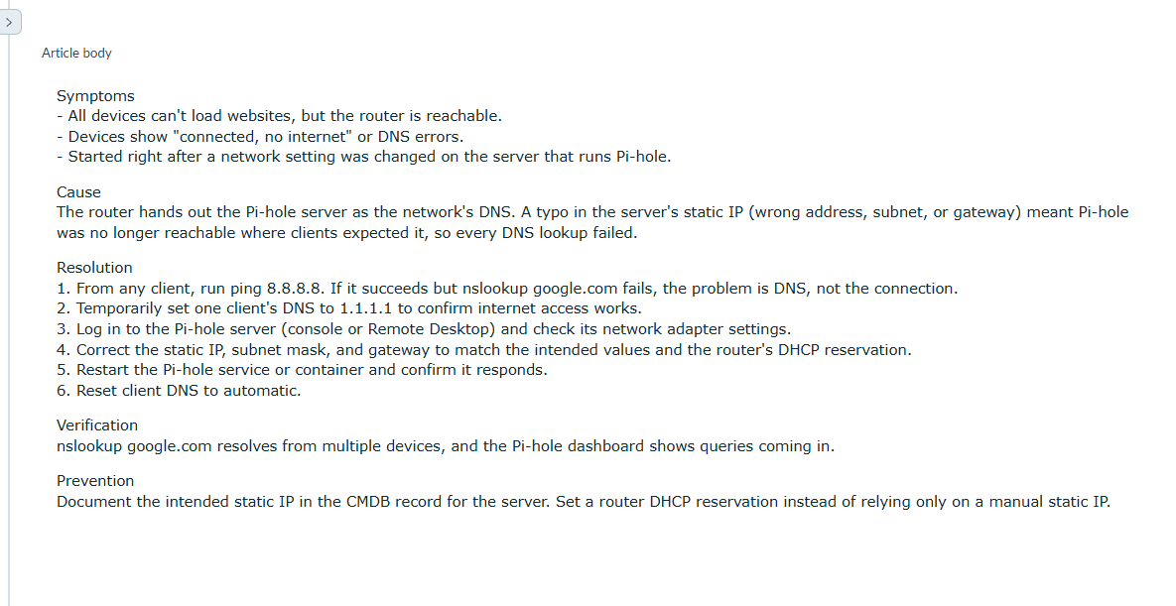
Figure 11 — Body of the first article, KB0010001.
ServiceNow assigned the article numbers itself; there is no KB0010003 in the list.

3.7 CMDB and Relationships
I built a core set of five configuration items rather than the 17 in my full plan: enough to model one real outage end to end. Each CI was created in its own class. Computers and Network Gear use an Assigned to field; Applications and Services use Owned by and Managed by, which I set to Bryan Sykes. IP addresses and serial numbers were left blank on purpose.
CI | Class | Purpose
SYKESHOMESERVER | Computer | Windows 11 Pro server hosting Docker containers and VMs
Home Router | Network Gear | Verizon G3100 router and DHCP server
Pi-hole | Application | Network-wide DNS sinkhole running in Docker
Home DNS and Ad Blocking | Service | Service that depends on Pi-hole
Home Lab Network Services | Service | Parent service that everything rolls up to

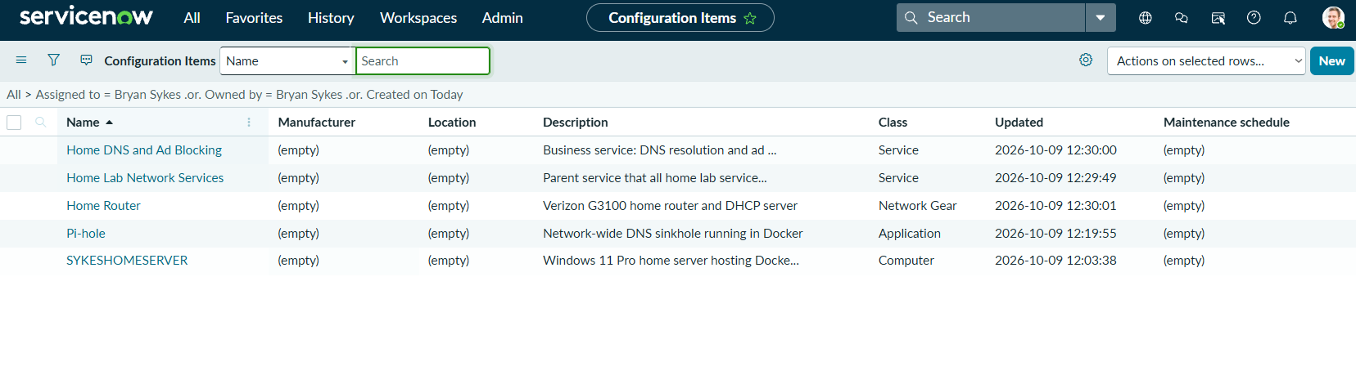
Figure 12 — The five CIs and their classes, filtered to the CIs created for this lab.
Four relationships connect them:
Parent CI | Relationship | Child CI
Pi-hole | Runs on::Runs | SYKESHOMESERVER
SYKESHOMESERVER | Connected by::Connects to | Home Router
Home DNS and Ad Blocking | Depends on::Used by | Pi-hole
Home Lab Network Services | Depends on::Used by | Home DNS and Ad Blocking

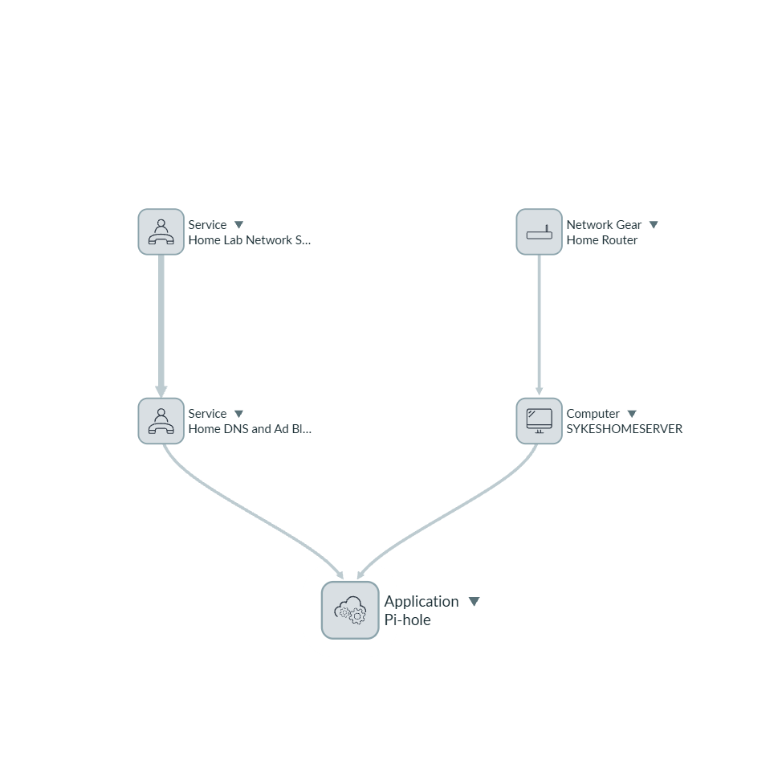
Figure 13 — Dependency map from Pi-hole: the server and router on one side, the two services above it on the other.

3.8 Impact-Analysis Incident
To tie the pieces together, I re-created the DNS outage as a Priority 1 incident, INC0010007: caller Kate Olsen, category Network/DNS, Configuration item = Pi-hole, assigned to Sam Okafor. I attached knowledge article KB0010001, then resolved the incident with a resolution code and notes that cite the article.
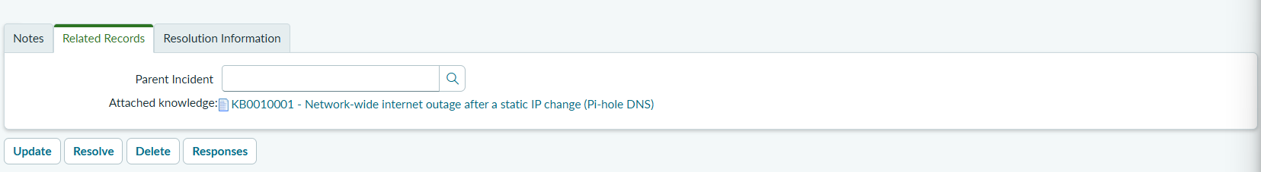
Figure 14 — KB0010001 attached to the incident, shown under Related Records.
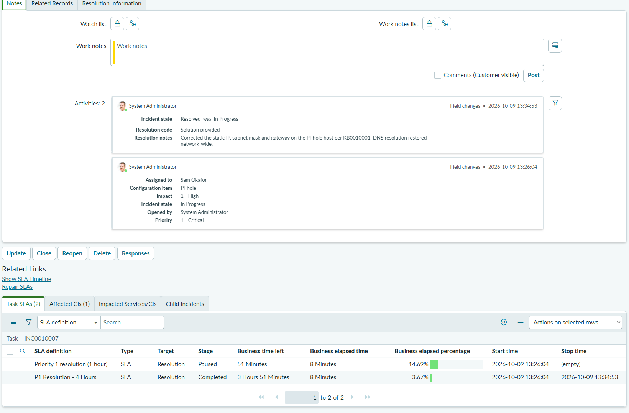
Figure 15 — Resolved incident: the activity log shows the Pi-hole CI, the assignment and the resolution notes, and the P1 Resolution SLA is Completed with 8 minutes elapsed.
Notes on this incident: no P1 Response SLA row appears in its Task SLAs. The incident was assigned when it was created, which I believe means the stop condition was already met, but I did not confirm that. The Impacted Services/CIs tab was not captured, so the impact chain comes from the dependency map.

4. Components Built
Everything below exists in the instance and is documented with screenshots in the repository.
Component | Detail | Status
Users | bsykes.admin, sam.okafor, kate.olsen | ✓ Built
Assignment group | Home Lab Help Desk, with manager and one member | ✓ Built
Role grant | itil on the group, Inherits = true | ✓ Built
Incident categories | 4 custom choices beside the defaults | ✓ Built
Priority matrix | Checked against the lookup rules and a test incident | ✓ Verified
24x7 schedule | US/Eastern, all-day daily entry | ✓ Built
SLA definitions | 8 definitions: Response and Resolution for P1 to P4 | ✓ Built
P1 SLA test | Attach, response, pause, resolve (INC0010006) | ✓ Tested
Knowledge base | Home Lab IT Knowledge Base, Instant Publish, 4 categories | ✓ Built
Knowledge articles | 5 published from real troubleshooting | ✓ Built
Configuration items | 5 CIs in 4 classes | ✓ Built
CI relationships | 4 relationships and a dependency map | ✓ Built
Impact-analysis incident | P1 on the Pi-hole CI with KB0010001 attached (INC0010007) | ✓ Built
P2 to P4 SLA tests | Definitions exist; not exercised | ○ Not tested
Escalation notifications and breach test | 50, 75 and 100 percent checkpoints from the SLA plan | ○ Not built
Remaining CIs | 12 of the 17 planned CIs | ○ Not built
Update set backup | Export of the configuration | ○ Not done

Note — Scope: this lab is a single-instance simulation with fictional users. The items marked Not tested, Not built or Not done are planned follow-ups, listed in Section 7, and nothing in this document claims them.

5. Troubleshooting Log
Every significant issue encountered during this project is documented below with root cause and resolution. In a real service desk team, this log is the institutional knowledge that keeps the same problems from recurring.
Issue 1 — Instance Reclaimed After Inactivity
Field | Detail
Symptom | After a long break, the original instance URL returned an instance-not-found page. A notification email later confirmed the reclaim.
Root Cause | Free Personal Developer Instances are reclaimed after a period of inactivity.
Resolution | Requested a new instance (there was a waitlist for the available regions and I received Australia) and rebuilt the configuration from my own documentation and screenshots.
Business Lesson | Treat non-production environments as disposable. Keep configuration documented and exportable so a rebuild takes hours, not days.

Issue 2 — Invalid Reference on the Group Manager Field
Field | Detail
Symptom | Saving the group with bsykes.admin in Manager failed with an Invalid reference error.
Root Cause | Manager is a reference to a User record, and that user did not exist yet.
Resolution | Cleared Manager, saved the group, created the users, then set Manager afterward.
Business Lesson | Build in dependency order. Reference fields need their target records first.

Issue 3 — New Category Choices Would Not Submit
Field | Detail
Symptom | A new Choice record would not submit.
Root Cause | Value is a required field on this release and does not auto-fill from Label.
Resolution | Entered a lowercase, underscore-separated Value for each choice, for example home_server.
Business Lesson | Required fields behave differently across releases. Check the form instead of assuming.

Issue 4 — Priority 5 Never Appeared
Field | Detail
Symptom | Impact 3 with Urgency 3 produced 4 - Low, where I expected 5 - Planning.
Root Cause | The lookup rules on this release map that combination to Priority 4. My own plan had the cell wrong.
Resolution | Verified the rules table, then corrected the SLA plan and README to cover priorities 1 to 4.
Business Lesson | Verify platform defaults before building on them, including defaults you believe you know.

Issue 5 — No 24x7 Schedule Available
Field | Detail
Symptom | The SLA Schedule field was required, and no 24x7 option was offered.
Root Cause | This release ships without a 24x7 schedule.
Resolution | Created a schedule named 24x7 with a single all-day entry that repeats daily. The stop condition field also turned red when I typed “not empty”, so I used the condition builder instead.
Business Lesson | SLA timing depends on the schedule. Know which schedule governs each target and document it.

Issue 6 — Resolution SLA Stopped at Assignment
Field | Detail
Symptom | On the first test, the P1 Resolution SLA showed Completed as soon as the incident was assigned.
Root Cause | Its stop condition was wrong. The incident’s activity log looked normal, so the defect only appeared in the Task SLA stage and stop time.
Resolution | Set the stop condition to State is Resolved on all four Resolution definitions and re-ran the test on a new incident, INC0010006.
Business Lesson | Verify outcomes, not just configuration. Checking the evidence caught a defect that would have reported false SLA success.

Issue 7 — CIs Created in the Wrong Class and Missing from the List
Field | Detail
Symptom | Every CI showed Class = Computer. Later, a filtered CI list showed only some of the CIs.
Root Cause | The router, application and services were created from the wrong form. The list filter used Assigned to, which Applications and Services do not use; they have Owned by and Managed by.
Resolution | Deleted the four wrong CIs and recreated each from its own class list after reading the form header. Filtered the list on Created today instead.
Business Lesson | A CI’s class decides its fields, relationships and reporting. Check the class before filling in the form.

Issue 8 — Knowledge Button Missing on the Incident Form
Field | Detail
Symptom | There was no Knowledge icon or menu item to attach an article to the incident.
Root Cause | The form layout on this instance does not expose the Knowledge action.
Resolution | Created the link directly in the attached-knowledge table (m2m_kb_task) with the incident and KB0010001. The article then appeared under Related Records.
Business Lesson | When a UI action is missing, find the record the action would create and create it directly.

Issue 9 — Git Push Rejected and File Lock Errors
Field | Detail
Symptom | The first push was rejected, then Git reported “Unlink of file failed”, and a Word lock file (~$README.md) was committed.
Root Cause | The remote repository already had a README (unrelated histories), and the working copy sat in a OneDrive-synced folder that held file locks.
Resolution | Moved the repository to C:\Projects, merged with --allow-unrelated-histories, added a .gitignore for Office lock files and OS files, and removed the lock file from tracking.
Business Lesson | Create the .gitignore before the first commit, and keep repositories out of sync folders.

6. Business and Career Alignment

6.1 Federal IT and Service Desk Relevance
Federal IT contractors such as CACI, SAIC and HII run service desks measured against contractual service levels. The practices in this lab map to common expectations:
- ITIL-aligned practices — Incident management, service level management, knowledge management and configuration management are core ITIL practices, and this lab exercises each one.
- NIST 800-53 AC-2 and AC-6 (Account Management, Least Privilege) — Granting the itil role to a group, and not to individuals, supports controlled and auditable access.
- NIST 800-53 IR-4 (Incident Handling) — A prioritized, assigned and resolved incident with documented resolution notes follows the incident handling workflow.
- NIST 800-53 CM-8 (System Component Inventory) — The CMDB records components and their relationships, which supports inventory and impact analysis.
These are alignments, not a compliance claim. A single-instance lab is not an assessed system.

6.2 Skills Demonstrated
Skill | Evidence in This Project
ServiceNow Administration | Users, groups, roles, reference fields, choice lists and schedules configured on a Personal Developer Instance
Role-Based Access Control | itil role granted at the group level with inheritance; members receive access by joining the group
Incident Management | Category design, Impact and Urgency priority matrix verified, P1 incidents created, assigned, held and resolved
SLA Design and Testing | 8 SLA definitions with start, pause and stop conditions; P1 tested end to end; a stop-condition defect found and fixed
Knowledge Management | 5 published articles in Symptoms, Cause, Resolution, Verification format; one attached to an incident
CMDB and Impact Analysis | 5 CIs in 4 classes, 4 relationships, dependency map, incident linked to a CI
Troubleshooting | 9 issues diagnosed and resolved, including a reclaimed instance, a wrong SLA stop condition and CIs in the wrong class
Documentation | README, project summary, rebuild checklist, troubleshooting log and 36 screenshots published on GitHub

6.3 Certification Alignment
Certification | Relevance to This Project
CompTIA Security+ ✓ | Access control and least privilege (group-level roles), incident response process, and asset inventory (CMDB)
AZ-900 ✓ | Cloud service concepts: the Personal Developer Instance is a hosted platform, and the lab reflects the split between what the platform provides and what the administrator configures
ITIL 4 Foundation (Option) | The incident, knowledge, service level and configuration practices built here are the same practices the certification covers
ServiceNow Certified System Administrator (Option) | Users and groups, tables and fields, incident management, SLAs, knowledge and the CMDB overlap with the certification’s core areas

7. Next Steps
Action | Purpose
Test P2, P3 and P4 SLAs end to end | Complete the SLA test coverage beyond Priority 1
Build the 50, 75 and 100 percent escalation notifications and run a deliberate breach test | Show Breached status and the notification path from the SLA plan
Enter the remaining 12 CIs and their relationships | Finish the CMDB plan: other hardware, the media and game-server applications, the three VMs and three services
Export an update set after each phase | Make a rebuild after a reclaim take minutes, not hours
Add a Problem record for the recurring DNS failure | Show the incident-to-problem workflow and root cause tracking
Pursue ITIL 4 Foundation or the ServiceNow System Administrator certification | Validate the practices demonstrated here with a recognized credential

8. Conclusion
This project demonstrates a working service desk on ServiceNow: role-based access, rules-driven incident priority, SLA clocks that start, pause and stop on their own, a knowledge base built from real fixes, and a CMDB whose dependency map shows what an outage affects. A single P1 incident ties them together, from the Pi-hole CI to the attached knowledge article to the completed Resolution SLA.
The troubleshooting challenges along the way were real: a reclaimed instance, a wrong SLA stop condition that only the evidence exposed, and CIs created in the wrong class. Diagnosing and fixing them is the job, and each one is recorded with its cause and lesson.
The lab is also honest about its edges. Only P1 was tested end to end, escalation notifications and a breach test are not built, and the CMDB is a core set of five CIs. What exists is documented step by step with screenshots and a rebuild checklist, so it can be reviewed, repeated and extended.

Appendix A. Rebuild Checklist
Personal Developer Instances are reclaimed after inactivity. This is the order to rebuild everything on a fresh instance.
Step | Configuration
1. Users | bsykes.admin (Bryan Sykes), sam.okafor (Sam Okafor), kate.olsen (Kate Olsen), with .local placeholder emails
2. Group | Home Lab Help Desk: manager Bryan Sykes, member Sam Okafor, role itil with Inherits on
3. Categories | Choices on table incident, element category: home_server (200), network_dns (210), pen_testing (220), account_access (230)
4. Schedule | 24x7, US/Eastern, one all-day entry that repeats every day
5. SLA definitions | Response and Resolution for P1 to P4 on the incident table. Start: Priority is X. Pause: State is On Hold. Response stops when Assigned to is not empty; Resolution stops when State is Resolved
6. Knowledge base | Home Lab IT Knowledge Base: owner Bryan Sykes, managers Bryan Sykes and Sam Okafor, Instant Publish; categories Network & DNS, Hardware, Operating Systems, Security; then the five articles
7. CIs | SYKESHOMESERVER (Computer), Home Router (Network Gear), Pi-hole (Application), Home DNS and Ad Blocking and Home Lab Network Services (both Service); read the form header to confirm the class before filling in
8. Relationships | Pi-hole Runs on SYKESHOMESERVER; SYKESHOMESERVER Connected by Home Router; Home DNS and Ad Blocking Depends on Pi-hole; Home Lab Network Services Depends on Home DNS and Ad Blocking
9. Backup | Export an update set after each phase and commit it to the repository

Documentation prepared by: Bryan Sykes | October 9, 2026 | ServiceNow Help Desk Lab: ITSM on a Personal Developer Instance

