Error Handling:

I catch a NoNullAllowedException to check if the user forgot to add a Product Name or Forgot to check Discontinued.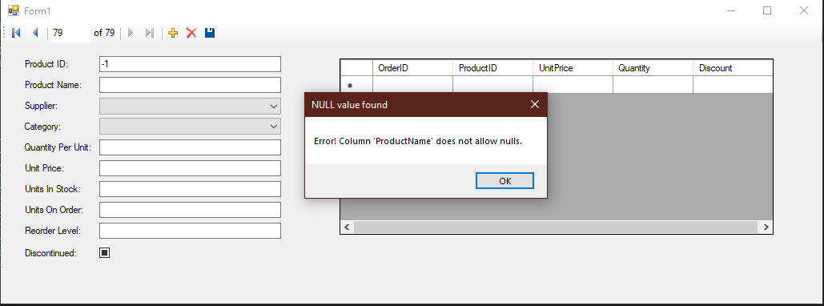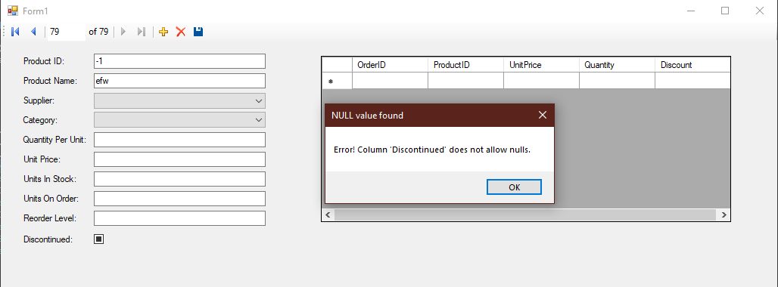

I catch a FormatException when the user adds a letter to the Unit Price

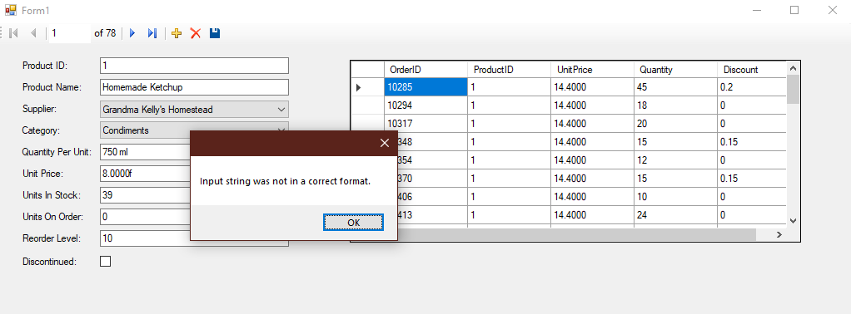

I catch an OverflowException when the user enters a value too large for the unit price

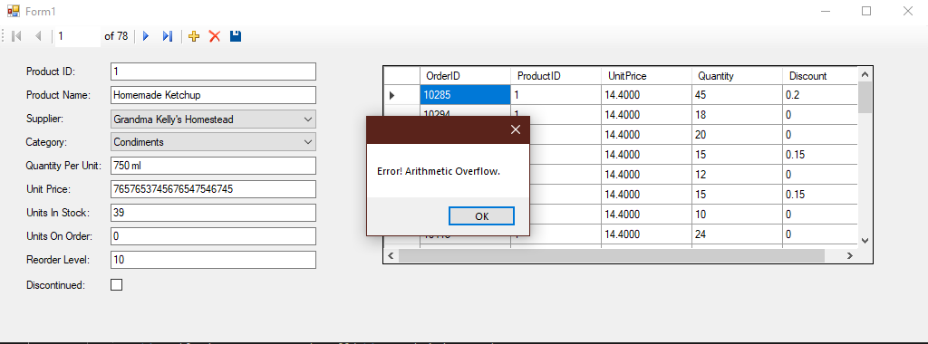

I catch an SqlException when the user tries to delete a Product that is referenced in another table

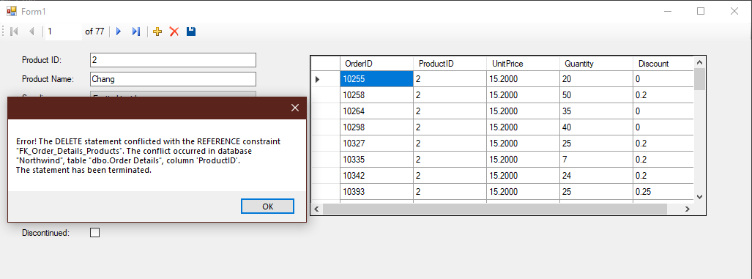

I catch a DBConcurrencyException when the database is modified by another user and then the form user tries to update the form

