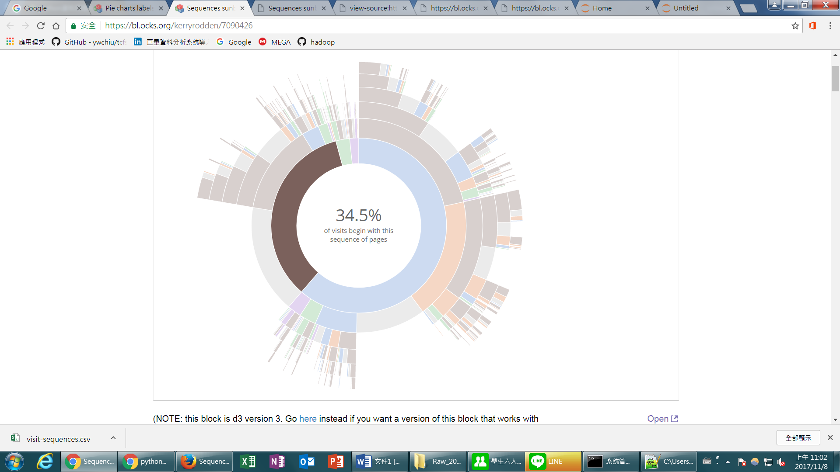

選open-呈現另一張圖,右鍵選”檢視網頁原始碼”

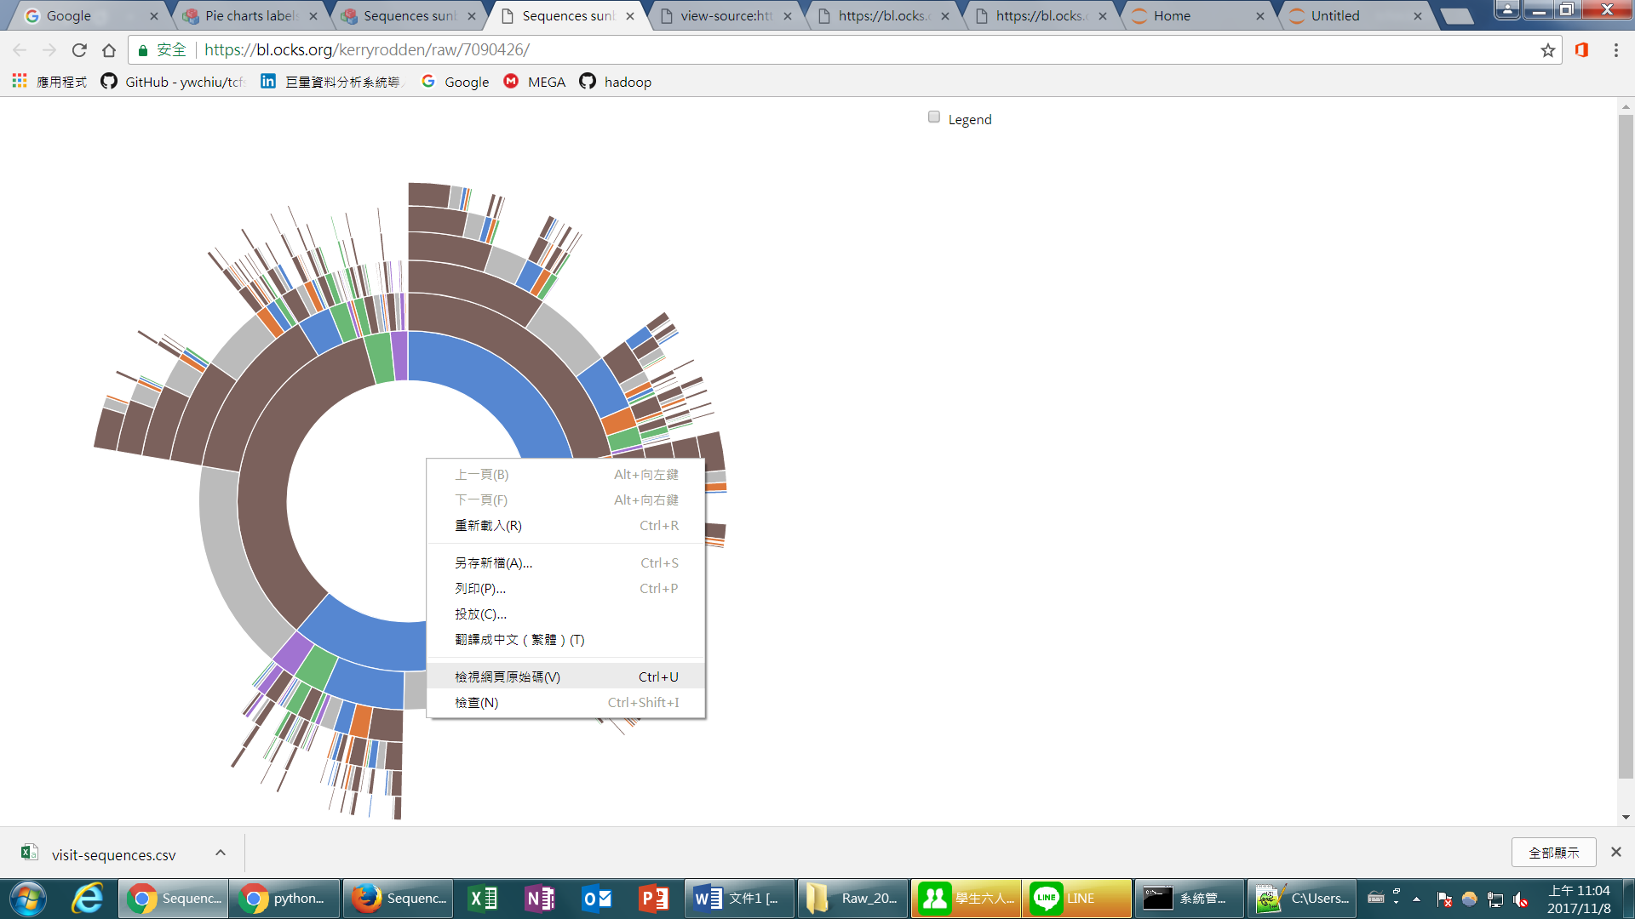

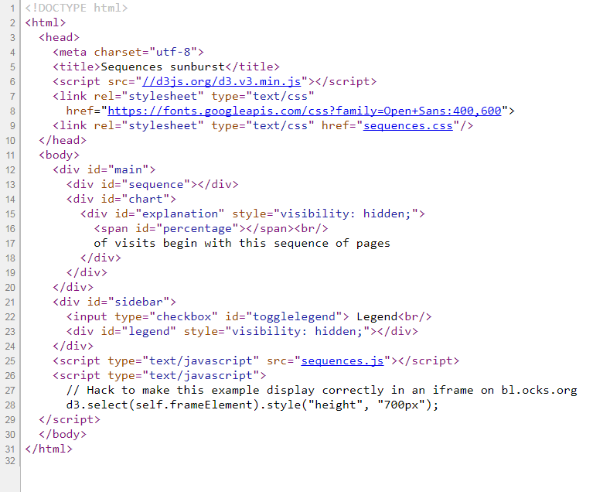

下載sequences.css & sequences.js

從sequences.js下載visit-sequences.csv

