CSCI222 System Development

Assignment 1

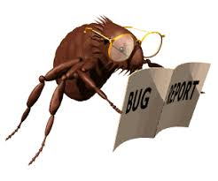

Bug Report System

Group 8 Report

Table of Contents

Revision History 3

Team 3

Brad 3

Jacob 3

Michael 3

Nathan 3

Introduction 3

Business Case 3

SRS 3

Meeting Minutes 3

Team Work Diaries 3

Brad 3

Jacob 3

Michael 3

Nathan 3

# Revision History

# Team

## Brad

## Jacob

## Michael

## Nathan

# Introduction

# Business Case

# SRS

# Meeting Minutes

# Team Work Diaries

## Brad

## Jacob

## Michael

## Nathan