CSCI222 System Development

Assignment 1

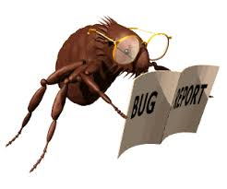

Bug Report System

Group 8 Report

Table of Contents

Revision History 3

Team 3

Brad 3

Jacob 3

Michael 3

Nathan 3

Introduction 3

Business Case 3

SRS 3

Meeting Minutes 3

Team Work Diaries 3

Brad 3

Jacob 3

Michael 3

Nathan 3

# Revision History

|  |  |  |  |
| --- | --- | --- | --- |
| **Date** | **Version** | **Description** | **Author** |
| 12/08/2016 | 0.0.1 | First draft of the group’s report | Michael |
|  |  |  |  |
|  |  |  |  |
|  |  |  |  |

# Team

## Brad

## Jacob

## Michael

Michael is a third year Computer Science student at University of Wollongong. He is studying a major in Digital Systems Security. His brother is a former Computer Science student as well and is currently a full stack developer in Wollongong. Michael works in the Library at UoW where he is in charge of all things regarding 3D printing and does some coding occasionally. Outside of University Michael enjoys keeping up with latest technology and is a casual gamer. At the end of his degree Michael aims to work in the industry as a security specialist and would like to be involved in the creation of Artificial Intelligence and its application to security.

## Nathan

# Introduction

# Business Case

# SRS

# Meeting Minutes

# Team Work Diaries

## Brad

## Jacob

## Michael

## Nathan