SYSTEM DESIGN DOCUMENT
UML Architecture, Data Model & Behavioral Views
Smart Clinic EMR
Electronic Medical Record Platform — Core Application

Document ID: | SCE-SDD-001
Companion Document: | SCE-SRS-001 (Software Requirements Specification)
Developed by: | codeAfar
Target Deployment: | Health Organizations & Clinics — Afar Region
Version: | 1.0
Date: | August 2026
Classification: | Internal — Engineering Review

1. Introduction

1.1 Purpose
This System Design Document (SDD) provides the detailed technical design of the Smart Clinic EMR platform using standard UML-style views: a use case model, a data/class model, dynamic sequence diagrams for key workflows, and static architecture and deployment diagrams. It is a companion to the Software Requirements Specification (Document ID: SCE-SRS-001) and translates the requirements captured there into concrete design artifacts the engineering team can implement directly against.

1.2 Related Documents
- SCE-SRS-001 — Software Requirements Specification (functional requirements REQ-01 through REQ-18, non-functional requirements NFR-01 through NFR-17).

1.3 Notation
Diagrams in this document follow standard UML and entity-relationship conventions: use case diagrams show actors and system capabilities; the data model uses crow's-foot entity-relationship notation; sequence diagrams show time-ordered message exchange between components with activation bars; and architecture/deployment diagrams use component and node notation to represent runtime topology.

2. Use Case Model
The use case model captures system capabilities from the perspective of each actor defined in the SRS. Each use case is labelled with the functional requirement it satisfies for direct traceability.

2.1 Receptionist Use Cases
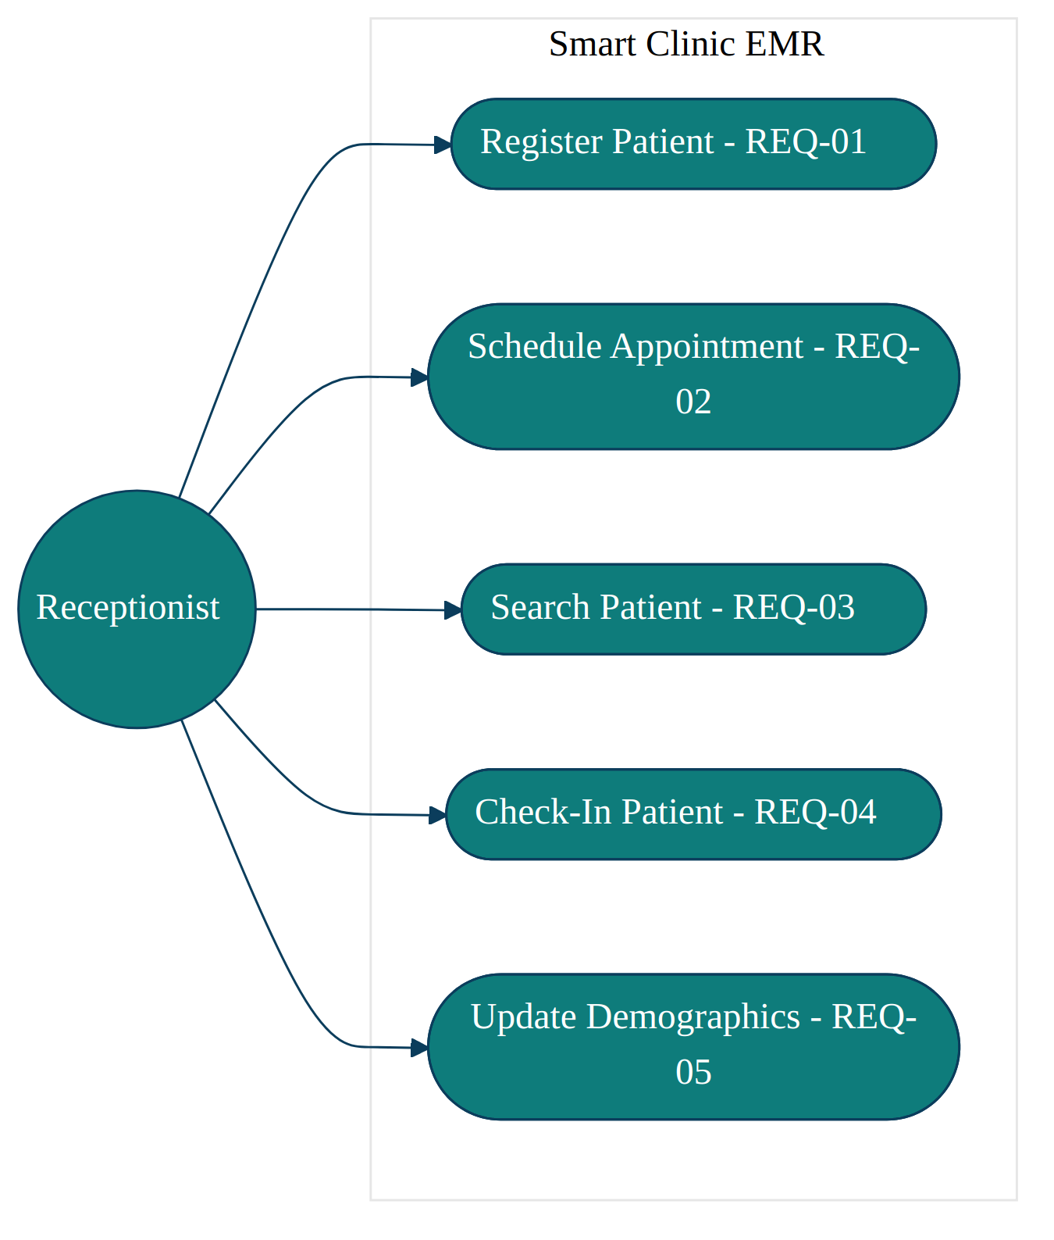
Figure 1. Receptionist use case diagram (REQ-01–REQ-05).

2.2 Doctor Use Cases
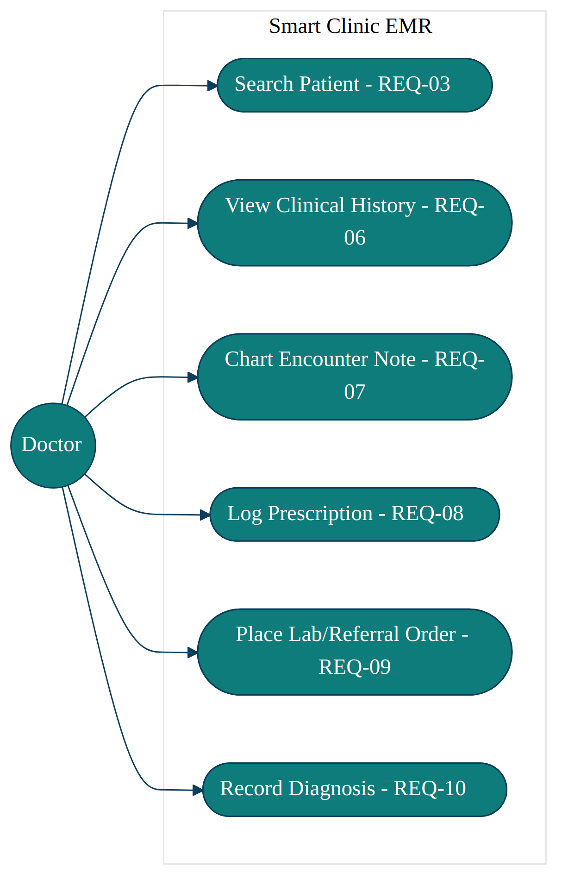
Figure 2. Doctor use case diagram (REQ-03, REQ-06–REQ-10).

2.3 System-Admin Use Cases
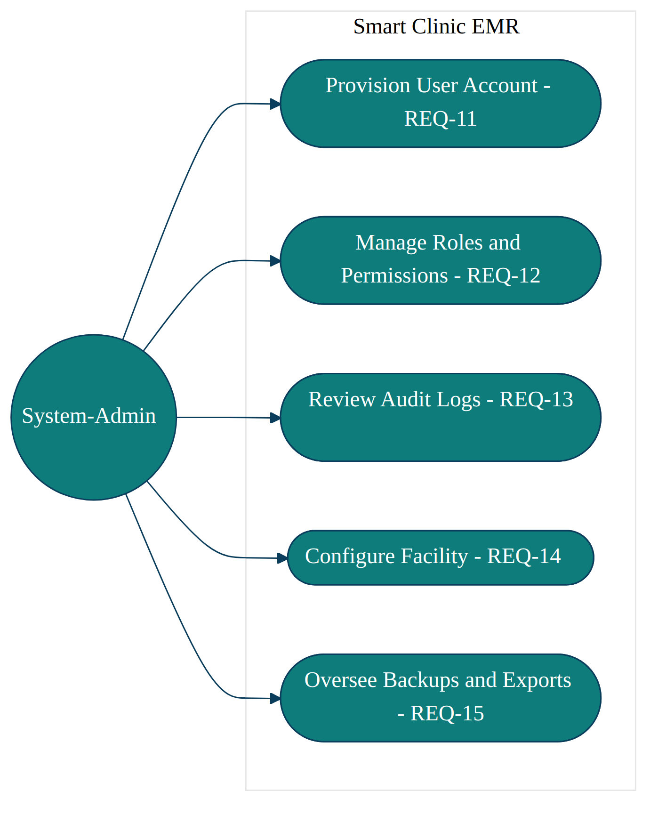
Figure 3. System-Admin use case diagram (REQ-11–REQ-15).

3. Data Design
The core data model centers on the Patient and User entities, with clinical activity captured through Encounters that fan out into Prescriptions and Clinical Orders. All write operations against these entities are mirrored into an append-only Audit Log, satisfying REQ-18.
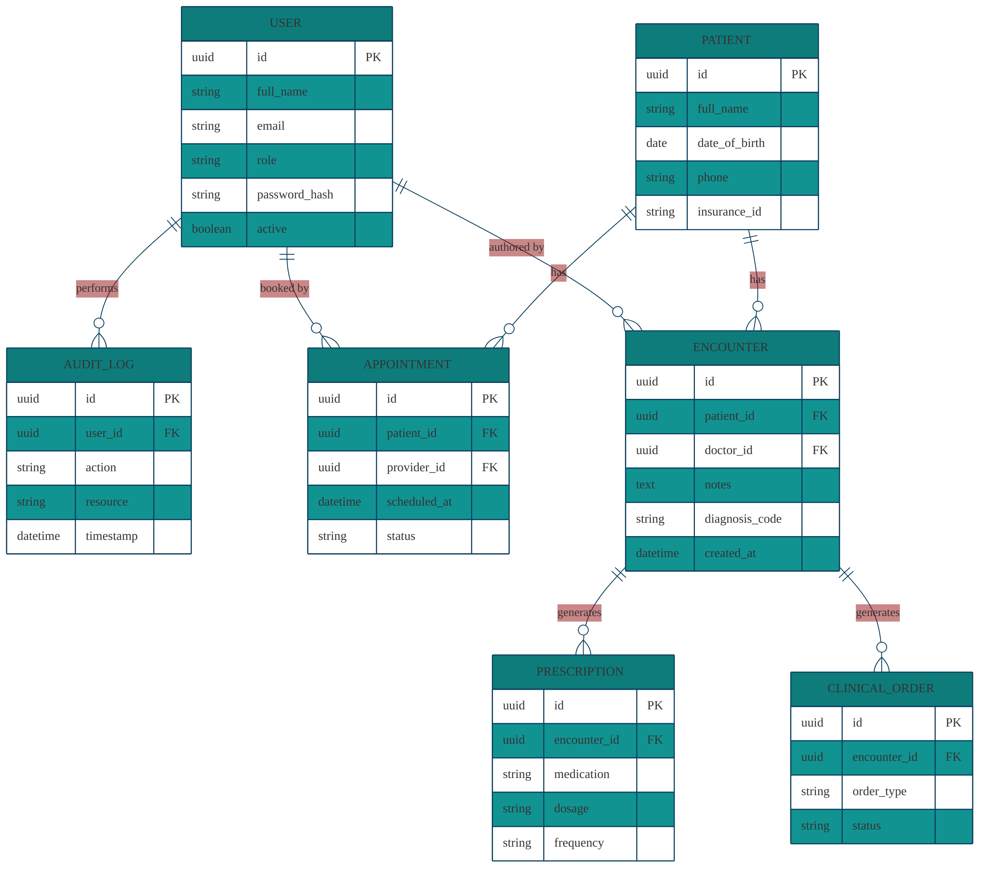
Figure 4. Entity-relationship diagram for the Smart Clinic EMR core data model.

3.1 Entity Summary
Entity | Purpose
USER | Staff account (Receptionist, Doctor, System-Admin) used for authentication and RBAC.
PATIENT | Demographic and insurance record for an individual receiving care.
APPOINTMENT | A scheduled visit linking a patient to a provider and time slot.
ENCOUNTER | A clinical visit record authored by a Doctor, containing notes and diagnosis coding.
PRESCRIPTION | A medication order generated from an encounter.
CLINICAL_ORDER | A lab test or referral order generated from an encounter.
AUDIT_LOG | Immutable record of security- and data-relevant actions performed by users.

4. Dynamic Behavior — Sequence Diagrams
The following sequence diagrams describe the message flow for the platform's three primary workflows, each spanning the frontend, API tier, RBAC middleware, cache, and database.

4.1 Authentication & RBAC Enforcement
Every session begins with credential-based login (REQ-16) and issuance of a signed JWT. Every subsequent request is independently authorized server-side (REQ-17, NFR-08), regardless of what the client believes the user is permitted to do.
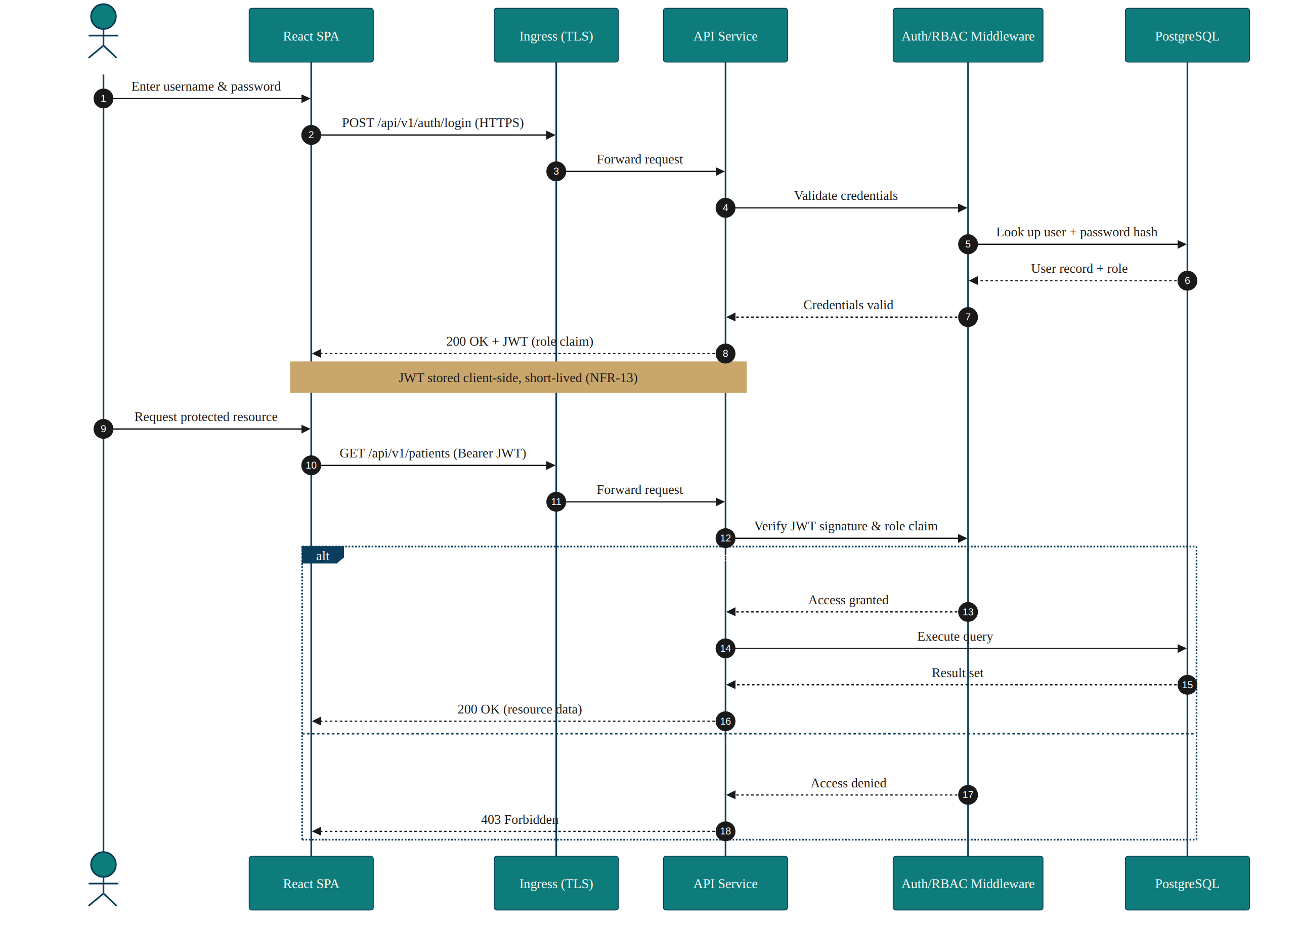
Figure 5. Authentication and role-based authorization sequence.

4.2 Patient Intake & Appointment Scheduling
This flow illustrates the Receptionist's core workflow: patient search, conditional registration, and appointment booking against cached provider availability (REQ-01–REQ-03, Section 4.4 of the SDD's caching strategy).
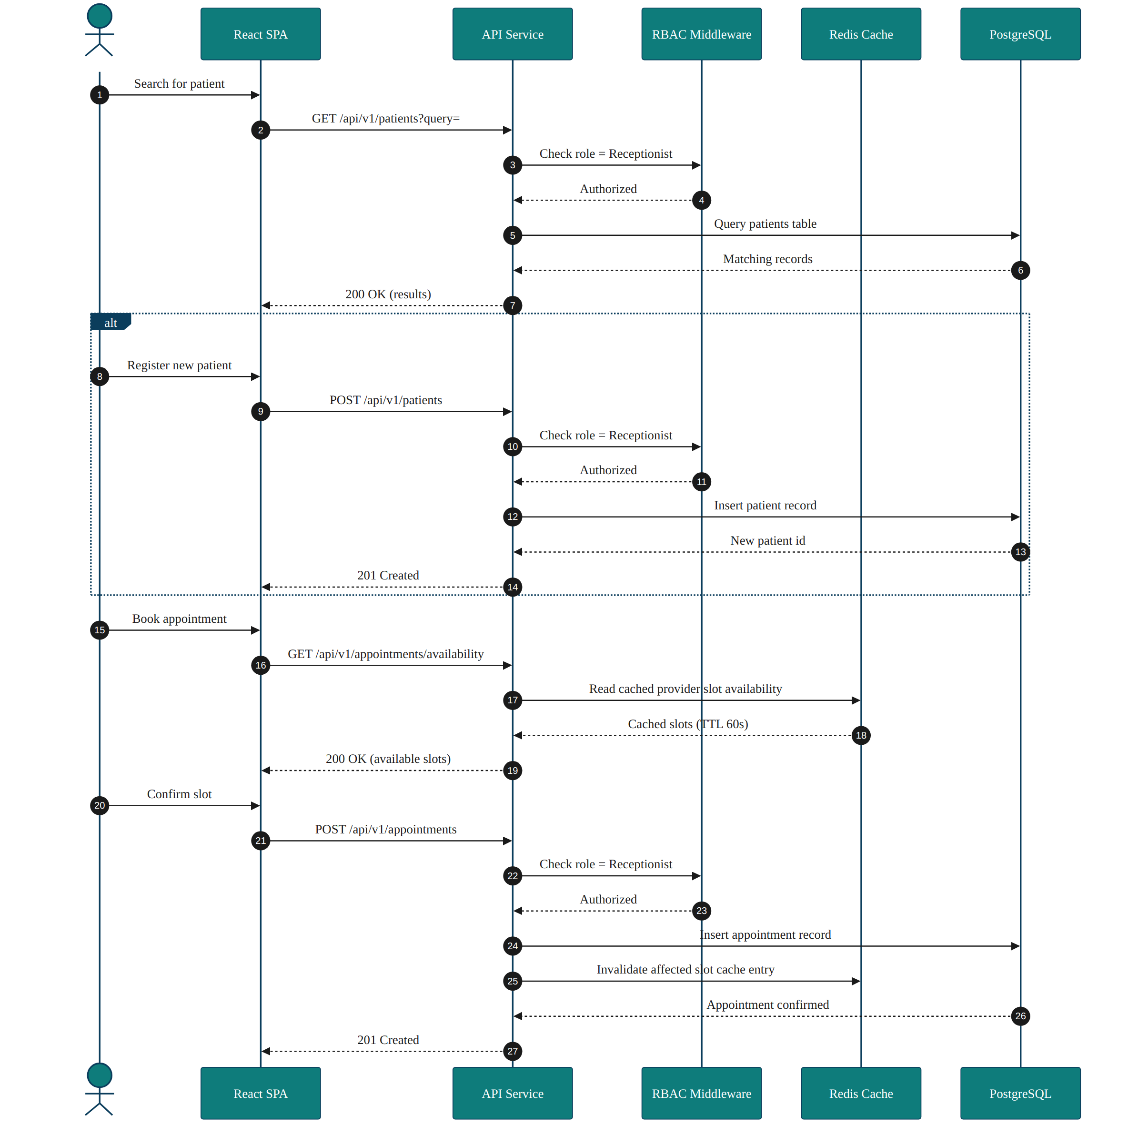
Figure 6. Patient intake and appointment scheduling sequence.

4.3 Clinical Encounter & Prescription Flow
This flow illustrates a Doctor authoring a clinical encounter and prescription against a patient record, including the mandatory audit log write and cache invalidation (REQ-07, REQ-08, REQ-18).
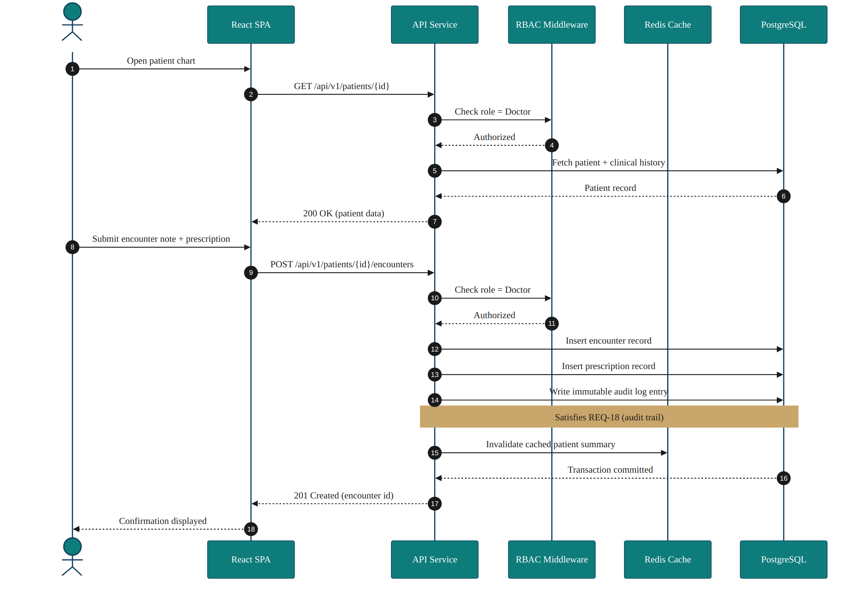
Figure 7. Clinical encounter and prescription sequence.

5. System Architecture
Smart Clinic EMR follows a three-tier architecture: a standalone React single-page application, a stateless RESTful API tier running on Kubernetes behind an Ingress Controller, and a data tier composed of PostgreSQL and Redis. This mirrors the architecture summary in the SRS (Section 4) and is expanded here as a component diagram.
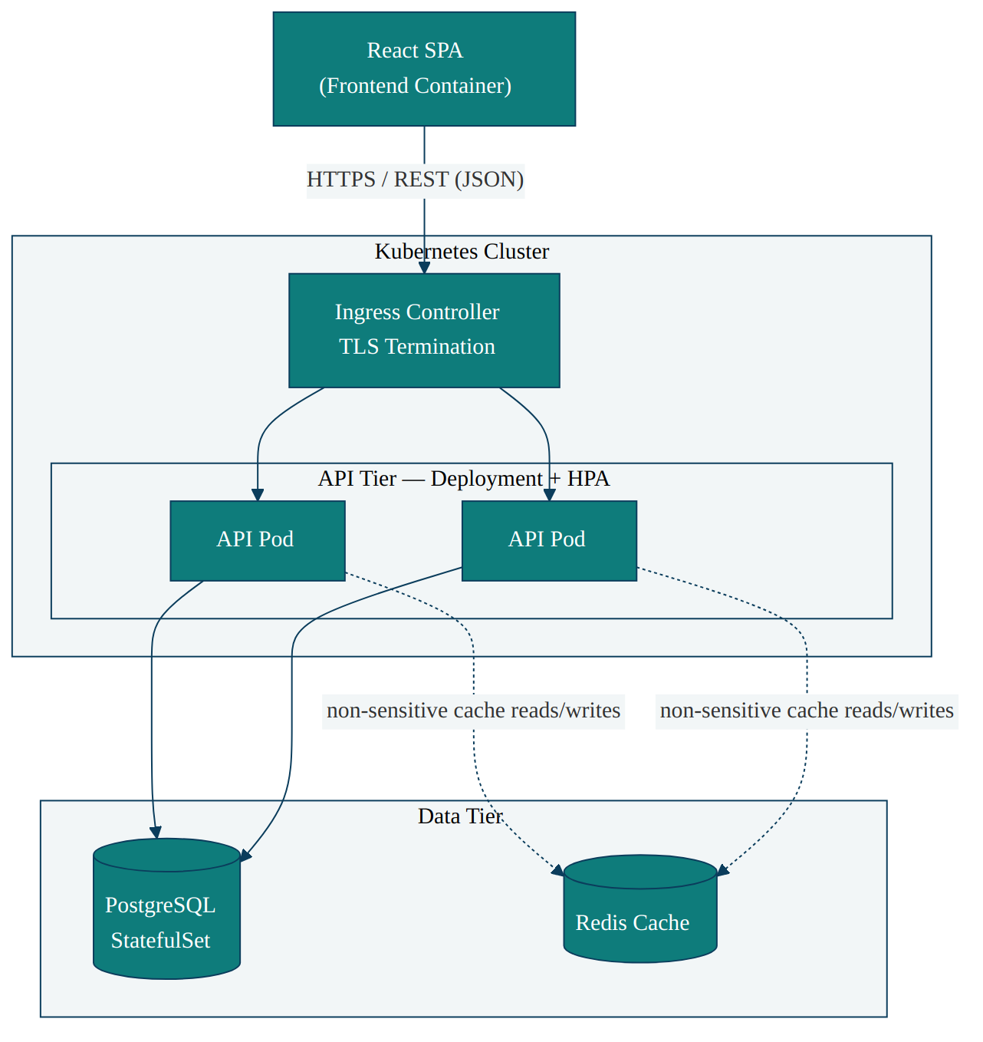
Figure 8. High-level component architecture.

6. Deployment Architecture
Deployment is fully automated through the GitHub Actions CI/CD pipeline. Every merge to the main branch is built, scanned, and published as a container image, then rolled out to the production Kubernetes cluster. The Horizontal Pod Autoscaler (HPA) scales API pods independently across nodes in response to load, satisfying NFR-14.
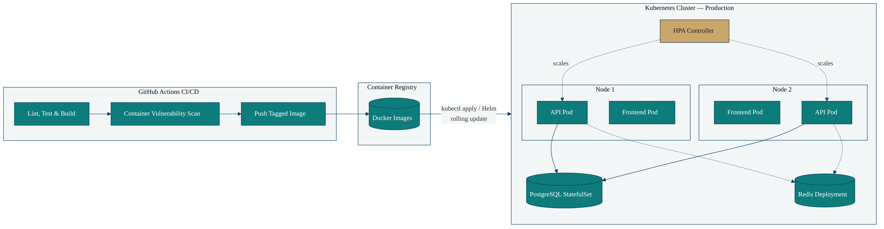
Figure 9. Deployment diagram — CI/CD pipeline to Kubernetes production topology.

7. Design Artifact Traceability
The table below maps each design artifact in this document back to the SRS requirement groups it realizes.
Design Artifact | Traces To
Figures 1–3 — Use Case Diagrams | REQ-01–REQ-15 (all role-based functional requirements)
Figure 4 — Data Model | REQ-06–REQ-10, REQ-18 (clinical data & audit trail)
Figure 5 — Auth/RBAC Sequence | REQ-16, REQ-17, NFR-07–NFR-09, NFR-13
Figure 6 — Intake/Scheduling Sequence | REQ-01–REQ-03, NFR-01–NFR-03 (caching)
Figure 7 — Encounter/Prescription Sequence | REQ-07, REQ-08, REQ-18
Figure 8 — Component Architecture | NFR-01–NFR-06, NFR-14–NFR-15
Figure 9 — Deployment Diagram | NFR-05, NFR-14, NFR-17 (CI/CD governance)

Document Control
This SDD is maintained alongside SCE-SRS-001 by the codeAfar engineering team. Diagrams should be regenerated and this document revised whenever the data model, API contracts, or deployment topology change materially.

